|  |
| --- |
|  |

**FPT UNIVERSITY**

|  |  |
| --- | --- |
| Capstone Project Document | |
| **Email marketing platform with Simple Email Service of Amazon Cloud** | |
| Group 3 -JS | |
| **Group members** | Ngô Minh Tấn – SE62503 (Leader)  Nguyễn Lưu Hồng Sơn – SE62414  Đặng Võ Anh Khoa – SE61550  Nguyễn Hữu Thắng –SE62447 |
| **Supervisor** | Lâm Hữu Khánh Phương |
| **Ext. Supervisor** | N/A |
| **Project Code** | EMP |

**– Ho Chi Minh City, May 13th, 2019 –**

This page is intentionally left blank

**Table of Contents**

**Table of Contents** 3

A. Introduction 12

1. Project Information 12

2. Introduction 12

3. Current Situation 12

4. Problem Definition 13

5. Proposed Solution 13

5.1. Functions 13

5.2. Advantages and disadvantages 14

6. Functional Requirements 15

6.1. Registered User website and mobile application 15

6.2. Admin website 15

7. Role & Responsibility 16

B. Software Project Management Plan 17

1. Problem Definition 17

1.1. Name of this Capstone Project 17

1.2. Problem Abstract 17

1.3. Project Overview 17

2. Project Organization 21

2.1. Software Process Model 21

2.2. Roles and responsibilities 21

2.3. Tools and Techniques 23

3. Project Management Plan 23

3.1. Product Backlog 23

3.2. Sprint Backlog 23

3.3. Deliverables 23

3.4. All Meeting Minutes 24

4. Coding Convention 24

C. Software Requirement Specification 25

1. User Requirement Specification 25

1.1. Guest requirement 25

1.2. Registered User requirement 25

1.3. Staff requirement 26

1.4. Admin requirement 27

2. System Requirement Specification 27

2.1. External Interface Requirement 27

2.2. System Overview Use Case 29

2.3. List of use case 31

3. Software System Attribute 205

3.1. Usability 205

3.2. Reliability 205

3.3. Availability 206

3.4. Security 206

3.5. Maintainability 206

3.6. Portability 206

3.7. Performance 206

4. Conceptual Diagram 207

D. Software Design Description 210

1. Design Overview 210

2. System Architecture Design 211

2.1. Admin web application: 212

2.2. Registered User web system: 212

3. Component Diagram 213

4. Detailed Description 215

4.1. Class Diagram 215

4.2. Class Diagram Explanation 217

4.3. Interaction Diagram 239

5. Interface 257

5.1. Component Interface 257

5.2. User Interface Design 257

6. Database Design 307

6.1. Entity Relationship Diagram (ERD) 307

6.2. Data Dictionary 309

7. AlgorithEMP 329

7.1. Price suggestion model 329

E. System implementation & Test 335

1. Introduction 335

1.1. Overview 335

1.2. Test Approach 335

2. Database Relationship Diagram 335

2.1. Physical Diagram 335

2.2. Data dictionary 337

3. Test Plan 339

3.1. Features to be tested 339

3.2. Features not to be tested 339

4. System Testing Test Case 340

4.1. Registered User testing case: 340

F. Software User’s Manual 343

1. Installation Guide 343

1.1. Setting up environment at server 343

1.2. Deployment at server side 344

1.3. Deploy web application on server 345

2. User Guide 346

2.1. Web application 346

2.2. Mobile application 346

G. Appendix 357

**List of tables**

Table 1 : Roles and Responsibilities 18

Table 2 - Hardware Requirements for Server 21

Table 3 Hardware requirement for PC 22

Table 4 Hardware requirement for the mobile 22

Table 5 Development Environment - Software Requirement 22

Table 6 Roles and responsibilities 25

Table 7 Tools and techniques 25

Table 8 Deliverables 26

Table 9 <Guest> Login 35

Table 10 <Guest> Register 37

Table 11 <Guest> Search equipment 39

Table 12 <Guest> Search materials 41

Table 13 <Guest> Search debris post 44

Table 14 <Registered User> Log out 46

Table 15 <Registered User> Search equipment 48

Table 16 <Registered User> Search materials 50

Table 17 <Registered User> Search debris post 53

Table 18 <Registered User> Add subscription 54

Table 19 <Registered User> Remove subscription 56

Table 20 <Registered User> Edit subscription 58

Table 21 <Registered User> Edit profile 59

Table 22 <Registered User> Report another Registered User 61

Table 23 <Registered User> Add construction 63

Table 24 <Registered User> Edit construction 65

Table 25 <Registered User> Delete construction 66

Table 26 <Supplier> View hiring transaction as supplier 69

Table 27<Supplier> Accept pending hiring transaction 71

Table 28 <Supplier> Deny hiring transaction 72

Table 29 <Supplier> Confirm equipment delivering 74

Table 30: <Supplier> Confirm equipment returned 75

Table 31 : <Supplier> Cancel hiring transaction 77

Table 32 <Supplier> Accept request for time extension 79

Table 33 <Supplier> Deny request for time extension 80

Table 34 <Supplier> Post equipment 83

Table 35 <Supplier> Delete equipment 85

Table 36 : <Supplier> Edit equipment 86

Table 37 : <Supplier> Post material 88

Table 38 <Supplier> Post material 90

Table 39 <Supplier> Delete material 91

Table 40 <Supplier> View material transaction 93

Table 41 : <Supplier> Accept pending material transaction 95

Table 42 <Supplier> Deny pending material transaction 96

Table 43 <Supplier> Confirm material delivering 98

Table 44 <Supplier> Cancel material transaction 99

Table 45 <Supplier>View debris transaction 101

Table 46 <Supplier> Bid on debris post 103

Table 47 <Supplier>Confirm preparing debris service 105

Table 48 <Supplier>Confirm working on debris service 106

Table 49 <Supplier>Cancel debris transaction 107

Table 50 <Requester>View hiring transaction 110

Table 51 <Requester>Confirm equipment received 112

Table 52 <Requester>Request equipment 114

Table 53 <Requester>Cancel hiring transaction 116

Table 54 <Requester>Request to extend hiring time 118

Table 55 <Requester>Cancel time extension request 119

Table 56 <Requester>Return equipment 122

Table 57 <Requester>Feedback hiring transaction 123

Table 58 <Requester>View material transaction 125

Table 59 <Requester>Send material request 127

Table 60 <Requester>Cancel material transaction 129

Table 61 <Requester>Confirm material received 130

Table 62 <Requester>Feedback material transaction 131

Table 63 <Requester>Publish debris post 133

Table 64 <Requester>Edit debris post 135

Table 65 <Requester>Close debris post 136

Table 66 <Requester>Delete debris post 138

Table 67 : <Requester>Edit debris post 139

Table 68 <Requester>Accept debris bid 141

Table 69 Requester>Cancel debris transaction 143

Table 70 <Requester>Confirm debris transaction finished 144

Table 71 <Requester>Feedback debris transaction 146

Table 72 <Scheduler>Check outdate equipment 147

Table 73 <Scheduler>Check subscription matched 149

Table 74 <Scheduler> Train price suggestion model 151

Table 75 <Staff>Verify Registered User 154

Table 76 <Staff>Verify Registered User 155

Table 77 <Staff>Verify Registered User 156

Table 78 <Staff>Verify report 158

Table 79 <Staff>Edit material 159

Table 80 <Staff>Edit equipment 161

Table 81 <Staff>Change password 162

Table 82 <Staff>Adjust hiring transaction 164

Table 83 <Staff>Adjust material transaction 165

Table 84 <Staff>Adjust debris transaction 167

Table 85 <Staff>Send custom notification 168

Table 86 <Staff>View equipment analytics 169

Table 87 : <Staff>View material analytics 171

Table 88 <Staff>View debris analytics 172

Table 89 <Admin>Add staff 175

Table 90 <Admin>Delete staff 176

Table 91 <Admin>Add equipment category 178

Table 92 <Admin>Edit equipment category 179

Table 93 <Admin>Migrate equipment category 181

Table 94 <Admin>Delete equipment category 182

Table 95 <Admin>Add equipment type 183

Table 96 <Admin>Edit equipment type 185

Table 97 <Admin>Delete equipment type 186

Table 98 <Admin>Add equipment type additional fields 188

Table 99 <Admin>Edit equipment type additional fields 189

Table 100 Conceptual Diagram Dictionary 211

Table 101 <Fields> Login 259

Table 102 <Buttons/Hyperlinks> Login 259

Table 103 <Fields> Sign Up 261

Table 104 <Buttons/Hyperlinks> Sign Up 261

Table 105 <Buttons/Hyperlinks> Main menu 262

Table 106 <Buttons/Hyperlinks> Equipment menu 263

Table 107 <Buttons/Hyperlinks> Material menu 264

Table 108 <Buttons/Hyperlinks> Debris menu 264

Table 109 <Buttons/Hyperlinks> User menu 265

Table 110 <Fields> Equipment search 266

Table 111 <Buttons/Hyperlinks> Search equipment 266

Table 112 <Fields> Post new equipment step 1 267

Table 113 <Buttons/Hyperlinks> Post new equipment step 1 268

Table 114 <Fields> Post new equipment step 2 268

Table 115 <Buttons/Hyperlinks> Post new equipment step 2 269

Table 116 <Fields> Post new equipment step 3 269

Table 117 <Buttons/Hyperlinks> Post new equipment step 3 269

Table 118 <Fields> Post new equipment step 2 270

Table 119 <Buttons/Hyperlinks> View and delete equipment 271

Table 120 <Fields> Edit equipment 272

Table 121 <Buttons/Hyperlinks> Edit equipment 273

Table 122 <Fields> Manage equipment transactions 274

Table 123 <Buttons/Hyperlinks> Manage equipment transactions 274

Table 124 <Fields> Manage equipment subscriptions 275

Table 125 <Buttons/Hyperlinks> Manage equipment subscriptions 276

Table 126 <Fields> Login 290

Table 127 <Buttons/Hyperlinks> Login 290

Table 128 <Buttons/Hyperlinks> Main menu 291

Table 129 <Buttons/Hyperlinks> Equipment menu 292

Table 130 <Buttons/Hyperlinks> Material menu 293

Table 131 <Buttons/Hyperlinks> Debris menu 294

Table 132 <Buttons/Hyperlinks> Report menu 294

Table 133 <Fields> Dashboard 296

Table 134 <Buttons/Hyperlinks> Dashboard 296

Table 135 <Fields> Manage Staff 298

Table 136 <Buttons/Hyperlinks> Manage Staff 298

Table 137 <Fields> Manage Registered User 300

Table 138 <Buttons/Hyperlinks> Manage Registered User 300

Table 139 <Fields> Manage Equipment Category 301

Table 140 <Buttons/Hyperlinks> Manage Equipment Category 302

Table 141 <Fields> Manage Equipment Type 303

Table 142 <Buttons/Hyperlinks> Manage Equipment Type 304

Table 143 <Fields> Manage Equipment 306

Table 144 <Buttons/Hyperlinks> Manage Equipment 306

Table 145 <Fields> Manage Hiring Transaction 308

Table 146 <Buttons/Hyperlinks> Manage Hiring Transaction 308

Table 147 Entity Relationship Diagram Dictionary 312

**List of Figures**

Figure 1 - Scrum Framework 23

Figure 2: <Guest> Overview use case 33

Figure 3 <Guest> Login 33

Figure 4 Conceptual Diagram 209

Figure 5 System Architecture diagram 213

Figure 6 Component Diagram - Registered User Web Api 215

Figure 7 Component Data Dictionary 217

Figure 8 Class Diagram 218

Figure 9 Class Diagram Dictionary 222

[Figure 10 Sequence Diagram - Search equipment 242](https://d.docs.live.net/fe447eae7a2d9c8b/Capstone/reports/Report-full.docx#_Toc7065941)

[Figure 11 Sequence Diagram - Login 243](https://d.docs.live.net/fe447eae7a2d9c8b/Capstone/reports/Report-full.docx#_Toc7065942)

[Figure 12 Sequence Diagram - Check Subscription 244](https://d.docs.live.net/fe447eae7a2d9c8b/Capstone/reports/Report-full.docx#_Toc7065943)

Figure 13 Sequence Diagram - Post equipment 245

Figure 14 Sequence Diagram - Request equipment 246

[Figure 15 Sequence Diagram - Chang hiring status 247](https://d.docs.live.net/fe447eae7a2d9c8b/Capstone/reports/Report-full.docx#_Toc7065946)

Figure 16 Sequence Diagram - Checkout Materials 248

Figure 17 Sequence Diagram - Publish Debris Post 249

Figure 18 Sequence Diagram - Bid on Debris Post 250

Figure 19 Sequence diagram - Verify Registered User 255

[Figure 20 Sequence diagram - Add staff 256](https://d.docs.live.net/fe447eae7a2d9c8b/Capstone/reports/Report-full.docx#_Toc7065951)

Figure 21 Sequence diagram - Add equipmen type 257

[Figure 22 Edit equipment type 258](https://d.docs.live.net/fe447eae7a2d9c8b/Capstone/reports/Report-full.docx#_Toc7065953)

Figure 23 Login 259

Figure 24 Entity Relation Diagram 310

**Figure 25 Linear regression plot - from Wikipedia** 332

**Figure 26 Gradient Descent Plot** 334

Figure 27: Physical Diagram 338

Figure 28: Data Dictionary 341

# Introduction

## Project Information

* Project name:  **Email marketing platform with Simple Email Service of Amazon Cloud**
* Project Code: **EMP**
* Product Type: **Website Application**
* Start Date: **May 13th, 2019**
* End Date: **July 24th, 2019**

## Introduction

We are living in the industrial age of 4.0, an era in which people will interact with machines and equipment to reduce manual work and automate machines. Not outside the development of the automation era, the marketing industry is also built by an automated marketing system to reduce the pure work that marketers have to do, including an automated email system. dynamic. Companies will not have to spend too much money to build an automated email system as well as the operating and maintenance team.

We built a software to solve the problem, it’s called Mindsending. Unlike Mailchimp and others email marketing applications on the market, it is only for users to create a simple pure automated email with a non-general look that will make it difficult for new entrants to marketing, MindSending helps people has a more general view of the system to automatically send emails to customers by supporting the drawing of BPMN( Business Process Modeling Notation) and then apply to the system of automatically sending emails to customers.

Our software will ensure the sending of mail throughout, in a user-customized HTML format (templates) with a high degree of customization. Besides, we can classify customers as well as mailing plans according to your company's sales campaign (campaign). The sender's and sender's information will always be kept confidential to avoid the risk of information leakage.

## Current Situation

- Email marketing is the act of sending a commercial message, typically to a group of people, using email. Email marketing is significantly cheaper and faster than traditional mail, mainly because with email, most of the cost falls on the recipient. Email marketing carries the benefit of allowing marketers to identify returns on investment and measure and improve efficiency.

- But email marketing also has some of disadvantages: spam emails, porn emails, in-appropriate content in the message which send to the customers.

## Problem Definition

Below are disadvantages of current situation:

* **Traditional marketing costs are very high,** sales companies spend a lot of money on 30s advertising on television or on other media such as newspapers and flyers.
* **Sending traditional emails is easy to send your mail to the spam mailbox,** making the approach to customers more restrictive.
* **Others email marketing applications on the market, it is only for users to create a simple pure automated email** with a non-general look that will make it difficult for new entrants to set up an email marketing.

## Proposed Solution

Our proposed solution is to build a system called MindSending (EMP) to resolve the current situation by helping people has a more general view of the system to automatically send emails to customers by supporting the drawing of BPMN( Business Process Modeling Notation) and then apply to the system of automatically sending emails to customers.

The EMP system includes two web applications with BPMN drawing tool.

### Functions

* Administrator system (Web application):
  + **Manage campaign**: Admin or staff can manage, adjust information with high authority actions.
  + **Manage account**: Admin or staff can check and verify sensitive information, account profile information.
  + **Manage sever**: Admin can view overall sever and manage sever with high authority actions.
* Client applications (Web application):
  + **Manage own account:** The customer has an overview of the account information….
  + **Manage report:** The customer can view report generated from the system by date, month, year.
  + **Manage contact:** When a contact is brought into the system, the customer can add, delete, edit contact and can export contact lists.
  + **Manage group:** Customers can categorize contacts into groups to facilitate contact entry into the appropriate sending email list.
  + **Manage templates:** Customers can add a new template or edit an existing template of the system.
  + **Draw BPNM model :** Customers can draw a BPNM model to set up automation campaign.

### Advantages and disavantages

The advantages and disadvantages of the proposed solution:

* Advantages
  + **Easy for managing and review:** Managing all workflow automation email marketing through BPMN model. Customer can drag/drop object from BPMN drawing tool.
  + **Helping for using contact database effectively through contact and group systeEMP:** Help customers categorize customers according to each status.
* Disadvantages:
  + **Can not satisfy all demands:** Marketing is a very flexible and complicated field and there are special business cases that the system cannot fit. Staff involvement may be required in order to resolve these special situations.

## Functional Requirements

Function requirements of the system are listed as below:

### Email marketing website

* Customer can view account information
* Customer can change password
* Customer can edit account information
* Customer can search for contact with filter and sorting
* Customer can manage contact in the system
* Customer can manage and change their contact status
* Customer can search for group contact with filter and sorting
* Customer can manage group contact
* Customer can export list contact
* Customer can add new template
* Customer can edit templates suitable for work purposes
* Customer can add new BPNM model
* Customer can edit BPNM model
* Customer can view analysis report by date, month, year

### Admin website

* Admin can manage campaign
* Admin can manage all accounts on the system
* Admin can manage sever

## Role & Responsibility

|  |  |  |  |  |
| --- | --- | --- | --- | --- |
| **No** | **Full Name** | **Role** | **Position** | **Contact** |
| 1 | Lâm Hữu Khánh Phương | Project Manager | Supervisor |  |
| 2 | Ngô Minh Tấn | Developer | Leader |  |
| 3 | Nguyễn Lưu Hồng Sơn | Developer | Member |  |
| 4 | Đặng Võ Anh Khoa | Developer | Member |  |
| 5 | Nguyễn Hữu Thắng | Developer | Member |  |

Table 1 : Roles and Responsibilities

# Software Project Management Plan

## Problem Definition

### Name of this Capstone Project

* Official name: Email marketing platform with Simple Email Service of Amazon Cloud
* Vietnamese name: Ứng dụng khởi tạo email tiếp thị với dịch vụ email của Amazon
* Abbreviation: EMP

### Problem Abstract

This project concentrates on creating an automation email marketing. It is called Mindsending (EMP). EMP is to assist customer for managing and initiating an automation email marketing.

In marketing, planning a marketing plan that suits the needs of customers is a central issue. Use email that has been collected effectively and can be reused.

The Mindsending web application supports customer an optimal solution for that problem, providing a BPNM model for easy manage and create an workflow.

### Project Overview

#### Current Situation

Below are the problems encountered in this project:

* **Limited time and human resource.** The team only has 4 members and 13 weeks to execute the project from requirement analytics, design, implement and testing.
* **Lack of business view.** Team members’ major is Software engineering, leading to little experience in general business fields, especially in the construction business field. Therefore, research and training effort would be made to adjust and improve the business model.
* **Lack of experience**. Team members do not have much experience in applying new technology into real projects. There would be new probleEMP arise that require research time and expertise.
* **Schedule conflict.** Team members have different schedule arrangement and lack of co-working time, leading to lack of synchronization of the team.
* **Lack of UX/UI skills.** As developers, the team do not have much knowledge in graphics design and user experience designing, which is a critical factor for a successful C2C product (customer-to-customer product)

#### The Proposed System

According to the recent trend in e-commerce, email marketing is a promising field that can solve access customer’s problem. Therefore, applying that model with necessary modification would be a possible solution.

The basic idea is that we create an email marketing platform with Simple Email Service of Amazon Cloud. We provide a website for end user (customer) to use the system. We also have an admin website to control the system with high authority.

#### Boundaries of the System

* The language of the system is English
* (pending)

#### Future Plans

* Current system can only support admin to manage equipment. We design the system to provide analytic views for admin:
  + Admin can view statistics and visualized graph about transaction process
  + Admin can view strategic information about equipment trends, hiring trends, Registered User needs trends
* Current system can only suggest price to Registered User based on equipment type. We design the system to support data for further machine learning features:
  + Suggest equipment price based on equipment name, location, time
* Current system can only provide delivery status to delivery management. We design the system to support more feature to delivery phase:
  + Support direction and route guidance for delivery
  + Support delivery time estimate based on city, time, traffic

#### Development environment

##### Hardware requirements

For server

|  |  |  |
| --- | --- | --- |
| Hardware | Minimum Requirement | Recommended |
| Internet Connection | Cable, Wi-Fi (8 Mbps) | Cable, Wi-Fi (50 Mbps or more) |
| Operation System | XP, Vista, 7, 10, Window Server 2008, Linux | 10, Window server 2008 |
| Computer Processor | Intel® Xeon ® 1.4GHz | Intel® Xeon ® Quad Core (12M Cache, 2.50 GHz) |
| Computer memory | 4GB RAM | 32 GB RAM or more |
| Storage space | 1GB | 5GB or more |

Table 2 - Hardware Requirements for Server

For PC

|  |  |  |
| --- | --- | --- |
| PC | Minimum Requirements | Recommended |
| Internet Connection | Cable, Wi-Fi (4 Mbps) | Cable, Wi-Fi (8 Mbps) |
| Operating System | Window 7 | Window 7 or more. |
| Computer Processor | Intel® Core i3 1.4GHz | Intel® Core i5 2.50GHz |
| Computer Memory | 1GB RAM | 2GB RAM or more |
| Web Browser | Chromes (v42 or higher) | Chrome latest stable version |

Table 3 Hardware requirement for PC

##### Software requirement

|  |  |  |
| --- | --- | --- |
| Software | Name / Version | Description |
| Operation System | Windows Server 2014 | Operating system and platform for development |
| Environment | Java EE 8.0, Node v10, npm v6 | Specification for developing web application |
| Modeling tool | StarUML, Draw.io | Used to design diagram |
| IDE | Intellij IDEA 2019.1.5, Visual Studio Code 1.27.2 | Programming tools |
| DBEMP | MYSQL 8.0 | Used to create & manage the database for system |
| Source control | Git (Github server) | Used for source control |
| Web browser | Chrome 69 or above | Testing browser |

Table 4 Development Environment - Software Requirement

## Project Organization

### Software Process Model

This project is developed using Scrum model – part of an agile framework for Software development project. Scrum model is chosen because of the following reasons:

* Scrum is the most suitable model for small and medium project, and we only have 4 members
* The term “machine learning” is new to the team and there would be many trial-and-error tests with the system design before applying to the official release
* There are many new technologies that team members have to learn and develop at the same time, so SCRUM would allow us to do that
* The business model may not be fully tested in real market condition so changes are highly possible. Using Scrum team members can adapt to changes better



Figure 1 - Scrum Framework

### Roles and responsibilities

|  |  |  |  |
| --- | --- | --- | --- |
| No | Full name | Role in Group | Responsibilities |
| 1 | Nguyễn Phan Quang Nhật | Product Owner | * Specify user requirement * Control the development process * Give out technique and business analysis support |
| 2 | Lưu Quang Nghĩa | Scrum Master | * Managing project * Designing databases * Clarifying requirements * Prepare documents * GUI Design * Create test plan * Coding * Testing * Arrange Meeting * Risk Management |
| 3 | Lê Hoàng Nam | Scrum team member | * Clarifying requirements * Preparing documents * Mobile GUI Design * Coding * Testing |
| 4 | Trương Tổ Kiệt | Scrum team member | * Clarifying and refining requirements * Handling business related probleEMP * Preparing documents * Admin GUI Design * Create test plan * Coding * Testing |
| 5 | Trần Công Minh | Scrum team member | * Preparing documents * Registered User website GUI Design * Deployment * Create test plan * Coding * Testing |

Table 6 Roles and responsibilities

### Tools and Techniques

|  |  |
| --- | --- |
| Tool/Technique | Name |
| Front-end | HTML, CSS, JavaScript, jQuery, ReactJs, React Native |
| Back-end | JavaEE, Spring, JPA, Hibernate |
| IDE | IntelliJ IDEA 17.2, Visual Studio Code |
| DBEMP | MySQL |
| Source Control | Git, Github |
| Modelling tool | StarUML, Draw.io |

Table 7 Tools and techniques

## Project Management Plan

### Product Backlog

Product Backlog could be found [here.](https://drive.google.com/open?id=1hJ2loRGJDPmh-D2Zm1oSJTu9u1qBt99ybJAj1JLJSt0)

### Sprint Backlog

Sprint Backlog can be found [here](https://docs.google.com/spreadsheets/d/1ei8C6OGqnKYWK0I5HX1T0Bcu-IQfVVulU_9_QmHVhEY/edit?usp=sharing)

### Deliverables

|  |  |  |
| --- | --- | --- |
| No | Deliverable | Note |
| 1 | Introduction, Entity Relationship Diagram, Business model detail, | Sprint 1 |
| 2 | Use case Overview, UI for mobile application, Conceptual Diagram, First deployment | Sprint 2 |
| 3 | Class Diagram, Physical Diagram, UI for Website Admin, Implement Search equipment | Sprint 3 |
| … |  |  |

Table 8 Deliverables

### All Meeting Minutes

All sprint meeting minutes could be found [here](https://drive.google.com/open?id=1LIwLFeSkVkFuURBqeYgy2I-vJnobL-u3).

## Coding Convention

Summary:

* Naming Convention:
  + Variable names should be short yet meaningful. The choice of a variable name should be designed to indicate to the casual observer the intent of its use.
  + Methods should be verbs, in mixed case with the first letter lowercase, with the first letter of each internal word capitalized.
* Indentation:
  + One declaration per line is recommended since it encourages commenting.
  + In absolutely no case should variables and functions be declared on the same line.
  + Do not put different types on the same line.
* Declarations Convention:
  + One declaration per line is recommended since it encourages commenting.
  + Using Java Code Convention from:

<http://www.oracle.com/technetwork/java/codeconvtoc-136057.html>

# Software Requirement Specification

## User Requirement Specification

### Guest Requirement

***Guest*** *is a person who doesn’t have access to the system. Guest can use some*

*functions in the system. To use all functions, guest must login. These are some*

*functions that guest can use*:

* Login.
* Register.

### User requirement

***User*** *is a guest who logged into the system with user’s role. There are some functions that user can use:*

* Manage own account
* Manage report:

-View report

-Analysis report

* Manage contact:

-Add contact

-Delete contact

-Edit information of contact

-Export list contact

* Manage group:

-Add contact to group

-Delete group

-Edit group

-Search group

-Create group

* Manage templates:

-Add formatted template

-Edit inside template

* Draw BPNM model:

-Add BPNM

-Edit BPNM

-Delete BPNM

### Admin requirement

***Admin*** *is an authorized user has permission to log in to the system. An admin has higher authority than user and can do whatever a user can. In addition, an admin can do the following functions:*

* Admin can manage account
* Admin can manage campaign
* Admin can manage sever

## System Requirement Specification

### External Interface Requirement

#### User Interface:

* GUI should be simple, clear, intuitive, and reminiscent.
* The interface design is an iterate process includes: design, sketching, prototyping, user assessment.
* The language for User Interface is English

#### Hardware Interface

* Mobile Device
* Desktop PC or Laptop

#### Software Interface

* Web application: work with browsers Firefox (v52 or higher), Chromes (v28 or higher), Internet Explorer (v10 or above) or with any web browser that supports HTML5 & CSS3.
* Mobile application: iOS (9.0 or higher)

#### Communication Protocol

* Use HTTP protocol 1.1 for communication between the web browser and the web server.

### System Overview Use Case

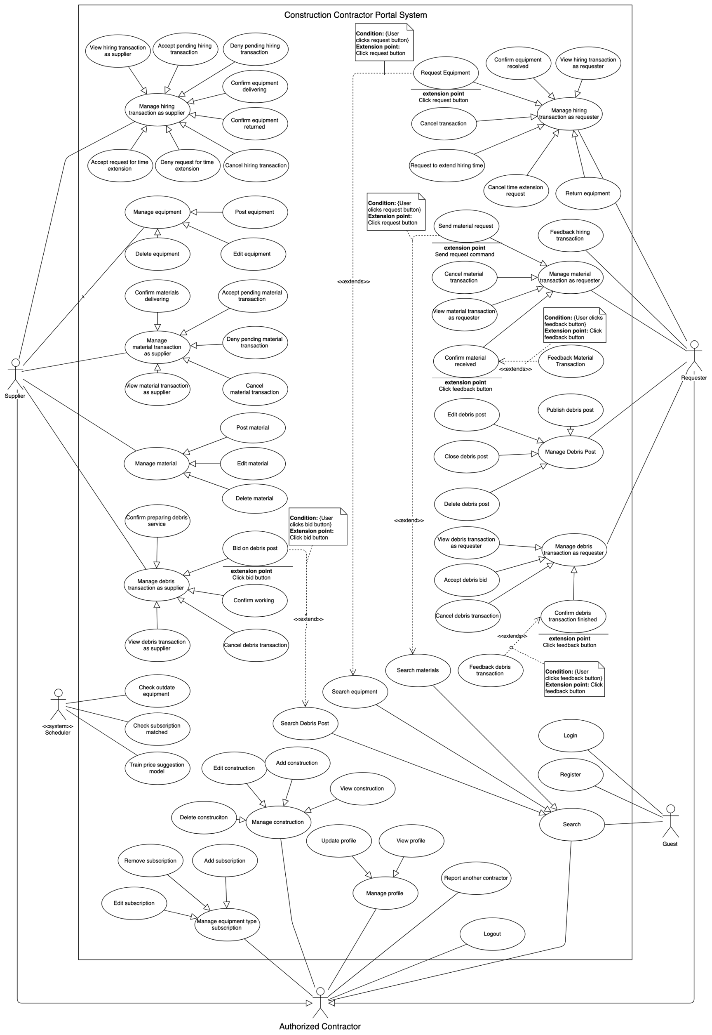

Figure 1: System overview use case

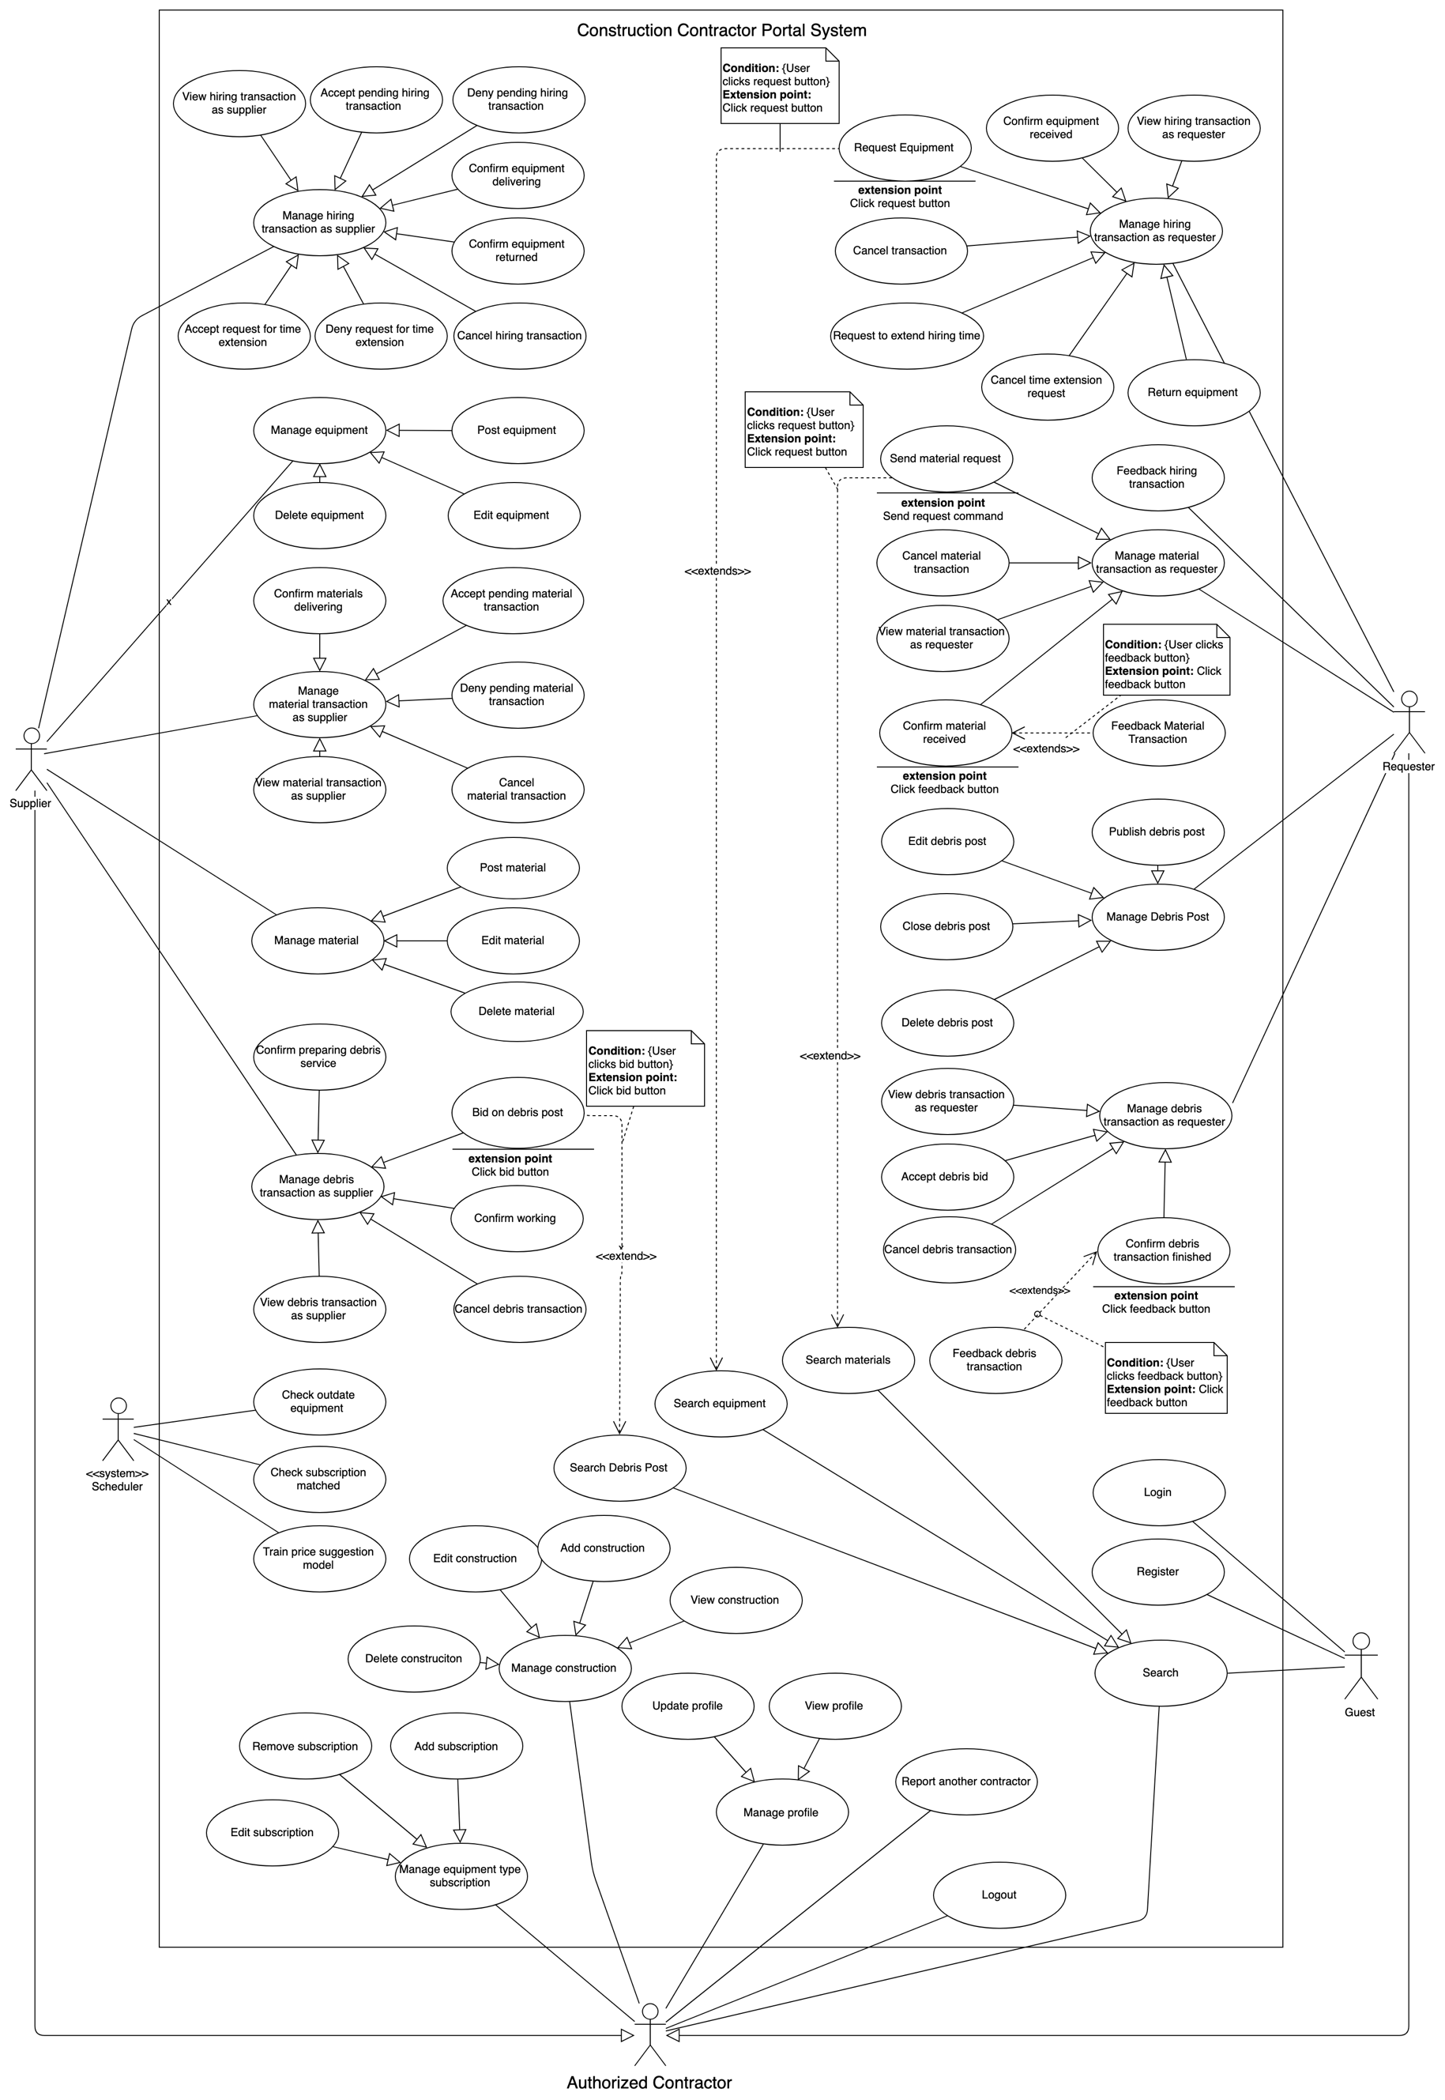

### List of use case

#### <Guest> Overview Use Case

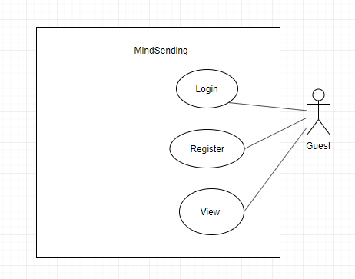

Figure 2: <Guest> Overview use case

##### <Guest> Login

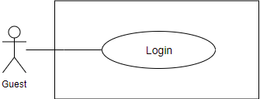

Figure 3 <Guest> Login

**Use Case Specification**

|  |  |  |  |
| --- | --- | --- | --- |
| **USE CASE – EMP_UC_01** | | | |
| **Use Case No.** | **EMP_UC_01** | Use Case Version | 1.1 |
| **Use Case Name** | Login | | |
| **Author** | Dang Vo Anh Khoa | | |
| **Date** | 09/06/2019 | **Priority** | Normal |
| **Actor:**   * Guest   **Summary:**   * This use case allows user to login to the system.   **Goal:**   * User can login to the system   **Trigger:**   * User send the login command.   **Precondition:**   * User is viewing the login screen   **Post Conditions:**   * Success: User login to the system successfully * Fail: Show error messages   **Main Success Scenario:**   |  |  |  | | --- | --- | --- | | Step | Actor Action | System Response | | 1 | User go to the login view | The system requires the following input from User includes:   * Username: text, required * Password: text, required | | 2 | User inputs information. |  | | 3 | User sends command to login | The system show message that the user has logged in successfully  [Exception 1] |   **Exception 1:**   |  |  |  | | --- | --- | --- | | **Step** | **Cause** | **System Response** | | 1 | No internet connection | System shows message the "Please check your connection" when the internet is lost. |   **Relationship:** N/A.  **Business rule:**   * User password character is secured and hidden with special character * The system generates an access token * The system generates a refresh token * System can use access token to verify identity without reenter username and password again * Refresh token can be used to retrieve new access token with no username or password needed * Access token have expiration time of 15 mins * Refresh token has expiration time of 90 days * Refresh token and access token is signed with RSA256 algorithm * Refresh token and access token also contain at least following information:   + Username   + User id   + Expire time   + Created time   + Signature for security * User is required a new refresh token if password changed or refresh token is expired | | | |

Table 9 <Guest> Login

##### <Guest> Register

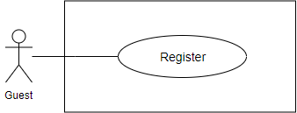

Figure 4: <Guest> Register

**Use Case Specification**

|  |  |  |  |
| --- | --- | --- | --- |
| **USE CASE - EMP_UC_02** | | | |
| **Use Case No.** | EMP_UC_02 | Use Case Version | 1.1 |
| **Use Case Name** | Register | | |
| **Author** | Dang Vo Anh Khoa | | |
| **Date** | 09/06/2019 | **Priority** | Normal |
| **Actor**:   * Guest   **Summary**:   * This use case allows user to register to the system.   **Goal**:   * User can register to the system   **Trigger**:   * User send the register command.   **Precondition**:   * User is viewing the register screen   **Post Conditions:**   * Success: User register to the system successfully * Fail: Show error messages   **Main Success Scenario:**   |  |  |  | | --- | --- | --- | | **Step** | **Actor Action** | **System Response** | | 1 | User go to the guess view | The system requires the following input from User includes:   * Username: text, required * Password: text, required * Confirm password: text, required * Name: text, required * Email: text, required * Phone: text as number, required * Profile image: image, required | | 2 | User inputs information. |  | | 3 | User sends the command to register | The system show message that the user has registered successfully  [Exception 1] |   Exception 1:   |  |  |  | | --- | --- | --- | | **Step** | **Cause** | **System Response** | | 1 | No internet connection | System shows message the "Please check your connection" when the internet is lost. |   **Relationship**: N/A.  **Business** rule:   * User password must not be saved directly plain text, and must be hashed * The system validates user input with the following constraints:   + Username: unique   + Phone number: number format   + Email: as an email format   + The confirm password matches the password | | | |

Table 10 <Guest> Register

#### <Registered User> Overview Use Case

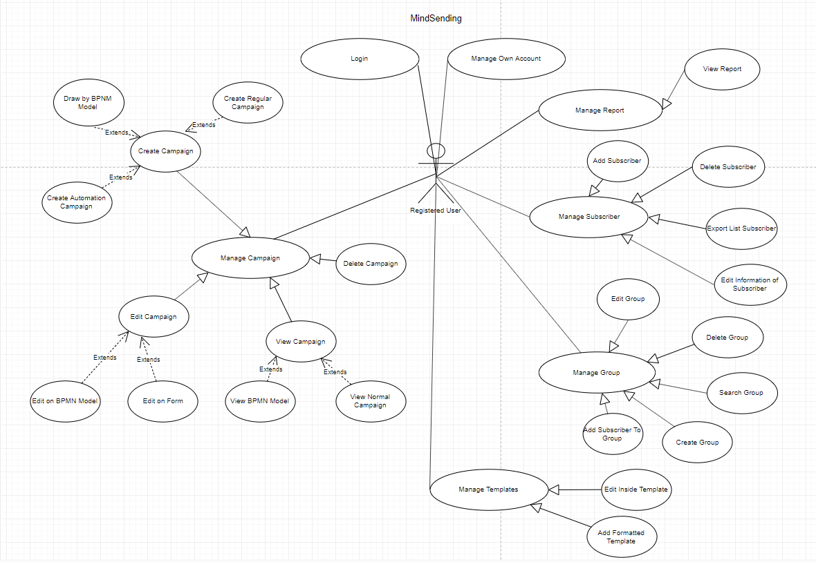

Figure 8: <Registered User>Overview use case

##### <Registered User> Login

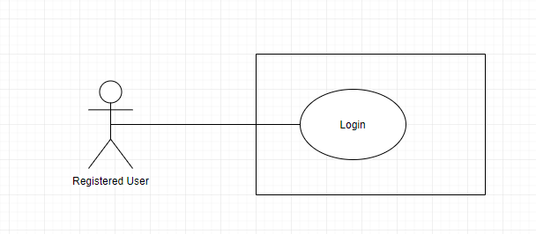

Figure 9: <Registered User> Login

**Use Case Specification**

|  |  |  |  |
| --- | --- | --- | --- |
| **USE CASE - EMP_UC_06** | | | |
| **Use Case No.** | **EMP_UC_06** | **Use Case Version** | 1.1 |
| **Use Case Name** | Login | | |
| **Author** | Dang Vo Anh Khoa | | |
| **Date** | 09/06/2019 | **Priority** | Normal |
| **Actor:**   * Registered User   **Summary:**   * This use case allows user to login to the system.   **Goal:**   * User can login to the system   **Trigger:**   * User send a login command.   **Precondition:**   * User is viewing the login screen   **Post Conditions:**   * Success: User login to the system successfully * Fail: Show error messages   **Main Success Scenario:**   |  |  |  | | --- | --- | --- | | **Step** | **Actor Action** | **System Response** | | 1 | User go to the login screen |  | | 2 | User send a login command. | The system allow user login to the system  [Exception 1] |   **Exception 1:**   |  |  |  | | --- | --- | --- | | **Step** | **Cause** | **System Response** | | 1 | No internet connection | System shows message the "Please check your connection" when the internet is lost. |   **Relationship:** N/A.  **Business rule:**   * After login, user access the system as role “Registered User” | | | |

Table 14 <Registered User> Log out

##### <Registered User> Manage Own Account

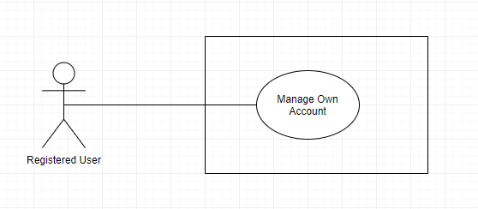

Figure 16: <Registered User> Manage Own Account

**Use Case Specification**

|  |  |  |  |
| --- | --- | --- | --- |
| **USE CASE - EMP_UC_07** | | | |
| **Use Case No.** | **EMP_UC_07** | **Use Case Version** | 1.0 |
| **Use Case Name** | Manage Own Account | | |
| **Author** | Dang Vo Anh Khoa | | |
| **Date** | 09/06/2019 | **Priority** | Normal |
| **Actor:**   * Registered User   **Summary:**   * This use case allows user to manage own account   **Goal:**   * User can manage own account   **Triggers:**   * User send manage account command to the system.   **Preconditions:**   * User must login into the system with role Registered User   **Post conditions:**   * Success: The profile successful edited. * Fail: Show error message   **Main Success Scenario:**   |  |  |  | | --- | --- | --- | | **Step** | **Actor Action** | **System Response** | | 1 | User goes to manage account view | The system requires input from user includes:   * Name: text, * Email: text, * Phone: text as number, * Profile image: image, * Password: text, password | | 2 | User inputs information. |  | | 3 | User send edit profile command. | System shows message profile has been edited successfully.  [Exception 1]  [Exception 2] |   **Exception 1:**   |  |  |  | | --- | --- | --- | | **No** | **Cause** | **System Response** | | 1 | Edit profile fail. (Input contain special characters) | The system shows an error message “Input may not contain special characters” |   **Exception 2:**   |  |  |  | | --- | --- | --- | | **Step** | **Cause** | **System Response** | | 1 | When the connection to the server is lost | System shows message the "Please check your connection" when the internet is lost. |   **Relationships:** N/A.  **Business Rules:**   * After editing profile, Registered User must be verified again by staff * Registered User status change to “Not verified” | | | |

Table 21 <Registered User> Edit profile

##### <Registered User> Manage Report

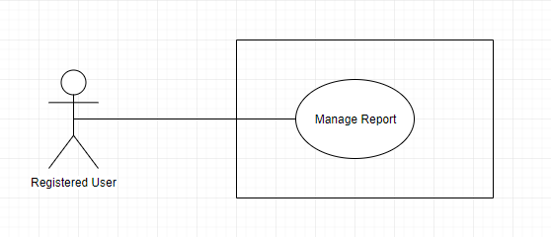

Figure 17: <Register User> Manage Report

**Use Case Specification**

|  |  |  |  |
| --- | --- | --- | --- |
| **USE CASE - EMP_UC_08** | | | |
| **Use Case No.** | **EMP_UC_08** | **Use Case Version** | 1.0 |
| **Use Case Name** | Manage report | | |
| **Author** | Dang Vo Anh Khoa | | |
| **Date** | 09/06/2019 | **Priority** | Normal |
| **Actor:**   * Registered User   **Summary:**   * This use case allows user to manage report   **Goal:**   * User can view the report by date, month, year   **Triggers:**   * User send manage report command.   **Preconditions:**   * User must login into the system with role Registered User.   **Post conditions:**   * Success: The report display on screen * Fail: Show error message   **Main Success Scenario:**   |  |  |  | | --- | --- | --- | | **Step** | **Actor Action** | **System Response** | | 1 | User goes to manage report | System display the report by date, month, year |   **Exception:**   |  |  |  | | --- | --- | --- | | **No** | **Actor Action** | **System Response** | |  | When the connection to the server is lost | System shows message the "Please check your connection" when the internet is lost. |   **Relationships:** N/A.  **Business Rules:**   * User can view the report of sent email, email pending by date, month, year * User can analyses the report | | | |

Table 22 <Registered User> Manage Report

##### <Registered User> Manage Contact

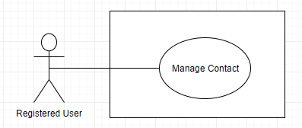

Figure 18: <Registered User> Manage Contact

**Use Case Specification**

|  |  |  |  |
| --- | --- | --- | --- |
| **USE CASE - EMP_UC_15** | | | |
| **Use Case No.** | **EMP_UC_15** | **Use Case Version** | 1.0 |
| **Use Case Name** | Manage contact | | |
| **Author** | Dang Vo Anh Khoa | | |
| **Date** | 14/06/2019 | **Priority** | Normal |
| **Actor:**   * Registered User   **Summary:**   * This use case allows registered user to manage contacts   **Goal:**   * User can view all the list of contact   **Triggers:**   * User click to contact to see list contact   **Preconditions:**   * User must login into the system with role Registered User.   **Post conditions:**   * Success: List all contact. * Fail: Show error message   **Main Success Scenario:**   |  |  |  | | --- | --- | --- | | **Step** | **Actor Action** | **System Response** | | 1 | User goes to contact | * The system show list contact |   **Exception 1:**   |  |  |  | | --- | --- | --- | | **Step** | **Cause** | **System Response** | | 1 | When the connection to the server is lost | System shows message the "Please check your connection" when the internet is lost. |   **Relationships:** N/A.  **Business Rules:**   * + User can view the list of contact | | | |

Table 23 <Registered User> Manage contact

##### <Registered User> Add contacts

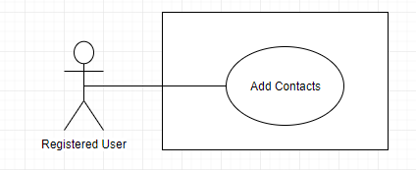

Figure 19: <Registered User> Add Contacts

**Use Case Specification**

|  |  |  |  |
| --- | --- | --- | --- |
| **USE CASE - EMP_UC_16** | | | |
| **Use Case No.** | **EMP_UC_16** | **Use Case Version** | 2.0 |
| **Use Case Name** | Add contacts | | |
| **Author** | Dang Vo Anh Khoa | | |
| **Date** | 14/06/2019 | **Priority** | Normal |
| **Actor:**   * Registered User   **Summary:**   * This use case allows Registered User to add a contacts   **Goal:**   * User successfully add contacts   **Triggers:**   * User send add contact command to the system.   **Preconditions:**   * User must login into the system with role Registered User.   **Post conditions:**   * Success: New contact will be add to the contact * Fail: Show error messages   **Main Success Scenario:**   |  |  |  | | --- | --- | --- | | **Step** | **Actor Action** | **System Response** | | 1 | User goes to contact screen | Display a table show all contacts with information:   * Email Address : @email.com * Status: * Date Added: date time * Action | | 2 | User choose add contacts button | Display two option:   * Upload CSV file * Manual Add | | 3 | User goes to upload CSV file | * Display three option: * Add contacts * Add contacts and include in an existing list * Add contacts and include in a new list * Drag or drop your file | | 4 | User goes to add contacts manually | * Display three option: * Add contacts * Add contacts and include in an existing list * Add contacts and include in a new list | | 5 | User fill in contact info | * Display three blank to fill * First name * Last name * Email | | 6 | User save contact | * System save new contact   [Exception 1]  [Exception 2] |   **Exception 1:**   |  |  |  | | --- | --- | --- | | **No** | **Cause** | **System Response** | | 1 | When the contact already in the list | System shows message the "Email đã tồn tại" when the contact already added to the list. |   **Exception 2:**   |  |  |  | | --- | --- | --- | | **No** | **Cause** | **System Response** | | 2 | When the connection to the server is lost | System shows message the "Please check your connection" when the internet is lost. |   **Relationships:** N/A.  **Business Rules:** | | | |

Table 24 <Registered User> Add Contacts

##### <Registered User> Delete contacts

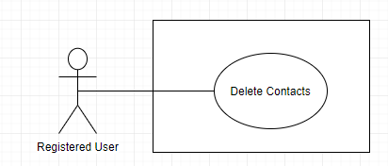

Figure 20: <Registered User> Delete contacts

**Use Case Specification**

|  |  |  |  |
| --- | --- | --- | --- |
| **USE CASE – EMP_UC_17** | | | |
| **Use Case No.** | **EMP_UC_17** | **Use Case Version** | 2.0 |
| **Use Case Name** | Delete contacts | | |
| **Author** | Dang Vo Anh Khoa | | |
| **Date** | 14/06/2019 | **Priority** | Normal |
| **Actor:**   * Authenticated Registered User   **Summary:**   * This use case allows User to delete contacts.   **Goal:**   * User successfully delete contacts in the system.   **Triggers:**   * User send delete command to the system.   **Preconditions:**   * User must login into the system with role Registered User.   **Post conditions:**   * Success: contacts is removed by user. * Fail: Show error message.   **Main Success Scenario:**   |  |  |  | | --- | --- | --- | | **Step** | **Actor Action** | **System Response** | | 1 | User goes to manage contacts screen. | Display a table show list of contacts. | | 2 | User send delete contacts command. | System start removing contacts.  [Exception 1]  [Exception 2]  System show message remove successful |   **Exception 1:**   |  |  |  | | --- | --- | --- | | **No** | **Cause** | **System Response** | | 1 | Removed fail. | Show message to notify User that remove failed. |   **Exception 2:**   |  |  |  | | --- | --- | --- | | **Step** | **Cause** | **System Response** | | 1 | When the connection to the server is lost | System shows message the "Please check your connection" when the internet is lost. |   **Relationships:** N/A  **Business Rules:**   * In case of success scenarios, contacts will be removed from the system. | | | |

Table 25 <Registered User> Delete contacts

##### <Registered User> Mange Templates

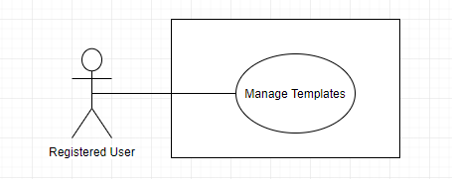

Figure 21: <Registered User> Manage Templates

**Use Case Specification**

|  |  |  |  |
| --- | --- | --- | --- |
| **USE CASE – EMP_UC_18** | | | |
| **Use Case No.** | **EMP_UC_18** | **Use Case Version** | 2.0 |
| **Use Case Name** | Manage templates | | |
| **Author** | Dang Vo Anh Khoa | | |
| **Date** | 14/06/2019 | **Priority** | High |
| **Actor:**   * Supplier   **Summary:**   * This use case allows registered user to manage templates   **Goal:**   * User can view all the list of templates   **Triggers:**   * User click to templates to see gallery   **Preconditions:**   * User must login into the system with role Registered User.   **Post conditions:**   * Success: List all templates. * Fail: Show error message   **Main Success Scenario:**   |  |  |  | | --- | --- | --- | | **Step** | **Actor Action** | **System Response** | | 1 | User goes to gallery | System show a list of Custom templates and Mindsending templates  [Exception 1] |   **Alternative Scenario: N/A**  **Exceptions:**   |  |  |  | | --- | --- | --- | | **No** | **Cause** | **System Response** | | 1 | No internet connection | System shows message the "Please check your connection" when the internet is lost. |   **Relationships:** N/A  **Business Rules:**   * User can view all the templates in the system: * Custom templates * Mindsending templates * User can preview template before choose * User can filter template by: | | | |

Table 26 <Registered User> Manage templates

##### <Registered User> Create new template

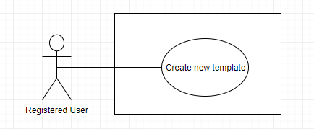

Figure 22: <Registered User> Create new template

**Use Case Specification**

|  |  |  |  |
| --- | --- | --- | --- |
| **USE CASE – EMP_UC_19** | | | |
| **Use Case No.** | **EMP_UC_19** | **Use Case Version** | 2.0 |
| **Use Case Name** | Create new template | | |
| **Author** | Dang Vo Anh Khoa | | |
| **Date** | 14/06/2019 | **Priority** | High |
| **Actor:**   * Registered user   **Summary:**   * This use case allows user to create new template   **Goal:**   * User can create new template   **Triggers:**   * User send command to create new template   **Preconditions:**   * User must login to the system with role Registered User   **Post conditions:**   * Success:   + New template will be added to the system * Fail: Show error message   **Main Success Scenario:**   |  |  |  | | --- | --- | --- | | **Step** | **Actor Action** | **System Response** | | 1 | User send the command to create new template | System suggest two option:   * Export HTML * Load HTML | | 2 | User save template | System show message “Đã thêm thành công”  [Exception ] |   **Exceptions:**   |  |  |  | | --- | --- | --- | | **No** | **Cause** | **System Response** | | 1 | No internet connection | System shows message the "Please check your connection" when the internet is lost. |   **Relationships:** N/A  **Business Rules:**   * User can review the template before save. * User can export HTML or load HTML on device to system | | | |

Table 27<Supplier> Accept pending hiring transaction

##### <Registered User> Edit template

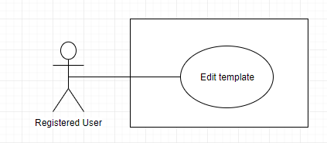

Figure 23: <Registered User> Edit template

**Use Case Specification**

|  |  |  |  |
| --- | --- | --- | --- |
| **USE CASE – EMP_UC_20** | | | |
| **Use Case No.** | **EMP_UC_20** | **Use Case Version** | 1.1 |
| **Use Case Name** | Edit template | | |
| **Author** | Dang Vo Anh Khoa | | |
| **Date** | 14/06/2019 | **Priority** | High |
| **Actor:**   * Registered User   **Summary:**   * This use case allows user to edit template   **Goal:**   * User edit template successfully   **Triggers:**   * User send command to edit template   **Preconditions:**   * User must login to the system   **Post conditions:**   * Success: Template edit successfully * Fail: Show error message   **Main Success Scenario:**   |  |  |  | | --- | --- | --- | | **Step** | **Actor Action** | **System Response** | | 1 | User view template before edit | System show template on screen | | 2 | User edit template |  | | 3 | User save edited template | System show message “ Template edited successfully” |   **Exceptions:**   |  |  |  | | --- | --- | --- | | **No** | **Cause** | **System Response** | | 1 | No internet connection | System shows message the "Please check your connection" when the internet is lost. |   **Relationships:** N/A  **Business Rules:**   * User can view the template before edit | | | |

Table 28 <Registered User> Edit template

##### <Registered User> Manage Lists

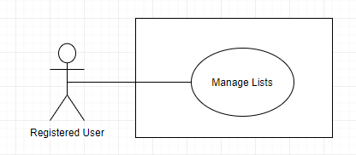

Figure 24: <Registered User> Manage Lists

**Use Case Specification**

|  |  |  |  |
| --- | --- | --- | --- |
| **USE CASE – EMP_UC_21** | | | |
| **Use Case No.** | **EMP_UC_21** | **Use Case Version** | 1.0 |
| **Use Case Name** | Manage Lists | | |
| **Author** | Dang Vo Anh Khoa | | |
| **Date** | 14/06/2019 | **Priority** | Normal |
| **Actor:**   * Registered User   **Summary:**   * This use case allows user to manage lists   **Goal:**   * User can manage lists   **Triggers:**   * User click into lists   **Preconditions:**   * User must login to the system   **Post conditions:**   * Success: Contact lists display on screen * Fail: Show error message   **Main Success Scenario:**   |  |  |  | | --- | --- | --- | | **Step** | **Actor Action** | **System Response** | | 1 | User goes to lists screen | Display a table show all lists with information:   * List name: * Description: * Contacts: * Actions: |   **Exceptions:**   |  |  |  | | --- | --- | --- | | **No** | **Cause** | **System Response** | | 1 | No internet connection | System shows message the "Please check your connection" when the internet is lost. |   **Relationships:** N/A  **Business Rules:**   * By this action, user can view all contact lists. | | | |

Table 29 <Registered User> Manage lists

##### <Registered User> Create Lists

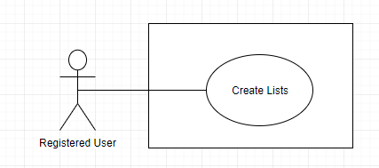

Figure 25: <Registered User> Create Lists

**Use Case Specification**

|  |  |  |  |
| --- | --- | --- | --- |
| **USE CASE – EMP_UC_22** | | | |
| **Use Case No.** | **EMP_UC_22** | **Use Case Version** | 1.0 |
| **Use Case Name** | Create lists | | |
| **Author** | Dang Vo Anh Khoa | | |
| **Date** | 14/06/2018 | **Priority** | Normal |
| **Actor:**   * Registered user   **Summary:**   * This use case allows user to create lists   **Goal:**   * User create lists successfully   **Triggers:**   * User send command to create list   **Preconditions:**   * User must login to the system   **Post conditions:**   * Success:   + The list added succesfully * Fail: Show error message   **Main Success Scenario:**   |  |  |  | | --- | --- | --- | | **Step** | **Actor Action** | **System Response** | | 1 | User send the command to create list | System show create list window | | 2 | User fill list name and list description |  | | 3 | User click create button | System show message “Đã thêm thành công” |   **Exceptions:**   |  |  |  | | --- | --- | --- | | **No** | **Cause** | **System Response** | | 1 | No internet connection | System shows message the "Please check your connection" when the internet is lost. |   **Relationships:** N/A  **Business Rules:**   * This is the last phase in renting process, when supplier confirmed that the equipment is returned back to the supplier * The equipment status changes from “waiting for returning” to “finished” * Requester is notified about the change * The renting process is finished from this phase | | | |

Table 30: <Supplier> Confirm equipment returned

##### <Supplier> Cancel hiring transaction

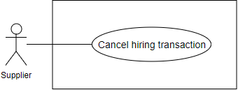

Figure 26: <Supplier> Cancel hiring transaction

**Use Case Specification**

|  |  |  |  |
| --- | --- | --- | --- |
| **USE CASE – EMP_UC_23** | | | |
| **Use Case No.** | **EMP_UC_23** | **Use Case Version** | 1.1 |
| **Use Case Name** | Cancel hiring transaction | | |
| **Author** | Luu Quang Nghia | | |
| **Date** | 18/3/2018 | **Priority** | Normal |
| **Actor:**   * Supplier   **Summary:**   * This use case allows supplier to cancel transaction for hiring equipment that has been sent before   **Goal:**   * Supplier cancel transaction for hiring equipment   **Triggers:**   * Supplier send command to cancel the request   **Preconditions:**   * User must login to the system * The transaction status must be “Pending” or “Accepted” * The supplier has not accepted nor denied the request   **Post conditions:**   * Success: Supplier cancel request for hiring equipment * Fail: Show error message   **Main Success Scenario:**   |  |  |  | | --- | --- | --- | | **Step** | **Actor Action** | **System Response** | | 1 | User send command to cancel the hiring transaction | System ask user to input:   * Cancel reason: text, required | | 2 | User input the required information | System ask user to confirm the action | | 3 | User confirm the action  [Alternative 1] | System show message that the transaction is canceled successfully  [Exception 1] |   **Alternative Scenario:**   |  |  |  | | --- | --- | --- | | **No** | **Actor Action** | **System Response** | | 1 | User choose not to confirm | System gets back to request list view |   **Exceptions:**   |  |  |  | | --- | --- | --- | | **No** | **Cause** | **System Response** | | 1 | No internet connection | System shows message the "Please check your connection" when the internet is lost. |   **Relationships:** N/A  **Business Rules:**   * Supplier can only cancel transaction that have status “Pending” or “Accepted”, meaning that the equipment Is not delivery yet * Supplier must provide cancel reason * Once canceled, the transaction cannot be uncanceled * Supplier get notified about the canceling | | | |

Table 31 : <Supplier> Cancel hiring transaction

##### <Supplier> Accept request for time extension

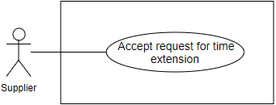

Figure 27: <Supplier> Accept request for time extension

**Use Case Specification**

|  |  |  |  |
| --- | --- | --- | --- |
| **USE CASE – EMP_UC_24** | | | |
| **Use Case No.** | **EMP_UC_24** | **Use Case Version** | 1.0 |
| **Use Case Name** | Accept request for time extension | | |
| **Author** | Luu Quang Nghia | | |
| **Date** | 18/1/2018 | **Priority** | High |
| **Actor:**   * Supplier   **Summary:**   * This use case allows supplier to accept the request for the system to extend the hiring time range   **Goal:**   * Supplier accept the request to extend hiring time   **Triggers:**   * Supplier send command to accept the request to extend hiring time   **Preconditions:**   * User must login to the system * The time extension request status is “Pending” * The related hiring transaction status is “Accepted” or “Processing”   **Post conditions:**   * Success:   + The request status changed to “Accepted”   + Related hiring transaction end date changed * Fail: Show error message   **Main Success Scenario:**   |  |  |  | | --- | --- | --- | | **Step** | **Actor Action** | **System Response** | | 1 | User send the command to accept the request | System ask user to confirm the action | | 2 | User choose to confirm the accept action [Alternative 1] | System show message that the request is approved  [Exception 1] |   **Alternative Scenario:**   |  |  |  | | --- | --- | --- | | **No** | **Actor Action** | **System Response** | | 1 | User choose not to confirm the action | System hides the message and does nothing |   **Exceptions:**   |  |  |  | | --- | --- | --- | | **No** | **Cause** | **System Response** | | 1 | No internet connection | System shows message the "Please check your connection" when the internet is lost. |   **Relationships:** N/A  **Business Rules:**   * If the request is accepted:   + Requester gets notified   + Hiring time of the equipment is extended accordingly   + Request status changed to “accepted”   + If the related equipment status is “Waiting for returning”, it changes to “Renting”   + All “Pending” transaction with intersected time range would be “Denied” * In business view, the acceptance of the supplier means that:   + Supplier agree to let the requesters extend the equipment   + All the required procedures are assumed to have been made privately between supplier and requester such as communicating, signing contract, payments * Requester can review the status of the request * Supplier can review the status of the request | | | |

Table 32 <Supplier> Accept request for time extension

##### <Supplier> Deny request for time extension

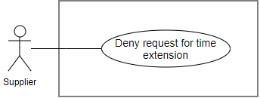

Figure 28: <Supplier> Deny request for time extension

**Use Case Specification**

|  |  |  |  |
| --- | --- | --- | --- |
| **USE CASE – EMP_UC_25** | | | |
| **Use Case No.** | **EMP_UC_25** | **Use Case Version** | 1.0 |
| **Use Case Name** | Deny request for time extension | | |
| **Author** | Luu Quang Nghia | | |
| **Date** | 18/1/2018 | **Priority** | High |
| **Actor:**   * Supplier   **Summary:**   * This use case allows supplier to deny the request for the system to extend the hiring time range   **Goal:**   * Supplier deny the request to extend hiring time   **Triggers:**   * Supplier send command to deny the request to extend hiring time   **Preconditions:**   * User must login to the system * The request status is “Pending”   **Post conditions:**   * Success: The request status changed to “denied”, equipment hiring time extended * Fail: Show error message   **Main Success Scenario:**   |  |  |  | | --- | --- | --- | | **Step** | **Actor Action** | **System Response** | | 1 | User send the command to deny the request | System ask user to confirm the action | | 2 | User choose to confirm the deny action [Alternative 1] | System show message that the request is approved  [Exception 1] |   **Alternative Scenario:**   |  |  |  | | --- | --- | --- | | **No** | **Actor Action** | **System Response** | | 1 | User choose not to confirm the action | System hides the message and does nothing |   **Exceptions:**   |  |  |  | | --- | --- | --- | | **No** | **Cause** | **System Response** | | 1 | No internet connection | System shows message the "Please check your connection" when the internet is lost. |   **Relationships:** N/A  **Business Rules:**   * If the request is denied:   + Requester gets notified   + Request status changed to “denied”   + Nothing changed in the related hiring transaction * Requester can review the status of the request * Supplier can review the status of the request | | | |

Table 33 <Supplier> Deny request for time extension

##### <Supplier> Post equipment

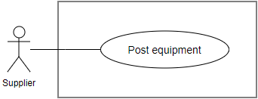

Figure 29: <Supplier> Post equipment

**Use Case Specification**

|  |  |  |  |
| --- | --- | --- | --- |
| **USE CASE – EMP_UC_26** | | | |
| **Use Case No.** | **EMP_UC_26** | **Use Case Version** | 1.1 |
| **Use Case Name** | Post equipment | | |
| **Author** | Luu Quang Nghia | | |
| **Date** | 19/3/2018 | **Priority** | High |
| **Actor:**   * Supplier   **Summary:**   * This use case allows supplier to post new equipment   **Goal:**   * Supplier can post new equipment   **Triggers:**   * Supplier send command to post new equipment   **Preconditions:**   * User must login to the system * Account of user must be activated   **Post conditions:**   * Success: New equipment is posted * Fail: Show error message   **Main Success Scenario:**   |  |  |  | | --- | --- | --- | | **Step** | **Actor Action** | **System Response** | | 1 | User go to new equipment view | System requires information about the equipment:   * Name: free text input, required, length 3-80 * Images: image, required, quantity: at least 1 * Thumbnail image: image, required, quantity: 1 * Construction: required * Equipment type: select from options list * Additional information related to selected equipment type * Price per day: number text input, required * Available time ranges * Description: free text input, length: 0- 1000 | | 2 | User input information |  | | 3 | User send command to create new equipment | System validate information, display request for confirmation | | 4 | User confirm the action  [Alternative 1] | System display successful message  [Exception 1] |   **Alternative Scenario:**   |  |  |  | | --- | --- | --- | | **No** | **Actor Action** | **System Response** | | 1 | User choose not to confirm the action | System hides the message and go back to inputting view |   **Exceptions:**   |  |  |  | | --- | --- | --- | | **No** | **Cause** | **System Response** | | 1 | No internet connection | System shows message the "Please check your connection" when the internet is lost. | | 2 | User input invalidate information. | System show error message for the input mistake |   **Relationships:** N/A  **Business Rules:**   * Posted equipment would have default status “Available” * Images are uploaded from user’s device * Thumbnail images are chosen from uploaded image list * Construction can be used as location information * Each construction has information about construction name and location * User can choose to create new construction or select from created constructions * Each available time range is the time duration that the equipment is available for rent * Each available time range includes a beginning date and an ending date * Each equipment can have multiple time ranges, which does not intersect each other * Requester can only request hiring time that included between available time range * Each equipment type has its own additional attributes * After supplier post new equipment successfully, other requester can find and view the new equipment * In some special real-life business cases, user can group multiple equipment into 1 post, to manage the whole group as a single equipment with a single status | | | |

Table 34 <Supplier> Post equipment

##### <Supplier> Delete equipment

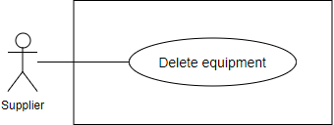

Figure 30: <Supplier> Delete equipment

**Use Case Specification**

|  |  |  |  |
| --- | --- | --- | --- |
| **USE CASE – EMP_UC_27** | | | |
| **Use Case No.** | **EMP_UC_27** | **Use Case Version** | 1.1 |
| **Use Case Name** | Delete equipement | | |
| **Author** | Luu Quang Nghia | | |
| **Date** | 18/3/2018 | **Priority** | Normal |
| **Actor:**   * Supplier   **Summary:**   * This use case allows supplier to delete equipment   **Goal:**   * Supplier can delete equipment   **Triggers:**   * Supplier send command to delete equipment   **Preconditions:**   * User must login to the system * The equipment status must be “Available” * There’re no transactions related to the equipment that have status “Accepted” or “Processing”   **Post conditions:**   * Success: The equipment is deleted * Fail: Show error message   **Main Success Scenario:**   |  |  |  | | --- | --- | --- | | **Step** | **Actor Action** | **System Response** | | 1 | User send the command delete equipment | System validate conditions before deleting  System ask user to confirm the action  [Exception] | | 2 | User choose to confirm the approve action  [Alternative] | System show message that the equipment is returned, and renting transaction is finished |   **Alternative Scenario:**   |  |  |  | | --- | --- | --- | | **No** | **Actor Action** | **System Response** | | 1 | User choose not to confirm the action | System hides the message and does nothing |   **Exceptions:**   |  |  |  | | --- | --- | --- | | **No** | **Cause** | **System Response** | | 1 | No internet connection | System shows message the "Please check your connection" when the internet is lost. | | 2 | The condition of the equipment is not valid to delete | System shows message about the invalid condition |   **Relationships:** N/A  **Business Rules:**   * User cannot delete equipment whose status is not “Available” * User cannot delete equipment that have “accepted” or “processing” transactions * Other pending transaction related to the equipment is denied * Transactions in the past related to the equipment still keep the information of the equipment | | | |

Table 35 <Supplier> Delete equipment

##### <Supplier> Edit equipment

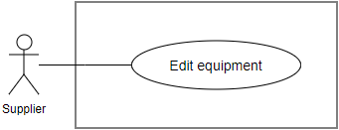

Figure 31: <Supplier> Edit equipment

**Use Case Specification**

|  |  |  |  |
| --- | --- | --- | --- |
| **USE CASE – EMP_UC_28** | | | |
| **Use Case No.** | **EMP_UC_28** | **Use Case Version** | 1.0 |
| **Use Case Name** | Edit equipment information | | |
| **Author** | Luu Quang Nghia | | |
| **Date** | 18/1/2018 | **Priority** | Normal |
| **Actor:**   * Supplier   **Summary:**   * This use case allows supplier to edit information about equipment   **Goal:**   * Supplier can edit equipment   **Triggers:**   * Supplier send command to edit the equipment   **Preconditions:**   * User must login to the system   **Post conditions:**   * Success: The equipment is edited * Fail: Show error message   **Main Success Scenario:**   |  |  |  | | --- | --- | --- | | **Step** | **Actor Action** | **System Response** | | 1 | User go to editing equipment view | System requires information about the equipment to edit, which contains:   * Name * Construction * Equipment type * Additional information related to selected equipment type * Price per day * Available time ranges * Description: free text input, length: 0- 1000 * Thumbnail: image input, required, quantity: 1 * Images: image input, requỉed, quantity: at leasts 1 | | 2 | User input information |  | | 3 | User send command to save new information | System validate information, display request for confirmation | | 4 | User confirm the action  [Alternative 1] | System display successful message  [Exception 1] |   **Alternative Scenario:**   |  |  |  | | --- | --- | --- | | **No** | **Actor Action** | **System Response** | | 1 | User choose not to confirm the action | System hides the message and go back to inputting view |   **Exceptions:**   |  |  |  | | --- | --- | --- | | **No** | **Cause** | **System Response** | | 1 | No internet connection | System shows message the "Please check your connection" when the internet is lost. | | 2 | User input invalidate information. | System show error message for the input mistake |   **Relationships:** N/A  **Business Rules:**   * User cannot update new available time range that intersect with renting time range * The validation rules for updating equipment are identical to posting new equipment * Further information can be found in the use case < **EMP_UC_26**> (Post equipment) | | | |

Table 36 : <Supplier> Edit equipment

##### <Supplier> Post material

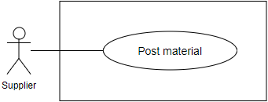

Figure 32: <Supplier> Post material

**Use Case Specification**

|  |  |  |  |
| --- | --- | --- | --- |
| **USE CASE – EMP_UC_29** | | | |
| **Use Case No.** | **EMP_UC_29** | **Use Case Version** | 1.1 |
| **Use Case Name** | Post material | | |
| **Author** | Luu Quang Nghia | | |
| **Date** | 19/3/2018 | **Priority** | High |
| **Actor:**   * Supplier   **Summary:**   * This use case allows supplier to post new material   **Goal:**   * Supplier can post new material   **Triggers:**   * Supplier send command to post new material   **Preconditions:**   * User must login to the system * Account of user must be activated   **Post conditions:**   * Success: New material is posted * Fail: Show error message   **Main Success Scenario:**   |  |  |  | | --- | --- | --- | | **Step** | **Actor Action** | **System Response** | | 1 | User go to the new material view | System requires information about the material:   * Name: text input, required, length 3-80 * Thumbnail image: image input, required, quantity: 1 * Manufacturer: text input, required * Construction: required * Material type: select from options list * Price per unit: number text input, required * Description: free text input, length: 0- 1000 | | 2 | User input information |  | | 3 | User send command to create new material | System validate information, display request for confirmation | | 4 | User confirm the action  [Alternative 1] | System display a successful message  [Exception 1] |   **Alternative Scenario:**   |  |  |  | | --- | --- | --- | | **No** | **Actor Action** | **System Response** | | 1 | User choose not to confirm the action | System hides the message and go back to inputting view |   **Exceptions:**   |  |  |  | | --- | --- | --- | | **No** | **Cause** | **System Response** | | 1 | No internet connection | System shows message the "Please check your connection" when the internet is lost. | | 2 | User input invalidate information. | System show error message for the input mistake |   **Relationships:** N/A  **Business Rules:**   1. Material unit information is based on chosen material type 2. Construction can be used as location information 3. Each construction has information about construction name and location 4. User can choose to create new construction or select from created constructions 5. After supplier post new material successfully, other requester can search and view the new material | | | |

Table 37 : <Supplier> Post material

##### <Supplier> Edit material

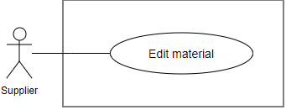

Figure 33: <Supplier> Edit material

**Use Case Specification**

|  |  |  |  |
| --- | --- | --- | --- |
| **USE CASE – EMP_UC_30** | | | |
| **Use Case No.** | **EMP_UC_30** | **Use Case Version** | 1.1 |
| **Use Case Name** | Edit material | | |
| **Author** | Luu Quang Nghia | | |
| **Date** | 19/3/2018 | **Priority** | High |
| **Actor:**   * Supplier   **Summary:**   * This use case allows supplier to edit new material   **Goal:**   * Supplier can edit new material   **Triggers:**   * Supplier send command to edit new material   **Preconditions:**   * User must login to the system * Account of user must be activated   **Post conditions:**   * Success: New material is edited * Fail: Show error message   **Main Success Scenario:**   |  |  |  | | --- | --- | --- | | **Step** | **Actor Action** | **System Response** | | 1 | User go to new material view | System requires information about the material:   * Name: text input, required, length 3-80 * Thumbnail image: image input, required, quantity: 1 * Manufacturer: text input, required * Construction: required * Material type: select from options list * Price per unit: number text input, required * Description: free text input, length: 0- 1000 | | 2 | User input information |  | | 3 | User send command to save | System validate information, display request for confirmation | | 4 | User confirm the action  [Alternative 1] | System display successful message  [Exception 1] |   **Alternative Scenario:**   |  |  |  | | --- | --- | --- | | **No** | **Actor Action** | **System Response** | | 1 | User choose not to confirm the action | System hides the message and go back to inputting view |   **Exceptions:**   |  |  |  | | --- | --- | --- | | **No** | **Cause** | **System Response** | | 1 | No internet connection | System shows message the "Please check your connection" when the internet is lost. | | 2 | User input invalidate information. | System show error message for the input mistake |   **Relationships:** N/A  **Business Rules:**   * Material unit information is based on chosen material type * Construction can be used as location information * Each construction has information about construction name and location * User can choose to create new construction or select from created constructions * After supplier edit material successfully, other requester can search and view the new material * Edited price does not affect any material transaction made in the past * Further business rules can be found in Use case < **EMP_UC_29**> (Post material) | | | |

Table 38 <Supplier> Post material

##### <Supplier> Delete material

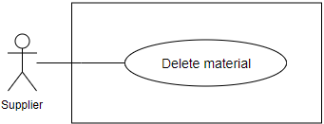

Figure 34: <Supplier> Delete material

**Use Case Specification**

|  |  |  |  |
| --- | --- | --- | --- |
| **USE CASE – EMP_UC_31** | | | |
| **Use Case No.** | **EMP_UC_31** | **Use Case Version** | 1.1 |
| **Use Case Name** | Delete material | | |
| **Author** | Luu Quang Nghia | | |
| **Date** | 18/3/2018 | **Priority** | Normal |
| **Actor:**   * Supplier   **Summary:**   * This use case allows supplier to delete material   **Goal:**   * Supplier can delete material   **Triggers:**   * Supplier send command to delete material   **Preconditions:**   * User must login to the system * There’re no transactions related to the material that have status “Accepted” or “Processing”   **Post conditions:**   * Success: The material is deleted * Fail: Show error message   **Main Success Scenario:**   |  |  |  | | --- | --- | --- | | **Step** | **Actor Action** | **System Response** | | 1 | User send the command delete material | System validate conditions before deleting  System ask user to confirm the action  [Exception] | | 2 | User choose to confirm the approve action  [Alternative] | System show message that the material is returned, and renting transaction is finished |   **Alternative Scenario:**   |  |  |  | | --- | --- | --- | | **No** | **Actor Action** | **System Response** | | 1 | User choose not to confirm the action | System hides the message and does nothing |   **Exceptions:**   |  |  |  | | --- | --- | --- | | **No** | **Cause** | **System Response** | | 1 | No internet connection | System shows message the "Please check your connection" when the internet is lost. | | 2 | The condition of the material is not valid to delete | System shows message about the invalid condition |   **Relationships:** N/A  **Business Rules:**   * User cannot delete material that have “accepted” or “processing” transactions * Other pending transaction related to the material is denied * Transactions in the past related to the material still keep the information of the material | | | |

Table 39 <Supplier> Delete material

##### <Supplier> View material transaction as supplier

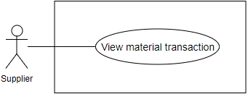

Figure 35: <Supplier> View material transaction

**Use Case Specification**

|  |  |  |  |
| --- | --- | --- | --- |
| **USE CASE - EMP_UC_32** | | | |
| **Use Case No.** | **EMP_UC_32** | **Use Case Version** | 2.0 |
| **Use Case Name** | View material transactions as supplier | | |
| **Author** | Luu Quang Nghia | | |
| **Date** | 18/1/2018 | **Priority** | High |
| **Actor:**   * Supplier   **Summary:**   * This use case allows supplier to view related material transactions under supplier’s view   **Goal:**   * Supplier can view related material transactions   **Triggers:**   * Supplier send command to view material transactions as supplier   **Preconditions:**   * User must login to the system as role Registered User   **Post conditions:**   * Success: Supplier can view material transactions as supplier * Fail: Show error message   **Main Success Scenario:**   |  |  |  | | --- | --- | --- | | **Step** | **Actor Action** | **System Response** | | 1 | Supplier sends command to view the material transactions | System show a list of transactions  [Exception 1] |   **Alternative Scenario: N/A**  **Exceptions:**   |  |  |  | | --- | --- | --- | | **No** | **Cause** | **System Response** | | 1 | No internet connection | System shows message the "Please check your connection" when the internet is lost. |   **Relationships:** N/A  **Business Rules:**   * Supplier can view all the material transactions related to him, created in the past or the present * Each material transaction can include multiple materials, or can be understood as material details * Each transaction has one of the following statuses at a time:   + Pending: transaction is created/requested by requester and waiting for supplier to accept   + Accepted: supplier accepted the transaction and prepare to deliver   + Delivering: Supplier is delivering materials to requester   + Finished: Supplier received the equipment, transaction finished   + Denied: supplier denied the transaction   + Canceled: the transaction is canceled by supplier or requester * User can see the following information about each transaction:   + Current status   + Materials included   + Requester name   + Requester thumbnail   + Transaction total price   + Transaction created time   + Transaction id   + Action button to change transaction status in allowed authority * User can choose to view material list related to the transaction. * Materials in a transaction must belong to the same supplier. * The information in the transaction, except status, cannot be modified in anyway, including price, location. | | | |

Table 40 <Supplier> View material transaction

##### <Supplier> Accept pending material transaction

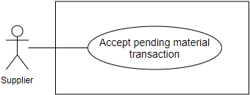

Figure 36: <Supplier> Accept pending material transaction

**Use Case Specification**

|  |  |  |  |
| --- | --- | --- | --- |
| **USE CASE – EMP_UC_33** | | | |
| **Use Case No.** | **EMP_UC_33** | **Use Case Version** | 2.0 |
| **Use Case Name** | Accept pending material transaction | | |
| **Author** | Luu Quang Nghia | | |
| **Date** | 18/1/2018 | **Priority** | High |
| **Actor:**   * Supplier   **Summary:**   * This use case allows supplier to accept a pending material transaction for materials from a requester   **Goal:**   * Supplier change transaction status from “Pending” to “Accepted”   **Triggers:**   * Supplier send command to accept the request   **Preconditions:**   * User must login to the system * Supplier account must be activated * The transaction status is “Pending”   **Post conditions:**   * Success: The transaction status changed from “Pending” to “Accepted” * Fail: Show error message   **Main Success Scenario:**   |  |  |  | | --- | --- | --- | | **Step** | **Actor Action** | **System Response** | | 1 | User send the command to accept the transaction | System ask user to confirm the action | | 2 | User choose to confirm the action [Alternative 1] | System show message that the transaction is accepted  [Exception 1] |   **Alternative Scenario:**   |  |  |  | | --- | --- | --- | | **No** | **Actor Action** | **System Response** | | 1 | User choose not to confirm the action | System hides the message and does nothing |   **Exceptions:**   |  |  |  | | --- | --- | --- | | **No** | **Cause** | **System Response** | | 1 | No internet connection | System shows message the "Please check your connection" when the internet is lost. |   **Relationships:** N/A  **Business Rules:**   * Supplier can view the details of transaction before accepting. * When supplier accept the transaction:   + Requester gets notified   + Transaction status changed to “Accepted” * In business view, the acceptance of the supplier means that:   + Supplier agree to sell the materials to requester   + All the required procedures are assumed to have been made privately between supplier and requester such as communicating, signing contract, payments * Supplier can view details about the pending transaction before answering. * The transaction is related multiple materials. | | | |

Table 41 : <Supplier> Accept pending material transaction

##### <Supplier> Deny pending material transaction

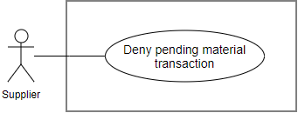

Figure 37: <Supplier> Deny pending material transaction

**Use Case Specification**

|  |  |  |  |
| --- | --- | --- | --- |
| **USE CASE – EMP_UC_34** | | | |
| **Use Case No.** | **EMP_UC_34** | **Use Case Version** | 1.1 |
| **Use Case Name** | Deny pending material transaction | | |
| **Author** | Luu Quang Nghia | | |
| **Date** | 18/1/2018 | **Priority** | High |
| **Actor:**   * Supplier   **Summary:**   * This use case allows supplier to deny a pending material transaction for materials from a requester   **Goal:**   * Supplier change transaction status from “Pending” to “Denied”   **Triggers:**   * Supplier send command to deny the request   **Preconditions:**   * User must login to the system * The transaction status is “Pending”   **Post conditions:**   * Success: The transaction status changed from “Pending” to “Denied” * Fail: Show error message   **Main Success Scenario:**   |  |  |  | | --- | --- | --- | | **Step** | **Actor Action** | **System Response** | | 1 | User send the command to deny the transaction | System ask user to confirm the action | | 2 | User choose to confirm the action [Alternative 1] | System show message that the transaction is denied  [Exception 1] |   **Alternative Scenario:**   |  |  |  | | --- | --- | --- | | **No** | **Actor Action** | **System Response** | | 1 | User choose not to confirm the action | System hides the message and does nothing |   **Exceptions:**   |  |  |  | | --- | --- | --- | | **No** | **Cause** | **System Response** | | 1 | No internet connection | System shows message the "Please check your connection" when the internet is lost. |   **Relationships:** N/A  **Business Rules:**   * Supplier can view the details of transaction before denying. * When supplier deny the transaction:   + Requester gets notified   + Transaction status changed to “Denied” * The transaction is related to multiple materials. | | | |

Table 42 <Supplier> Deny pending material transaction

##### <Supplier> Confirm material delivering

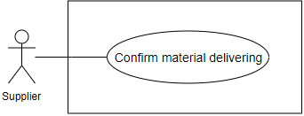

Figure 38: <Supplier> Confirm material delivering

**Use Case Specification**

|  |  |  |  |
| --- | --- | --- | --- |
| **USE CASE – EMP_UC_35** | | | |
| **Use Case No.** | **EMP_UC_35** | **Use Case Version** | 1.0 |
| **Use Case Name** | Confirm material delivering | | |
| **Author** | Luu Quang Nghia | | |
| **Date** | 18/1/2018 | **Priority** | Normal |
| **Actor:**   * Supplier   **Summary:**   * This use case allows supplier to confirm that the material is delivering to the requester   **Goal:**   * Supplier confirm that the request is delivering   **Triggers:**   * Supplier send command to confirm that the material is delivering   **Preconditions:**   * User must login to the system * The transaction status is “Accepted”   **Post conditions:**   * Success: The transaction status changes to “Delivering” * Fail: Show error message   **Main Success Scenario:**   |  |  |  | | --- | --- | --- | | **Step** | **Actor Action** | **System Response** | | 1 | User send the command to confirm the material is delivering | System ask user to confirm the action | | 2 | User choose to confirm the approve action  [Alternative 1] | System show message that the material is delivering  [Exception 1] |   **Alternative Scenario:**   |  |  |  | | --- | --- | --- | | **No** | **Actor Action** | **System Response** | | 1 | User choose not to confirm the action | System hides the message and does nothing |   **Exceptions:**   |  |  |  | | --- | --- | --- | | **No** | **Cause** | **System Response** | | 1 | No internet connection | System shows message the "Please check your connection" when the internet is lost. |   **Relationships:** N/A  **Business Rules:**   * By this action, supplier confirmed to the requester that the materials are on their way * The transaction status changes from “Accepted” to “Delivering” * Requester is notified about the change | | | |

Table 43 <Supplier> Confirm material delivering

##### <Supplier> Cancel material transaction

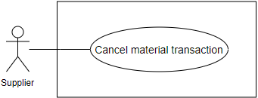

Figure 39: <Supplier> Cancel material transaction

**Use Case Specification**

|  |  |  |  |
| --- | --- | --- | --- |
| **USE CASE – EMP_UC_36** | | | |
| **Use Case No.** | **EMP_UC_36** | **Use Case Version** | 1.1 |
| **Use Case Name** | Cancel material transaction | | |
| **Author** | Luu Quang Nghia | | |
| **Date** | 18/3/2018 | **Priority** | Normal |
| **Actor:**   * Supplier   **Summary:**   * This use case allows supplier to cancel material transaction   **Goal:**   * Supplier cancel transaction for material transaction   **Triggers:**   * Supplier send command to cancel the transaction   **Preconditions:**   * User must login to the system * The transaction status must be “Pending”, “Accepted”, or “Delivering”   **Post conditions:**   * Success: Supplier cancel material transaction * Fail: Show error message   **Main Success Scenario:**   |  |  |  | | --- | --- | --- | | **Step** | **Actor Action** | **System Response** | | 1 | User send command to cancel the material transaction | System ask user to input:   * Cancel reason: text, required | | 2 | User input the required information | System ask user to confirm the action | | 3 | User confirm the action  [Alternative 1] | System show message that the transaction is canceled successfully  [Exception 1] |   **Alternative Scenario:**   |  |  |  | | --- | --- | --- | | **No** | **Actor Action** | **System Response** | | 1 | User choose not to confirm | System hides the message and does nothing |   **Exceptions:**   |  |  |  | | --- | --- | --- | | **No** | **Cause** | **System Response** | | 1 | No internet connection | System shows message the "Please check your connection" when the internet is lost. |   **Relationships:** N/A  **Business Rules:**   * Supplier can only cancel transaction that have status “Pending”, “Accepted”, or “Delivering”, meaning that the transaction is no longer active and cannot continue what is doing * Supplier must provide cancel reason * System automatically save the supplier as the one who canceled the transaction * Once canceled, the transaction cannot be uncanceled * Requester get notified about the canceling | | | |

Table 44 <Supplier> Cancel material transaction

##### <Supplier> View debris transaction as supplier

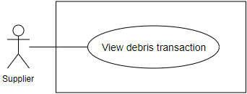

Figure 40: <Supplier>View debris transaction

**Use Case Specification**

|  |  |  |  |
| --- | --- | --- | --- |
| **EMP_UC_37** | | | |
| **Use Case No.** | **EMP_UC_37** | **Use Case Version** | 2.0 |
| **Use Case Name** | View debris transaction as supplier | | |
| **Author** | Luu Quang Nghia | | |
| **Date** | 18/1/2018 | **Priority** | High |
| **Actor:**   * Supplier   **Summary:**   * This use case allows supplier to view debris transactions as a supplier’s view   **Goal:**   * Supplier can view transactions   **Triggers:**   * Supplier send command to view debris transactions as supplier   **Preconditions:**   * User must login to the system as role Registered User   **Post conditions:**   * Success: Supplier can view all the transactions * Fail: Show error message   **Main Success Scenario:**   |  |  |  | | --- | --- | --- | | **Step** | **Actor Action** | **System Response** | | ` | Supplier sends command to view the transactions | System show a list of transactions  [Exception 1] |   **Alternative Scenario: N/A**  **Exceptions:**   |  |  |  | | --- | --- | --- | | **No** | **Actor Action** | **System Response** | | 1 | No internet connection | System shows message the "Please check your connection" when the internet is lost. |   **Relationships:** N/A  **Business Rules:**   * Supplier can view all the debris transactions related to him, created in the past or the present. * Each transaction is related to one debris bid and one debris post. * Each transaction has one of the following statuses at a time:   + Accepted: first state of the process, meaning the requester chose a debris bid and created a transaction,   + Delivering: Supplier is preparing debris service   + Working: The Supplier arrived the construction and start to work on debris service   + Finished: The supplier finished the service   + Canceled: the transaction is canceled by supplier or requester * User can see the following information about each transaction:   + Transaction status   + Debris post details   + Debris bid details   + Supplier name   + Supplier thumbnail   + Acton button to change transaction status in allowed authority | | | |

Table 45 <Supplier>View debris transaction

##### <Supplier> Bid on debris post

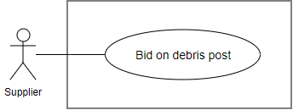

Figure 41: <Supplier>Bid on debris post

**Use Case Specification**

|  |  |  |  |
| --- | --- | --- | --- |
| **USE CASE – EMP_UC_38** | | | |
| **Use Case No.** | **EMP_UC_38** | **Use Case Version** | 1.1 |
| **Use Case Name** | Bid on debris post | | |
| **Author** | Luu Quang Nghia | | |
| **Date** | 18/3/2018 | **Priority** | High |
| **Actor:**   * Supplier   **Summary:**   * This use case allow supplier to bid on a debris post   **Goal:**   * Supplier can bid on debris post   **Triggers:**   * Supplier send command to bid on debris post   **Preconditions:**   * User must login to the system * Account of user must be activated * Debris post status is “Pending”   **Post conditions:**   * Success: Supplier successfully bid on debris post * Fail: Show error message   **Main Success Scenario:**   |  |  |  | | --- | --- | --- | | **Step** | **Actor Action** | **System Response** | | 1 | User viewing debris post details and send command to bid on debris bid | System require the following information from user:   * Price: double, required * Description: text, required | | 2 | User provide required input |  | | 3 | User sends the command to create bid on debris post | System validates information  If validated, system ask user for confirmation [Exception 1, 2] | | 4 | User send command to confirm the request  [Alternative 1] | System shows message that request have made successfully, waiting for supplier’s acceptance |   **Alternative Scenario:**   |  |  |  | | --- | --- | --- | | **No** | **Actor Action** | **System Response** | | 1 | User send command to unconfirm the request | System back to the making request view |   **Exceptions:**   |  |  |  | | --- | --- | --- | | **No** | **Cause** | **System Response** | | 1 | No internet connection | System shows message the "Please check your connection" when the internet is lost. | | 2 | User send command to create new request | System shows error message show that input date is not available and ask user to input again |   **Relationships:** N/A  **Business Rules:**   * Debris bid can be understood as a service proposal, with a price, according to the requester’s requirement. * Supplier can view debris post details before place a bid with the following information:   + Debris post’s title   + Debris post’s image   + Debris post’s description   + Debris post’s services required   + Requester’s profile   + Requester’s phone number * Supplier can view other bids placed on the debris post, each bid has the following information:   + Price   + Description   + The supplier’s profile   + A bid can have the following status:   + Pending: supplier bid on a post and waiting for requester to choose   + Accepted: Requester chose the bid and created a debris transaction   + Finished: Debris transaction is finished * A bid is created with status “Pending”. * Requester is notified about the bid. * Each bid is related to only 1 debris post. * A supplier can only place 1 bid on 1 debris post. * Supplier can only bid on “Pending” post. * If the request is made successfully, system notify supplier about the request . | | | |

Table 46 <Supplier> Bid on debris post

##### <Supplier> Confirm preparing debris service

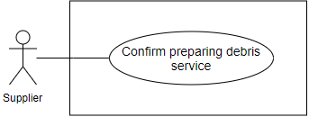

Figure 42: <Supplier>Confirm preparing debris service

**Use Case Specification**

|  |  |  |  |
| --- | --- | --- | --- |
| **USE CASE – EMP_UC_39** | | | |
| **Use Case No.** | **EMP_UC_39** | **Use Case Version** | 1.0 |
| **Use Case Name** | Confirm preparing debris service | | |
| **Author** | Luu Quang Nghia | | |
| **Date** | 18/1/2018 | **Priority** | Normal |
| **Actor:**   * Supplier   **Summary:**   * This use case allows supplier to confirm that the debris service is being prepared   **Goal:**   * Supplier confirm that the debris service is being prepared   **Triggers:**   * Supplier send command to confirm that the debris service is being prepared   **Preconditions:**   * User must login to the system * The debris transaction status is “Accepted”   **Post conditions:**   * Success: The debris transaction status changes to “Delivering” * Fail: Show error message   **Main Success Scenario:**   |  |  |  | | --- | --- | --- | | **Step** | **Actor Action** | **System Response** | | 1 | User send the command to confirm preparing debris service | System ask user to confirm the action | | 2 | User choose to confirm the approve action  [Alternative 1] | System show message that the equipment is delivering  [Exception 1] |   **Alternative Scenario:**   |  |  |  | | --- | --- | --- | | **No** | **Actor Action** | **System Response** | | 1 | User choose not to confirm the action | System hides the message and does nothing |   **Exceptions:**   |  |  |  | | --- | --- | --- | | **No** | **Cause** | **System Response** | | 1 | No internet connection | System shows message the "Please check your connection" when the internet is lost. |   **Relationships:** N/A  **Business Rules:**   * By this action, supplier confirmed to the requester that the service is being prepared * The transaction status changes from “Accepted” to “Delivering” * Requester is notified about the change | | | |

Table 47 <Supplier>Confirm preparing debris service

##### <Supplier> Confirm working on debris service

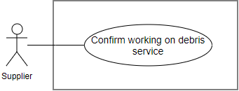

Figure 43: <Supplier>Confirm working on debris service

**Use Case Specification**

|  |  |  |  |
| --- | --- | --- | --- |
| **USE CASE – EMP_UC_40** | | | |
| **Use Case No.** | **EMP_UC_40** | **Use Case Version** | 1.0 |
| **Use Case Name** | Confirm working on debris service | | |
| **Author** | Luu Quang Nghia | | |
| **Date** | 28/1/2018 | **Priority** | Normal |
| **Actor:**   * Supplier   **Summary:**   * This use case allows supplier to confirm to have arrived at the location and start working on the debris service   **Goal:**   * Supplier confirm working on the debris service   **Triggers:**   * Supplier send command to start working debris service   **Preconditions:**   * User must login to the system * The debris transaction status is “Delivering”   **Post conditions:**   * Success: The debris transaction status changes to “Working” * Fail: Show error message   **Main Success Scenario:**   |  |  |  | | --- | --- | --- | | **Step** | **Actor Action** | **System Response** | | 1 | User send the command to confirm working on debris service | System ask user to confirm the action | | 2 | User choose to confirm the approve action  [Alternative 1] | System show message that the equipment is delivering  [Exception 1] |   **Alternative Scenario:**   |  |  |  | | --- | --- | --- | | **No** | **Actor Action** | **System Response** | | 1 | User choose not to confirm the action | System hides the message and does nothing |   **Exceptions:**   |  |  |  | | --- | --- | --- | | **No** | **Cause** | **System Response** | | 1 | No internet connection | System shows message the "Please check your connection" when the internet is lost. |   **Relationships:** N/A  **Business Rules:**   * By this action, supplier confirmed to the requester that the supplier arrived and start working on the debris service * The transaction status changes from “Delivering” to “Working” * Requester is notified about the change | | | |

Table 48 <Supplier>Confirm working on debris service

##### <Supplier> Cancel debris transaction

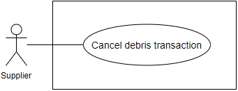

Figure 44: <Supplier>Cancel debris transaction

**Use Case Specification**

|  |  |  |  |
| --- | --- | --- | --- |
| **USE CASE – EMP_UC_41** | | | |
| **Use Case No.** | **EMP_UC_41** | **Use Case Version** | 1.0 |
| **Use Case Name** | Cancel debris transaction | | |
| **Author** | Luu Quang Nghia | | |
| **Date** | 28/1/2018 | **Priority** | Normal |
| **Actor:**   * Supplier   **Summary:**   * This use case allows supplier to cancel debris transaction   **Goal:**   * Supplier cancel debris transaction   **Triggers:**   * Supplier send command to cancel debris transaction   **Preconditions:**   * User must login to the system   **Post conditions:**   * Success: The debris transaction is canceled * Fail: Show error message   **Main Success Scenario:**   |  |  |  | | --- | --- | --- | | **Step** | **Actor Action** | **System Response** | | 1 | User send the command to cancel debris transaction | System ask user to provide the following information:   * Cancel reason: text, required | | 2 | User provide the required information and send command to continue the action | System ask user to confirm the action | | 2 | User choose to confirm the action  [Alternative 1] | System show message that the equipment is delivering  [Exception 1] |   **Alternative Scenario:**   |  |  |  | | --- | --- | --- | | **No** | **Actor Action** | **System Response** | | 1 | User choose not to confirm the action | System hides the message and does nothing |   **Exceptions:**   |  |  |  | | --- | --- | --- | | **No** | **Cause** | **System Response** | | 1 | No internet connection | System shows message the "Please check your connection" when the internet is lost. |   **Relationships:** N/A  **Business Rules:**   * If supplier cancel the transaction successfully:   + Debris transaction status changes to “Canceled”   + The related debris post status changes to “Pending”   + The related debris bid status changes to “Pending”   + Supplier get notified about the canceling * Supplier must provide cancel reason. * Once canceled, the transaction cannot be uncanceled. | | | |

Table 49 <Supplier>Cancel debris transaction

#### <Requester> Overview Use Case

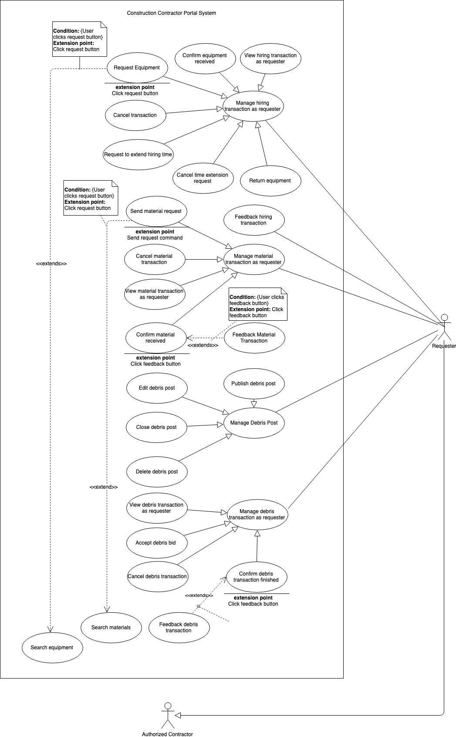

Figure 45: <Requester>Overview use case

##### <Requester> View hiring transaction as requester

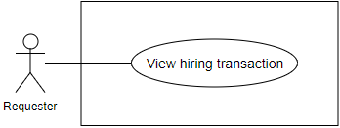

Figure 46: <Requester>View hiring transaction

**Use Case Specification**

|  |  |  |  |
| --- | --- | --- | --- |
| **USE CASE – EMP_UC_42** | | | |
| **Use Case No.** | **EMP_UC_42** | **Use Case Version** | 1.1 |
| **Use Case Name** | View hiring transaction as requester | | |
| **Author** | Luu Quang Nghia | | |
| **Date** | 18/3/2018 | **Priority** | Normal |
| **Actor:**   * Requester   **Summary:**   * This use case allows requester to view related material transactions as a requester’s view   **Goal:**   * Requester can view material transaction as a requester’s view   **Triggers:**   * User send command to view material transaction as a requester’s view   **Preconditions:**   * User must login to the system   **Post conditions:**   * Success: Display material transaction list on the screen * Fail: Show error message   **Main Success Scenario:**   |  |  |  | | --- | --- | --- | | **Step** | **Actor Action** | **System Response** | | 1 | User go to requester transaction view | System render transaction list [Alternative 1] [Exception 1] |   **Alternative Scenario:**   |  |  |  | | --- | --- | --- | | **No** | **Actor Action** | **System Response** | | 1 | If there’s no transaction available. | System inform that there’s no transaction |   **Exceptions:**   |  |  |  | | --- | --- | --- | | **No** | **Cause** | **System Response** | | 1 | No internet connection | System shows message the "Please check your connection" when the internet is lost. |   **Relationships:** N/A  **Business Rules:**   * Requester can view all the transactions related to him, created in the past or the present. * Each transaction has one of the following statuses at a time:   + Pending: transaction is created/requested by requester and waiting for supplier to accept   + Accepted: supplier accepted the transaction   + Processing: The transaction is processing, meaning that the equipment current status is “Delivering”, “Renting”, or “Waiting for returning”   + Finished: the supplier received the equipment, transaction finished   + Denied: supplier denied the transaction   + Canceled: the transaction is canceled by supplier or requester * Each transaction is related to only one equipment. * User can see the following information about each transaction:   + Request status   + Equipment name   + Equipment thumbnail   + Supplier name   + Supplier thumbnail   + Transaction total price   + Transaction time range   + Action button to change transaction status in allowed authority * Each transaction related to one equipment, one beginning date and one ending date. * User can choose to view equipment detail related to each transaction. | | | |

Table 50 <Requester>View hiring transaction

##### <Requester> Confirm equipment received

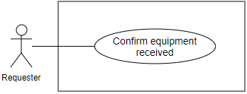

Figure 47: <Requester>Confirm equipment received

**Use Case Specification**

|  |  |  |  |
| --- | --- | --- | --- |
| **USE CASE – EMP_UC_43** | | | |
| **Use Case No.** | **EMP_UC_43** | **Use Case Version** | 1.1 |
| **Use Case Name** | Confirm equipment received | | |
| **Author** | Luu Quang Nghia | | |
| **Date** | 18/3/2018 | **Priority** | High |
| **Actor:** Requester  **Summary:**   * This use case allows requester to confirm having received the equipment   **Goal:**   * Requester set equipment status from “delivering” to “renting”   **Triggers:**   * Requester send command to confirm the delivery   **Preconditions:**   * User must login to the system * The equipment status must be “delivering” * The transaction status must be “processing”   **Post conditions:**   * Success: The equipment status changed to “renting” * Fail: Show error message   **Main Success Scenario:**   |  |  |  | | --- | --- | --- | | **Step** | **Actor Action** | **System Response** | | 1 | User send the command to change the status | System ask user to confirm the action | | 2 | User choose to confirm the action [Alternative 1] | System show message that the status has changed to “renting”  [Exception 1] |   **Alternative Scenario:**   |  |  |  | | --- | --- | --- | | **No** | **Actor Action** | **System Response** | | 1 | User choose not to confirm the action | System hides the message and does nothing |   **Exceptions:**   |  |  |  | | --- | --- | --- | | **No** | **Cause** | **System Response** | | 1 | No internet connection | System shows message the "Please check your connection" when the internet is lost. |   **Relationships:** N/A  **Business Rules:**   * Requester set the status to “renting” after supplier deliver the equipment to the requester * Supplier is notified and can see the status change * Requester is the only one who can change this status, not even the system * For some special business cases, supplier can flexibly neglect the business rules to fit the situation, for example, requester hiEMPelf does the delivery, * Requester can ask staff to change the status back to “delivering” for mis-pressing situations | | | |

Table 51 <Requester>Confirm equipment received

##### <Requester> Request equipment

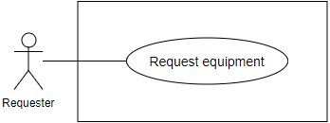

Figure 48: <Requester>Request equipment

**Use Case Specification**

|  |  |  |  |
| --- | --- | --- | --- |
| **USE CASE – EMP_UC_44** | | | |
| **Use Case No.** | **EMP_UC_44** | **Use Case Version** | 1.1 |
| **Use Case Name** | Request equipment | | |
| **Author** | Luu Quang Nghia | | |
| **Date** | 18/3/2018 | **Priority** | High |
| **Actor:**   * Requester   **Summary:**   * This use case allow requester to request equipment for material   **Goal:**   * Requester request equipment   **Triggers:**   * Requester send the command to view equipment details   **Preconditions:**   * User must login to the system * Account of user must be activated * Equipment status must be available   **Post conditions:**   * Success: The new request is composed * Fail: Show error message   **Main Success Scenario:**   |  |  |  | | --- | --- | --- | | **Step** | **Actor Action** | **System Response** | | 1 | User viewing equipment details | System require the following information from user:   * Begin material date * End material date * Address | | 2 | User provide the correct information |  | | 3 | User send the command to create new request | System validates information  If validated, system ask user for confirmation [Exception 1, 2] | | 4 | User send command to confirm the request  [Alternative 1] | System shows message that request have made successfully, waiting for supplier’s acceptance |   **Alternative Scenario:**   |  |  |  | | --- | --- | --- | | **No** | **Actor Action** | **System Response** | | 1 | User send command to unconfirm the request | System back to the making request view |   **Exceptions:**   |  |  |  | | --- | --- | --- | | **No** | **Cause** | **System Response** | | 1 | No internet connection | System shows message the "Please check your connection" when the internet is lost. | | 2 | User send command to create new request | System shows error message show that input date is not available and ask user to input again |   **Relationships:** N/A  **Business Rules:**   * The request can be understood as a “Pending” transaction * Each request is related to only one equipment * Time range means the time from beginning date to ending date * Time range’s unit is date (not hour nor month) * User can choose to use construction’s location as equipment’s location * User can view at least the following information before making request:   + Equipment name, price, images, description type   + Distance from supplier’s equipment to requester’s construction   + Price calculated based on input time range and daily price   + Available time range of equipment   + Supplier’s profile   + Supplier’s phone number * When user change beginning date, ending date, or construction/location, the price change accordingly. * System validate user’s input for the following criteria:   + The requested time range is “contained” in the equipment’s available time range   + There are no “Accepted” or “Processing” transaction with time range intersecting with the requested time range * If the request is made successfully, system notify supplier about the request. | | | |

Table 52 <Requester>Request equipment

##### <Requester> Cancel hiring transaction

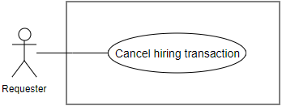

Figure 49: <Requester>Cancel hiring transaction

**Use Case Specification**

|  |  |  |  |
| --- | --- | --- | --- |
| **USE CASE – EMP_UC_45** | | | |
| **Use Case No.** | **EMP_UC_45** | **Use Case Version** | 1.1 |
| **Use Case Name** | Cancel hiring transaction | | |
| **Author** | Luu Quang Nghia | | |
| **Date** | 18/3/2018 | **Priority** | Normal |
| **Actor:**   * Requester   **Summary:**   * This use case allows requester to cancel transaction for hiring equipment that has been sent before   **Goal:**   * Requester cancel transaction for hiring equipment   **Triggers:**   * Requester send command to cancel the request   **Preconditions:**   * User must login to the system * The transaction status must be “Pending” or “Accepted” * The supplier has not accepted nor denied the request   **Post conditions:**   * Success: Requester cancel request for hiring equipment * Fail: Show error message   **Main Success Scenario:**   |  |  |  | | --- | --- | --- | | **Step** | **Actor Action** | **System Response** | | 1 | User send command to cancel the hiring transaction | System ask user to input:  Cancel reason: text, required | | 2 | User input the required information | System ask user to confirm the action | | 3 | User confirm the action  [Alternative 1] | System show message that the transaction is canceled successfully  [Exception 1] |   **Alternative Scenario:**   |  |  |  | | --- | --- | --- | | **No** | **Actor Action** | **System Response** | | 1 | User choose not to confirm | System gets back to request list view |   **Exceptions:**   |  |  |  | | --- | --- | --- | | **No** | **Cause** | **System Response** | | 1 | No internet connection | System shows message the "Please check your connection" when the internet is lost. |   **Relationships:** N/A  **Business Rules:**   * Requester can only cancel transaction that have status “Pending” or “Accepted”, meaning that the equipment Is not delivery yet * Requester must provide cancel reason * Once canceled, the transaction cannot be uncanceled * Supplier get notified about the canceling | | | |

Table 53 <Requester>Cancel hiring transaction

##### <Requester> Request to extend hiring time

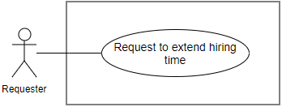

Figure 50: <Requester>Request to extend hiring time

**Use Case Specification**

|  |  |  |  |
| --- | --- | --- | --- |
| **USE CASE – EMP_UC_46** | | | |
| **Use Case No.** | **EMP_UC_46** | **Use Case Version** | 1.0 |
| **Use Case Name** | Request to extend hiring time | | |
| **Author** | Luu Quang Nghia | | |
| **Date** | 18/3/2018 | **Priority** | High |
| **Actor:**   * Requester   **Summary:**   * This use case allows requester to send request for extend equipment hiring time   **Goal:**   * Requester send request for extending equipment hiring time to the supplier   **Triggers:**   * Requester send command to make request for extending equipment hiring time   **Preconditions:**   * User must login to the system * There’s no other pending request for hiring time extension * The transaction status is “Accepted” or “Processing”   **Post conditions:**   * Success: Requester send request to extend equipment hiring time * Fail: Show error message   **Main Success Scenario:**   |  |  |  | | --- | --- | --- | | **Step** | **Actor Action** | **System Response** | | 1 | User send command to extend hiring request | System requires user to input extended end date | | 2 | User input required information |  | | 3 | User send command to make the request | SysteEMP validate user input for the following criteria:   * The extended time range must be in between available time range * Extended end date must be after the current date * Extended end date must be after the current end date   If input validated, system ask user to confirm the request  [Exception 1, 2] | | 4 | User confirm the request  [Alternative 1] | System show message that the request has been sent successfully  [Exception 1] |   **Alternative Scenario:**   |  |  |  | | --- | --- | --- | | **No** | **Actor Action** | **System Response** | | 1 | User choose not to confirm | System back to the making-requests view |   **Exceptions:**   |  |  |  | | --- | --- | --- | | **No** | **Cause** | **System Response** | | 1 | No internet connection | System shows message the "Please check your connection" when the internet is lost. | | 2 | User send command to make the request | Input not validated, system show error to user |   **Relationships:** N/A  **Business Rules:**   * Requester cannot extend the beginning date when the transaction status is other than “Accepted” or “Processing” * If requester want to extend hiring time of a “Pending” transaction, he must cancel it and make a new “Pending” transaction * Time range means the time from beginning date to ending date * Time range’s unit is date (not hour nor month) * Extended time range has the following information:   + Begin date: current transaction’s begin date   + End date: input by user * The extended time range must wider than the current time range. * The extended time range is “contained” in the equipment’s available time range. * There are no “accepted” or “processing” transaction that intersect with the extended time range * The supplier is notified about the request * The sent request has status “Pending” * There are only 1 “Pending” time extension request at a time * Requester can review the request later | | | |

Table 54 <Requester>Request to extend hiring time

##### <Requester> Cancel time extension request

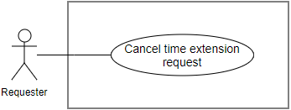

Figure 51: <Requester>Cancel time extension request

**Use Case Specification**

|  |  |  |  |
| --- | --- | --- | --- |
| **USE CASE – EMP_UC_47** | | | |
| **Use Case No.** | **EMP_UC_47** | **Use Case Version** | 1.0 |
| **Use Case Name** | Cancel time extension request | | |
| **Author** | Luu Quang Nghia | | |
| **Date** | 18/1/2018 | **Priority** | High |
| **Actor:**   * Requester   **Summary:**   * This use case allows requester to cancel request for extending equipment hiring time that has been sent before   **Goal:**   * Requester cancel request for extending equipment hiring time   **Triggers:**   * Requester send command to cancel the request   **Preconditions:**   * User must login to the system * There’s one and only one pending request for hiring time extension * The request’s status must be “Pending”   **Post conditions:**   * Success: Requester cancel request to adjust equipment hiring time * Fail: Show error message   **Main Success Scenario:**   |  |  |  | | --- | --- | --- | | **Step** | **Actor Action** | **System Response** | | 1 | User send command to cancel the request | System ask user to confirm the action | |  | User confirm the action  [Alternative 1] | System show message that the request is canceled successfully  [Exception 1] |   **Alternative Scenario:**   |  |  |  | | --- | --- | --- | | **No** | **Actor Action** | **System Response** | | 1 | User choose not to confirm | System gets back to request list view |   **Exceptions:**   |  |  |  | | --- | --- | --- | | **No** | **Cause** | **System Response** | | 1 | No internet connection | System shows message the "Please check your connection" when the internet is lost. |   **Relationships:** N/A  **Business Rules:**   * Only after user cancel the request that user can make another request | | | |

Table 55 <Requester>Cancel time extension request

##### <Requester> Return equipment

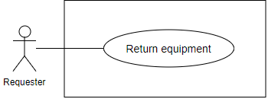

Figure 52: <Requester>Return equipment

**Use Case Specification**

|  |  |  |  |
| --- | --- | --- | --- |
| **USE CASE – EMP_UC_48** | | | |
| **Use Case No.** | **EMP_UC_48** | **Use Case Version** | 1.1 |
| **Use Case Name** | Return equipment | | |
| **Author** | Tran Cong Minh | | |
| **Date** | 28/3/2018 | **Priority** | High |
| **Actor:** Requester  **Summary:**   * This use case allows requester to proactively return the equipment to the supplier   **Goal:**   * Requester set equipment status from “Renting” to “Waiting for returning”   **Triggers:**   * Requester send command to return the equipment   **Preconditions:**   * User must login to the system * The equipment status is “Renting” * The transaction status is “Processing”   **Post conditions:**   * Success: The equipment status changed to “Waiting for delivering” * Fail: Show error message   **Main Success Scenario:**   |  |  |  | | --- | --- | --- | | **Step** | **Actor Action** | **System Response** | | 1 | User send the command to change the status | System ask user to confirm the action | | 2 | User choose to confirm the action [Alternative 1] | System show message that the status has changed to “renting”  [Exception 1] |   **Alternative Scenario:**   |  |  |  | | --- | --- | --- | | **No** | **Actor Action** | **System Response** | | 1 | User choose not to confirm the action | System hides the message and does nothing |   **Exceptions:**   |  |  |  | | --- | --- | --- | | **No** | **Cause** | **System Response** | | 1 | No internet connection | System shows message the "Please check your connection" when the internet is lost. |   **Relationships:** N/A  **Business Rules:**   * Requester set the equipment status to “waiting for returning”. * In business view, the “return” action of requester means that:   + Requester agree to end renting process and return the equipment   + The transaction’s price would not be changed even if the requester returns equipment early   + The delivery of returning process can be made by either requester or supplier * Supplier is notified and can see the status change. | | | |

Table 56 <Requester>Return equipment

##### <Requester> Feedback hiring transaction

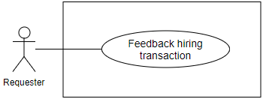

Figure 53: <Requester>Feedback hiring transaction

**Use Case Specification**

|  |  |  |  |
| --- | --- | --- | --- |
| **USE CASE – EMP_UC_49** | | | |
| **Use Case No.** | **EMP_UC_49** | **Use Case Version** | 1.1 |
| **Use Case Name** | Feedback hiring transaction | | |
| **Author** | Tran Cong Minh | | |
| **Date** | 28/3/2018 | **Priority** | High |
| **Actor:**   * Requester   **Summary:**   * This use case allow requester to send feedback about a finished hiring transaction   **Goal:**   * Requester feedback hiring transaction   **Triggers:**   * Requester send the command to feedback hiring transaction   **Preconditions:**   * User must login to the system * Transaction status is “Finished”   **Post conditions:**   * Success: A new feedback is sent * Fail: Show error message   **Main Success Scenario:**   |  |  |  | | --- | --- | --- | | **Step** | **Actor Action** | **System Response** | | 1 | User send command to feedback the transaction | System require the following information from user:   * Rating: double, required * Content: text, required, >30 characters | | 2 | User provide the correct information |  | | 3 | User send the command to send feedback | System validates information  If validated, system ask user for confirmation [Exception 1, 2] | | 4 | User send command to confirm the request  [Alternative 1] | System shows message that the action is complete |   **Alternative Scenario:**   |  |  |  | | --- | --- | --- | | **No** | **Actor Action** | **System Response** | | 1 | User send command to unconfirm the request | System back to the making request view |   **Exceptions:**   |  |  |  | | --- | --- | --- | | **No** | **Cause** | **System Response** | | 1 | No internet connection | System shows message the "Please check your connection" when the internet is lost. | | 2 | User send command to send feedback | System shows error message show that input information is not validated |   **Relationships:** N/A  **Business Rules:**   * A hiring transaction can only have one feedback * User can only feedback on the transaction that he involved as a requester * A feedback cannot be adjusted or deleted * Supplier is notified about the feedback | | | |

Table 57 <Requester>Feedback hiring transaction

##### <Requester> View material transaction as requester

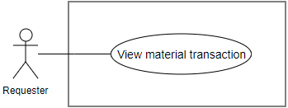

Figure 54: <Requester>View material transaction

**Use Case Specification**

|  |  |  |  |
| --- | --- | --- | --- |
| **USE CASE - EMP_UC_50** | | | |
| **Use Case No.** | **EMP_UC_50** | **Use Case Version** | 2.0 |
| Use Case Name | View material transactions as requester | | |
| **Author** | Tran Cong Minh | | |
| **Date** | 28/1/2018 | **Priority** | High |
| **Actor:**   * Requester   **Summary:**   * This use case allows requester to view related material transactions under requester’s view   **Goal:**   * Requester can view related material transactions   **Triggers:**   * Requester send command to view material transactions as requester   **Preconditions:**   * User must login to the system as role Registered User   **Post conditions:**   * Success: Requester can view material transactions as requester * Fail: Show error message   **Main Success Scenario:**   |  |  |  | | --- | --- | --- | | **Step** | **Actor Action** | **System Response** | | 1 | Requester sends command to view the material transactions | System show a list of transactions  [Exception 1] |   **Alternative Scenario: N/A**  **Exceptions:**   |  |  |  | | --- | --- | --- | | **No** | **Cause** | **System Response** | | 1 | No internet connection | System shows message the "Please check your connection" when the internet is lost. |   **Relationships:** N/A  **Business Rules:**   * Requester can view all the material transactions related to him, created in the past or the present * Each material transaction can include multiple materials, or can be understood as material details * Each transaction has one of the following statuses at a time:   + Pending: transaction is created/requested by requester and waiting for requester to accept   + Accepted: requester accepted the transaction and prepare to deliver   + Delivering: Requester is delivering materials to requester   + Finished: Requester received the equipment, transaction finished   + Denied: requester denied the transaction   + Canceled: the transaction is canceled by requester or requester * User can see the following information about each transaction:   + Current status   + Materials included   + Requester name   + Requester thumbnail   + Transaction total price   + Transaction created time   + Transaction id   + Action button to change transaction status in allowed authority * User can choose to view material list related to the transaction. * Materials in a transaction must belong to the same supplier. * The information in the transaction, except status, cannot be modified in anyway, including price, location. | | | |

Table 58 <Requester>View material transaction

##### <Requester> Send material request

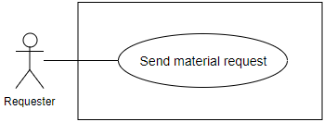

Figure 55: <Requester>Send material request

**Use Case Specification**

|  |  |  |  |
| --- | --- | --- | --- |
| **USE CASE – EMP_UC_51** | | | |
| **Use Case No.** | **EMP_UC_51** | **Use Case Version** | 1.1 |
| **Use Case Name** | Send material request | | |
| **Author** | Luu Quang Nghia | | |
| **Date** | 11/4/2018 | **Priority** | High |
| **Actor:**   * Requester   **Summary:**   * This use case allow requester to send material request   **Goal:**   * Requester request material   **Triggers:**   * Requester send the command to request materials   **Preconditions:**   * User must login to the system * Account of user must be activated   **Post conditions:**   * Success: The new request is sent * Fail: Show error message   **Main Success Scenario:**   |  |  |  | | --- | --- | --- | | **Step** | **Actor Action** | **System Response** | | 1 | User create new request | System require the following information from user:   * Address: text, required * Materials: entity, required * Quantity of each material: double, required | | 2 | User provide the correct information |  | | 3 | User send the command to create new request | System validates information  If validated, system ask user for confirmation [Exception 1, 2] | | 4 | User send command to confirm the request  [Alternative 1] | System shows message that request have made successfully, waiting for supplier’s acceptance |   **Alternative Scenario:**   |  |  |  | | --- | --- | --- | | **No** | **Actor Action** | **System Response** | | 1 | User send command to unconfirm the request | System back to the making request view |   **Exceptions:**   |  |  |  | | --- | --- | --- | | **No** | **Cause** | **System Response** | | 1 | No internet connection | System shows message the "Please check your connection" when the internet is lost. | | 2 | User send command to create new request | System shows error message show that input date is not available and ask user to input again |   **Relationships:** N/A  **Business Rules:**   * The request can be understood as a “Pending” transaction * Request material means create a new “Pending” material transaction * Each material transaction can include multiple materials, which can be understood as “material details” * User can choose multiple materials and checkout at once. * Materials in a transaction must belong to the same supplier * Server must separate checked-out materials into multiple transaction so that each material in the same transaction must belong to the same supplier * User can view at least the following information before making request:   + Material name, unit, image, description, manufacturer, price   + Total price calculated based quantity and cost of material   + Supplier’s profile   + Supplier’s phone number * System get longitude, latitude information based on provided address. * The information in the transaction, except status, cannot be modified in anyway, including price, receiving address. * If the request is made successfully, system notify supplier about the request. | | | |

Table 59 <Requester>Send material request

##### <Requester> Cancel material transaction

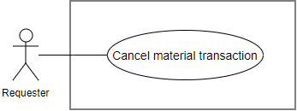

Figure 56: <Requester>Cancel material transaction

**Use Case Specification**

|  |  |  |  |
| --- | --- | --- | --- |
| **USE CASE – EMP_UC_52** | | | |
| **Use Case No.** | **EMP_UC_52** | **Use Case Version** | 1.1 |
| **Use Case Name** | Cancel material transaction | | |
| **Author** | Tran Cong Minh | | |
| **Date** | 18/3/2018 | **Priority** | Normal |
| **Actor:**   * Requester   **Summary:**   * This use case allows requester to cancel material transaction   **Goal:**   * Requester cancel transaction for material transaction   **Triggers:**   * Requester send command to cancel the transaction   **Preconditions:**   * User must login to the system * The transaction status must be “Pending”, “Accepted”, or “Delivering”   **Post conditions:**   * Success: Requester cancel material transaction * Fail: Show error message   **Main Success Scenario:**   |  |  |  | | --- | --- | --- | | **Step** | **Actor Action** | **System Response** | | 1 | User send command to cancel the material transaction | System ask user to input:   * Cancel reason: text, required | | 2 | User input the required information | System ask user to confirm the action | | 3 | User confirm the action  [Alternative 1] | System show message that the transaction is canceled successfully  [Exception 1] |   **Alternative Scenario:**   |  |  |  | | --- | --- | --- | | **No** | **Actor Action** | **System Response** | | 1 | User choose not to confirm | System hides the message and does nothing |   **Exceptions:**   |  |  |  | | --- | --- | --- | | **No** | **Cause** | **System Response** | | 1 | No internet connection | System shows message the "Please check your connection" when the internet is lost. |   **Relationships:** N/A  **Business Rules:**   * Requester can only cancel transaction that have status “Pending”, “Accepted”, or “Delivering”, meaning that the transaction is no longer active and cannot continue what is doing * Requester must provide cancel reason * System automatically save the requester as the one who canceled the transaction * Once canceled, the transaction cannot be uncanceled * Supplier get notified about the canceling | | | |

Table 60 <Requester>Cancel material transaction

##### <Requester> Confirm material received

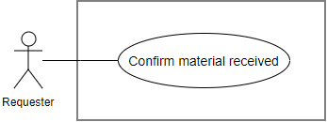

Figure 57: <Requester>Confirm material received

**Use Case Specification**

|  |  |  |  |
| --- | --- | --- | --- |
| **USE CASE – EMP_UC_53** | | | |
| **Use Case No.** | **EMP_UC_53** | **Use Case Version** | 1.0 |
| **Use Case Name** | Confirm material received | | |
| **Author** | Tran Cong Minh | | |
| **Date** | 18/1/2018 | **Priority** | Normal |
| **Actor:**   * Requester   **Summary:**   * This use case allows requester to confirm that the material is received to the requester   **Goal:**   * Requester confirm that the request is received   **Triggers:**   * Requester send command to confirm that the material is received   **Preconditions:**   * User must login to the system * The transaction status is “Delivering”   **Post conditions:**   * Success: The transaction status changes to “Finished” * Fail: Show error message   **Main Success Scenario:**   |  |  |  | | --- | --- | --- | | **Step** | **Actor Action** | **System Response** | | 1 | User send the command to confirm the material is received | System ask user to confirm the action | | 2 | User choose to confirm the approve action  [Alternative 1] | System show message that the material is received  [Exception 1] |   **Alternative Scenario:**   |  |  |  | | --- | --- | --- | | **No** | **Actor Action** | **System Response** | | 1 | User choose not to confirm the action | System hides the message and does nothing |   **Exceptions:**   |  |  |  | | --- | --- | --- | | **No** | **Cause** | **System Response** | | 1 | No internet connection | System shows message the "Please check your connection" when the internet is lost. |   **Relationships:** N/A  **Business Rules:**   * By this action, requester confirmed to receive the material delivery by supplier * The transaction status changes from “Delivering” to “Finished” * Supplier is notified about the change | | | |

Table 61 <Requester>Confirm material received

##### <Requester> Feedback material transaction

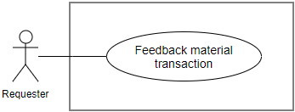

Figure 58: <Requester>Feedback material transaction

**Use Case Specification**

|  |  |  |  |
| --- | --- | --- | --- |
| **USE CASE – EMP_UC_54** | | | |
| **Use Case No.** | **EMP_UC_54** | **Use Case Version** | 1.1 |
| **Use Case Name** | Feedback material transaction | | |
| **Author** | Tran Cong Minh | | |
| **Date** | 28/3/2018 | **Priority** | High |
| **Actor:**   * Requester   **Summary:**   * This use case allow requester to send feedback about a finished material transaction   **Goal:**   * Requester feedback material transaction   **Triggers:**   * Requester send the command to feedback material transaction   **Preconditions:**   * User must login to the system * Transaction status is “Finished”   **Post conditions:**   * Success: A new feedback is sent * Fail: Show error message   **Main Success Scenario:**   |  |  |  | | --- | --- | --- | | **Step** | **Actor Action** | **System Response** | | 1 | User send command to feedback the transaction | System require the following information from user:   * Rating: double, required * Content: text, required, >30 characters | | 2 | User provide the correct information |  | | 3 | User send the command to send feedback | System validates information  If validated, system ask user for confirmation [Exception 1, 2] | | 4 | User send command to confirm the request  [Alternative 1] | System shows message that the action is complete |   **Alternative Scenario:**   |  |  |  | | --- | --- | --- | | **No** | **Actor Action** | **System Response** | | 1 | User send command to unconfirm the request | System back to the making request view |   **Exceptions:**   |  |  |  | | --- | --- | --- | | **No** | **Cause** | **System Response** | | 1 | No internet connection | System shows message the "Please check your connection" when the internet is lost. | | 2 | User send command to send feedback | System shows error message show that input information is not validated |   **Relationships:** N/A  **Business Rules:**   * A material transaction can only have one feedback * User can only feedback on the transaction that he involved as a requester * A feedback cannot be adjusted or deleted * Supplier is notified about the feedback | | | |

Table 62 <Requester>Feedback material transaction

##### <Requester> Publish debris post

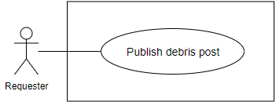

Figure 59: <Requester>Publish debris post

**Use Case Specification**

|  |  |  |  |
| --- | --- | --- | --- |
| **USE CASE – EMP_UC_55** | | | |
| **Use Case No.** | **EMP_UC_55** | **Use Case Version** | 1.1 |
| **Use Case Name** | Publish debris post | | |
| **Author** | Tran Cong Minh | | |
| **Date** | 19/3/2018 | **Priority** | High |
| **Actor:**   * Requester   **Summary:**   * This use case allows requester to publish a debris post   **Goal:**   * Requester can publish a debris post   **Triggers:**   * Requester send command to publish a debris post   **Preconditions:**   * User must login to the system * Account of user must be activated   **Post conditions:**   * Success: New debris post is published * Fail: Show error message   **Main Success Scenario:**   |  |  |  | | --- | --- | --- | | **Step** | **Actor Action** | **System Response** | | 1 | User send command to publish a debris post | System requires information about the debris post:   * Title: free text input, required, length < 1000 * Additional images: image, required, quantity: at least 1 * Thumbnail image: image, required, quantity: 1 * Construction: choose from construction list, required * Debris service type: select from options list, multiple choices allowed * Description: free text input, length: 0- 1000 | | 2 | User input information |  | | 3 | User send command to create new debris post | System validate information, display request for confirmation | | 4 | User confirm the action  [Alternative 1] | System display successful message  [Exception 1] |   **Alternative Scenario:**   |  |  |  | | --- | --- | --- | | **No** | **Actor Action** | **System Response** | | 1 | User choose not to confirm the action | System hides the message and go back to inputting view |   **Exceptions:**   |  |  |  | | --- | --- | --- | | **No** | **Cause** | **System Response** | | 1 | No internet connection | System shows message the "Please check your connection" when the internet is lost. | | 2 | User input invalidate information. | System show error message for the input invalidation |   **Relationships:** N/A  **Business Rules:**   * A debris post can be understood as a job description or requirement for supplier to read before offer debris services and price * Images are uploaded from user’s device * Thumbnail images are chosen from uploaded image list * Debris service type is the type of service required for supplier to offer * Each debris post can have multiple debris service types * Posted debris post would have default status “Pending” * Construction can be used as location information * Each construction has information about construction name and location * User can choose to create new construction or select from created constructions * After requester publish the debris post successfully, other requester can find and view the debris post * In real-life business cases, a debris post is not required to be fully described. It’s supplier’s duty to contact and gather sufficient information before offer the service. | | | |

Table 63 <Requester>Publish debris post

##### <Requester> Edit debris post

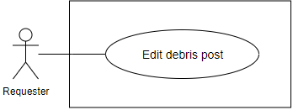

Figure 60: <Requester>Edit debris post

**Use Case Specification**

|  |  |  |  |
| --- | --- | --- | --- |
| **USE CASE – EMP_UC_56** | | | |
| **Use Case No.** | **EMP_UC_56** | **Use Case Version** | 1.1 |
| **Use Case Name** | Edit debris post | | |
| **Author** | Tran Cong Minh | | |
| **Date** | 19/3/2018 | **Priority** | High |
| **Actor:**   * Requester   **Summary:**   * This use case allows requester to edit a debris post   **Goal:**   * Requester can edit a debris post   **Triggers:**   * Requester send command to edit a debris post   **Preconditions:**   * User must login to the system   **Post conditions:**   * Success: New debris post is edited * Fail: Show error message   **Main Success Scenario:**   |  |  |  | | --- | --- | --- | | **Step** | **Actor Action** | **System Response** | | 1 | User send command to edit a debris post | System requires information about the debris post:   * Title: free text input, required, length < 1000 * Additional images: image, required, quantity: at least 1 * Thumbnail image: image, required, quantity: 1 * Construction: choose from construction list, required * Debris service type: select from options list, multiple choices allowed * Description: free text input, length: 0- 1000 | | 2 | User input information |  | | 3 | User send command to create new debris post | System validate information, display request for confirmation | | 4 | User confirm the action  [Alternative 1] | System display successful message  [Exception 1] |   **Alternative Scenario:**   |  |  |  | | --- | --- | --- | | **No** | **Actor Action** | **System Response** | | 1 | User choose not to confirm the action | System hides the message and go back to inputting view |   **Exceptions:**   |  |  |  | | --- | --- | --- | | **No** | **Cause** | **System Response** | | 1 | No internet connection | System shows message the "Please check your connection" when the internet is lost. | | 2 | User input invalidate information. | System show error message for the input invalidation |   **Relationships:** N/A  **Business Rules:**   * Thumbnail images are chosen from uploaded image list * User cannot edit debris post’ status * User can choose to create new construction or select from created constructions * Further information can be found in Use case < **EMP_UC_55**> (Publish debris post) | | | |

Table 64 <Requester>Edit debris post

##### <Requester> Close debris post

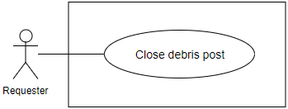

Figure 61: <Requester>Close debris post

**Use Case Specification**

|  |  |  |  |
| --- | --- | --- | --- |
| **USE CASE – EMP_UC_57** | | | |
| **Use Case No.** | **EMP_UC_57** | **Use Case Version** | 1.1 |
| **Use Case Name** | Close debris post | | |
| **Author** | Tran Cong Minh | | |
| **Date** | 19/3/2018 | **Priority** | High |
| **Actor:**   * Requester   **Summary:**   * This use case allows requester to close a debris post   **Goal:**   * Requester can close a debris post   **Triggers:**   * Requester send command to close a debris post   **Preconditions:**   * User must login to the system * Debris post status is “Pending”   **Post conditions:**   * Success: Debris post status is “Closed” * Fail: Show error message   **Main Success Scenario:**   |  |  |  | | --- | --- | --- | | **Step** | **Actor Action** | **System Response** | | 1 | User send command to close a debris post | System ask user to confirm the action | | 4 | User confirm the action  [Alternative 1] | System display successful message  [Exception 1] |   **Alternative Scenario:**   |  |  |  | | --- | --- | --- | | **No** | **Actor Action** | **System Response** | | 1 | User choose not to confirm the action | System hides the message and go back to inputting view |   **Exceptions:**   |  |  |  | | --- | --- | --- | | **No** | **Cause** | **System Response** | | 1 | No internet connection | System shows message the "Please check your connection" when the internet is lost. |   **Relationships:** N/A  **Business Rules:**   * User can only close debris post with “Pending” status, meaning there are no processing debris transaction related to the debris post * Closed debris post cannot be found and cannot be bided by suppliers * Once closed, the debris post can be changed back to “Pending” by user | | | |

Table 65 <Requester>Close debris post

##### <Requester> Delete debris post

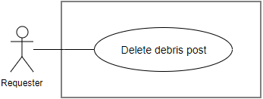

Figure 62: <Requester>Delete debris post

**Use Case Specification**

|  |  |  |  |
| --- | --- | --- | --- |
| **USE CASE – EMP_UC_58** | | | |
| **Use Case No.** | **EMP_UC_58** | **Use Case Version** | 1.1 |
| **Use Case Name** | Delete debris post | | |
| **Author** | Tran Cong Minh | | |
| **Date** | 19/3/2018 | **Priority** | High |
| **Actor:**   * Requester   **Summary:**   * This use case allows requester to delete a debris post   **Goal:**   * Requester can delete a debris post   **Triggers:**   * Requester send command to delete a debris post   **Preconditions:**   * User must login to the system   **Post conditions:**   * Success: Debris post is deleted * Fail: Show error message   **Main Success Scenario:**   |  |  |  | | --- | --- | --- | | **Step** | **Actor Action** | **System Response** | | 1 | User send command to delete a debris post | System ask user to confirm the action | | 4 | User confirm the action  [Alternative 1] | System display successful message  [Exception 1] |   **Alternative Scenario:**   |  |  |  | | --- | --- | --- | | **No** | **Actor Action** | **System Response** | | 1 | User choose not to confirm the action | System hides the message |   **Exceptions:**   |  |  |  | | --- | --- | --- | | **No** | **Cause** | **System Response** | | 1 | No internet connection | System shows message the "Please check your connection" when the internet is lost. |   **Relationships:** N/A  **Business Rules:**   * User cannot delete debris post if:   + There is an active transaction related to the debris post, which is a transaction whose status is not “Finished”   + Debris post status is not “Pending” or “Closed” * Once deleted, the debris post cannot be found or managed any more. | | | |

Table 66 <Requester>Delete debris post

##### <Requester> View debris transaction as requester

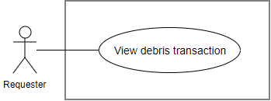

Figure 63: <Requester>Edit debris post

**Use Case Specification**

|  |  |  |  |
| --- | --- | --- | --- |
| **EMP_UC_61** | | | |
| **Use Case No.** | **EMP_UC_61** | **Use Case Version** | 2.0 |
| **Use Case Name** | View debris transaction as requester | | |
| **Author** | Luu Quang Nghia | | |
| **Date** | 18/1/2018 | **Priority** | High |
| **Actor:**   * Requester   **Summary:**   * This use case allows requester to view debris transactions as a requester’s view   **Goal:**   * Requester can view transactions   **Triggers:**   * Requester send command to view debris transactions as requester   **Preconditions:**   * User must login to the system as role Registered User   **Post conditions:**   * Success: Requester can view all the transactions * Fail: Show error message   **Main Success Scenario:**   |  |  |  | | --- | --- | --- | | **Step** | **Actor Action** | **System Response** | | 1 | Requester sends command to view the transactions | System show a list of transactions  [Exception 1] |   **Alternative Scenario: N/A**  **Exceptions:**   |  |  |  | | --- | --- | --- | | **No** | **Actor Action** | **System Response** | | 1 | No internet connection | System shows message the "Please check your connection" when the internet is lost. |   **Relationships:** N/A  **Business Rules:**   * Requester can view all the debris transactions related to him, created in the past or the present * Each transaction is related to one debris bid and one debris post * Each transaction has one of the following statuses at a time:   + Accepted: first state of the process, meaning the requester chose a debris bid and created a transaction   + Delivering: Requester is preparing debris service   + Working: The Requester arrived the construction and start to work on debris service   + Finished: The requester finished the service   + Canceled: the transaction is canceled by requester or requester * User can see the following information about each transaction:   + Transaction status   + Debris post details   + Debris bid details   + Requester name   + Requester thumbnail   + Acton button to change transaction status in allowed authority | | | |

Table 67 : <Requester>Edit debris post

##### <Requester> Accept debris bid

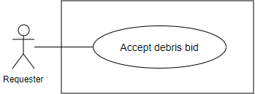

Figure 64: <Requester>Accept debris bid

**Use Case Specification**

|  |  |  |  |
| --- | --- | --- | --- |
| **USE CASE – EMP_UC_60** | | | |
| **Use Case No.** | **EMP_UC_60** | **Use Case Version** | 2.0 |
| **Use Case Name** | Accept debris bid | | |
| **Author** | Tran Cong Minh | | |
| **Date** | 18/1/2018 | **Priority** | High |
| **Actor:**   * Requester   **Summary:**   * This use case allows requester to accept debris bid   **Goal:**   * Requester accept debris bid for the debris post   **Triggers:**   * Requester send command to accept the debris bid   **Preconditions:**   * User must login to the system * Requester account must be activated * The debris post status is “Pending” * The debris bid status is “Pending”   **Post conditions:**   * Success: Debris post is accepted * Fail: Show error message   **Main Success Scenario:**   |  |  |  | | --- | --- | --- | | **Step** | **Actor Action** | **System Response** | | 1 | User send the command to accept the debris bid | System ask user to confirm the action | | 2 | User choose to confirm the action [Alternative 1] | System show message that the debris bid is accepted  [Exception 1] |   **Alternative Scenario:**   |  |  |  | | --- | --- | --- | | **No** | **Actor Action** | **System Response** | | 1 | User choose not to confirm the action | System hides the message and does nothing |   **Exceptions:**   |  |  |  | | --- | --- | --- | | **No** | **Cause** | **System Response** | | 1 | No internet connection | System shows message the "Please check your connection" when the internet is lost. |   **Relationships:** N/A  **Business Rules:**   * Requester can view the details of bid before accept. * The requester can only accept the debris bid if:   + The debris post status is “Pending”   + The debris bid status is “Pending”   + There are no related active debris transactions, whose status is not “Finished” * When requester accept the transaction:   + A debris transaction is created with status “Accepted”   + Debris post status change from “Pending” to “Accepted”   + Debris bid status change from “Pending” to “Accepted”   + Supplier gets notified * In business view, the acceptance of the requester means that:   + Requester agree to let the supplier do the proposed service   + All the required procedures are assumed to have been made privately between requester and requester such as communicating, signing contract, payments * Supplier can review the status of the transaction. * Requester can review the status of the transaction. | | | |

Table 68 <Requester>Accept debris bid

##### <Requester> Cancel debris transaction

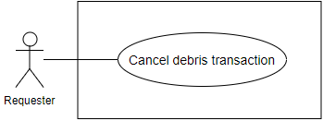

Figure 65: <Requester>Cancel debris transaction

**Use Case Specification**

|  |  |  |  |
| --- | --- | --- | --- |
| **USE CASE – EMP_UC_61** | | | |
| **Use Case No.** | **EMP_UC_61** | **Use Case Version** | 1.0 |
| **Use Case Name** | Cancel debris transaction | | |
| **Author** | Tran Cong Minh | | |
| **Date** | 28/1/2018 | **Priority** | Normal |
| **Actor:**   * Requester   **Summary:**   * This use case allows requester to cancel debris transaction   **Goal:**   * Requester cancel debris transaction   **Triggers:**   * Requester send command to cancel debris transaction   **Preconditions:**   * User must login to the system   **Post conditions:**   * Success: The debris transaction is canceled * Fail: Show error message   **Main Success Scenario:**   |  |  |  | | --- | --- | --- | | **Step** | **Actor Action** | **System Response** | | 1 | User send the command to cancel debris transaction | System ask user to provide the following information:   * Cancel reason: text, required | | 2 | User provide the required information and send command to continue the action | System ask user to confirm the action | | 2 | User choose to confirm the action  [Alternative 1] | System show message that the equipment is delivering  [Exception 1] |   **Alternative Scenario:**   |  |  |  | | --- | --- | --- | | **No** | **Actor Action** | **System Response** | | 1 | User choose not to confirm the action | System hides the message and does nothing |   **Exceptions:**   |  |  |  | | --- | --- | --- | | **No** | **Cause** | **System Response** | | 1 | No internet connection | System shows message the "Please check your connection" when the internet is lost. |   **Relationships:** N/A  **Business Rules:**   * If requester cancel the transaction successfully:   + Debris transaction status changes to “Canceled”   + The related debris post status changes to “Pending”   + The related debris bid status changes to “Pending”   + Supplier get notified about the canceling * Requester must provide cancel reason. * Once canceled, the transaction cannot be uncanceled. | | | |

Table 69 Requester>Cancel debris transaction

##### <Requester> Confirm debris transaction finished

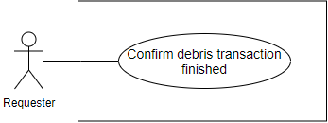

Figure 66: <Requester>Confirm debris transaction finished

**Use Case Specification**

|  |  |  |  |
| --- | --- | --- | --- |
| **USE CASE – EMP_UC_62** | | | |
| **Use Case No.** | **EMP_UC_62** | **Use Case Version** | 1.0 |
| **Use Case Name** | Confirm debris transaction finished | | |
| **Author** | Tran Cong Minh | | |
| **Date** | 28/1/2018 | **Priority** | Normal |
| **Actor:**   * Requester   **Summary:**   * This use case allows requester to confirm the debris transaction finished   **Goal:**   * Requester to confirm the debris transaction finished   **Triggers:**   * Requester send command to confirm the debris transaction finished   **Preconditions:**   * User must login to the system * The debris transaction status is “Working”   **Post conditions:**   * Success: The debris transaction status changes to “Finished” * Fail: Show error message   **Main Success Scenario:**   |  |  |  | | --- | --- | --- | | **Step** | **Actor Action** | **System Response** | | 1 | User send the command to confirm debris transaction finished | System ask user to confirm the action | | 2 | User choose to confirm the approve action  [Alternative 1] | System show message that the equipment is delivering  [Exception 1] |   **Alternative Scenario:**   |  |  |  | | --- | --- | --- | | **No** | **Actor Action** | **System Response** | | 1 | User choose not to confirm the action | System hides the message and does nothing |   **Exceptions:**   |  |  |  | | --- | --- | --- | | **No** | **Cause** | **System Response** | | 1 | No internet connection | System shows message the "Please check your connection" when the internet is lost. |   **Relationships:** N/A  **Business Rules:**   * By this action, requester confirEMP that the supplier has done required service and finishes the transaction * The transaction status changes from “Working” to “Finished” * The debris bid status changes from “Accepted” to “Finished” * The debris post status changes from ‘Accepted” to “Finished” * Supplier is notified about the change | | | |

Table 70 <Requester>Confirm debris transaction finished

##### <Requester> Feedback debris transaction

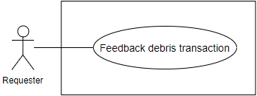

Figure 67: <Requester>Feedback debris transaction

**Use Case Specification**

|  |  |  |  |
| --- | --- | --- | --- |
| **USE CASE – EMP_UC_63** | | | |
| **Use Case No.** | **EMP_UC_63** | **Use Case Version** | 1.1 |
| **Use Case Name** | Feedback debris transaction | | |
| **Author** | Tran Cong Minh | | |
| **Date** | 28/3/2018 | **Priority** | High |
| **Actor:**   * Requester   **Summary:**   * This use case allow requester to send feedback about a finished debris transaction   **Goal:**   * Requester feedback debris transaction   **Triggers:**   * Requester send the command to feedback debris transaction   **Preconditions:**   * User must login to the system * Transaction status is “Finished”   **Post conditions:**   * Success: A debris feedback is sent * Fail: Show error message   **Main Success Scenario:**   |  |  |  | | --- | --- | --- | | **Step** | **Actor Action** | **System Response** | | 1 | User send command to feedback the transaction | System require the following information from user:   * Rating: double, required * Content: text, required, >30 characters | | 2 | User provide the correct information |  | | 3 | User send the command to send feedback | System validates information  If validated, system ask user for confirmation [Exception 1, 2] | | 4 | User send command to confirm the request  [Alternative 1] | System shows message that the action is complete |   **Alternative Scenario:**   |  |  |  | | --- | --- | --- | | **No** | **Actor Action** | **System Response** | | 1 | User send command to unconfirm the request | System back to the making request view |   **Exceptions:**   |  |  |  | | --- | --- | --- | | **No** | **Cause** | **System Response** | | 1 | No internet connection | System shows message the "Please check your connection" when the internet is lost. | | 2 | User send command to send feedback | System shows error message show that input information is not validated |   **Relationships:** N/A  **Business Rules:**   * A debris transaction can only have one feedback * User can only feedback on the transaction that he involved as a requester * A feedback cannot be adjusted or deleted * Supplier is notified about the feedback | | | |

Table 71 <Requester>Feedback debris transaction

#### <Scheduler> Overview Use Case

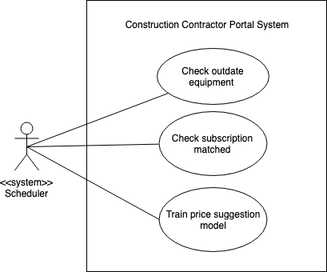

Figure 68: <Scheduler>Overview use case

##### <Scheduler> Check outdate equipment

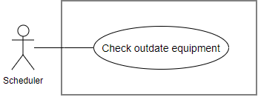

Figure 69: <Scheduler>Check outdate equipment

**Use Case Specification**

|  |  |  |  |
| --- | --- | --- | --- |
| **USE CASE – EMP_UC_64** | | | |
| **Use Case No.** | **EMP_UC_64** | **Use Case Version** | 1.0 |
| **Use Case Name** | Check outdate equipment | | |
| **Author** | Luu Quang Nghia | | |
| **Date** | 28/3/2018 | **Priority** | Normal |
| **Actor:**   * Scheduler   **Summary:**   * Scheduler check outdate renting equipment and end the renting process   **Goal:**   * Check outdate equipment and end the renting process   **Triggers:**   * At 5:00 am every day   **Preconditions:**   * The system is running   **Post conditions:**   * Success: Outdate equipment found and change status to “Waiting for returning” * Fail: No outdate equipment found.   **Main Success Scenario:**   |  |  |  | | --- | --- | --- | | **Step** | **Actor Action** | **System Response** | | 1 | Scheduler send command to check each outdate equipment | System check the equipment based on the following conditions:   * Equipment status is “Renting” * Related hiring transaction status is “Processing” * Related hiring transaction end date is before the current date | | 2 |  | If the equipment satisfies all the required conditions, change equipment status to “Waiting for returning” |   **Alternative Scenario:** N/A  **Exceptions:** N/A  **Relationships:** N/A  **Business Rules:**   * Supplier and requester are notified about the status change | | | |

Table 72 <Scheduler>Check outdate equipment

##### <Scheduler> Check subscription matched

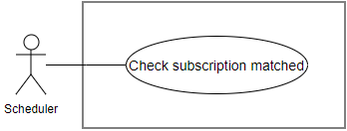

Figure 70: <Scheduler>Check subscription matched

**Use Case Specification**

|  |  |  |  |
| --- | --- | --- | --- |
| **USE CASE – EMP_UC_65** | | | |
| **Use Case No.** | **EMP_UC_65** | **Use Case Version** | 1.0 |
| **Use Case Name** | Check subscription matched | | |
| **Author** | Luu Quang Nghia | | |
| **Date** | 18/1/2018 | **Priority** | Normal |
| **Actor:**   * Scheduler   **Summary:**   * Scheduler check if any equipment matched subscribed conditions   **Goal:**   * Check if any equipment matched subscribed conditions   **Triggers:**   * After every fixed time   **Preconditions:**   * There is at least 1 subscription in the system   **Post conditions:**   * Success: Found matched equipment * Fail: No matched equipment found.   **Main Success Scenario:**   |  |  |  | | --- | --- | --- | | **Step** | **Actor Action** | **System Response** | | 1 | Scheduler send command to check to an equipment when:   * New equipment is posted * Equipment is edited * Transaction time range is updated | System check the equipment based on the required conditions on:   * Available time range * Equipment type * Max price * Max distance | | 2 |  | If the equipment satisfies all the required conditions, notify the contact about the equipment  [Alternative 1]  [Exception 1] |   **Alternative Scenario:**   |  |  |  | | --- | --- | --- | | **No** | **Actor Action** | **System Response** | | 1 |  | If the equipment does not satisfy the required conditions, no notification is sent |   **Exceptions:**   |  |  |  | | --- | --- | --- | | **No** | **Cause** | **System Response** | | 1 | Account of user is not activated | System cancel the notifying command and unsubscribe the contact |   **Relationships:** N/A  **Business Rules:**   * Subscription can be understood as a requirement for the system to find matched equipment in the future * If the contact account is not activated, no notification sent * Notification content must include found equipment information | | | |

Table 73 <Scheduler>Check subscription matched

##### <Scheduler> Train price suggestion model

|  |  |  |  |
| --- | --- | --- | --- |
| **USE CASE – EMP_UC_109** | | | |
| **Use Case No.** | **EMP_UC_109** | **Use Case Version** | 1.0 |
| **Use Case Name** | Train price suggestion model | | |
| **Author** | Luu Quang Nghia | | |
| **Date** | 18/1/2018 | **Priority** | Normal |
| **Actor:**   * Scheduler   **Summary:**   * Scheduler collect data and train machine learning model for price suggestion   **Goal:**   * Scheduler train price suggestion model   **Triggers:**   * After every fixed time   **Preconditions:**   * There are fresh data available to train   **Post conditions:**   * Success: New price suggestion weight is generated * Fail: Log error message in the system   **Main Success Scenario:**   |  |  |  | | --- | --- | --- | | Step | Actor Action | System Response | | 1 | Scheduler send command to start model training process | Display in log file: “Model training process started” | | 2 | Scheduler retrieve necessary data batch from database for each equipment type | Display in log file “Data collected”  [Alternative 1]  [Exception 1] | | 3 | Scheduler use collected data to train suggestion model | Display in log file “Data trained successfully” | | 4 | Scheduler save newly trained model to database | Price suggestion model is inserted to database  Information about training process is logged directly to database, including:   * Training time * Validation rate of the model * Each specific weight value of the model * Equipment type related to each weight * Equipment additional specs field related to the model * The time duration in which the data belonged to |   **Alternative Scenario:**   |  |  |  | | --- | --- | --- | | No | Actor Action | System Response | | 1 | Scheduler retrieve data which is not available at the time | Display in log file “The equipment type id = {id} is not calculable” with {id} is the equipment type’s id  Skip to the next equipment type |   **Exceptions:**   |  |  |  | | --- | --- | --- | | No | Cause | System Response | | 1 | Data format is not correct | Display error and stack trace in log file  Skip to the next equipment type | | 2 | Unknown exception throwed | Display error and stack trace in log file  Skip to the next equipment type |   **Relationships**: **EMP_UC_28**  **Business** **Rules**:   * Training data is collected directly from the system * The training data is extracted from equipment data in the system, for specific:   + Equipment price   + Equipment additional specs value with Integer or Double datatype   + Equipment additional specs field related to the value   + Equipment type * The time duration in which the data is collected is 6 months from the current date * The trained model result can be used for later price suggestion calculating * The extracted data is not validated if: * There are no addition specs fields of the equipment type have the numeric datatype (Integer or Double) * The data value does not match the defined data type, for example, Integer datatype with value of “abc” | | | |

Table 74 <Scheduler> Train price suggestion model

#### <Staff> Overview Use Case

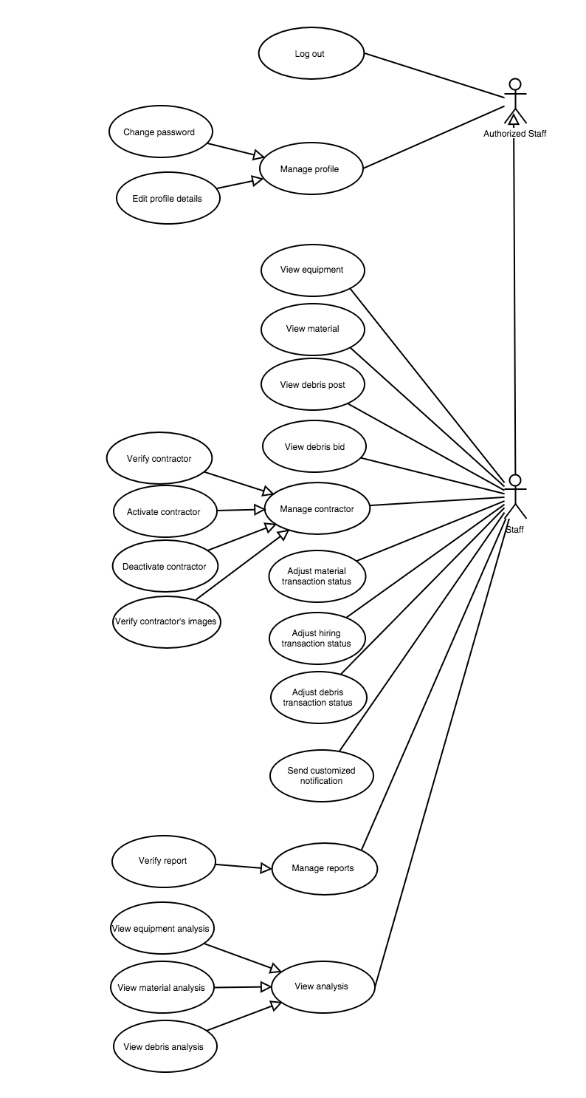

Figure 71: <Staff>Overview use case

##### <Staff> Verify Registered User

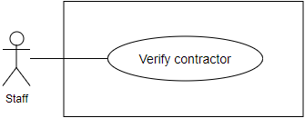

Figure 72: <Staff>Verify Registered User

**Use Case Specification**

|  |  |  |  |
| --- | --- | --- | --- |
| USE CASE – EMP_UC_66 | | | |
| Use Case No. | EMP_UC_66 | Use Case Version | 1.1 |
| Use Case Name | Verify Registered User | | |
| Author | Truong To Kiet | | |
| Date | 18/1/2018 | Priority | Normal |
| Actor:   * Staff   Summary:   * This use case allows staff to verify Registered User.   Goal:   * Staff change Registered User status from “Not verified” to “Activated”.   Triggers:   * Staff send verify Registered User command to the system.   Preconditions:   * User must login to the system with role Staff   Post conditions:   * **Success**: A Registered User status successful update in database. * **Fail**: A Registered User status cannot be updated.   Main Success Scenario:   |  |  |  | | --- | --- | --- | | Step | Actor Action | System Response | | 1 | Staff goes to Registered User’s detail screen. | Registered User’s detail screen is shown with following labels and fields:  Registered User verification information  Verify Registered User button | | 2 | Staff send update Registered User status command. | Update Registered User status in the system.  [Exception 1]  System shows message verify Registered User has been updated successfully. |   Alternative Scenario:   |  |  |  | | --- | --- | --- | | No | Actor Action | System Response |   Exceptions:   |  |  |  | | --- | --- | --- | | No | Cause | System Response | | 1 | Update Registered User status fail. | Show message to notify staff that update Registered User failed. |   Relationships: N/A  Business Rules:   * Registered User must send verification information before staff checks verify. * Verification information includes: pictures of Registered User’s Identity Card. * Staff can only verify Registered User on Registered User’s detail screen. * Registered User who is not verified cannot: post equipment, material, debris post, debris bid and send hiring equipment request, buying material. | | | |

Table 75 <Staff>Verify Registered User

##### <Staff> Activate Registered User

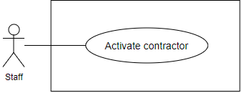

Figure 73: <Staff>Activate Registered User

**Use Case Specification**

|  |  |  |  |
| --- | --- | --- | --- |
| **USE CASE – EMP_UC_67** | | | |
| **Use Case No.** | **EMP_UC_67** | **Use Case Version** | 1.1 |
| **Use Case Name** | Activate Registered User | | |
| **Author** | Truong To Kiet | | |
| **Date** | 18/1/2018 | **Priority** | Normal |
| **Actor:**   * Staff   **Summary:**   * This use case allows staff to verify Registered User.   **Goal:**   * Staff change Registered User status from “Deactivated” to “Activated”.   **Triggers:**   * Staff send activate Registered User command to the system.   **Preconditions:**   * User must login to the system with role Staff   **Post conditions:**   * Success: A Registered User status successful update in database. * Fail: A Registered User status cannot be updated.   **Main Success Scenario:**   |  |  |  | | --- | --- | --- | | **Step** | **Actor Action** | **System Response** | | 1 | Staff goes to Registered User’s detail screen. | Registered User’s detail screen is shown with following labels and fields:   * Activate Registered User button | | 2 | Staff send update Registered User status command. | Update Registered User status in the system.  [Exception 1]  System shows message activate Registered User has been updated successfully. |   **Alternative Scenario:**   |  |  |  | | --- | --- | --- | | **No** | **Actor Action** | **System Response** |   **Exceptions:**   |  |  |  | | --- | --- | --- | | **No** | **Cause** | **System Response** | | 1 | Update Registered User status fail. | Show message to notify staff that update Registered User status failed. |   **Relationships:** N/A  **Business Rules:**   * Registered User who has reports received equal 3 will be deactivated 6 months. * Registered User who is deactivated cannot request new transaction and post equipment, material, debris post. | | | |

Table 76 <Staff>Verify Registered User

##### <Staff> Deactivate Registered User

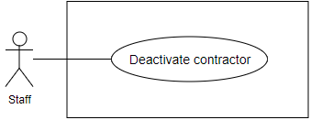

Figure 74: <Staff>Deactivate Registered User

**Use Case Specification**

|  |  |  |  |
| --- | --- | --- | --- |
| **USE CASE – EMP_UC_68** | | | |
| **Use Case No.** | **EMP_UC_68** | **Use Case Version** | 1.1 |
| **Use Case Name** | Deactivate Registered User | | |
| **Author** | Truong To Kiet | | |
| **Date** | 18/1/2018 | **Priority** | Normal |
| **Actor:**   * Staff   **Summary:**   * This use case allows staff to verify Registered User.   **Goal:**   * Staff change Registered User status from “Activated” to “Deactivated”.   **Triggers:**   * Staff send deactivate Registered User command to the system.   **Preconditions:**   * User must login to the system with role Staff   **Post conditions:**   * Success: A Registered User status successful update in database. * Fail: A Registered User status cannot be updated.   **Main Success Scenario:**   |  |  |  | | --- | --- | --- | | **Step** | **Actor Action** | **System Response** | | 1 | Staff goes to Registered User’s detail screen. | Registered User’s detail screen is shown with following labels and fields:   * Deactivate Registered User button | | 2 | Staff send update Registered User status command. | Update Registered User status in the system.  [Exception 1]  System shows message deactivate Registered User has been updated successfully. |   **Alternative Scenario:**   |  |  |  | | --- | --- | --- | | **No** | **Actor Action** | **System Response** |   **Exceptions:**   |  |  |  | | --- | --- | --- | | **No** | **Cause** | **System Response** | | 1 | Update Registered User status fail. | Show message to notify staff that update Registered User status failed. |   **Relationships:** N/A  **Business Rules:**   * Registered User who has reports received equal 3 will be deactivated 6 months. * Registered User who is deactivated cannot request new transaction and post equipment, material, debris post. | | | |

Table 77 <Staff>Verify Registered User

##### <Staff> Verify report

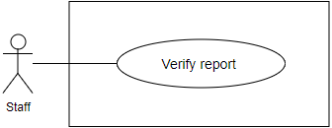

Figure 75: <Staff>Verify report

**Use Case Specification**

|  |  |  |  |
| --- | --- | --- | --- |
| **USE CASE – EMP_UC_69** | | | |
| **Use Case No.** | **EMP_UC_69** | **Use Case Version** | 1.1 |
| **Use Case Name** | Verify report | | |
| **Author** | Truong To Kiet | | |
| **Date** | 18/1/2018 | **Priority** | Normal |
| **Actor:**   * Staff   **Summary:**   * This use case allows staff to verify report.   **Goal:**   * Staff changes report status from “Pending” to “Verified” or “Not verified”.   **Triggers:**   * Staff send activate Registered User command to the system.   **Preconditions:**   * User must login to the system with role Staff   **Post conditions:**   * Success: A Registered User status successful update in database. * Fail: A Registered User status cannot be updated.   **Main Success Scenario:**   |  |  |  | | --- | --- | --- | | **Step** | **Actor Action** | **System Response** | | 1 | Staff goes to report’s detail screen. | Report’s detail screen is shown with following labels and fields:   * List report’s status: dropdown list | | 2 | Staff send update report status command. | Update report status in the system.  [Exception 1]  System shows message verify report has been updated successfully. |   **Alternative Scenario:**   |  |  |  | | --- | --- | --- | | **No** | **Actor Action** | **System Response** |   **Exceptions:**   |  |  |  | | --- | --- | --- | | **No** | **Cause** | **System Response** | | 1 | Update report status fail. | Show message to notify staff that update report status failed. |   **Relationships:** N/A  **Business Rules:**   * Staff verifies report which is created by a Registered User who has reported another Registered User. * A Registered User has been reported with reasonable reason in 3 times will be sent warning notification. * A Registered User has been reported with reasonable reason in 6 times will be deactivated. * Registered User is deactivated cannot post or request equipment, material, debris. | | | |

Table 78 <Staff>Verify report

##### <Staff> Edit material

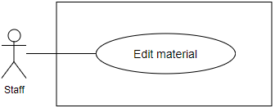

Figure 76: <Staff>Edit material

**Use Case Specification**

|  |  |  |  |
| --- | --- | --- | --- |
| **USE CASE – EMP_UC_70** | | | |
| **Use Case No.** | **EMP_UC_70** | **Use Case Version** | 1.1 |
| **Use Case Name** | Edit material | | |
| **Author** | Truong To Kiet | | |
| **Date** | 18/1/2018 | **Priority** | Normal |
| **Actor:**   * Staff   **Summary:**   * This use case allows staff to edit material.   **Goal:**   * Staff successfully edit material.   **Triggers:**   * Staff send edit material command to the system.   **Preconditions:**   * User must login to the system with role Staff   **Post conditions:**   * Success: A material successfully update in database. * Fail: A material cannot be updated.   **Main Success Scenario:**   |  |  |  | | --- | --- | --- | | **Step** | **Actor Action** | **System Response** | | 1 | Staff goes to material’s detail screen. | Material’s detail screen is shown with following labels and fields:   * Material Name: text, required. * Price: number, required. * Manufacturer: text, required. | | 2 | Staff inputs information. |  | | 3 | Staff send edit material command. | Edit material in the system.  [Exception 1]  System shows message material has been updated successfully. |   **Alternative Scenario:**   |  |  |  | | --- | --- | --- | | **No** | **Actor Action** | **System Response** |   **Exceptions:**   |  |  |  | | --- | --- | --- | | **No** | **Cause** | **System Response** | | 1 | Edit material fail. | Show message to notify staff that edit material failed. |   **Relationships:** N/A  **Business Rules:**   * Registered User calls hotline to require to edit material’s detail. * Staff must check requested Registered User’s information. * Only if Registered User has requested that staff can edit material’s detail | | | |

Table 79 <Staff>Edit material

##### <Staff> Edit equipment

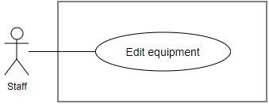

Figure 77: <Staff>Edit equipment

**Use Case Specification**

|  |  |  |  |
| --- | --- | --- | --- |
| **USE CASE – EMP_UC_71** | | | |
| **Use Case No.** | **EMP_UC_71** | **Use Case Version** | 1.1 |
| **Use Case Name** | Edit equipment | | |
| **Author** | Truong To Kiet | | |
| **Date** | 18/1/2018 | **Priority** | Normal |
| **Actor:**   * Staff   **Summary:**   * This use case allows staff to edit equipment.   **Goal:**   * Staff successfully edit equipment.   **Triggers:**   * Staff send edit equipment command to the system.   **Preconditions:**   * User must login to the system with role Staff   **Post conditions:**   * Success: A equipment successfully update in database. * Fail: A equipment cannot be updated.   **Main Success Scenario:**   |  |  |  | | --- | --- | --- | | **Step** | **Actor Action** | **System Response** | | 1 | Staff goes to equipment’s detail screen. | Equipment’s detail screen is shown with following labels and fields:   * Equipment Name: text, required. * Price: number, required. * Equipment Address: text, required. | | 2 | Staff inputs information. |  | | 3 | Staff send edit equipment command. | Edit equipment in the system.  [Exception 1]  System shows message equipment has been updated successfully. |   **Alternative Scenario:**   |  |  |  | | --- | --- | --- | | **No** | **Actor Action** | **System Response** |   **Exceptions:**   |  |  |  | | --- | --- | --- | | **No** | **Cause** | **System Response** | | 1 | Edit equipment fail. | Show message to notify staff that edit equipment failed. |   **Relationships:** N/A  **Business Rules:**   * Registered User calls hotline to require to edit equipment’s detail. * Staff must check requested Registered User’s information. * Only if Registered User has requested that staff can edit equipment’s detail | | | |

Table 80 <Staff>Edit equipment

##### <Staff> Change password

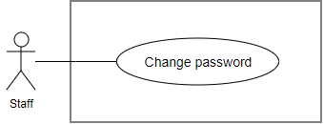

Figure 78: <Staff>Change password

**Use Case Specification**

|  |  |  |  |
| --- | --- | --- | --- |
| **USE CASE – EMP_UC_72** | | | |
| **Use Case No.** | **EMP_UC_72** | **Use Case Version** | 1.1 |
| **Use Case Name** | Change password | | |
| **Author** | Truong To Kiet | | |
| **Date** | 18/1/2018 | **Priority** | Normal |
| **Actor:**   * Staff   **Summary:**   * This use case allows staff to change password.   **Goal:**   * Staff successfully change password.   **Triggers:**   * Staff send change password command to the system.   **Preconditions:**   * User must login to the system with role Staff   **Post conditions:**   * Success: A staff’s password successful update in database. * Fail: A staff’s password cannot be updated.   **Main Success Scenario:**   |  |  |  | | --- | --- | --- | | **Step** | **Actor Action** | **System Response** | | 1 | Staff goes to change password screen. | Change password screen is shown with following labels and fields:   * Old password: text input, required. * New password: text input, required, length 3-30. * Confirm new password: text input, required, length 3-30. | | 2 | Staff inputs information.  [Exception 1] [Exception 2] |  | | 2 | Staff send update password command. | Update password in the system.  [Exception 3]  System shows message password has been updated successfully. |   **Alternative Scenario:**   |  |  |  | | --- | --- | --- | | **No** | **Actor Action** | **System Response** |   **Exceptions:**   |  |  |  | | --- | --- | --- | | **No** | **Cause** | **System Response** | | 1 | Staff inputs wrong old password. | Show message to notify staff that input wrong old password | | 2 | Staff inputs not match new password and confirm new password. | Show message to notify staff that new password is not matched. | | 3 | Update report status fail. | Show message to notify staff that update report status failed. |   **Relationships:** N/A  **Business Rules:**   * Old password is encrypted before being sent to server. * Staff’s encoded old password must be matched with password stored in database. * New password and confirm new password must be matched. * New password must be hashed before store in database. | | | |

Table 81 <Staff>Change password

##### <Staff> Adjust hiring transaction

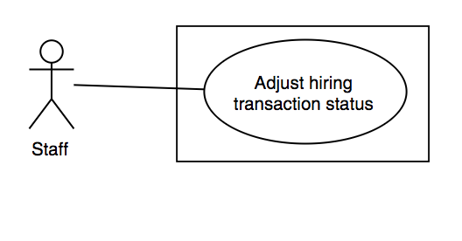

Figure 79: <Staff>Adjust hiring transaction

**Use Case Specification**

|  |  |  |  |
| --- | --- | --- | --- |
| **USE CASE – EMP_UC_73** | | | |
| **Use Case No.** | **EMP_UC_73** | **Use Case Version** | 1.1 |
| **Use Case Name** | Adjust hiring transaction | | |
| **Author** | Truong To Kiet | | |
| **Date** | 18/1/2018 | **Priority** | Normal |
| **Actor:**   * Staff   **Summary:**   * This use case allows staff to edit hiring transaction.   **Goal:**   * Staff successfully edit hiring transaction.   **Triggers:**   * Staff send edit hiring transaction command to the system.   **Preconditions:**   * User must login to the system with role Staff   **Post conditions:**   * Success: A hiring transaction successfully update in database. * Fail: A hiring transaction cannot be updated.   **Main Success Scenario:**   |  |  |  | | --- | --- | --- | | **Step** | **Actor Action** | **System Response** | | 1 | Staff goes to hiring transaction’s detail screen. | Hiring transaction’s detail screen is shown with following labels and fields:   * Hiring transaction status: dropdown list. * Equipment status: dropdown list. | | 2 | Staff inputs information. |  | | 3 | Staff send edit hiring transaction command. | Edit hiring transaction in the system.  [Exception 1]  System shows message hiring transaction has been updated successfully. |   **Alternative Scenario:**   |  |  |  | | --- | --- | --- | | **No** | **Actor Action** | **System Response** |   **Exceptions:**   |  |  |  | | --- | --- | --- | | **No** | **Cause** | **System Response** | | 1 | Edit hiring transaction fail. | Show message to notify staff that edit hiring transaction failed. |   **Relationships:** N/A  **Business Rules:**   * Both supplier and requester must require to edit hiring transaction’s detail. * Staff must check requested Registered User’s information. * Only if Registered User has requested that staff can edit hiring transaction’s detail. * Hiring transaction’s status and equipment's status must be matched. * Staff must send edited material transaction’s notification to supplier and Registered User. | | | |

Table 82 <Staff>Adjust hiring transaction

##### <Staff> Adjust material transaction

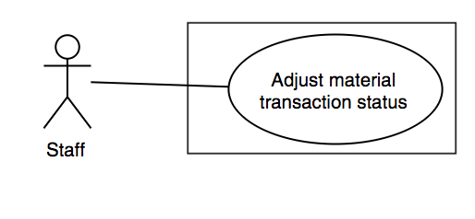

Figure 80: <Staff>Adjust material transaction

**Use Case Specification**

|  |  |  |  |
| --- | --- | --- | --- |
| **USE CASE – EMP_UC_74** | | | |
| **Use Case No.** | **EMP_UC_74** | **Use Case Version** | 1.1 |
| **Use Case Name** | Adjust material transaction | | |
| **Author** | Truong To Kiet | | |
| **Date** | 18/1/2018 | **Priority** | Normal |
| **Actor:**   * Staff   **Summary:**   * This use case allows staff to edit material transaction.   **Goal:**   * Staff successfully edit material transaction.   **Triggers:**   * Staff send edit material transaction command to the system.   **Preconditions:**   * User must login to the system with role Staff   **Post conditions:**   * Success: A material transaction successfully update in database. * Fail: A material transaction cannot be updated.   **Main Success Scenario:**   |  |  |  | | --- | --- | --- | | **Step** | **Actor Action** | **System Response** | | 1 | Staff goes to material transaction’s detail screen. | Material transaction’s detail screen is shown with following labels and fields:   * Material transaction status: dropdown list. | | 2 | Staff inputs information. |  | | 3 | Staff send edit material transaction command. | Edit material transaction in the system.  [Exception 1]  System shows message material transaction has been updated successfully. |   **Exceptions:**   |  |  |  | | --- | --- | --- | | **No** | **Cause** | **System Response** | | 1 | Edit material transaction fail. | Show message to notify staff that edit material transaction failed. |   **Relationships:** N/A  **Business Rules:**   * Both supplier and requester must require to edit material transaction’s detail. * Staff must check requested Registered User’s information. * Only if Registered User has requested that staff can edit material transaction’s detail. * Staff must send edited material transaction’s notification to supplier and Registered User. | | | |

Table 83 <Staff>Adjust material transaction

##### <Staff> Adjust debris transaction

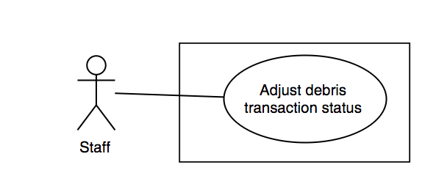

Figure 81: <Staff>Adjust debris transaction

**Use Case Specification**

|  |  |  |  |
| --- | --- | --- | --- |
| **USE CASE – EMP_UC_75** | | | |
| **Use Case No.** | **EMP_UC_75** | **Use Case Version** | 1.1 |
| **Use Case Name** | Adjust debris transaction | | |
| **Author** | Truong To Kiet | | |
| **Date** | 18/1/2018 | **Priority** | Normal |
| **Actor:**   * Staff   **Summary:**   * This use case allows staff to edit debris transaction.   **Goal:**   * Staff successfully edit debris transaction.   **Triggers:**   * Staff send edit debris transaction command to the system.   **Preconditions:**   * User must login to the system with role Staff   **Post conditions:**   * Success: A debris transaction successfully update in database. * Fail: A debris transaction cannot be updated.   **Main Success Scenario:**   |  |  |  | | --- | --- | --- | | **Step** | **Actor Action** | **System Response** | | 1 | Staff goes to debris transaction’s detail screen. | Debris transaction’s detail screen is shown with following labels and fields:   * Debris transaction status: dropdown list. * Debris post status: dropdown list. * Debris bid status: dropdown list. | | 2 | Staff inputs information. |  | | 3 | Staff send edit debris transaction command. | Edit debris transaction in the system.  [Exception 1]  System shows message debris transaction has been updated successfully. |   **Exceptions:**   |  |  |  | | --- | --- | --- | | **No** | **Cause** | **System Response** | | 1 | Edit debris transaction fail. | Show message to notify staff that edit debris transaction failed. |   **Relationships:** N/A  **Business Rules:**   * Both supplier and requester must require to edit debris transaction’s detail. * Staff must check requested Registered User’s information. * Only if Registered User has requested that staff can edit debris transaction’s detail. * Debris transaction’s status, debris post's status and debris bid's status must be matched. * Staff must send edited debris transaction’s notification to supplier and Registered User. | | | |

Table 84 <Staff>Adjust debris transaction

##### <Staff> Send custom notification

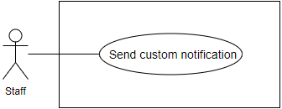

Figure 82: <Staff>Send custom notification

**Use Case Specification**

|  |  |  |  |
| --- | --- | --- | --- |
| **USE CASE – EMP_UC_76** | | | |
| **Use Case No.** | **EMP_UC_76** | **Use Case Version** | 1.1 |
| **Use Case Name** | Send custom notification | | |
| **Author** | Truong To Kiet | | |
| **Date** | 18/1/2018 | **Priority** | Normal |
| **Actor:**   * Staff   **Summary:**   * This use case allows staff to send custom notification to Registered User.   **Goal:**   * Staff successfully send custom notification to Registered User.   **Triggers:**   * Staff send custom notification command to the system.   **Preconditions:**   * User must login to the system with role Staff. * Staff must go to Registered User’s detail screen.   **Post conditions:**   * Success: A new notification successfully added in database and send to Registered User. * Fail: A new notification cannot be saved.   **Main Success Scenario:**   |  |  |  | | --- | --- | --- | | **Step** | **Actor Action** | **System Response** | | 1 | Staff goes to create notification screen. | Create notification screen is shown with following labels and fields:   * Title: text, required. * Content: text, required. * Registered User: link. | | 2 | Staff inputs information. |  | | 3 | Staff send create notification command. | Add notification in the system.  [Exception 1]  System shows message notification has been added successfully.  Send notification to Registered User by Firebase Cloud Messaging  [Exception 2]  System shows message notification has been sent to Registered User successfully. |   **Exceptions:**   |  |  |  | | --- | --- | --- | | **No** | **Cause** | **System Response** | | 1 | Create notification fail. | Show message to notify staff that create notification failed. | | 2 | Send notification fail. | Show message to notify staff that send notification failed. |   **Relationships:** N/A  **Business Rules:**   * Staff must send notification to all Registered User’s device. | | | |

Table 85 <Staff>Send custom notification

##### <Staff> View equipment analytics

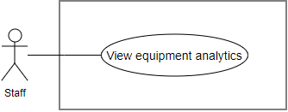

Figure 83: <Staff>View equipment analytics

**Use Case Specification**

|  |  |  |  |
| --- | --- | --- | --- |
| **USE CASE – EMP_UC_77** | | | |
| **Use Case No.** | **EMP_UC_77** | **Use Case Version** | 1.1 |
| **Use Case Name** | View equipment analytics | | |
| **Author** | Truong To Kiet | | |
| **Date** | 18/1/2018 | **Priority** | Normal |
| **Actor:**   * Staff   **Summary:**   * This use case allows staff to view equipment analytics.   **Goal:**   * Staff successfully view equipment analytics.   **Triggers:**   * Staff send get equipment analytics command to the system.   **Preconditions:**   * User must login to the system with role Staff.   **Post conditions:**   * Success: Equipment analytics successfully display. * Fail: Equipment analytics cannot be displayed.   **Main Success Scenario:**   |  |  |  | | --- | --- | --- | | **Step** | **Actor Action** | **System Response** | | 1 | Staff goes to dashboard screen. | Dashboard screen is shown with following labels and fields:   * Date Range: date range picker, required, default value (3 months previous) * Time Unit: dropdown list. | | 2 | Staff inputs information. |  | | 3 | Staff send get equipment analytics command. | Get equipment analytics in the system.  [Exception 1]  System successfully shows equipment analytics. |   **Exceptions:**   |  |  |  | | --- | --- | --- | | **No** | **Cause** | **System Response** | | 1 | Get equipment analytics fail. | Show message to notify staff that get equipment analytics failed. |   **Relationships:** N/A  **Business Rules:**   * Equipment analytics include: hiring transaction’s status, equipment type, equipment posted, total hiring transaction created and total hiring transaction’s price. * Equipment analytics must be filtered between begin date, end date and time unit (week, month, year) | | | |

Table 86 <Staff>View equipment analytics

##### <Staff> View material analytics

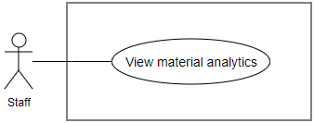

Figure 84: <Staff>View material analytics

**Use Case Specification**

|  |  |  |  |
| --- | --- | --- | --- |
| **USE CASE – EMP_UC_78** | | | |
| **Use Case No.** | **EMP_UC_78** | **Use Case Version** | 1.1 |
| **Use Case Name** | View material analytics | | |
| **Author** | Truong To Kiet | | |
| **Date** | 18/1/2018 | **Priority** | Normal |
| **Actor:**   * Staff   **Summary:**   * This use case allows staff to view material analytics.   **Goal:**   * Staff successfully view material analytics.   **Triggers:**   * Staff send get material analytics command to the system.   **Preconditions:**   * User must login to the system with role Staff.   **Post conditions:**   * Success: Material analytics successfully display. * Fail: Material analytics cannot be displayed.   **Main Success Scenario:**   |  |  |  | | --- | --- | --- | | **Step** | **Actor Action** | **System Response** | | 1 | Staff goes to dashboard screen. | Dashboard screen is shown with following labels and fields:   * Date Range: date range picker, required, default value (3 months previous) * Time Unit: dropdown list. | | 2 | Staff inputs information. |  | | 3 | Staff send get material analytics command. | Get material analytics in the system.  [Exception 1]  System successfully shows material analytics. |   **Exceptions:**   |  |  |  | | --- | --- | --- | | **No** | **Cause** | **System Response** | | 1 | Get material analytics fail. | Show message to notify staff that get material analytics failed. |   **Relationships:** N/A  **Business Rules:**   * Material analytics include: material transaction’s status, material type, material posted, total material transaction created and total material transaction’s price. * Material analytics must be filtered between begin date, end date and time unit (week, month, year) | | | |

Table 87 : <Staff>View material analytics

##### <Staff> View debris analytics

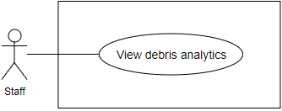

Figure 85: <Staff>View debris analytics

**Use Case Specification**

|  |  |  |  |
| --- | --- | --- | --- |
| **USE CASE – EMP_UC_79** | | | |
| **Use Case No.** | **EMP_UC_79** | **Use Case Version** | 1.1 |
| **Use Case Name** | View debris analytics | | |
| **Author** | Truong To Kiet | | |
| **Date** | 18/1/2018 | **Priority** | Normal |
| **Actor:**   * Staff   **Summary:**   * This use case allows staff to view debris analytics.   **Goal:**   * Staff successfully view debris analytics.   **Triggers:**   * Staff send get debris analytics command to the system.   **Preconditions:**   * User must login to the system with role Staff.   **Post conditions:**   * Success: Debris analytics successfully display. * Fail: Debris analytics cannot be displayed.   **Main Success Scenario:**   |  |  |  | | --- | --- | --- | | **Step** | **Actor Action** | **System Response** | | 1 | Staff goes to dashboard screen. | Dashboard screen is shown with following labels and fields:   * Date Range: date range picker, required, default value (3 months previous) * Time Unit: dropdown list. | | 2 | Staff inputs information. |  | | 3 | Staff send get debris analytics command. | Get debris analytics in the system.  [Exception 1]  System successfully shows debris analytics. |   **Exceptions:**   |  |  |  | | --- | --- | --- | | **No** | **Cause** | **System Response** | | 1 | Get debris analytics fail. | Show message to notify staff that get debris analytics failed. |   **Relationships:** N/A  **Business Rules:**   * Debris analytics include: debris transaction’s status, debris type, debris post posted, debris bid posted and total debris transaction created. * Debris analytics must be filtered between begin date, end date and time unit (week, month, year) | | | |

Table 88 <Staff>View debris analytics

#### <Admin> Overview Use Case

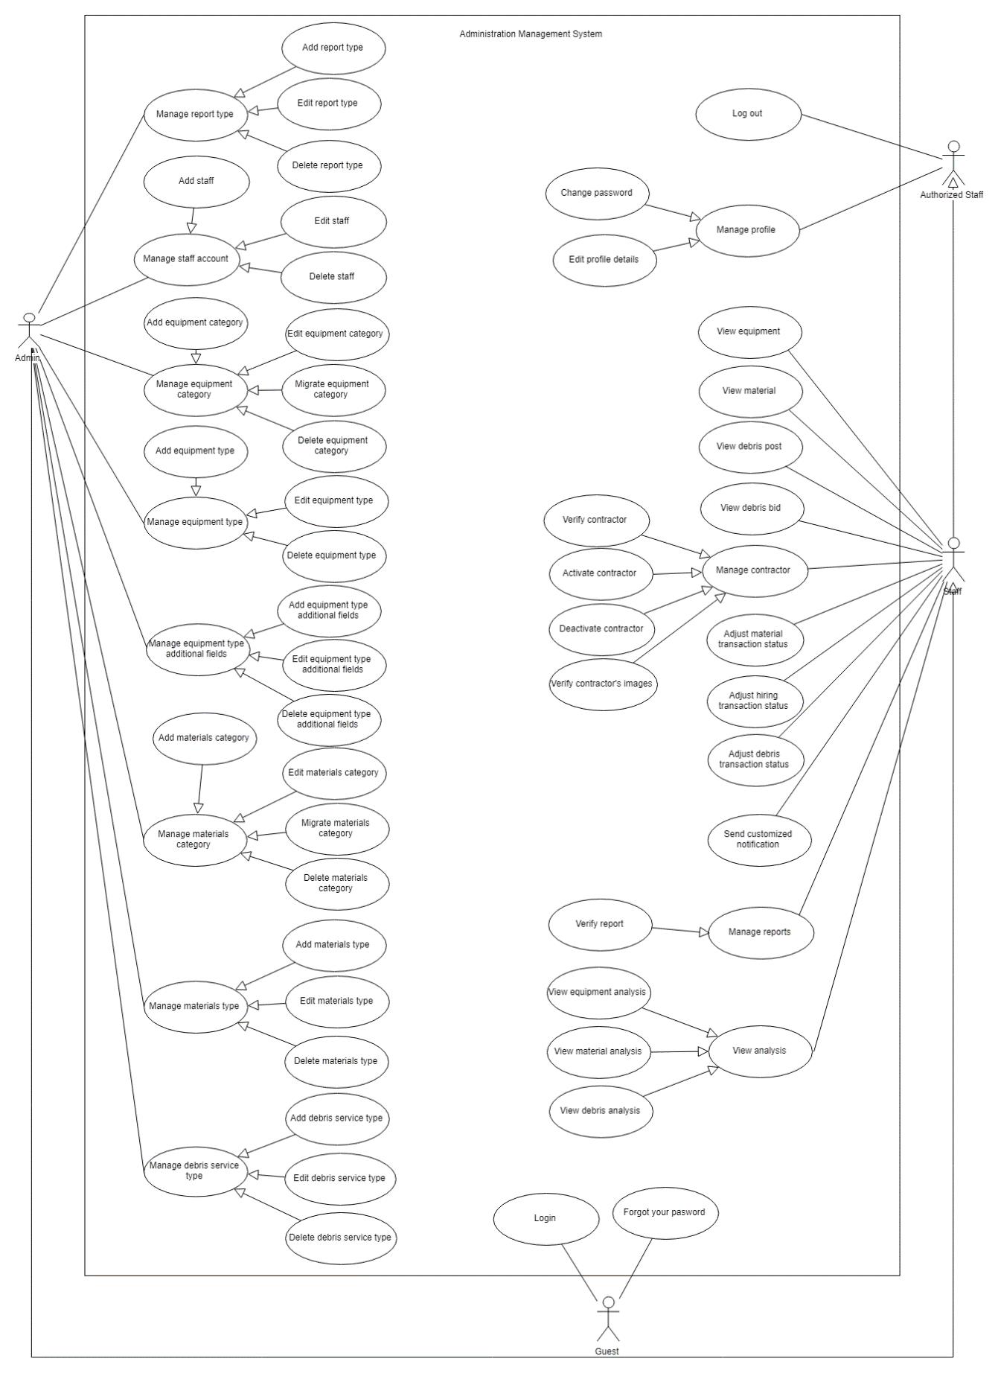

Figure 86: <Admin>Overview use case

##### <Admin> Add staff

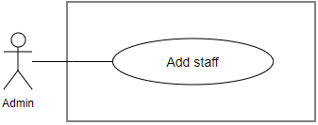

Figure 87: <Admin>Add staff

**Use Case Specification**

|  |  |  |  |
| --- | --- | --- | --- |
| **USE CASE – EMP_UC_80** | | | |
| **Use Case No.** | **EMP_UC_80** | **Use Case Version** | 1.1 |
| **Use Case Name** | Add staff | | |
| **Author** | Truong To Kiet | | |
| **Date** | 18/1/2018 | **Priority** | Normal |
| **Actor:**   * Admin   **Summary:**   * This use case allows admin to add new staff.   **Goal:**   * Admin successfully adds new staff.   **Triggers:**   * Admin send add new staff command to the system.   **Preconditions:**   * User must login into the system with role Admin.   **Post conditions:**   * Success: New staff successful store in database. * Fail: New staff cannot be saved.   **Main Success Scenario:**   |  |  |  | | --- | --- | --- | | **Step** | **Actor Action** | **System Response** | | 1 | Admin goes to add new staff screen. | Add new staff screen is shown with following labels and fields:   * Username staff: text, required, length 4-30. * Full name: text, required, length 4-30. * Thumbnail * Gender: dropdown list * Phone number: number, required, length 9-10. * Address: text, required. * Email: text, required. * Role: dropdown list | | 2 | Admin inputs information. |  | | 3 | Admin send add new staff command. | Add new staff in the system.  [Exception 1]  System shows message staff has been added successfully. |   **Exceptions:**   |  |  |  | | --- | --- | --- | | **No** | **Cause** | **System Response** | | 1 | Add new staff fail. | Show message to notify admin that add new staff failed. |   **Relationships:** N/A  **Business Rules:**   * In case of success scenarios, a new staff is added in the system. * Staff’s username and email are not duplicate. * A random password will be sent to staff by email. * Password must be hashed. | | | |

Table 89 <Admin>Add staff

##### <Admin> Delete staff

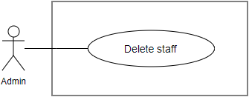

Figure 88: <Admin>Delete staff

**Use Case Specification**

|  |  |  |  |
| --- | --- | --- | --- |
| **USE CASE – EMP_UC_81** | | | |
| **Use Case No.** | **EMP_UC_81** | **Use Case Version** | 1.1 |
| **Use Case Name** | Delete staff | | |
| **Author** | Truong To Kiet | | |
| **Date** | 18/1/2018 | **Priority** | Normal |
| **Actor:**   * Admin   **Summary:**   * This use case allows admin to soft delete staff.   **Goal:**   * Admin successfully soft deletes new staff.   **Triggers:**   * Admin send soft delete staff command to the system.   **Preconditions:**   * User must login into the system with role Admin.   **Post conditions:**   * Success: Staff is soft deleted in database. * Fail: Staff cannot be removed.   **Main Success Scenario:**   |  |  |  | | --- | --- | --- | | **Step** | **Actor Action** | **System Response** | | 1 | Admin goes to staff’s detail screen. | Staff’s detail screen is shown with following labels and fields:   * Delete staff: button | | 2 | Admin send delete staff command. | System show popup to confirm the command. | | 3 | Admin confirm to delete staff.  [Alternative 1] | System start removing staff.  [Exception 1]  System show message remove successful |   **Alternative Scenario:**   |  |  |  | | --- | --- | --- | | **No** | **Actor Action** | **System Response** | | 1 | Admin cancel delete staff command. | Display staff’s detail view. |   **Exceptions:**   |  |  |  | | --- | --- | --- | | **No** | **Cause** | **System Response** | | 1 | Delete staff fail. | Show message to notify admin that delete staff failed. |   **Relationships:** N/A  **Business Rules:**   * Admin cannot delete his/her account. * Staff has been deleted cannot login. | | | |

Table 90 <Admin>Delete staff

##### <Admin> Add equipment category

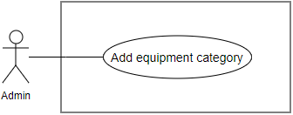

Figure 89: <Admin>Add equipment category

**Use Case Specification**

|  |  |  |  |
| --- | --- | --- | --- |
| **USE CASE – EMP_UC_82** | | | |
| **Use Case No.** | **EMP_UC_82** | **Use Case Version** | 1.1 |
| **Use Case Name** | Add equipment category | | |
| **Author** | Truong To Kiet | | |
| **Date** | 18/1/2018 | **Priority** | Normal |
| **Actor:**   * Admin   **Summary:**   * This use case allows admin to add new equipment category.   **Goal:**   * Admin successfully adds new equipment category.   **Triggers:**   * Admin send add new equipment category command to the system.   **Preconditions:**   * User must login into the system with role Admin.   **Post conditions:**   * Success: New equipment category successful store in database. * Fail: New equipment category cannot be saved.   **Main Success Scenario:**   |  |  |  | | --- | --- | --- | | **Step** | **Actor Action** | **System Response** | | 1 | Admin goes to add new equipment category screen. | Add new equipment category screen is shown with following labels and fields:   * Name: text, required, length 4-30. | | 2 | Admin inputs information. |  | | 3 | Admin send add new equipment category command. | Add new equipment category in the system.  [Exception 1]  System shows message equipment category has been added successfully. |   **Exceptions:**   |  |  |  | | --- | --- | --- | | **No** | **Cause** | **System Response** | | 1 | Add new equipment category fail. | Show message to notify admin that add new equipment category failed. |   **Relationships:** N/A  **Business Rules:**   * Equipment category’s name must be suitable in construction industry. * Equipment category’s name is not duplicate. | | | |

Table 91 <Admin>Add equipment category

##### <Admin> Edit equipment category

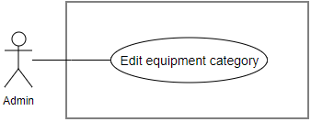

Figure 90: <Admin>Edit equipment category

**Use Case Specification**

|  |  |  |  |
| --- | --- | --- | --- |
| **USE CASE – EMP_UC_83** | | | |
| **Use Case No.** | **EMP_UC_83** | **Use Case Version** | 1.1 |
| **Use Case Name** | Edit equipment category | | |
| **Author** | Truong To Kiet | | |
| **Date** | 18/1/2018 | **Priority** | Normal |
| **Actor:**   * Admin   **Summary:**   * This use case allows admin to edit equipment category.   **Goal:**   * Admin successfully edits equipment category.   **Triggers:**   * Admin send edit equipment category command to the system.   **Preconditions:**   * User must login into the system with role Admin.   **Post conditions:**   * Success: Equipment category successful update in database. * Fail: Equipment category cannot be updated.   **Main Success Scenario:**   |  |  |  | | --- | --- | --- | | **Step** | **Actor Action** | **System Response** | | 1 | Admin goes to edit equipment category screen. | Edit equipment category screen is shown with following labels and fields:   * Name: text, required, length 4-30. | | 2 | Admin inputs information. |  | | 3 | Admin send edit equipment category command. | Edit equipment category in the system.  [Exception 1]  System shows message equipment category has been updated successfully. |   **Exceptions:**   |  |  |  | | --- | --- | --- | | **No** | **Cause** | **System Response** | | 1 | Edit equipment category fail. | Show message to notify admin that update equipment category failed. |   **Relationships:** N/A  **Business Rules:**   * Equipment category’s name must be suitable in construction industry. * Equipment category’s name is not duplicate. | | | |

Table 92 <Admin>Edit equipment category

##### <Admin> Migrate equipment category

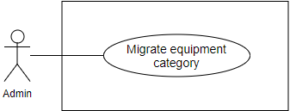

Figure 91: <Admin>Migrate equipment category

**Use Case Specification**

|  |  |  |  |
| --- | --- | --- | --- |
| **USE CASE – EMP_UC_84** | | | |
| **Use Case No.** | **EMP_UC_84** | **Use Case Version** | 1.1 |
| **Use Case Name** | Migrate equipment category | | |
| **Author** | Truong To Kiet | | |
| **Date** | 18/1/2018 | **Priority** | Normal |
| **Actor:**   * Admin   **Summary:**   * This use case allows admin to migrate equipment category.   **Goal:**   * Admin successfully migrates equipment category.   **Triggers:**   * Admin send migrate equipment category command to the system.   **Preconditions:**   * User must login into the system with role Admin.   **Post conditions:**   * Success: Equipment category successful update in database. * Fail: Equipment category cannot be updated.   **Main Success Scenario:**   |  |  |  | | --- | --- | --- | | **Step** | **Actor Action** | **System Response** | | 1 | Admin goes to migrate equipment category screen. | Migrate equipment category screen is shown with following labels and fields:   * From Equipment Category: dropdown list * To Equipment Category: dropdown list | | 2 | Admin inputs information. |  | | 3 | Admin send migrate equipment category command. | Migrate equipment category in the system.  [Exception 1]  System shows message equipment category has been updated successfully. |   **Exceptions:**   |  |  |  | | --- | --- | --- | | **No** | **Cause** | **System Response** | | 1 | Migrate equipment category fail. | Show message to notify admin that update equipment category failed. |   **Relationships:** N/A  **Business Rules:**   * Staff migrates equipment category when equipment category’s name is duplicated or synonymous and both material category contain material type. * System moves all equipment types which belong to “from equipment category” to “to equipment category” and deletes “from equipment category” * Staff cannot input the same value for “from equipment category” and “to equipment category” | | | |

Table 93 <Admin>Migrate equipment category

##### <Admin> Delete equipment category

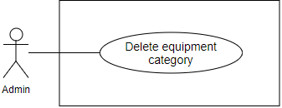

Figure 92: <Admin>Delete equipment category

**Use Case Specification**

|  |  |  |  |
| --- | --- | --- | --- |
| **USE CASE – EMP_UC_85** | | | |
| **Use Case No.** | **EMP_UC_85** | **Use Case Version** | 1.1 |
| **Use Case Name** | Delete equipment category | | |
| **Author** | Truong To Kiet | | |
| **Date** | 18/1/2018 | **Priority** | Normal |
| **Actor:**   * Admin   **Summary:**   * This use case allows admin to delete equipment category.   **Goal:**   * Admin successfully deletes equipment category.   **Triggers:**   * Admin send delete equipment category command to the system.   **Preconditions:**   * User must login into the system with role Admin.   **Post conditions:**   * Success: Equipment category successful delete in database. * Fail: Equipment category cannot be deleted.   **Main Success Scenario:**   |  |  |  | | --- | --- | --- | | **Step** | **Actor Action** | **System Response** | | 1 | Admin goes to equipment category’s detail screen. |  | | 2 | Admin send delete equipment category command. | Delete equipment category in the system.  [Exception 1]  System shows message equipment category has been deleted successfully. |   **Exceptions:**   |  |  |  | | --- | --- | --- | | **No** | **Cause** | **System Response** | | 1 | Delete equipment category fail. | Show message to notify admin that delete equipment category failed. |   **Relationships:** N/A  **Business Rules:**   * Staff soft delete equipment category by updating equipment category’s status to “is deleted”. * Staff must delete all related fields:   + Equipment type   + Equipment type additional fields   + Equipment type additional value   + Equipment | | | |

Table 94 <Admin>Delete equipment category

##### <Admin> Add equipment type

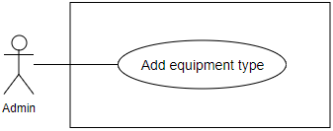

Figure 93: <Admin>Add equipment type

**Use Case Specification**

|  |  |  |  |
| --- | --- | --- | --- |
| **USE CASE – EMP_UC_86** | | | |
| **Use Case No.** | **EMP_UC_86** | **Use Case Version** | 1.1 |
| **Use Case Name** | Add equipment type | | |
| **Author** | Truong To Kiet | | |
| **Date** | 18/1/2018 | **Priority** | Normal |
| **Actor:**   * Admin   **Summary:**   * This use case allows admin to add new equipment type.   **Goal:**   * Admin successfully adds new equipment type.   **Triggers:**   * Admin send add new equipment type command to the system.   **Preconditions:**   * User must login into the system with role Admin. * Equipment category must be added before by Admin.   **Post conditions:**   * Success: New equipment type successful store in database. * Fail: New equipment type cannot be saved.   **Main Success Scenario:**   |  |  |  | | --- | --- | --- | | **Step** | **Actor Action** | **System Response** | | 1 | Admin goes to add new equipment type screen. | Add new equipment type screen is shown with following labels and fields:   * Name: text, required, length 4-30. * Equipment Category: dropdown list. | | 2 | Admin inputs information. |  | | 3 | Admin send add new equipment type command. | Add new equipment type in the system.  [Exception 1]  System shows message equipment type has been added successfully. |   **Exceptions:**   |  |  |  | | --- | --- | --- | | **No** | **Cause** | **System Response** | | 1 | Add new equipment type fail. | Show message to notify admin that add new equipment type failed. |   **Relationships:** N/A  **Business Rules:**   * Equipment type’s name must be suitable in construction industry. * Equipment type’s name is not duplicate. | | | |

Table 95 <Admin>Add equipment type

##### <Admin> Edit equipment type

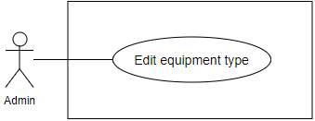

Figure 94: <Admin>Edit equipment type

**Use Case Specification**

|  |  |  |  |
| --- | --- | --- | --- |
| **USE CASE – EMP_UC_87** | | | |
| **Use Case No.** | **EMP_UC_87** | **Use Case Version** | 1.1 |
| **Use Case Name** | Edit equipment type | | |
| **Author** | Truong To Kiet | | |
| **Date** | 18/1/2018 | **Priority** | Normal |
| **Actor:**   * Admin   **Summary:**   * This use case allows admin to edit equipment type.   **Goal:**   * Admin successfully edits equipment type.   **Triggers:**   * Admin send edit equipment type command to the system.   **Preconditions:**   * User must login into the system with role Admin. * Equipment category must be added before by Admin.   **Post conditions:**   * Success: Equipment type successful update in database. * Fail: Equipment type cannot be updated.   **Main Success Scenario:**   |  |  |  | | --- | --- | --- | | **Step** | **Actor Action** | **System Response** | | 1 | Admin goes to edit equipment type screen. | Edit equipment type screen is shown with following labels and fields:   * Name: text, required, length 4-30. * Equipment Category: dropdown list. | | 2 | Admin inputs information. |  | | 3 | Admin send edit equipment type command. | Edit equipment type in the system.  [Exception 1]  System shows message equipment type has been updated successfully. |   **Exceptions:**   |  |  |  | | --- | --- | --- | | **No** | **Cause** | **System Response** | | 1 | Edit equipment type fail. | Show message to notify admin that update equipment type failed. |   **Relationships:** N/A  **Business Rules:**   * Equipment type’s name must be suitable in construction industry. * Equipment type ‘s name is not duplicate. | | | |

Table 96 <Admin>Edit equipment type

##### <Admin> Delete equipment type

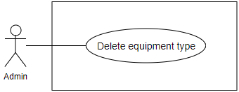

Figure 95: <Admin>Delete equipment type

**Use Case Specification**

|  |  |  |  |
| --- | --- | --- | --- |
| **USE CASE – EMP_UC_88** | | | |
| **Use Case No.** | **EMP_UC_88** | **Use Case Version** | 1.1 |
| **Use Case Name** | Delete equipment type | | |
| **Author** | Truong To Kiet | | |
| **Date** | 18/1/2018 | **Priority** | Normal |
| **Actor:**   * Admin   **Summary:**   * This use case allows admin to delete equipment type.   **Goal:**   * Admin successfully deletes equipment type.   **Triggers:**   * Admin send delete equipment type command to the system.   **Preconditions:**   * User must login into the system with role Admin.   **Post conditions:**   * Success: Equipment type successful delete in database. * Fail: Equipment type cannot be deleted.   **Main Success Scenario:**   |  |  |  | | --- | --- | --- | | **Step** | **Actor Action** | **System Response** | | 1 | Admin goes to equipment type ‘s detail screen. |  | | 2 | Admin send delete equipment type command. | Delete equipment type in the system.  [Exception 1]  System shows message equipment type has been deleted successfully. |   **Exceptions:**   |  |  |  | | --- | --- | --- | | **No** | **Cause** | **System Response** | | 1 | Delete equipment type fail. | Show message to notify admin that delete equipment type failed. |   **Relationships:** N/A  **Business Rules:**   * Staff soft delete equipment type by updating equipment type’s status to “is deleted”. * Staff must delete all related fields:   + Equipment type additional fields   + Equipment type additional value   + Equipment | | | |

Table 97 <Admin>Delete equipment type

##### <Admin> Add equipment type additional fields

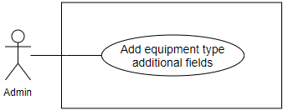

Figure 96: <Admin>Add equipment type additional fields

**Use Case Specification**

|  |  |  |  |
| --- | --- | --- | --- |
| **USE CASE – EMP_UC_89** | | | |
| **Use Case No.** | **EMP_UC_89** | **Use Case Version** | 1.1 |
| **Use Case Name** | Add equipment type additional fields | | |
| **Author** | Truong To Kiet | | |
| **Date** | 18/1/2018 | **Priority** | Normal |
| **Actor:**   * Admin   **Summary:**   * This use case allows admin to add new equipment type additional fields.   **Goal:**   * Admin successfully adds new equipment type additional fields.   **Triggers:**   * Admin send add new equipment type additional fields command to the system.   **Preconditions:**   * User must login into the system with role Admin. * Equipment category must be added before by Admin. * Equipment type must be added before by Admin.   **Post conditions:**   * Success: New equipment type additional fields successful store in database. * Fail: New equipment type additional fields cannot be saved.   **Main Success Scenario:**   |  |  |  | | --- | --- | --- | | **Step** | **Actor Action** | **System Response** | | 1 | Admin goes to add new equipment type additional fields screen. | Add new equipment type additional fields screen is shown with following labels and fields:   * Name: text, required, length 4-30. * Data Type: dropdown list. | | 2 | Admin inputs information. |  | | 3 | Admin send add new equipment type additional fields command. | Add new equipment type in the system.  [Exception 1]  System shows message equipment type has been added successfully. |   **Exceptions:**   |  |  |  | | --- | --- | --- | | **No** | **Cause** | **System Response** | | 1 | Add new equipment type additional fields fail. | Show message to notify admin that add new equipment type additional fields failed. |   **Relationships:** N/A  **Business Rules:**   * Equipment type additional field’s name must be suitable in construction industry. * Equipment type additional field’s name is not duplicate. * Equipment type additional field must describe detail of equipment type. * Equipment type additional field’s data type includes: “String", “Integer" and “Double" | | | |

Table 98 <Admin>Add equipment type additional fields

##### <Admin> Edit equipment type additional fields

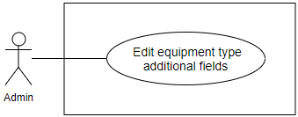

Figure 97: <Admin>Edit equipment type additional fields

**Use Case Specification**

|  |  |  |  |
| --- | --- | --- | --- |
| **USE CASE – EMP_UC_90** | | | |
| **Use Case No.** | **EMP_UC_90** | **Use Case Version** | 1.1 |
| **Use Case Name** | Edit equipment type additional fields | | |
| **Author** | Truong To Kiet | | |
| **Date** | 18/1/2018 | **Priority** | Normal |
| **Actor:**   * Admin   **Summary:**   * This use case allows admin to edit equipment type additional fields.   **Goal:**   * Admin successfully edits equipment type additional fields.   **Triggers:**   * Admin send edit equipment type additional fields command to the system.   **Preconditions:**   * User must login into the system with role Admin. * Equipment category must be added before by Admin. * Equipment type must be added before by Admin.   **Post conditions:**   * Success: Equipment type additional fields successful update in database. * Fail: Equipment type additional fields cannot be updated.   **Main Success Scenario:**   |  |  |  | | --- | --- | --- | | **Step** | **Actor Action** | **System Response** | | 1 | Admin goes to edit equipment type additional fields screen. | Edit equipment type additional fields screen is shown with following labels and fields:   * Name: text, required, length 4-30. * Data Type: dropdown list. | | 2 | Admin inputs information. |  | | 3 | Admin send edit equipment type additional fields command. | Edit equipment type additional fields in the system.  [Exception 1]  System shows message equipment type additional fields has been updated successfully. |   **Exceptions:**   |  |  |  | | --- | --- | --- | | **No** | **Cause** | **System Response** | | 1 | Edit equipment type additional fields fail. | Show message to notify admin that update equipment type additional fields failed. |   **Relationships:** N/A  **Business Rules:**   * Equipment type additional field’s name must be suitable in construction industry. * Equipment type additional field’s name is not duplicate. * Equipment type additional field must describe detail of equipment type. * Equipment type additional field’s data type includes: “String", “Integer" and “Double" | | | |

Table 99 <Admin>Edit equipment type additional fields

##### <Admin> Delete equipment type additional field

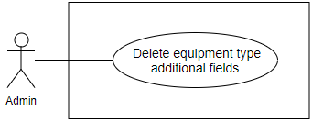

Figure 98: <Admin>Delete equipment type additional fields

**Use Case Specification**

|  |  |  |  |
| --- | --- | --- | --- |
| **USE CASE – EMP_UC_91** | | | |
| **Use Case No.** | **EMP_UC_91** | **Use Case Version** | 1.1 |
| **Use Case Name** | Delete equipment type additional field | | |
| **Author** | Truong To Kiet | | |
| **Date** | 18/1/2018 | **Priority** | Normal |
| **Actor:**   * Admin   **Summary:**   * This use case allows admin to delete equipment type additional field.   **Goal:**   * Admin successfully deletes equipment type additional field.   **Triggers:**   * Admin send delete equipment type additional field command to the system.   **Preconditions:**   * User must login into the system with role Admin.   **Post conditions:**   * Success: Equipment type additional field successful delete in database. * Fail: Equipment type additional field cannot be deleted.   **Main Success Scenario:**   |  |  |  | | --- | --- | --- | | **Step** | **Actor Action** | **System Response** | | 1 | Admin goes to equipment type additional field ‘s detail screen. |  | | 2 | Admin send delete equipment type additional field command. | Delete equipment type additional field in the system.  [Exception 1]  System shows message equipment type additional field has been deleted successfully. |   **Exceptions:**   |  |  |  | | --- | --- | --- | | **No** | **Cause** | **System Response** | | 1 | Delete equipment type additional field fail. | Show message to notify admin that delete equipment type additional field failed. |   **Relationships:** N/A  **Business Rules:**   * Staff soft delete equipment type additional field by updating equipment type additional field ‘s status to “is deleted”. * Staff must delete all related fields:   + Equipment type additional value | | | |

##### <Admin> Add material category

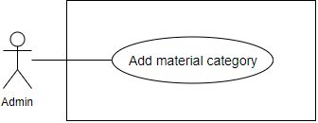

Figure 99: <Admin>Add material category

**Use Case Specification**

|  |  |  |  |
| --- | --- | --- | --- |
| **USE CASE – EMP_UC_92** | | | |
| **Use Case No.** | **EMP_UC_92** | **Use Case Version** | 1.1 |
| **Use Case Name** | Add material category | | |
| **Author** | Truong To Kiet | | |
| **Date** | 18/1/2018 | **Priority** | Normal |
| **Actor:**   * Admin   **Summary:**   * This use case allows admin to add new material category.   **Goal:**   * Admin successfully adds new material category.   **Triggers:**   * Admin send add new material category command to the system.   **Preconditions:**   * User must login into the system with role Admin.   **Post conditions:**   * Success: New material category successful store in database. * Fail: New material category cannot be saved.   **Main Success Scenario:**   |  |  |  | | --- | --- | --- | | **Step** | **Actor Action** | **System Response** | | 1 | Admin goes to add new material category screen. | Add new material category screen is shown with following labels and fields:   * Name: text, required, length 4-30. | | 2 | Admin inputs information. |  | | 3 | Admin send add new material category command. | Add new material category in the system.  [Exception 1]  System shows message material category has been added successfully. |   **Exceptions:**   |  |  |  | | --- | --- | --- | | **No** | **Cause** | **System Response** | | 1 | Add new material category fail. | Show message to notify admin that add new material category failed. |   **Relationships:** N/A  **Business Rules:**   * Material category’s name must be suitable in construction industry. * Material category’s name is not duplicate. | | | |

##### <Admin> Edit material category

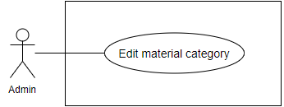

Figure 100: <Admin>Edit material category

**Use Case Specification**

|  |  |  |  |
| --- | --- | --- | --- |
| **USE CASE – EMP_UC_93** | | | |
| **Use Case No.** | **EMP_UC_93** | **Use Case Version** | 1.1 |
| **Use Case Name** | Edit material category | | |
| **Author** | Truong To Kiet | | |
| **Date** | 18/1/2018 | **Priority** | Normal |
| **Actor:**   * Admin   **Summary:**   * This use case allows admin to edit material category.   **Goal:**   * Admin successfully edits material category.   **Triggers:**   * Admin send edit material category command to the system.   **Preconditions:**   * User must login into the system with role Admin.   **Post conditions:**   * Success: Material category successful update in database. * Fail: Material category cannot be updated.   **Main Success Scenario:**   |  |  |  | | --- | --- | --- | | **Step** | **Actor Action** | **System Response** | | 1 | Admin goes to edit material category screen. | Edit material category screen is shown with following labels and fields:   * Name: text, required, length 4-30. | | 2 | Admin inputs information. |  | | 3 | Admin send edit material category command. | Edit material category in the system.  [Exception 1]  System shows message material category has been updated successfully. |   **Exceptions:**   |  |  |  | | --- | --- | --- | | **No** | **Cause** | **System Response** | | 1 | Edit material category fail. | Show message to notify admin that update material category failed. |   **Relationships:** N/A  **Business Rules:**   * Material category’s name must be suitable in construction industry. * Material category’s name is not duplicate. | | | |

##### <Admin> Migrate material category

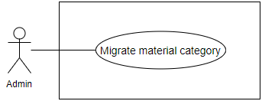

Figure 101: <Admin>Migrate material category

**Use Case Specification**

|  |  |  |  |
| --- | --- | --- | --- |
| **USE CASE – EMP_UC_94** | | | |
| **Use Case No.** | **EMP_UC_94** | **Use Case Version** | 1.1 |
| **Use Case Name** | Migrate material category | | |
| **Author** | Truong To Kiet | | |
| **Date** | 18/1/2018 | **Priority** | Normal |
| **Actor:**   * Admin   **Summary:**   * This use case allows admin to migrate material category.   **Goal:**   * Admin successfully migrates material category.   **Triggers:**   * Admin send migrate material category command to the system.   **Preconditions:**   * User must login into the system with role Admin.   **Post conditions:**   * Success: Material category successful update in database. * Fail: Material category cannot be updated.   **Main Success Scenario:**   |  |  |  | | --- | --- | --- | | **Step** | **Actor Action** | **System Response** | | 1 | Admin goes to migrate material category screen. | Migrate material category screen is shown with following labels and fields:   * From Material Category: dropdown list * To Material Category: dropdown list | | 2 | Admin inputs information. |  | | 3 | Admin send migrate v category command. | Migrate material category in the system.  [Exception 1]  System shows message equipment category has been updated successfully. |   **Exceptions:**   |  |  |  | | --- | --- | --- | | **No** | **Cause** | **System Response** | | 1 | Migrate material category fail. | Show message to notify admin that update material category failed. |   **Relationships:** N/A  **Business Rules:**   * Staff migrates material category when material category’s name is duplicated or synonymous and both material category contain material type. * System moves all material types which belong to “from material category” to “to material category” and deletes “from material category”. * Staff cannot input the same value for “from material category” and “to material category” | | | |

##### <Admin> Delete material category

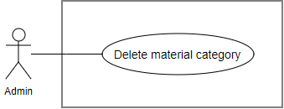

Figure 102: <Admin>Delete material category

**Use Case Specification**

|  |  |  |  |
| --- | --- | --- | --- |
| **USE CASE – EMP_UC_95** | | | |
| **Use Case No.** | **EMP_UC_95** | **Use Case Version** | 1.1 |
| **Use Case Name** | Delete material category | | |
| **Author** | Truong To Kiet | | |
| **Date** | 18/1/2018 | **Priority** | Normal |
| **Actor:**   * Admin   **Summary:**   * This use case allows admin to delete material category.   **Goal:**   * Admin successfully deletes material category.   **Triggers:**   * Admin send delete material category command to the system.   **Preconditions:**   * User must login into the system with role Admin.   **Post conditions:**   * Success: Material category successful delete in database. * Fail: Material category cannot be deleted.   **Main Success Scenario:**   |  |  |  | | --- | --- | --- | | **Step** | **Actor Action** | **System Response** | | 1 | Admin goes to material category’s detail screen. |  | | 2 | Admin send delete material category command. | Delete material category in the system.  [Exception 1]  System shows message material category has been deleted successfully. |   **Exceptions:**   |  |  |  | | --- | --- | --- | | **No** | **Cause** | **System Response** | | 1 | Delete material category fail. | Show message to notify admin that delete material category failed. |   **Relationships:** N/A  **Business Rules:**   * Staff soft delete material category by updating material category’s status to “is deleted”. * Staff must delete all related fields:   + Material type   + Material | | | |

##### <Admin> Add material type

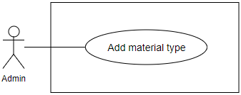

Figure 103: <Admin>Add material type

**Use Case Specification**

|  |  |  |  |
| --- | --- | --- | --- |
| **USE CASE – EMP_UC_96** | | | |
| **Use Case No.** | **EMP_UC_96** | **Use Case Version** | 1.1 |
| **Use Case Name** | Add material type | | |
| **Author** | Truong To Kiet | | |
| **Date** | 18/1/2018 | **Priority** | Normal |
| **Actor:**   * Admin   **Summary:**   * This use case allows admin to add new material type.   **Goal:**   * Admin successfully adds new material type.   **Triggers:**   * Admin send add new material type command to the system.   **Preconditions:**   * User must login into the system with role Admin. * Material category must be added before by Admin.   **Post conditions:**   * Success: New material type successful store in database. * Fail: New material type cannot be saved.   **Main Success Scenario:**   |  |  |  | | --- | --- | --- | | **Step** | **Actor Action** | **System Response** | | 1 | Admin goes to add new material type screen. | Add new material type screen is shown with following labels and fields:   * Name: text, required, length 4-30. * Unit: text input, required. * Material Category: dropdown list. | | 2 | Admin inputs information. |  | | 3 | Admin send add new material type command. | Add new material type in the system.  [Exception 1]  System shows message material type has been added successfully. |   **Exceptions:**   |  |  |  | | --- | --- | --- | | **No** | **Cause** | **System Response** | | 1 | Add new material type fail. | Show message to notify admin that add new material type failed. |   **Relationships:** N/A  **Business Rules:**   * Material type’s name must be suitable in construction industry. * Material type’s name is not duplicate. | | | |

##### <Admin> Edit material type

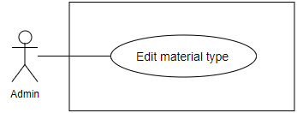

Figure 104: <Admin>Edit material type

**Use Case Specification**

|  |  |  |  |
| --- | --- | --- | --- |
| **USE CASE – EMP_UC_97** | | | |
| **Use Case No.** | **EMP_UC_97** | **Use Case Version** | 1.1 |
| **Use Case Name** | Edit material type | | |
| **Author** | Truong To Kiet | | |
| **Date** | 18/1/2018 | **Priority** | Normal |
| **Actor:**   * Admin   **Summary:**   * This use case allows admin to edit material type.   **Goal:**   * Admin successfully edits material type.   **Triggers:**   * Admin send edit material type command to the system.   **Preconditions:**   * User must login into the system with role Admin. * Material category must be added before by Admin.   **Post conditions:**   * Success: Material type successful update in database. * Fail: Material type cannot be updated.   **Main Success Scenario:**   |  |  |  | | --- | --- | --- | | **Step** | **Actor Action** | **System Response** | | 1 | Admin goes to edit material type screen. | Edit material type screen is shown with following labels and fields:   * Name: text, required, length 4-30. * Material Category: dropdown list. | | 2 | Admin inputs information. |  | | 3 | Admin send edit material type command. | Edit material type in the system.  [Exception 1]  System shows message material type has been updated successfully. |   **Exceptions:**   |  |  |  | | --- | --- | --- | | **No** | **Cause** | **System Response** | | 1 | Edit material type fail. | Show message to notify admin that update material type failed. |   **Relationships:** N/A  **Business Rules:**   * Material type’s name must be suitable in construction industry. * Material type ‘s name is not duplicate. | | | |

##### <Admin> Delete material type

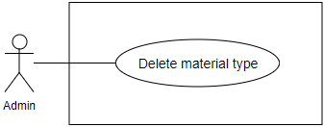

Figure 105: <Admin>Delete material type

**Use Case Specification**

|  |  |  |  |
| --- | --- | --- | --- |
| **USE CASE – EMP_UC_98** | | | |
| **Use Case No.** | **EMP_UC_98** | **Use Case Version** | 1.1 |
| **Use Case Name** | Delete material type | | |
| **Author** | Truong To Kiet | | |
| **Date** | 18/1/2018 | **Priority** | Normal |
| **Actor:**   * Admin   **Summary:**   * This use case allows admin to delete material type.   **Goal:**   * Admin successfully deletes material type.   **Triggers:**   * Admin send delete material type command to the system.   **Preconditions:**   * User must login into the system with role Admin.   **Post conditions:**   * Success: Material type successful delete in database. * Fail: Material type cannot be deleted.   **Main Success Scenario:**   |  |  |  | | --- | --- | --- | | **Step** | **Actor Action** | **System Response** | | 1 | Admin goes to material type’s detail screen. |  | | 2 | Admin send delete material type command. | Delete material type in the system.  [Exception 1]  System shows message material type has been deleted successfully. |   **Exceptions:**   |  |  |  | | --- | --- | --- | | **No** | **Cause** | **System Response** | | 1 | Delete material type fail. | Show message to notify admin that delete material type failed. |   **Relationships:** N/A  **Business Rules:**   * Staff soft delete material type by updating material type’s status to “is deleted”. * Staff must delete all related fields:   + Material | | | |

##### <Admin> Add debris service type

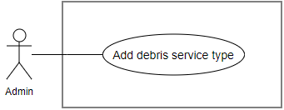

Figure 106: <Admin>Add debris service type

**Use Case Specification**

|  |  |  |  |
| --- | --- | --- | --- |
| **USE CASE – EMP_UC_99** | | | |
| **Use Case No.** | **EMP_UC_99** | **Use Case Version** | 1.1 |
| **Use Case Name** | Add debris service type | | |
| **Author** | Truong To Kiet | | |
| **Date** | 18/1/2018 | **Priority** | Normal |
| **Actor:**   * Admin   **Summary:**   * This use case allows admin to add new debris service type.   **Goal:**   * Admin successfully adds new debris service type.   **Triggers:**   * Admin send add new debris service type command to the system.   **Preconditions:**   * User must login into the system with role Admin.   **Post conditions:**   * Success: New debris service type successful store in database. * Fail: New debris service type cannot be saved.   **Main Success Scenario:**   |  |  |  | | --- | --- | --- | | **Step** | **Actor Action** | **System Response** | | 1 | Admin goes to add new debris service type screen. | Add new debris service type screen is shown with following labels and fields:   * Name: text, required, length 4-30. | | 2 | Admin inputs information. |  | | 3 | Admin send add new debris service type command. | Add new debris service type in the system.  [Exception 1]  System shows message debris service type has been added successfully. |   **Exceptions:**   |  |  |  | | --- | --- | --- | | **No** | **Cause** | **System Response** | | 1 | Add new debris service type fail. | Show message to notify admin that add new debris service type failed. |   **Relationships:** N/A  **Business Rules:**   * Debris service type’s name must be suitable in construction industry. * Debris service type’s name is not duplicate. | | | |

##### <Admin> Edit debris service type

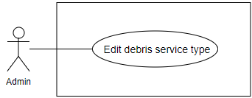

Figure 107: <Admin>Edit debris service type

**Use Case Specification**

|  |  |  |  |
| --- | --- | --- | --- |
| **USE CASE – EMP_UC_100** | | | |
| **Use Case No.** | **EMP_UC_100** | **Use Case Version** | 1.1 |
| **Use Case Name** | Edit debris service type | | |
| **Author** | Truong To Kiet | | |
| **Date** | 18/1/2018 | **Priority** | Normal |
| **Actor:**   * Admin   **Summary:**   * This use case allows admin to edit debris service type.   **Goal:**   * Admin successfully edits debris service type.   **Triggers:**   * Admin send edit debris service type command to the system.   **Preconditions:**   * User must login into the system with role Admin. * Debris service category must be added before by Admin.   **Post conditions:**   * Success: Debris service type successful update in database. * Fail: Debris service type cannot be updated.   **Main Success Scenario:**   |  |  |  | | --- | --- | --- | | **Step** | **Actor Action** | **System Response** | | 1 | Admin goes to edit debris service type screen. | Edit debris service type screen is shown with following labels and fields:   * Name: text, required, length 4-30. | | 2 | Admin inputs information. |  | | 3 | Admin send edit debris service type command. | Edit debris service type in the system.  [Exception 1]  System shows message debris service type has been updated successfully. |   **Exceptions:**   |  |  |  | | --- | --- | --- | | **No** | **Cause** | **System Response** | | 1 | Edit debris service type fail. | Show message to notify admin that update debris service type failed. |   **Relationships:** N/A  **Business Rules:**   * Debris service type’s name must be suitable in construction industry. * Debris service type’s name is not duplicate. | | | |

##### <Admin> Delete debris service type

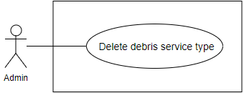

Figure 108: <Admin>Delete debris service type

**Use Case Specification**

|  |  |  |  |
| --- | --- | --- | --- |
| **USE CASE – EMP_UC_101** | | | |
| **Use Case No.** | **EMP_UC_101** | **Use Case Version** | 1.1 |
| **Use Case Name** | Delete debris service type | | |
| **Author** | Truong To Kiet | | |
| **Date** | 18/1/2018 | **Priority** | Normal |
| **Actor:**   * Admin   **Summary:**   * This use case allows admin to delete debris service type.   **Goal:**   * Admin successfully deletes debris service type.   **Triggers:**   * Admin send delete debris service type command to the system.   **Preconditions:**   * User must login into the system with role Admin.   **Post conditions:**   * Success: Debris service type successful delete in database. * Fail: Debris service type cannot be deleted.   **Main Success Scenario:**   |  |  |  | | --- | --- | --- | | **Step** | **Actor Action** | **System Response** | | 1 | Admin goes to debris service type’s detail screen. |  | | 2 | Admin send delete debris service type command. | Delete debris service type in the system.  [Exception 1]  System shows message debris service type has been deleted successfully. |   **Exceptions:**   |  |  |  | | --- | --- | --- | | **No** | **Cause** | **System Response** | | 1 | Delete debris service type fail. | Show message to notify admin that delete debris service type failed. |   **Relationships:** N/A  **Business Rules:**   * Staff soft delete debris service type by updating debris service type’s status to “is deleted”. * Staff must delete all related fields:   + Debris post | | | |

#### <Admin guest> Overview Use Case

Figure 109: <Admin guest>Overview use case

##### <Admin guest> Login to web admin

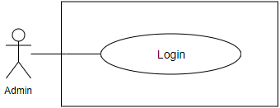

Figure 110: <Admin guest>Login to web admin

**Use Case Specification**

|  |  |  |  |
| --- | --- | --- | --- |
| **USE CASE – EMP_UC_102** | | | |
| **Use Case No.** | **EMP_UC_102** | **Use Case Version** | 1.1 |
| **Use Case Name** | Login to web admin | | |
| **Author** | Truong To Kiet | | |
| **Date** | 18/1/2018 | **Priority** | Normal |
| **Actor:**   * Admin guest   **Summary:**   * This use case allows guest to log in the system.   **Goal:**   * Guest can log in the system with specific role.   **Triggers:**   * Guest sends login command.   **Preconditions:** N/A  **Post conditions:**   * Success: Guest is exactly authorized with specific role in the system. * Fail: System shows error messages.   **Main Success Scenario:**   |  |  |  | | --- | --- | --- | | **Step** | **Actor Action** | **System Response** | | 1 | Guest go to login screen. | Login screen is shown with following labels and fields:   * Username: text input, required. * Password: text input, required. | | 2 | Guest inputs information. |  | | 3 | Guest sends command to login to system. | Guest logins system with his specific role. [Alternative 1] [Exception 1] |   **Alternative Scenario:**   |  |  |  | | --- | --- | --- | | **No** | **Actor Action** | **System Response** | | 1 | Guest enter wrong identity information. | System shows error message “Wrong username or password. Please try again.” |   **Exceptions:**   |  |  |  | | --- | --- | --- | | **No** | **Cause** | **System Response** | | 1 | Login failed. | Show message to notify admin that login failed. |   **Relationships:** N/A  **Business Rules:**   * Password is encrypted before being sent to server. | | | |

##### <Admin guest> Forgot your password

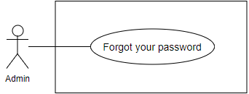

Figure 111: <Admin guest>Forgot your password

**Use Case Specification**

|  |  |  |  |
| --- | --- | --- | --- |
| **USE CASE – EMP_UC_103** | | | |
| **Use Case No.** | **EMP_UC_103** | **Use Case Version** | 1.1 |
| **Use Case Name** | Forgot your password | | |
| **Author** | Truong To Kiet | | |
| **Date** | 18/1/2018 | **Priority** | Normal |
| **Actor:**   * Admin guest   **Summary:**   * This use case allows guest to reset password by email.   **Goal:**   * Guest can reset password by email.   **Triggers:**   * Guest sends reset password command.   **Preconditions:** N/A  **Post conditions:**   * Success: A staff password successful update in database and send to staff’s email. * Fail: A staff password cannot be updated.   **Main Success Scenario:**   |  |  |  | | --- | --- | --- | | **Step** | **Actor Action** | **System Response** | | 1 | Guest go to forgot your password screen. | Forgot your password screen is shown with following labels and fields:   * Email: text input, required. | | 2 | Guest inputs information. |  | | 3 | Guest sends command to reset password to system. | Update staff password in the system.  [Alternative 1]  [Exception 1]  System shows message reset password has been updated successfully |   **Alternative Scenario:**   |  |  |  | | --- | --- | --- | | **No** | **Actor Action** | **System Response** | | 1 | Guest enter wrong identity information. | System shows error message” Wrong email.” |   **Exceptions:**   |  |  |  | | --- | --- | --- | | **No** | **Cause** | **System Response** | | 1 | Reset password failed. | Show message to notify admin that reset password failed. |   **Relationships:** N/A  **Business Rules:**   * Password is encrypted before being sent to server. * Email have been registered before. | | | |

## Software System Attribute

### Usability

Website’s UI is fit for each browser on each device

* Font style: Arial, Sans-serif
* Font size: 12px -26px
* Color: green, black, red, white, blue, Light Slate Grey, Fuego, Honeysuckle…
* Background: White, Catalina Blue, Whisper…

### Reliability

* The information storing on the database is permanent.

### Availability

* The system must be available at any time 24/7.

### Security

* Only Manager has fully access to the system
* Input data is validated before saving to database.

### Maintainability

* The system is divided into separated modules for easy maintain.

### Portability

* Web application can be run on Chrome browser version 42 or later

### Performance

* System has successfully test with basic standard

## Conceptual Diagram

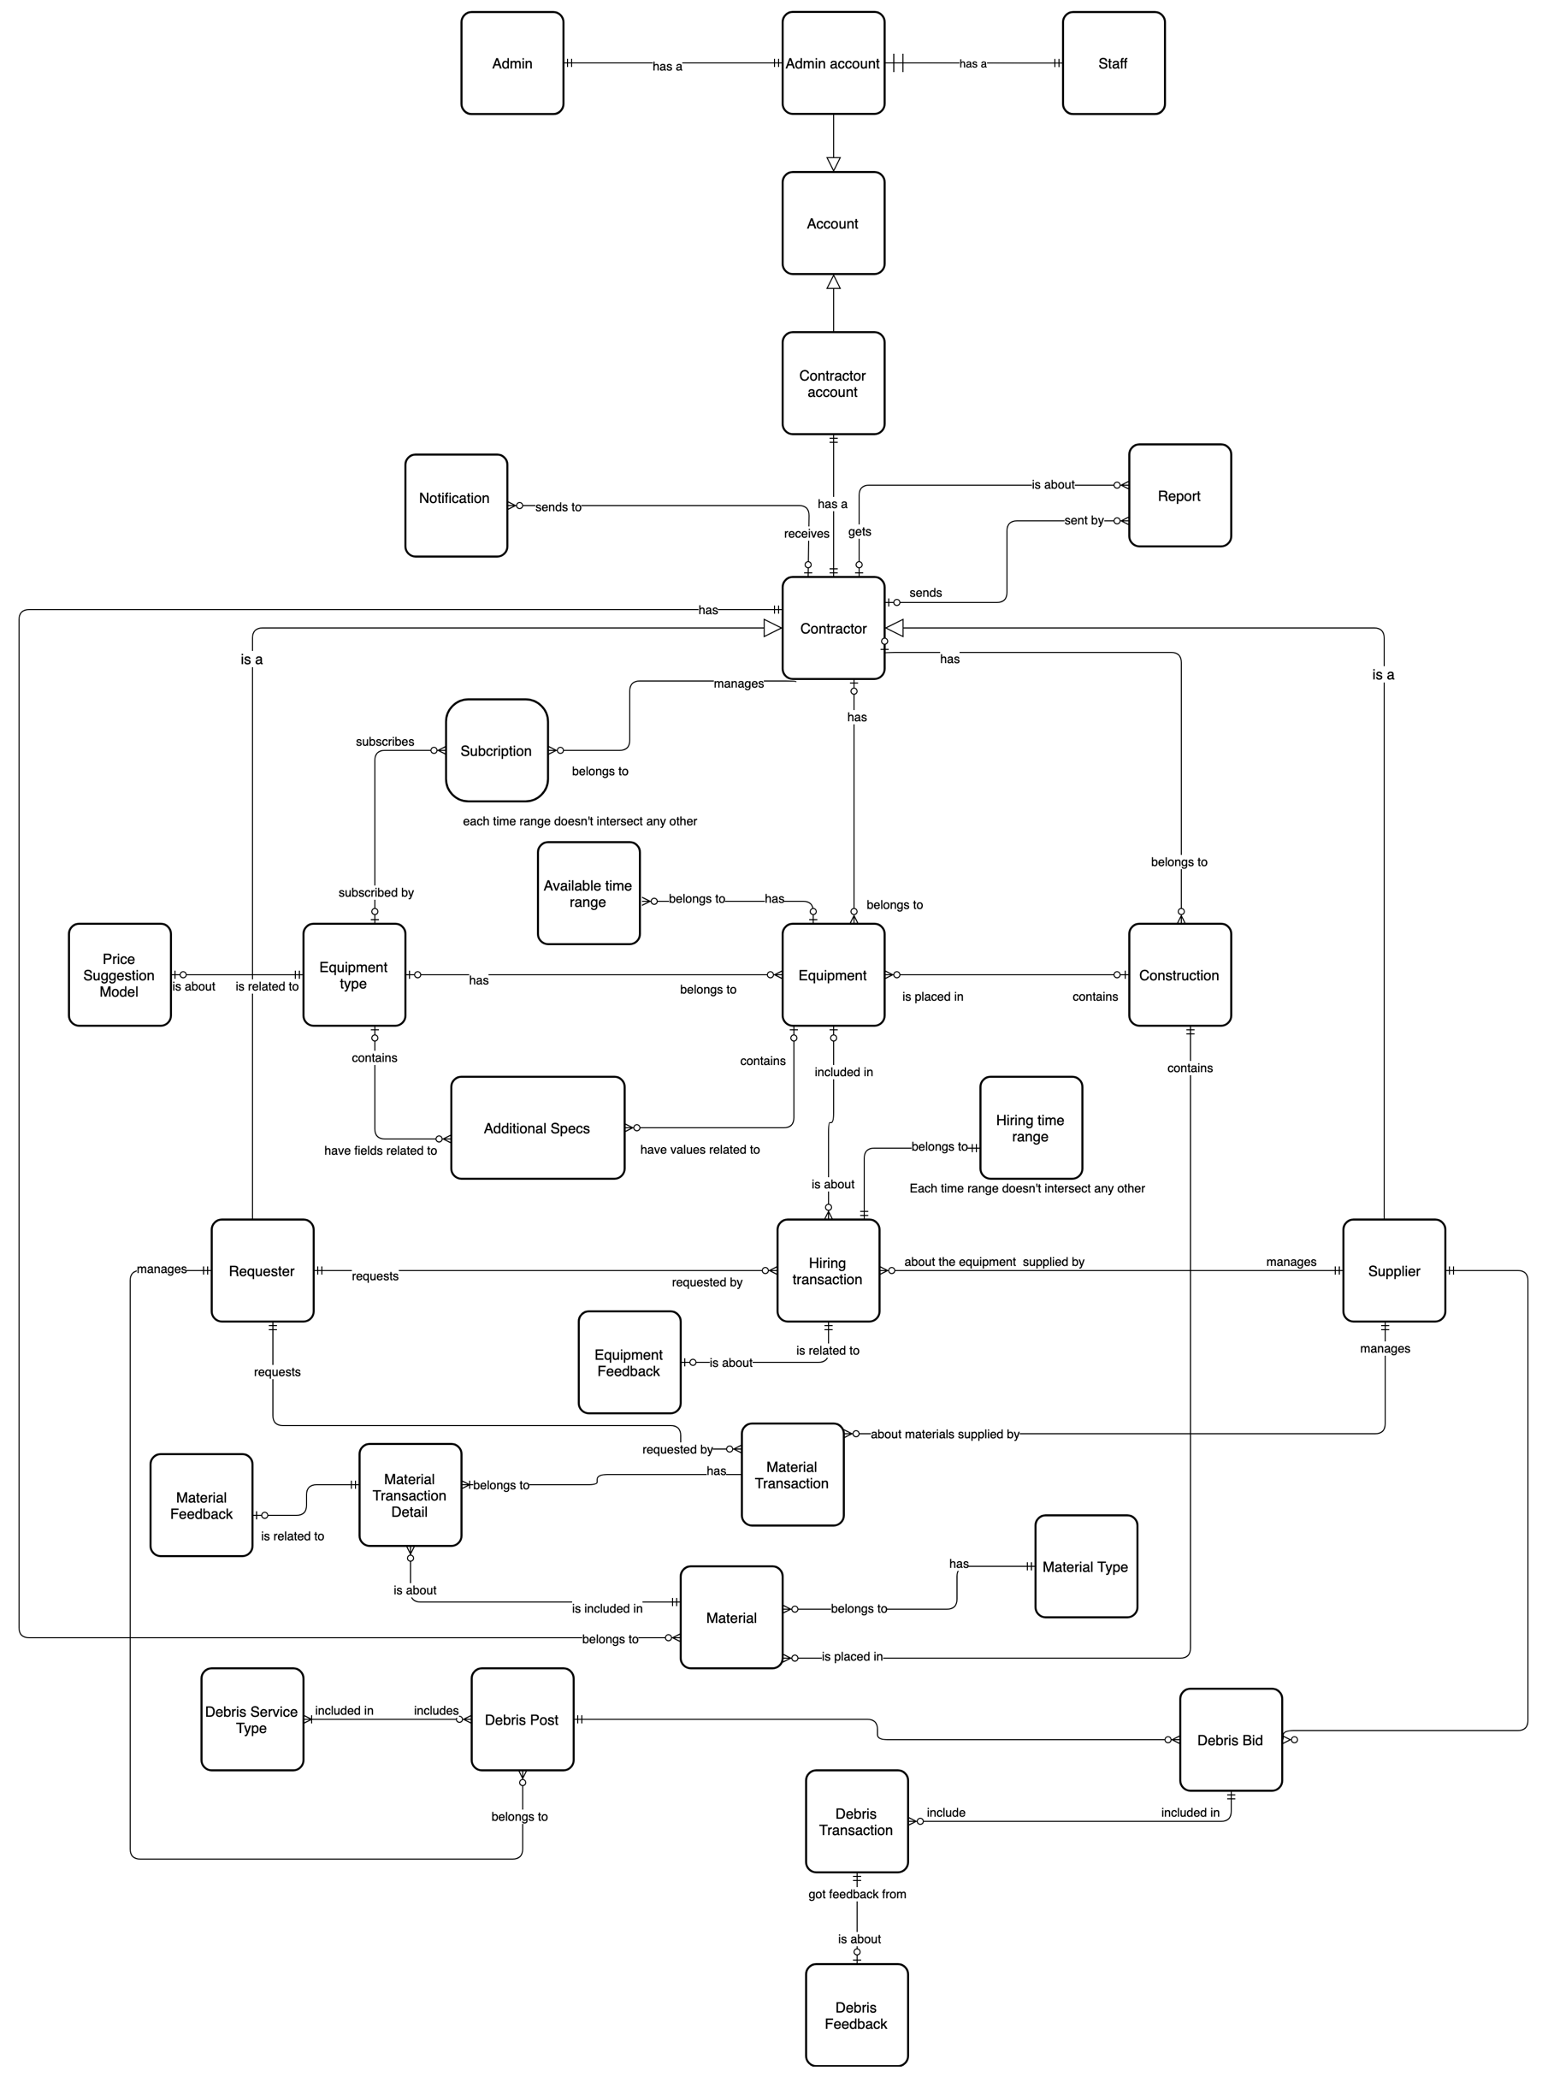

Figure 4 Conceptual Diagram

**Data Dictionary**

|  |  |
| --- | --- |
| **ENTITY DATA DICTIONARY: DESCRIBE ALL CONTENT OF ALL ENTITIES** | |
| **Entity Name** | **Description** |
| Additional Specs | Contain all additional specs information |
| Account | Contain account information |
| Admin account | Contain admin account information |
| Admin | Contain the admin information |
| Available time range | Contain available time range information of an equipment |
| Construction | Contain construction information |
| Registered User | Contain Registered User profile information |
| Registered User account | Contain Registered User account information |
| Equipment | Contain equipment information |
| Equipment type | Contain equipment type information |
| Report | Contain information of reported behavior |
| Hiring transaction | Contain hiring transaction information |
| Hiring time range | Contain hiring time range information |
| Notification | Describe a handler which will manage notifications of the system |
| Subscription | Contain subscription information |
| Material | Contain material information |
| Material transaction | Contain material transaction information |
| Material type | Contain material type information |
| Debris bid | Contain bid information for a debris post |
| Debris feedback | Contain feedback information for a finished debris transaction |
| Debris post | Contain post information for a debris service |
| Debris service type | Contain debris service type information |
| Debris transaction | Contain debris transaction information |
| Material transaction detail | Contain material transaction detail information |
| Material feedback | Contain feedback information of a finished material transaction |
| Equipment feedback | Contain feedback information for a finished hiring transaction |
| Supplier | Contain supplier information |
| Staff | Contain the staff information |
| Requester | Contain requester information |
| Price suggestion model | Contain information of the price suggestion model training result |

Table 100 Conceptual Diagram Dictionary

# Software Design Description

## Design Overview

This document describes the technical and user interface design of EMP system. It includes the architectural design, the detailed design of common functions and business functions and the design of database model.

The architectural design describes the overall architecture of the system and the architecture of each main component and subsystem.

The detailed design describes static and dynamic structure for each component and functions. It includes class diagraEMP, class explanations and sequence diagraEMP for each use cases.

 The database design describes the relationships between entities and details of each entity.

Document overview:

* Section 2: gives an overall description of the system architecture design.
* Section 3: gives component diagraEMP that describe the connection and integration of the system.
* Section 4: gives the detail design description which includes class diagram, class explanation, and sequence diagram to details the application functions.
* Section 5: describe screens design.
* Section 6: describe a fully attributed ERD.
* Section 7: describe algorithEMP.

## System Architecture Design

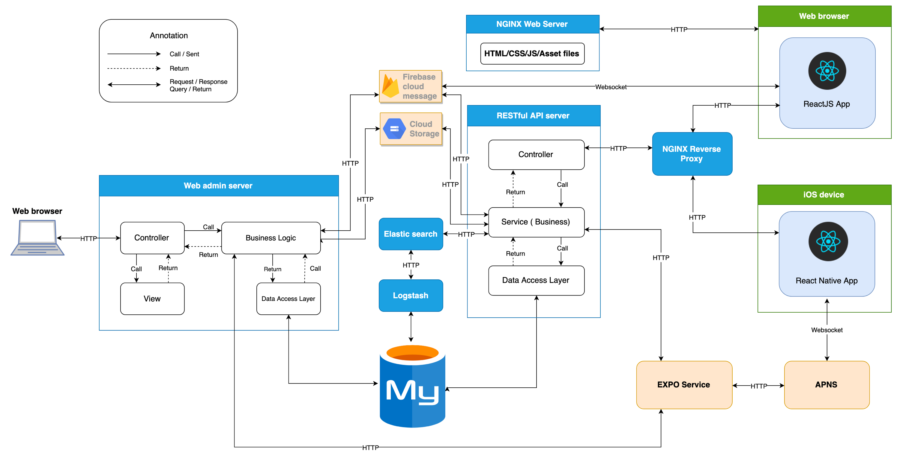

Figure 5 System Architecture diagram

### Admin web application:

In Admin Web Application, the system is developed under MVC architecture style. We choose this architecture for Admin Web Application because the following advantages:

* Quickly to develop and maintain, because the lack of human resource of our team
* Have enough flexibility and maintainability, comprehension, convention because MVC model is a classical model with variety resources and eco system.
* Save memory leaks with small amount of Javascript because of server-side rendering
* No need heavy loading in client, save computing resources for devices in offices
* Preferable for simple applications

### Registered User web system:

In Registered User web application, we choose to develop the system in Single Page Application approach because of the following advantages:

* Provide rich user interface with many features, preferable for C2C or B2C products
* Better UX/UI for end users for quick data loading and background fetching
* ReactJS is easy to master
* It is a light-weighted framework comparing to other popular ones today

In Registered User mobile application, we choose to develop the system with React Native because of the following advantages:

* Mobile app can be built with the help of Web technology which enables any web developer to easily enhance his/her skills and create React apps.
* Saves time and cost to build mobile apps on multiple platforEMP.
* A React Native app ensures speed and agility for the mobile apps with responsiveness and a great native app based user experience.

## Component Diagram

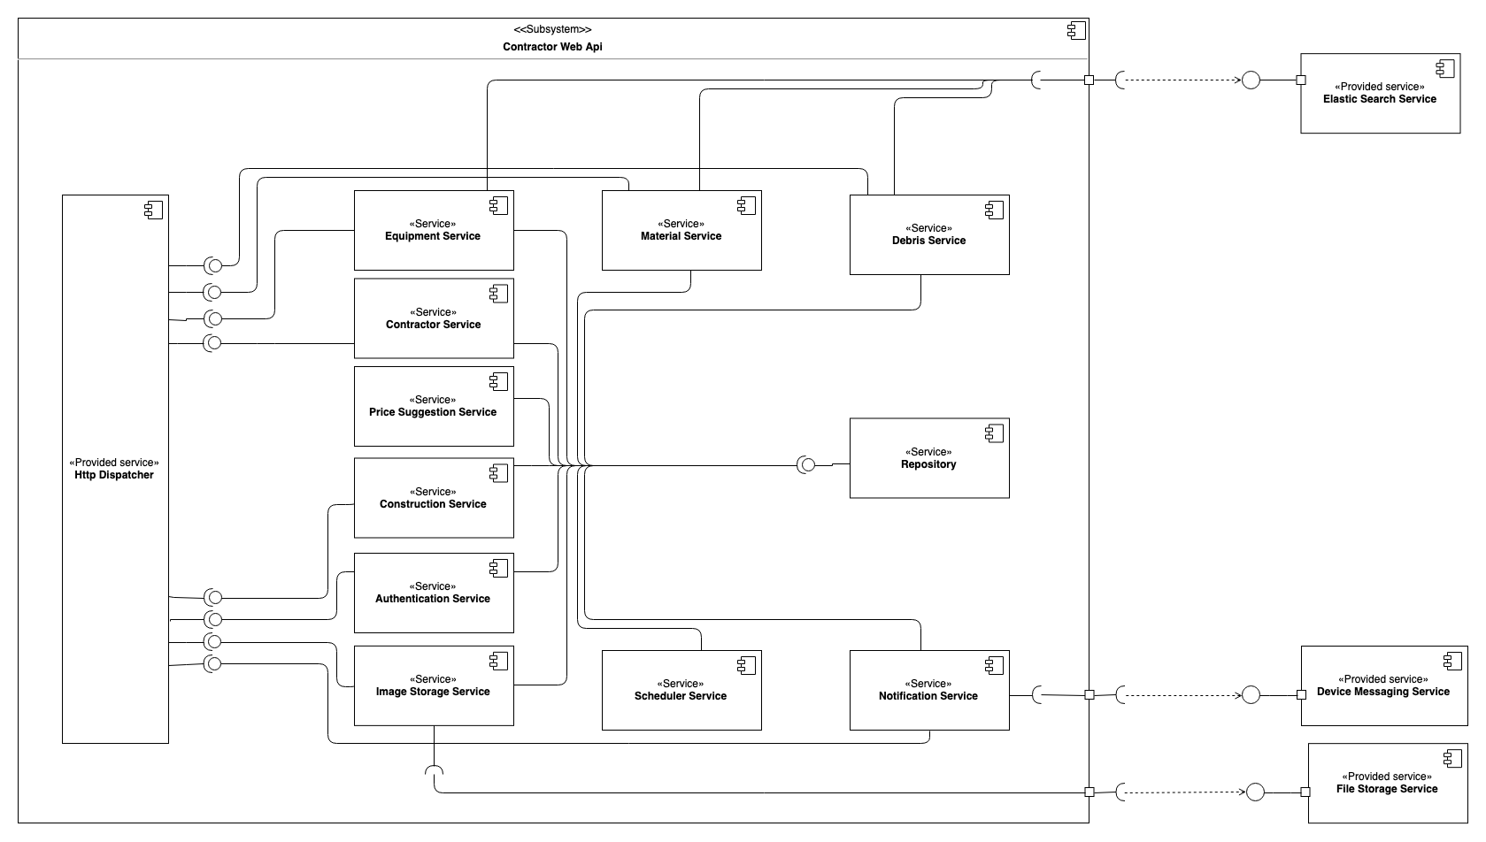

Figure 6 Component Diagram - Registered User Web Api

|  |  |
| --- | --- |
| **Component dictionary** | |
| **Component name** | **Description** |
| Equipment Service | A service responsible for managing information related to equipment, hiring transaction, hiring transaction feedbacks. |
| Material Service | A service responsible for managing information related to materials, material transactions, material transaction feedbacks. |
| Debris Service | A service responsible for managing information related to debris, debris post, debris bids, debris transactions, debris transaction feedbacks. |
| Registered User Service | A service responsible for managing information related to Registered Users. |
| Construction Service | A service responsible for managing information related to constructions. |
| Authentication Service | A service responsible for authentication and authorization. |
| Image Storage Service | A service responsible for uploading images, including equipment images, material images, debris images, profile images. |
| Scheduler Service | A service responsible for time-related tasks. |
| Notification Service | A service responsible for managing notification |
| Repository | A service responsible for data management. |
| Elastic Search Service | A provided service of Elastic search, responsible for low-latency performance information gathering and managing searchable resource |
| Device Messaging Service | An external service responsible for send notifications to actual devices. This service can be realized by Firebase Cloud Messaging service and Expo Messaging service. |
| File Storage Service | An external service responsible for raw resource storage. This service can be realized by Google Cloud Storage service, Imgur Storage service, etc. |
| Price Suggestion Service | A service responsible for model training, data collecting data, data processing, model applying for price suggestion. |

Figure 7 Component Data Dictionary

## Detailed Description

### Class Diagram

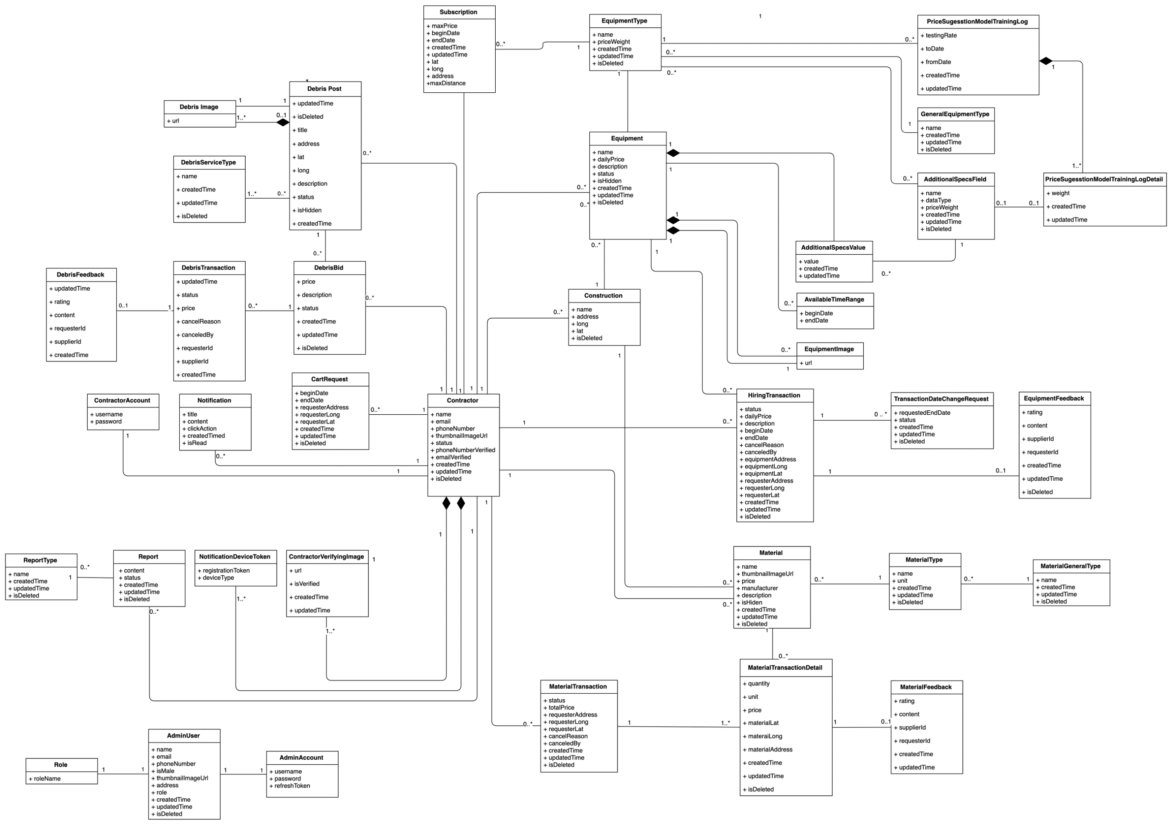

Figure 8 Class Diagram

### Class Diagram Explanation

|  |  |  |
| --- | --- | --- |
| **CLASS DICTIONARY: DESCRIBE CLASS** | | |
| **Class Name** | **Mapping column with Conceptual diagram** | **Description** |
| Registered UserAccount | Registered User Account | Contain Registered User account information |
| AdditionalSpecsField | N/A | Not exist in conceptual diagram but need this table to separate responsibility with AdditionalSpecs |
| AdditionalSpecsValue | N/A | Not exist in conceptual diagram but need this table to separate responsibility with AdditionalSpecs |
| AdminUser | Admin | Contain admin user profile information |
| AdminAccount | Admin account | Contain admin account information |
| AvailableTimeRange | Available time range | Contain available time range information of a equipment |
| Construction | Construction | Contain construction information |
| Registered User | Registered User | Contain Registered User profile information |
| EquipmentImage | N/A | Not exist in conceptual diagram but need this table to contain information of equipment’s image |
| Equipment | Equipment | Contain equipment information |
| EquipmentType | Equipment type | Contain equipment type information |
| Report | Report | Contain information of reported behavior |
| ReportType | N/A | Not exist in conceptual diagram but need this table to contain information of report type |
| GeneralEquipmentType | N/A | Not exist in conceptual diagram but need this table to contain information of equipment category, which has multiple equipment types |
| HiringTransaction | Hiring transaction | Contain hiring transaction information |
| Notification | Notification | Contain notification information |
| Subscription | Subscription | Contain subscription information |
| TransactionDateChangeRequest | N/A | Not exist in conceptual diagram but need this table to contain information of hiring transaction’s date changing request |
| NotificationDeviceToken | N/A | Not exist in conceptual diagram but need this table to contain information of the token of each device for notification |
| GeneralMaterialType | N/A | Not exist in conceptual diagram but need this table to contain information of material category, which has multiple material types |
| Material | Material | Contain material information |
| MaterialTransaction | Material transaction | Contain material transaction information |
| MaterialType | Material type | Contain material type information |
| DebrisBid | Debris bid | Contain bid information for a debris post |
| DebrisFeedback | Debris feedback | Contain feedback information for a finished debris transaction |
| DebrisPost | Debris post | Contain post information for a debris service |
| DebrisServiceType | Debris service type | Contain debris service type information |
| DebrisTransaction | Debris transaction | Contain debris transaction information |
| DebrisImage | N/A | Not exist in conceptual diagram but need this table to contain information of image of a debris post |
| MaterialTransactionDetail | Material transaction detail | Contain material transaction detail information |
| MaterialFeedback | Material feedback | Contain feedback information of a finished material transaction |
| EquipmentFeedback | Equipment feedback | Contain feedback information for a finished hiring transaction |
| Registered UserVerifyingImage | N/A | Not exist in conceptual diagram but need this table to contain information of the Registered User’s images for verifying |
| Role | N/A | Contain role information |
| PriceSuggestionModalTrainingLogDetail | Price Suggestion Model | Contain log information of Price Suggestion Model Training process |
| PriceSuggestionModalTrainingLog | N/A | Contain Details of Price Suggestion Model Training Log |

Figure 9 Class Diagram Dictionary

#### Registered UserAccount

|  |  |  |  |
| --- | --- | --- | --- |
| **Attribute** | **Type** | **Visibility** | **Description** |
| id | Integer | Private | Unique identifier of Registered User account |
| username | String | Private | Registered User account’s username |
| password | String | Private | Account’s password |
| Registered UserId | Integer | Private | Registered User’s id |
| createdTime | Datetime | Private | The created time of the data |
| updatedTime | Datetime | Private | The updated time of the data |

#### AdditionalSpecsField

|  |  |  |  |
| --- | --- | --- | --- |
| **Attribute** | **Type** | **Visibility** | **Description** |
| id | Integer | Private | Unique identifier of an additional specs field |
| name | String | Private | Additional specs field’s name |
| dataType | String | Private | Additional specs field’s data type |
| equipmentTypeId | Integer | Private | Equipment type’s id |
| idDeleted | Tiny Integer | Private | Soft delete information |
| createdTime | Datetime | Private | The created time of the data |
| updatedTime | Datetime | Private | The updated time of the data |

#### AdditionalSpecsValue

|  |  |  |  |
| --- | --- | --- | --- |
| **Attribute** | **Type** | **Visibility** | **Description** |
| id | Integer | Private | Unique identifier of an additional specs value |
| value | String | Private | Additional specs value’s name |
| additionalSpecsFieldId | Integer | Private | Contain information of the mentioned attribute |
| equipmentId | Integer | Private | Contain information of the mentioned attribute |
| createdTime | Datetime | Private | The created time of the data |
| updatedTime | Datetime | Private | The updated time of the data |

#### AdminUser

|  |  |  |  |
| --- | --- | --- | --- |
| **Attribute** | **Type** | **Visibility** | **Description** |
| id | Integer | Private | Unique identifier of an additional specs value |
| name | String | Private | Contain information of the mentioned attribute |
| isMale | Bit | Private | Contain information of the mentioned attribute |
| phone | String | Private | Contain information of the mentioned attribute |
| email | String | Private | Contain information of the mentioned attribute |
| roleId | Integer | Private | Contain information of the mentioned attribute |
| thumbnailImage | String | Private | Thumbnail image url |
| address | String | Private | Contain information of the mentioned attribute |

#### AdminAccount

|  |  |  |  |
| --- | --- | --- | --- |
| **Attribute** | **Type** | **Visibility** | **Description** |
| id | Integer | Private | Unique identifier of an admin account |
| username | String | Private | Contain information of the mentioned attribute |
| password | String | Private | Contain information of the mentioned attribute |
| adminUserId | Integer | Private | Contain information of the mentioned attribute |

#### AvailableTimeRange

|  |  |  |  |
| --- | --- | --- | --- |
| **Attribute** | **Type** | **Visibility** | **Description** |
| id | Integer | Private | Unique identifier of an available time range |
| beginDate | Date | Private | The begin date of hiring transaction |
| endDate | Date | Private | The end date of hiring transaction |
| equipmentId | Integer | Private | Contain information of the mentioned attribute |

#### Construction

|  |  |  |  |
| --- | --- | --- | --- |
| **Attribute** | **Type** | **Visibility** | **Description** |
| id | Integer | Private | Unique identifier of the construction |
| name | String | Private | Contain information of the mentioned attribute |
| address | String | Private | Contain information of the mentioned attribute |
| long | Double | Private | Contain information of the mentioned attribute |
| lat | Double | Private | Contain information of the mentioned attribute |
| isDeleted | Tiny Integer | Private | Soft delete information |
| Registered UserId | Integer | Private | Contain information of the mentioned attribute |

#### Registered User

|  |  |  |  |
| --- | --- | --- | --- |
| **Attribute** | **Type** | **Visibility** | **Description** |
| id | Integer | Private | Unique identifier of a Registered User |
| name | String | Private | Contain information of the mentioned attribute |
| email | Bit | Private | Contain information of the mentioned attribute |
| phoneNumber | String | Private | Contain information of the mentioned attribue |
| thumbnailImage | String | Private | Contain information of the mentioned attribue |
| isActivated | Integer | Private | Contain information of the mentioned attribute |
| createdTime | String | Private | The created time of the data |
| updatedTime | String | Private | The updated time of the data |
| isDeleted | Tiny Integer | Private | Soft delete information |

#### EquipmentImage

|  |  |  |  |
| --- | --- | --- | --- |
| **Attribute** | **Type** | **Visibility** | **Description** |
| id | Integer | Private | Unique identifier of an equipment image |
| url | String | Private | Contain information of the mentioned attribute |
| equipmentId | Integer | Private | Contain information of the mentioned attribute |
| createdTime | String | Private | The created time of the data |
| updatedTime | String | Private | The updated time of the data |

#### Equipment

|  |  |  |  |
| --- | --- | --- | --- |
| **Attribute** | **Type** | **Visibility** | **Description** |
| id | Integer | Private | Unique identifier of an equipment |
| name | String | Private | Contain information of the mentioned attribute |
| dailyPrice | Double | Private | Contain information of the mentioned attribute |
| description | String | Private | Contain information of the mentioned attribute |
| status | String | Private | Contain information of the mentioned attribute |
| thumbnailImageId | Integer | Private | Contain information of the mentioned attribute |
| isDeleted | Tiny Integer | Private | Soft delete information |
| createdTime | Datetime | Private | The updated time of the data |
| updatedTime | Datetime | Private | The updated time of the data |
| equipmentTypeId | Integer | Private | Contain information of the mentioned attribute |
| Registered UserId | Integer | Private | Contain information of the mentioned attribute |
| constructionId | Integer | Private | Contain information of the mentioned attribute |
| equipmentImageId | Integer | Private | Contain information of the mentioned attribute |

#### EquipmentType

|  |  |  |  |
| --- | --- | --- | --- |
| **Attribute** | **Type** | **Visibility** | **Description** |
| id | Integer | Private | Unique identifier of an equipment type |
| name | String | Private | Contain information of the mentioned attribute |
| generalEquipmentTypeId | Integer | Private | Contain information of the mentioned attribute |
| isDeleted | Bit | Private | Soft delete information |
| createdTime | Datetime | Private | The created time of the data |
| updatedTime | Datetime | Private | The updated time of the data |
| priceWeight | Double | Private | Contain information of the mentioned attribute |

#### Report

|  |  |  |  |
| --- | --- | --- | --- |
| **Attribute** | **Type** | **Visibility** | **Description** |
| id | Integer | Private | Unique identifier of report |
| content | String | Private | Additional specs field’s name |
| createdTime | Datetime | Private | The updated time of the data |
| updatedTime | Datetime | Private | The updated time of the data |
| toRegistered UserId | Datetime | Private | Contain information of the mentioned attribute |
| fromRegistered UserId | Datetime | Private | Contain information of the mentioned attribute |
| reportTypeId | Double | Private | Contain information of the mentioned attribute |
| status | String | Private | Contain information of the mentioned attribute |
| isDeleted | Bit | Private | Soft delete information |

#### ReportType

|  |  |  |  |
| --- | --- | --- | --- |
| **Attribute** | **Type** | **Visibility** | **Description** |
| id | Integer | Private | Unique identifier of report type |
| name | String | Private | Additional specs field’s name |
| isDeleted | Bit | Private | Soft delete information |
| createdTime | Datetime | Private | The updated time of the data |
| updatedTime | Datetime | Private | The updated time of the data |

#### GeneralEquipmentType

|  |  |  |  |
| --- | --- | --- | --- |
| **Attribute** | **Type** | **Visibility** | **Description** |
| id | Integer | Private | Unique identifier of a general equipment type |
| name | String | Private | General equipment type name |
| isDeleted | Bit | Private | Soft delete information |
| createdTime | Datetime | Private | The created time of the data |
| updatedTime | Datetime | Private | The updated time of the data |

#### HiringTransaction

|  |  |  |  |
| --- | --- | --- | --- |
| **Attribute** | **Type** | **Visibility** | **Description** |
| id | Integer | Private | Unique identifier of hiring transaction |
| status | String | Private | Hiring transaction’s status |
| dailyPrice | Double | Private | Contain information of the mentioned attribute |
| createdTime | Datetime | Private | The updated time of the data |
| updatedTime | Datetime | Private | The updated time of the data |
| beginDate | Date | Private | The begin date of hiring transaction |
| endDate | Date | Private | The begin date of hiring transaction |
| equipmentAddress | String | Private | Contain information of the mentioned attribute |
| equipmentLong | Double | Private | Contain information of the mentioned attribute |
| equipmentLat | Double | Private | Contain information of the mentioned attribute |
| requesterAddress | String | Private | Contain information of the mentioned attribute |
| requesterLong | Double | Private | Contain information of the mentioned attribute |
| requesterLat | Double | Private | Contain information of the mentioned attribute |
| isDeleted | Bit | Private | Soft delete information |
| equipmentId | Integer | Private | Contain information of the mentioned attribute |
| requesterId | Integer | Private | Contain information of the mentioned attribute |
| cancelReason | String | Private | Contain information of the mentioned attribute |
| canceledBy | Integer | Private | Contain information of the mentioned attribute |

#### Notification

|  |  |  |  |
| --- | --- | --- | --- |
| **Attribute** | **Type** | **Visibility** | **Description** |
| id | Integer | Private | Unique identifier of notification |
| title | String | Private | Additional specs field’s name |
| content | String | Private | Contain information of the mentioned attribute |
| isRead | Tiny Integer | Private | Contain information of the mentioned attribute |
| Registered UserId | Integer | Private | Contain information of the mentioned attribute |
| clickAction | String | Private | Contain information of the mentioned attribute |

#### Subscription

|  |  |  |  |
| --- | --- | --- | --- |
| **Attribute** | **Type** | **Visibility** | **Description** |
| id | Integer | Private | Unique identifier of an additional specs value |
| equipmentTypeId | String | Private | Additional specs field’s name |
| Registered UserId | Bit | Private | Contain information of the mentioned attribute |
| maxPrice | Double | Private | Contain information of the mentioned attribute |
| beginDate | Date | Private | Contain information of the mentioned attribute |
| endDate | Date | Private | Contain information of the mentioned attribute |
| createdTime | Datetime | Private | The updated time of the data |
| updatedTime | Datetime | Private | The updated time of the data |
| lat | Double | Private | Contain information of the mentioned attribute |
| long | Double | Private | Contain information of the mentioned attribute |
| maxDistance | Double | Private | Contain information of the mentioned attribute |
| address | String | Private | Contain information of the mentioned attribute |

#### TransactionDateChangeRequest

|  |  |  |  |
| --- | --- | --- | --- |
| **Attribute** | **Type** | **Visibility** | **Description** |
| id | Integer | Private | Unique identifier of an additional specs value |
| requestedEndDate | Date | Private | Additional specs field’s name |
| isDeleted | Bit | Private | Soft delete information |
| createdTime | Datetime | Private | The updated time of the data |
| updatedTime | Datetime | Private | The updated time of the data |
| status | String | Private | Contain information of the mentioned attribute |
| transactionId | Integer | Private | Contain information of the mentioned attribute |

#### NotificationDeviceToken

|  |  |  |  |
| --- | --- | --- | --- |
| **Attribute** | **Type** | **Visibility** | **Description** |
| id | Integer | Private | Unique identifier of a general equipment type |
| registrationToken | String | Private | General equipment type name |
| Registered UserId | Integer | Private | Soft delete information |
| deviceType | String | Private |  |
| createdTime | Datetime | Private | The created time of the data |
| updatedTime | Datetime | Private | The updated time of the data |

#### GeneralMaterialType

|  |  |  |  |
| --- | --- | --- | --- |
| **Attribute** | **Type** | **Visibility** | **Description** |
| id | Integer | Private | Unique identifier of a general material type |
| name | String | Private | General material type name |
| isDeleted | Bit | Private | Soft delete information |
| createdTime | Datetime | Private | The created time of the data |
| updatedTime | Datetime | Private | The updated time of the data |

#### Material

|  |  |  |  |
| --- | --- | --- | --- |
| **Attribute** | **Type** | **Visibility** | **Description** |
| id | Integer | Private | Unique identifier of a material |
| name | String | Private | Material’s name |
| price | Double | Private | Material’s price |
| manufacturer | String | Private | Material’s manufacturer |
| description | String | Private | Material’s description |
| isHidden | Tiny Integer | Private | Hide material post |
| isDeleted | Bit | Private | Soft delete information |
| createdTime | Datetime | Private | The created time of the data |
| updatedTime | Datetime | Private | The updated time of the data |
| constructionId | Integer | Private | Construction id |
| Registered UserId | Integer | Private | Registered User id |
| materialTypeId | Integer | Private | Material type id |
| thumbnailImageUrl | String | Private | Material thumbnail image |

#### MaterialTransaction

|  |  |  |  |
| --- | --- | --- | --- |
| **Attribute** | **Type** | **Visibility** | **Description** |
| id | Integer | Private | Unique identifier of a material transaction |
| totalPrice | Double | Private | Material transaction total price |
| requesterAddress | String | Private | Material transaction requester address |
| requesterLat | Double | Private | Requester latitude |
| requesterLong | Double | Private | Requester longitude |
| status | String | Private | Material transaction’s status |
| isDeleted | Bit | Private | Soft delete information |
| createdTime | Datetime | Private | The created time of the data |
| updatedTime | Datetime | Private | The updated time of the data |
| requesterId | Integer | Private | Requester’s id |
| supplierId | Integer | Private | Supplier’s id |
| cancelReason | String | Private | Material transaction cancel reason |
| canceledBy | Integer | Private | Material transaction canceled by id |

#### MaterialType

|  |  |  |  |
| --- | --- | --- | --- |
| **Attribute** | **Type** | **Visibility** | **Description** |
| id | Integer | Private | Unique identifier of a material type |
| name | String | Private | Material type name |
| isDeleted | Bit | Private | Soft delete information |
| createdTime | Datetime | Private | The created time of the data |
| updatedTime | Datetime | Private | The updated time of the data |
| generalMaterialTypeId | Integer | Private | Id of general material type |
| unit | Integer | Private | Define unit of material |

#### DebrisBid

|  |  |  |  |
| --- | --- | --- | --- |
| **Attribute** | **Type** | **Visibility** | **Description** |
| id | Integer | Private | Unique identifier of a debris bid |
| price | Double | Private | Debris bid’s price |
| status | String | Private | Debris bid’s status |
| createdTime | Datetime | Private | The created time of the data |
| updatedTime | Datetime | Private | The updated time of the data |
| isDeleted | Bit | Private | Soft delete information |
| supplierId | Integer | Private | Supplier’s id |
| debrisPostId | Integer | Private | Debris post’s id |
| description | String | Private | Description of debris bid |

#### DebrisFeedback

|  |  |  |  |
| --- | --- | --- | --- |
| **Attribute** | **Type** | **Visibility** | **Description** |
| id | Integer | Private | Unique identifier of a debris feedback |
| rating | Double | Private | Feedback rating |
| content | String | Private | Feedback content |
| requesterId | Integer | Private | Requester’s id |
| supplierId | Integer | Private | Supplier’s Id |
| createdTime | Datetime | Private | The created time of the data |
| updatedTime | Datetime | Private | The updated time of the data |
| debrisTransactionId | Integer | Private | Debris transaction’s id |

#### DebrisPost

|  |  |  |  |
| --- | --- | --- | --- |
| **Attribute** | **Type** | **Visibility** | **Description** |
| id | Integer | Private | Unique identifier of a debris post |
| title | String | Private | Debris post’s title |
| address | String | Private | Debris post’s address |
| longitude | Double | Private | Debris post’s longitude |
| latitude | Double | Private | Debris post’s latitude |
| description | String | Private | Debris post’s description |
| status | String | Private | Debris post’s status |
| isHidden | Tiny Integer | Private | Soft remove debris post |
| isDeleted | Bit | Private | Soft delete information |
| createdTime | Datetime | Private | The created time of the data |
| updatedTime | Datetime | Private | The updated time of the data |
| requesterId | Integer | Private | Requester’s id |
| thumbnailImageId | Integer | Private | Thumbnail image’s id |

#### DebrisServiceType

|  |  |  |  |
| --- | --- | --- | --- |
| **Attribute** | **Type** | **Visibility** | **Description** |
| id | Integer | Private | Unique identifier of a debris service type |
| name | String | Private | Debris service type name |
| isDeleted | Bit | Private | Soft delete information |
| createdTime | Datetime | Private | The created time of the data |
| updatedTime | Datetime | Private | The updated time of the data |

#### DebrisTransaction

|  |  |  |  |
| --- | --- | --- | --- |
| **Attribute** | **Type** | **Visibility** | **Description** |
| id | Integer | Private | Unique identifier of a debris transaction |
| price | Double | Private | Debris transaction’s price |
| status | String | Private | Debris transaction’s status |
| cancelReason | Integer | Private | Debris transaction’s cancel reason |
| requesterId | Integer | Private | Requester’s id |
| supplierId | String | Private | Debris transaction name |
| createdTime | Datetime | Private | The created time of the data |
| updatedTime | Datetime | Private | The updated time of the data |
| debrisPostId | Integer | Private | Debris post’s id |
| debrisBidId | Integer | Private | Debris bid’s id |
| canceledBy | Integer | Private | Debris transaction canceled by id |

#### DebrisImage

|  |  |  |  |
| --- | --- | --- | --- |
| **Attribute** | **Type** | **Visibility** | **Description** |
| id | Integer | Private | Unique identifier of a debris image |
| url | String | Private | Debris image’s url |
| debrisPostId | Bit | Private | Debris post ‘s id |
| createdTime | Datetime | Private | The created time of the data |
| updatedTime | Datetime | Private | The updated time of the data |

#### MaterialTransactionDetail

|  |  |  |  |
| --- | --- | --- | --- |
| **Attribute** | **Type** | **Visibility** | **Description** |
| id | Integer | Private | Unique identifier of a material transaction detail |
| quantity | Double | Private | Material transaction detail’s quantity |
| unit | String | Private | Material transaction detail’s unit |
| price | Double | Private | Material transaction detail’s price |
| materialLat | Double | Private | Material transaction detail’s latitude |
| materialLong | Double | Private | Material transaction detail’s longitude |
| materialAddress | String | Private | Material transaction detail’s address |
| isDeleted | Bit | Private | Soft delete information |
| createdTime | Datetime | Private | The created time of the data |
| updatedTime | Datetime | Private | The updated time of the data |
| materialId | Integer | Private | Material’s id |
| materialTransactionId | Integer | Private | Material transaction’s id |

#### MaterialFeedback

|  |  |  |  |
| --- | --- | --- | --- |
| **Attribute** | **Type** | **Visibility** | **Description** |
| id | Integer | Private | Unique identifier of a material feedback |
| rating | Double | Private | Material feedback’s rating |
| content | String | Private | Material feedback’s  content |
| createdTime | Datetime | Private | The created time of the data |
| updatedTime | Datetime | Private | The updated time of the data |
| supplierId | Integer | Private | Supplier’s id |
| requesterId | Integer | Private | Requester’s id |
| materialTransactionDetailId | Integer | Private | Material transaction detail’s id |

#### EquipmentFeedback

|  |  |  |  |
| --- | --- | --- | --- |
| **Attribute** | **Type** | **Visibility** | **Description** |
| id | Integer | Private | Unique identifier of a equipment feedback |
| rating | Double | Private | Equipment feedback’s rating |
| content | String | Private | Equipment feedback’s  content |
| isDeleted | Bit | Private | Soft delete information |
| createdTime | Datetime | Private | The created time of the data |
| updatedTime | Datetime | Private | The updated time of the data |
| supplierId | Integer | Private | Supplier’s id |
| requesterId | Integer | Private | Requester’s id |
| hiringTransactionId | Integer | Private | Equipment transaction’s id |

#### Registered UserVerifyingImage

|  |  |  |  |
| --- | --- | --- | --- |
| **Attribute** | **Type** | **Visibility** | **Description** |
| id | Integer | Private | Unique identifier of a Registered User verifying image |
| url | String | Private | Registered User verifying image’s url |
| Registered UserId | Integer | Private | Registered User’s id |
| isVerified | Tiny Integer | Private | Verify image information |
| createdTime | Datetime | Private | The created time of the data |
| updatedTime | Datetime | Private | The updated time of the data |

Role

|  |  |  |  |
| --- | --- | --- | --- |
| **Attribute** | **Type** | **Visibility** | **Description** |
| id | Integer | Private | Unique identifier of role |
| roleName | String | Private | Role’s name |

PriceSuggestionModalTrainingLogDetail

|  |  |  |  |
| --- | --- | --- | --- |
| **Attribute** | **Type** | **Visibility** | **Description** |
| id | Integer | Private | Unique identifier of price suggestion detail |
| weight | Double | Private | Contain information of the mentioned attribute |
| priceSuggestionModelTraninglog Id | Integer | Private | Contain information of the mentioned attribute |
| additionalSpecsFieldId | Integer | Private | Contain information of the mentioned attribute |
| createdTime | Datetime | Private | The updated time of the data |
| updatedTime | Datetime | Private | The updated time of the data |

PriceSuggestionModalTrainingLog

|  |  |  |  |
| --- | --- | --- | --- |
| **Attribute** | **Type** | **Visibility** | **Description** |
| id | Integer | Private | Unique identifier of price suggestion |
| weight | Double | Private | Contain information of the mentioned attribute |
| toDate | Integer | Private | Contain information of the mentioned attribute |
| fromDate | Integer | Private | Contain information of the mentioned attribute |
| equipmentTypeId | Integer | Private | Contain information of the mentioned attribute |
| createdTime | Datetime | Private | The updated time of the data |
| updatedTime | Datetime | Private | The updated time of the data |

### Interaction Diagram

#### Registered User web application

##### Search equipment

Summary:

* This diagram shows process of Registered User searching for equipment after providing all required information
* Described in use case EMP_UC_2

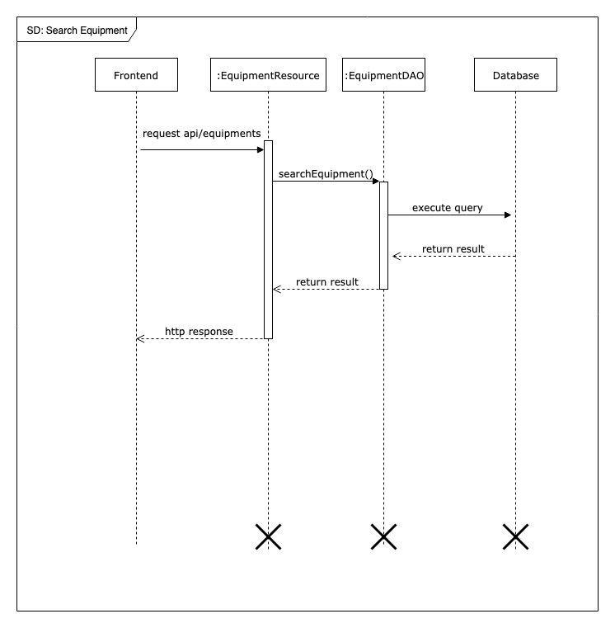

Figure 10 Sequence Diagram - Search equipment

##### Login

Summary:

* This diagram shows process of guest logging into the system
* Described in use case EMP_UC_5

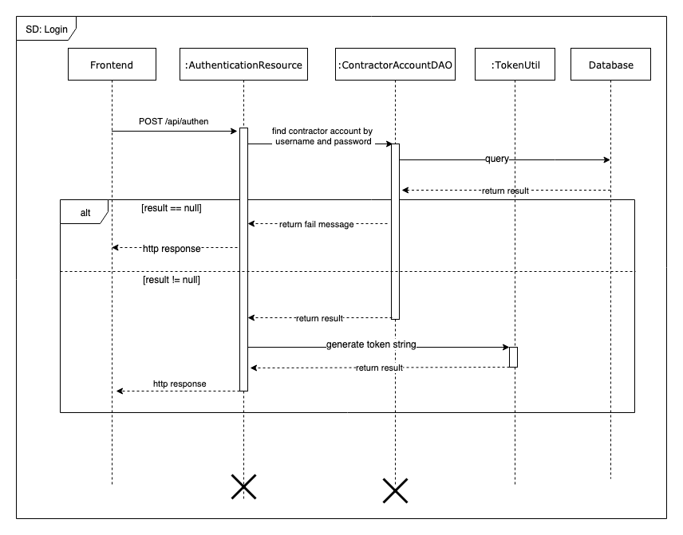

Figure 11 Sequence Diagram - Login

##### Check subscription matched

Summary:

* This diagram shows the process of Scheduler check if there are any equipment match the subscriptions
* Described in use case EMP_UC_68

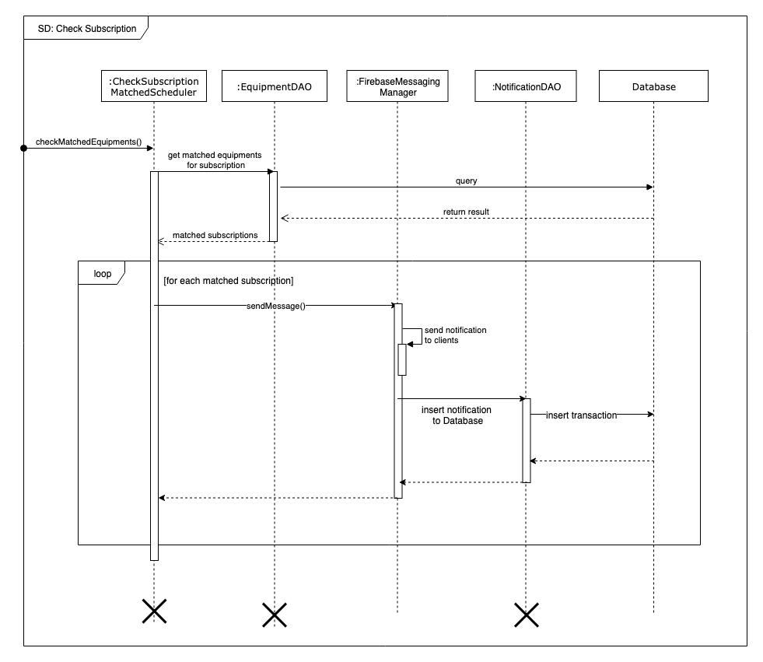

Figure 12 Sequence Diagram - Check Subscription

##### Post equipment

Summary:

* This diagram shows the process of Registered User posting a new equipment to the system after input required information
* Described in use case EMP_UC_31

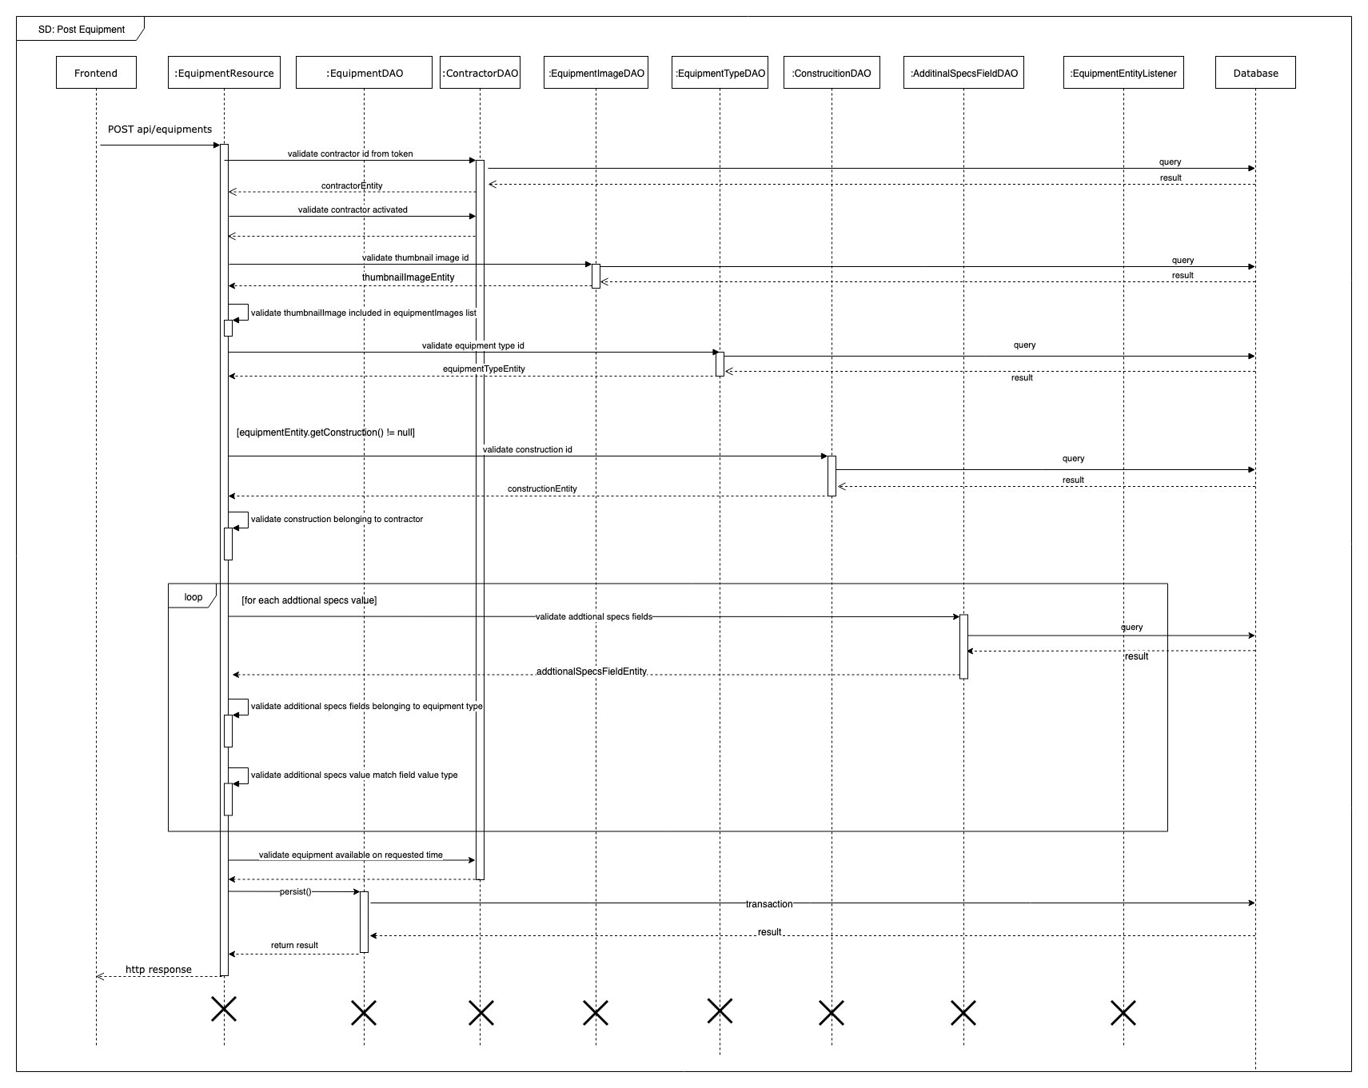

Figure 13 Sequence Diagram - Post equipment

##### Request equipment

Summary:

* This diagram shows the process of Registered User request an equipment of a supplier
* Described in use case EMP_UC_46

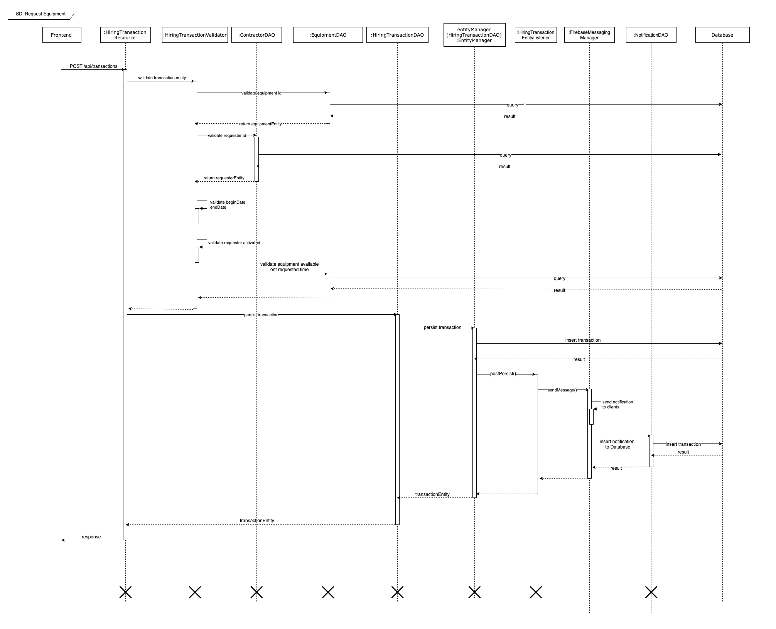

Figure 14 Sequence Diagram - Request equipment

##### Change hiring transaction status

Summary:

* This diagram shows the process of Registered User changing status of hiring transaction
* Described in use case EMP_UC_45, EMP_UC_46, EMP_UC_47, EMP_UC_50, EMP_UC_21, EMP_UC_22, EMP_UC_23, EMP_UC_24 EMP_UC_25

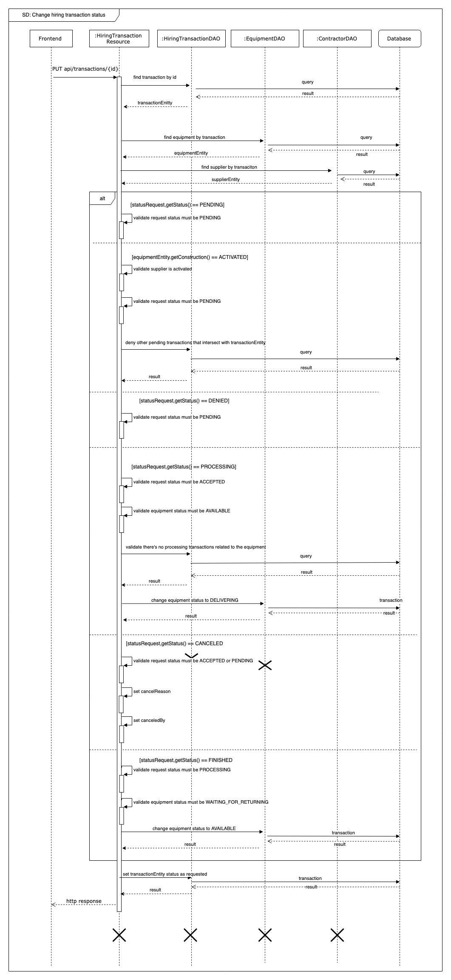

Figure 15 Sequence Diagram - Chang hiring status

##### Checkout material

Summary:

* This diagram shows the process of Registered User checkout multiple materials from cart after providing required information
* Described in use case EMP_UC_53

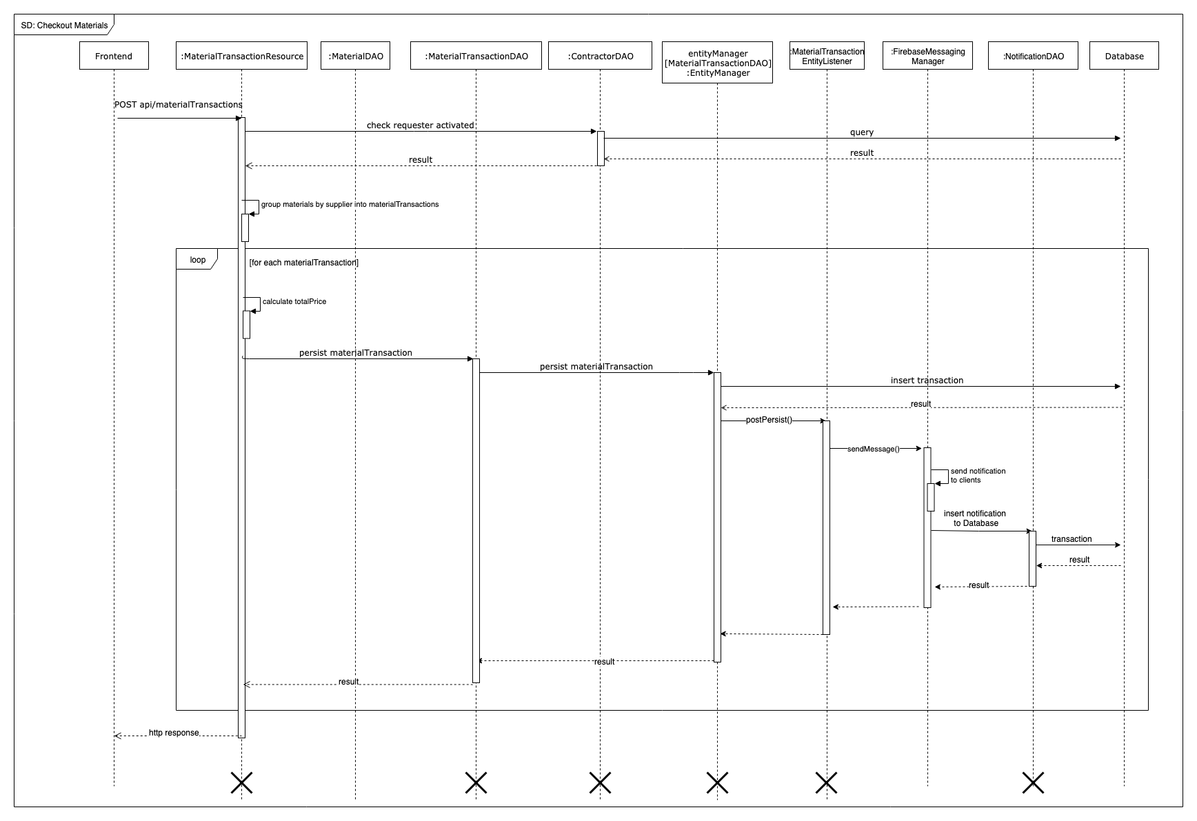

Figure 16 Sequence Diagram - Checkout Materials

##### Publish debris post

Summary:

* This diagram shows the process of Registered User publishing debris post with provided requirements to the system
* Described in use case EMP_UC_57

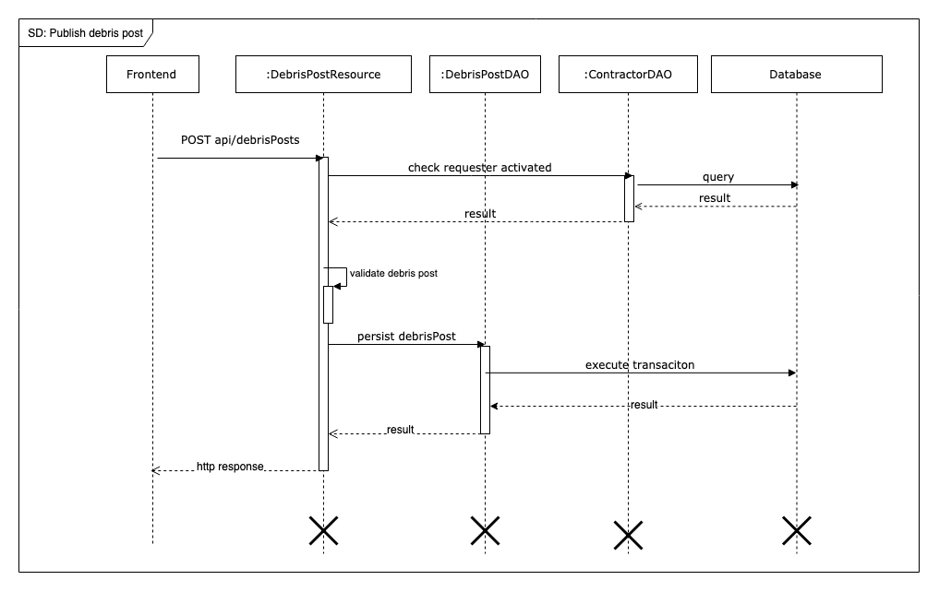

Figure 17 Sequence Diagram - Publish Debris Post

##### Bid on debris post

Summary:

* This diagram shows the process of Supplier bid on a debris post for a service offer
* Described in use case EMP_UC_40

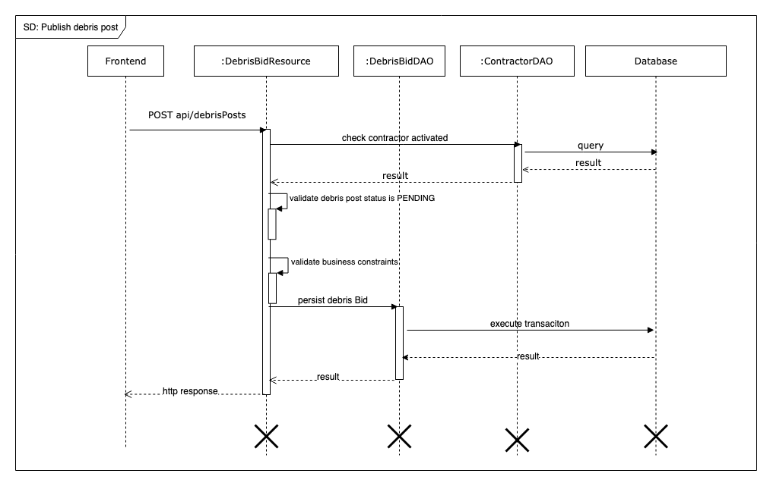

Figure 18 Sequence Diagram - Bid on Debris Post

#### Mobile application

##### Authentication

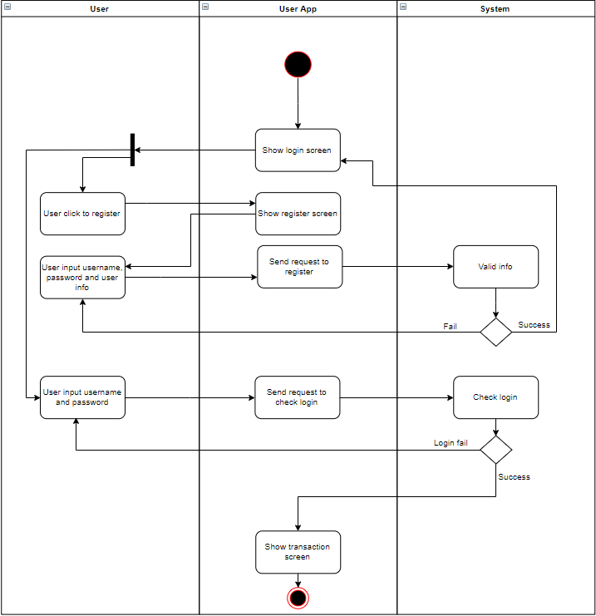

##### Rent equipment

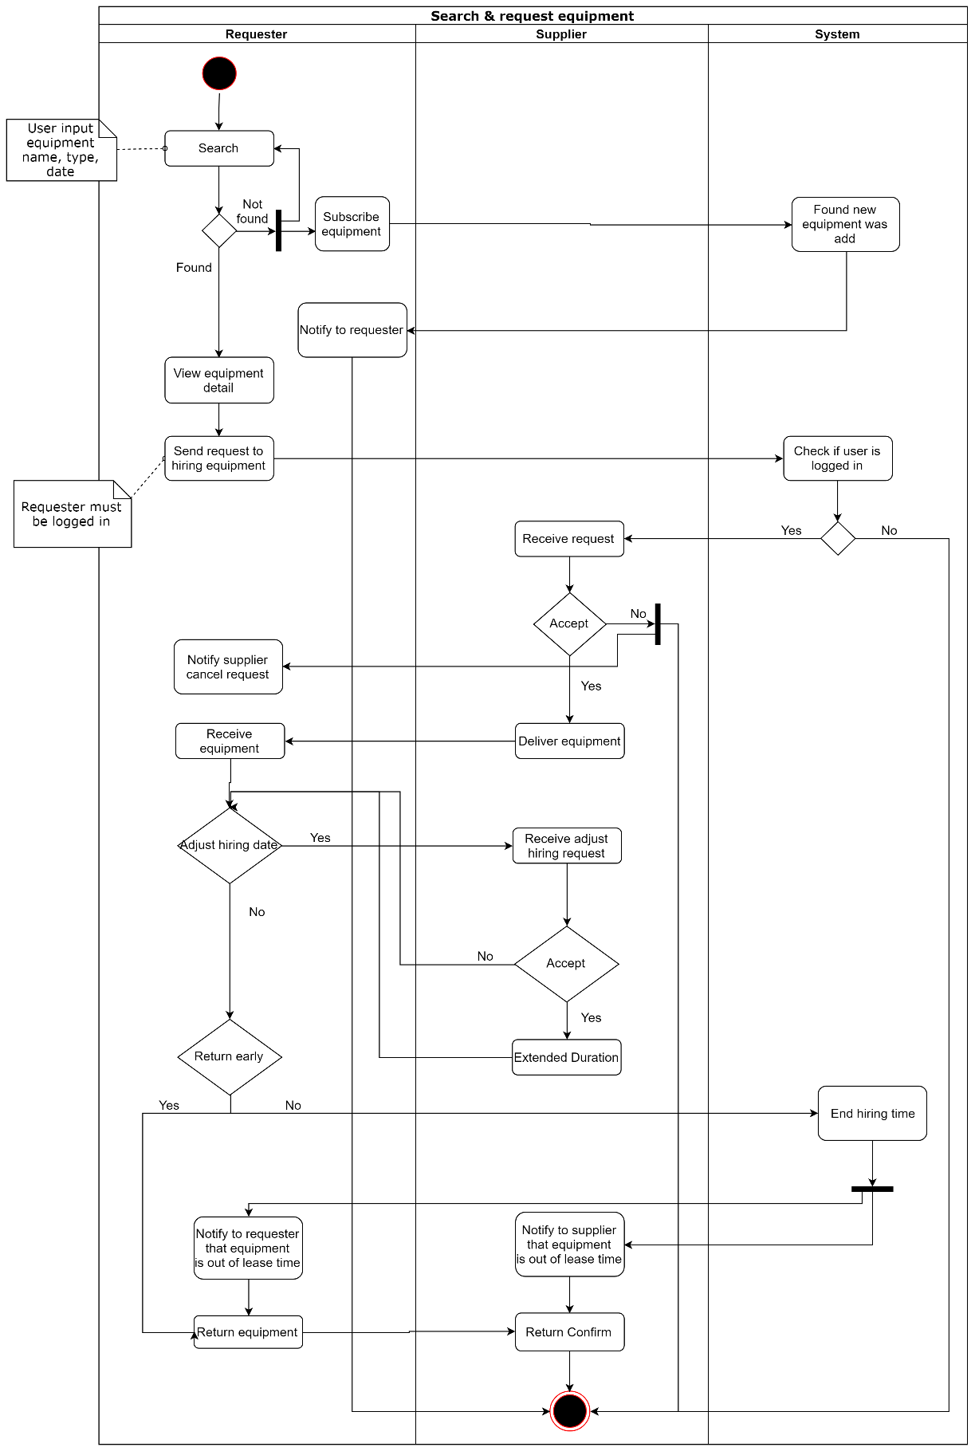

##### Buy material

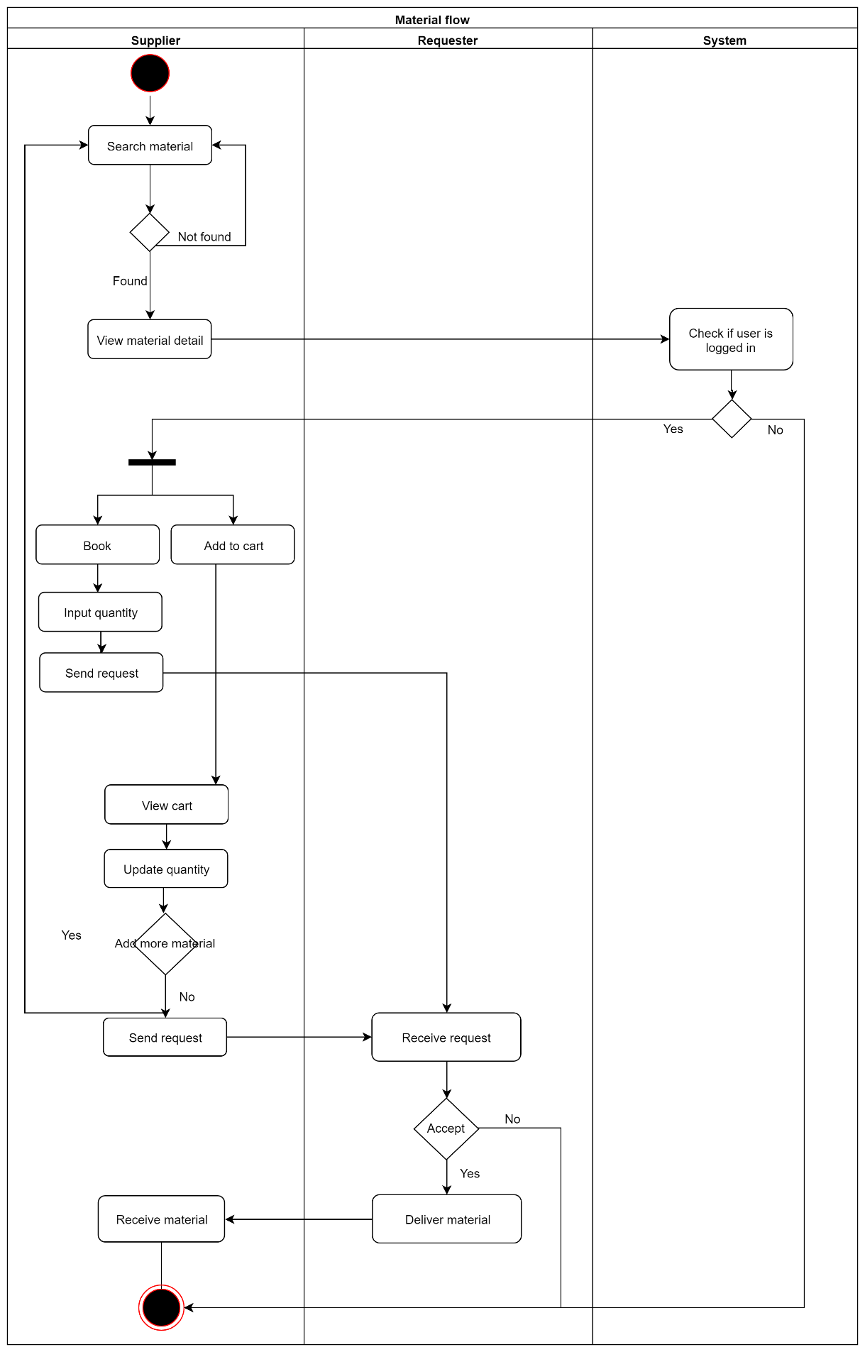

##### Bid on debris service

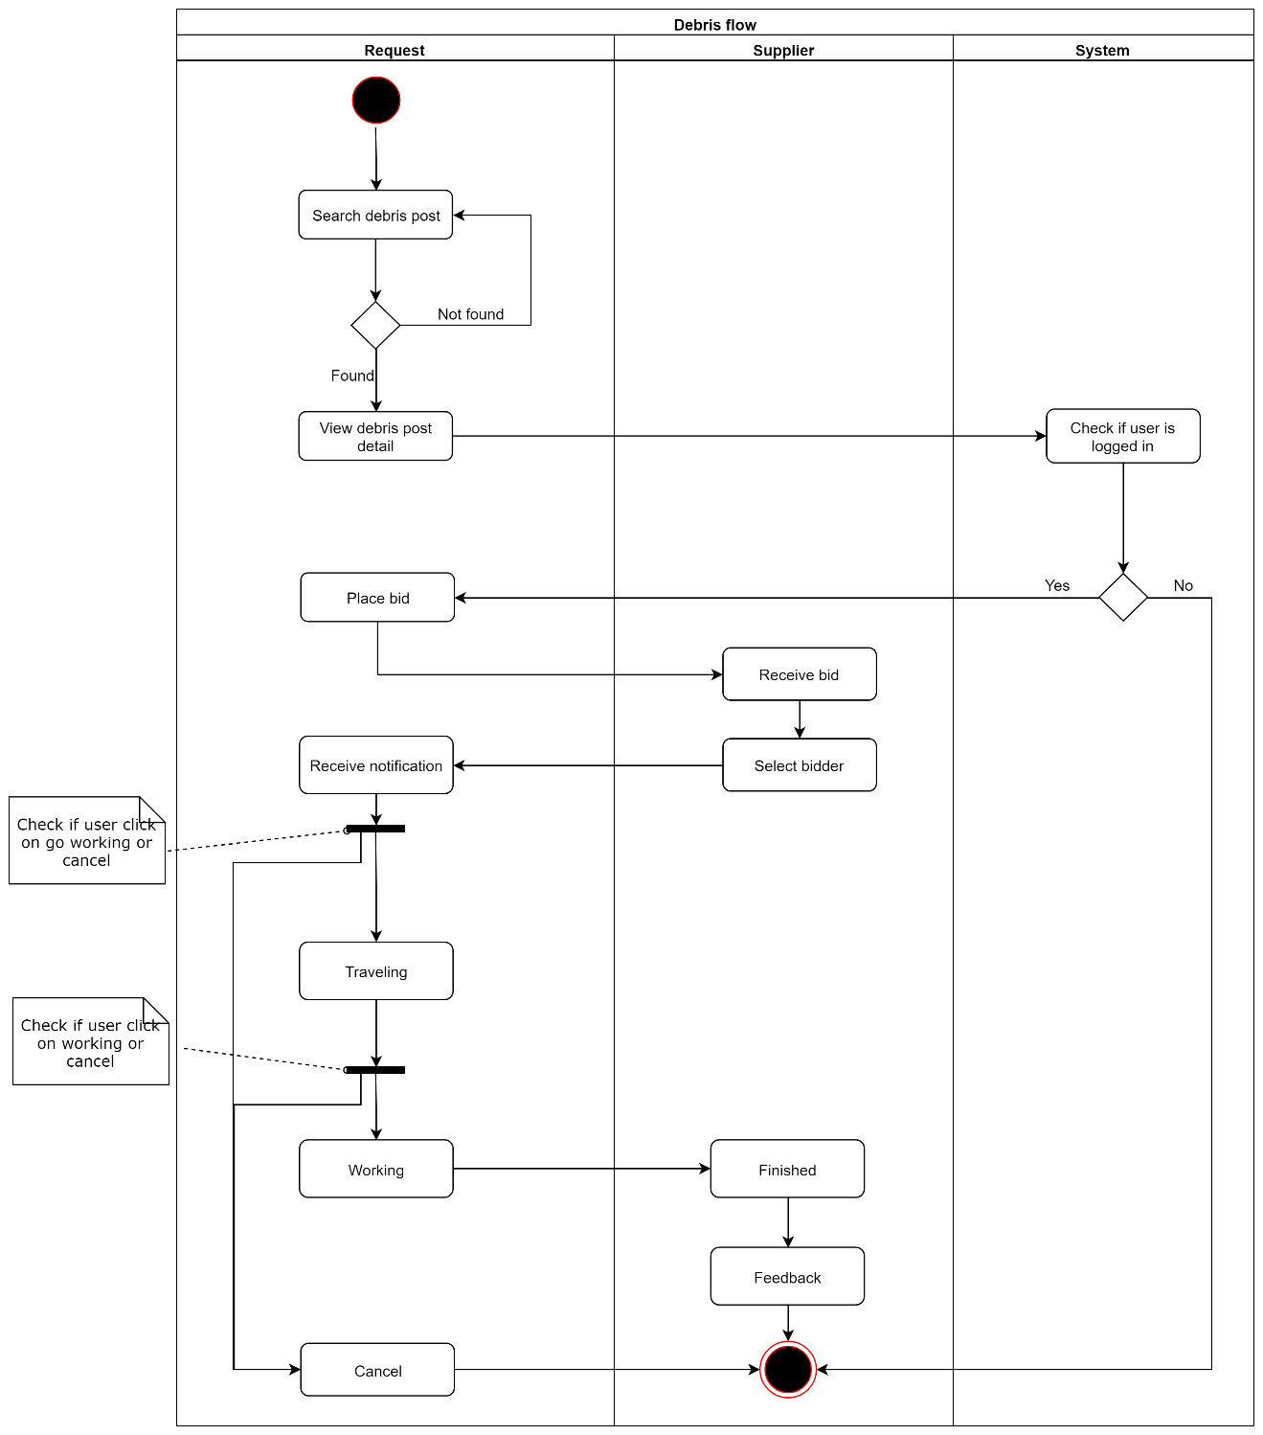

#### Admin web application

##### <Staff> Verify Registered User

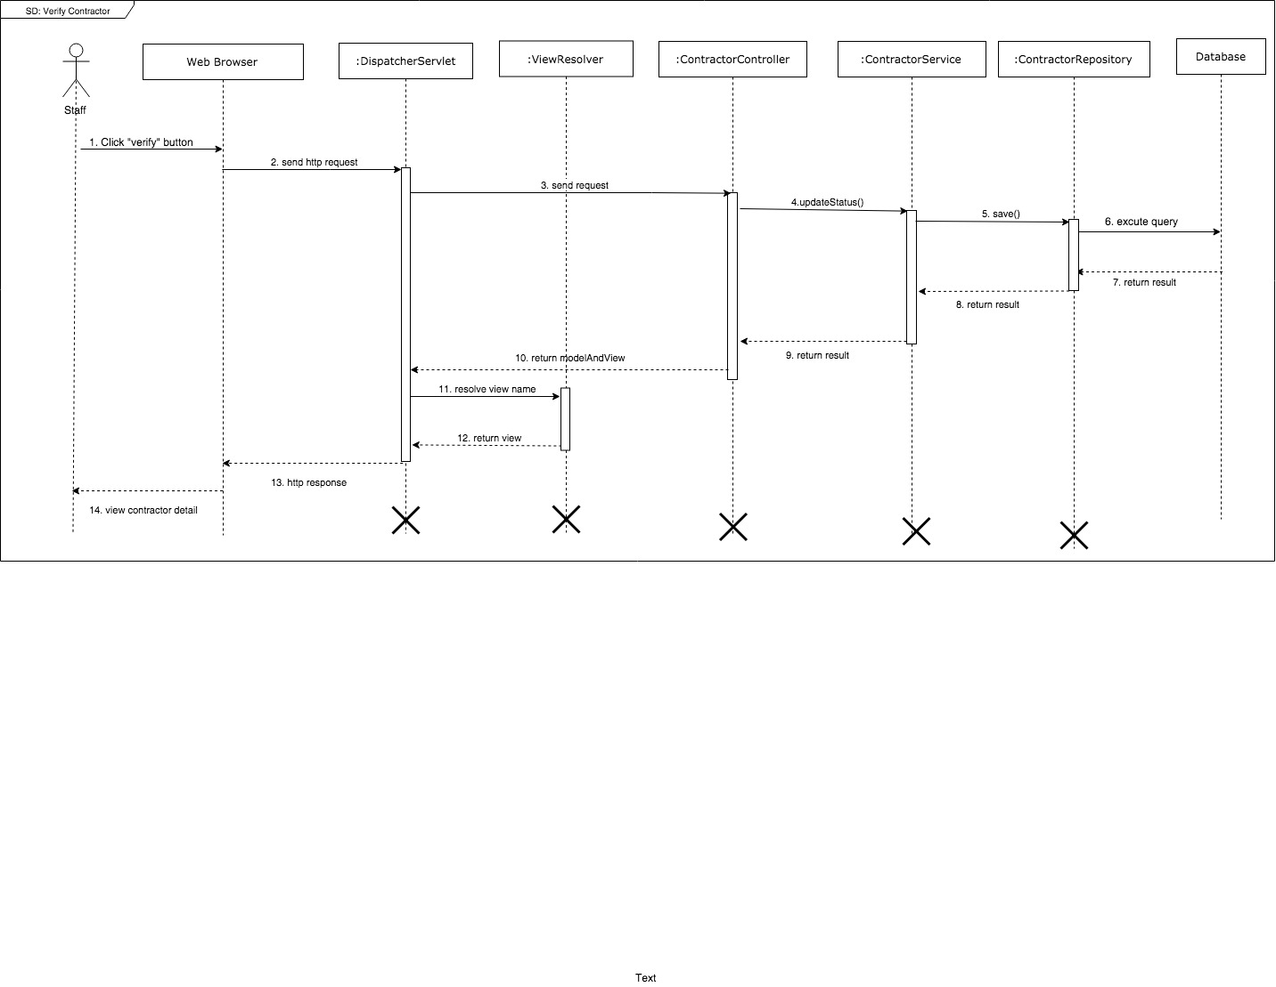

Figure 19 Sequence diagram - Verify Registered User

##### <Admin> Add staff

Figure 20 Sequence diagram - Add staff

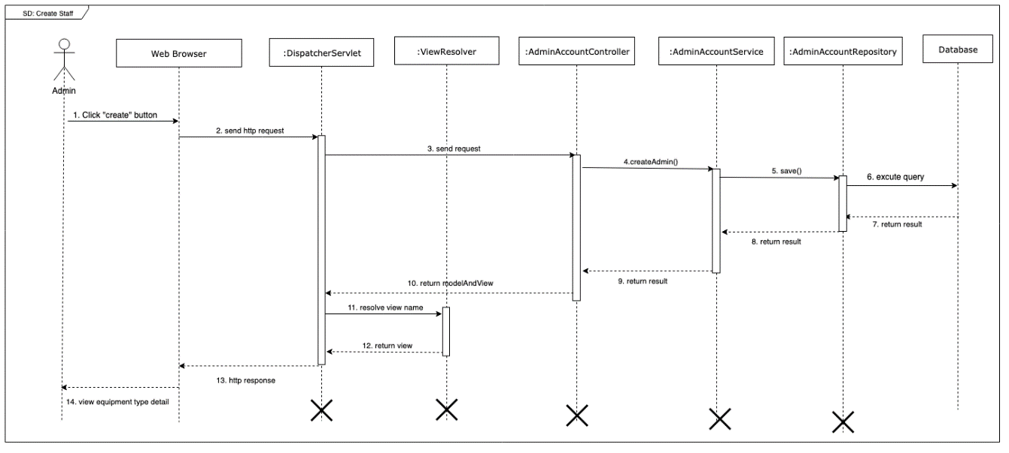

##### <Admin> Add equipment type

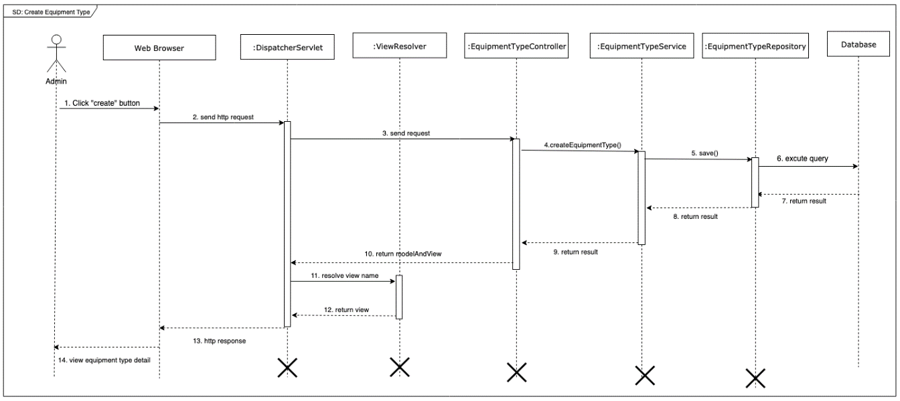

Figure 21 Sequence diagram - Add equipmen type

##### <Admin> Edit equipment type

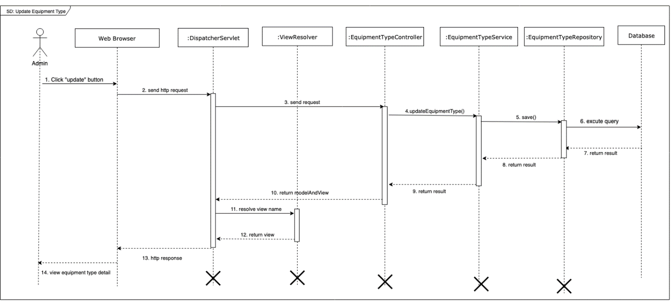

Figure 22 Edit equipment type

## Interface

### Component Interface

### User Interface Design

#### Registered User web application

##### Login

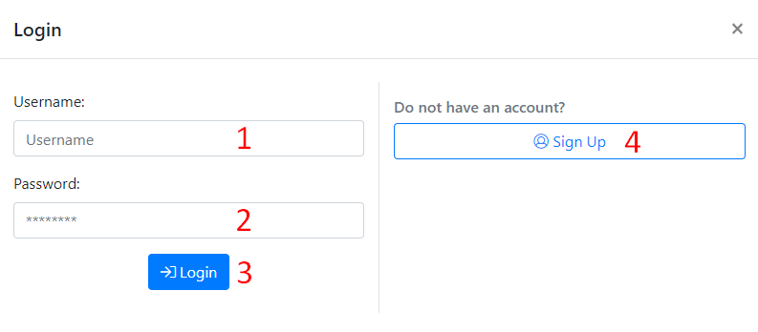

Figure 23 Login

**Fields**

|  |  |  |  |  |  |  |
| --- | --- | --- | --- | --- | --- | --- |
| **No** | **Field Name** | **Description** | **Read only** | **Mandatory** | **Control Type** | **Data Type** |
| 1 | Username | Username to login | No | Yes | TextBox | String |
| 2 | Password | Password to login | No | Yes | TexBox | String |

Table 101 <Fields> Login

**Buttons/Hyperlinks:**

|  |  |  |  |  |
| --- | --- | --- | --- | --- |
| **No** | **Function** | **Description** | **Validation** | **Outcome** |
| 3 | Login | Login into the system | Required | User logged in into the system |

Table 102 <Buttons/Hyperlinks> Login

##### Sign Up

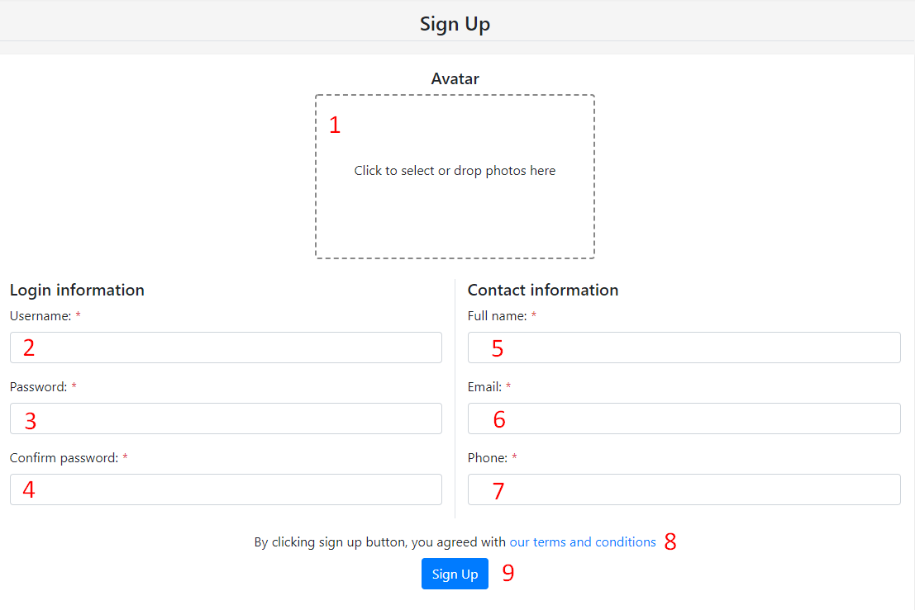

**Fields**

|  |  |  |  |  |  |  |
| --- | --- | --- | --- | --- | --- | --- |
| **No** | **Field Name** | **Description** | **Read only** | **Mandatory** | **Control Type** | **Data Type** |
| 1 | Aavatar | Avatar image to sign up | No | Yes | Image Dropzone | Image |
| 2 | Username | Username to sign up | No | Yes | TextBox | String |
| 3 | Password | Password to sign up | No | Yes | TexBox | String |
| 4 | Confirm password | Confirm enterred password | No | Yes | TextBox | String |
| 5 | Full name | Full name to sign up | No | Yes | Textbox | String |
| 6 | Email | Email to sign up | No | Yes | Textbox | String |
| 7 | Phone | Phone number to sign up | No | Yes | Textbox | String |

Table 103 <Fields> Sign Up

**Buttons/Hyperlinks:**

|  |  |  |  |  |
| --- | --- | --- | --- | --- |
| **No** | **Function** | **Description** | **Validation** | **Outcome** |
| 8 | View term and conditions | View term and conditions page | N/A | User was redirected to term and conditions page |
| 9 | Sign Up | User sign up new account | Required | User signed up new account successfully |

Table 104 <Buttons/Hyperlinks> Sign Up

##### Main menu



**Buttons/Hyperlinks:**

|  |  |  |  |  |
| --- | --- | --- | --- | --- |
| **No** | **Function** | **Description** | **Validation** | **Outcome** |
| 1 | Home | Home | N/A | Redirect to home page |
| 2 | Equipments | Search equipments page | N/A | Redirect to search equipments page |
| 3 | Materials | Search materials page | N/A | Redirect to search materials page |
| 4 | Debrises | Search debris posts page | N/A | Redirect to search debris posts page |
| 5 | Notfications | Notifications with count of unread notifications | N/A | Show list of notifications |
| 6 | User menu | User menu | N/A | Show user menu |

Table 105 <Buttons/Hyperlinks> Main menu

##### Equipment menu

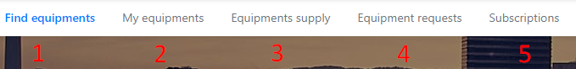

**Buttons/Hyperlinks:**

|  |  |  |  |  |
| --- | --- | --- | --- | --- |
| **No** | **Function** | **Description** | **Validation** | **Outcome** |
| 1 | Find equipments | Search equipments page | N/A | Redirect to search equipments page |
| 2 | My equipments | Manage equipments page | User must had been authorized | Redirect to manage equipments page |
| 3 | Equipments supply | Manage equipment transactions as supplier page | User must had been authorized | Redirect to manage equipment transactions as supplier page |
| 4 | Equipment requests | Manage equipment transactions as requester page | User must had been authorized | Redirect to manage equipment transactions as requester page |
| 5 | Subscriptions | Manage equipment subscriptions page | User must had been authorized | Redirect to manage equipment subscriptions page |

Table 106 <Buttons/Hyperlinks> Equipment menu

##### Material menu

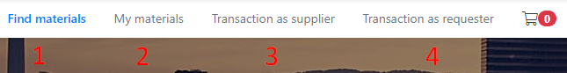

**Buttons/Hyperlinks:**

|  |  |  |  |  |
| --- | --- | --- | --- | --- |
| **No** | **Function** | **Description** | **Validation** | **Outcome** |
| 1 | Find materials | Search materials page | N/A | Redirect to search mateirals page |
| 2 | My materials | Manage materials page | User must had been authorized | Redirect to manage materials page |
| 3 | Transaction as supplier | Manage material transactions as supplier page | User must had been authorized | Redirect to manage material transactions as supplier page |
| 4 | Transaction as requester | Manage material transactions as requester page | User must had been authorized | Redirect to manage material transactions as requester page |
| 5 | Material cart | View materials cart with count of all quantity of materials in cart | User must had been authorized | Redirect to view materials cart |

Table 107 <Buttons/Hyperlinks> Material menu

##### Debris menu

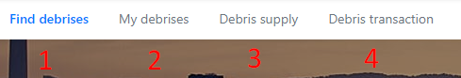

**Buttons/Hyperlinks:**

|  |  |  |  |  |
| --- | --- | --- | --- | --- |
| **No** | **Function** | **Description** | **Validation** | **Outcome** |
| 1 | Find debrises | Search debris posts page | N/A | Redirect to search debris posts page |
| 2 | My debrises | Manage debris posts page | User must had been authorized | Redirect to manage debris posts page |
| 3 | Debris supply | Manage debris transactions as supplier page | User must had been authorized | Redirect to manage debris transactions as supplier page |
| 4 | Debris transction | Manage debris transactions as requester page | User must had been authorized | Redirect to manage debris transactions as requester page |

Table 108 <Buttons/Hyperlinks> Debris menu

##### User menu

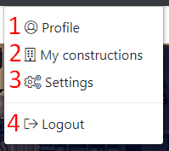

**Buttons/Hyperlinks:**

|  |  |  |  |  |
| --- | --- | --- | --- | --- |
| **No** | **Function** | **Description** | **Validation** | **Outcome** |
| 1 | Profile | Profile | User must had been authorized | Redirect to view current Registered User profile page |
| 2 | My constructions | My constructions | User must had been authorized | Redirect to manage constructions page |
| 3 | Settings | Settings | User must had been authorized | Redirect to change account settings page |
| 4 | Logout | Logout | User must had been authorized | Logout of the system |

Table 109 <Buttons/Hyperlinks> User menu

##### Search equipment

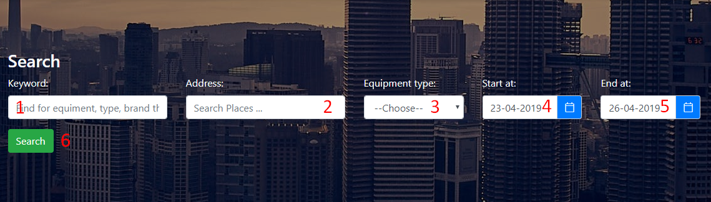

**Fields**

|  |  |  |  |  |  |  |
| --- | --- | --- | --- | --- | --- | --- |
| **No** | **Field Name** | **Description** | **Read only** | **Mandatory** | **Control Type** | **Data Type** |
| 1 | Keyword | Keyword to search | No | No | TextBox | String |
| 2 | Address | Address to search | No | No | Location select | Location |
| 3 | Equipment type | Equipment type to search | No | No | SelectBox | Number |
| 4 | Start at | Begin date of hiring period | No | Yes | Date picker | Date string |
| 5 | End at | End date of hiring period | No | Yes | Date picker | Date string |

Table 110 <Fields> Equipment search

**Buttons/Hyperlinks:**

|  |  |  |  |  |
| --- | --- | --- | --- | --- |
| **No** | **Function** | **Description** | **Validation** | **Outcome** |
| 1 | Search | Search equipments | N/A | Search equipments with inputed criteria and show results |

Table 111 <Buttons/Hyperlinks> Search equipment

##### Equipment search results

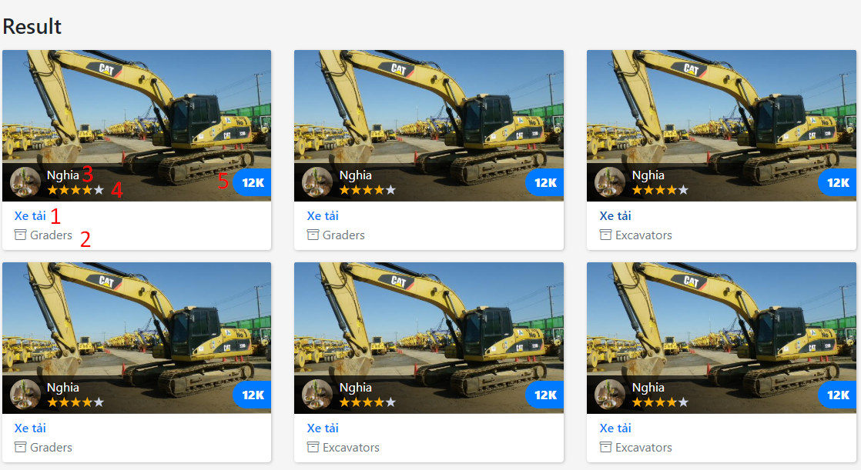

##### Equipment detail

##### Post new equipment

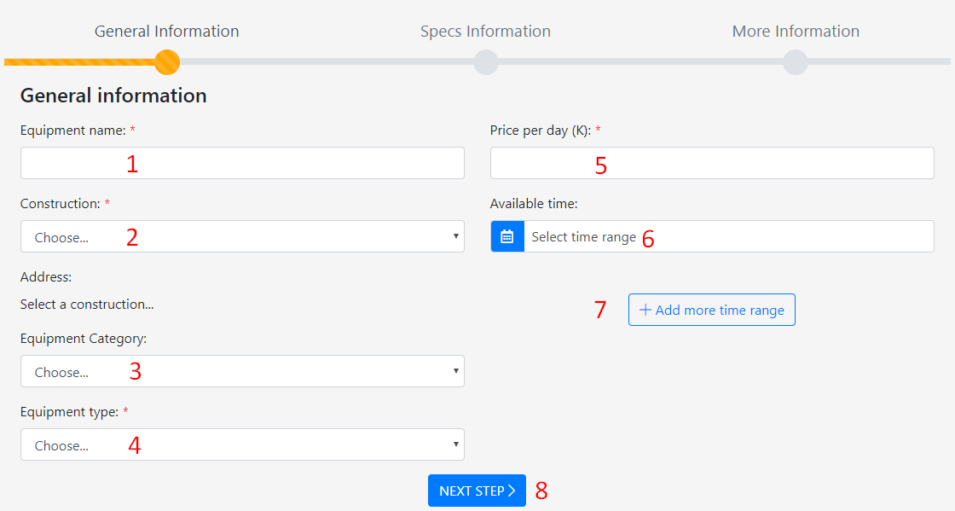

**Fields**

|  |  |  |  |  |  |  |
| --- | --- | --- | --- | --- | --- | --- |
| **No** | **Field Name** | **Description** | **Read only** | **Mandatory** | **Control Type** | **Data Type** |
| 1 | Equipment name | Name of equipment | No | Yes | TextBox | String |
| 2 | Construction | Construction where equipment located | No | Yes | Select box | Number |
| 3 | Equipment category | Equipment category of equipment type | No | No | Select box | Number |
| 4 | Equipment type | Type of equipment | No | Yes | Select box | Number |
| 5 | Price per day | Price per day | No | Yes | Text box | Number |
| 6 | Available time range | Available time range | No | Yes | Date range picker | Date range |

Table 112 <Fields> Post new equipment step 1

**Buttons/Hyperlinks:**

|  |  |  |  |  |
| --- | --- | --- | --- | --- |
| **No** | **Function** | **Description** | **Validation** | **Outcome** |
| 7 | Add more time range | Add one time range | N/A | New time range was added |
| 8 | Next step | Move to next step | Validate form | Moved to step 2 |

Table 113 <Buttons/Hyperlinks> Post new equipment step 1

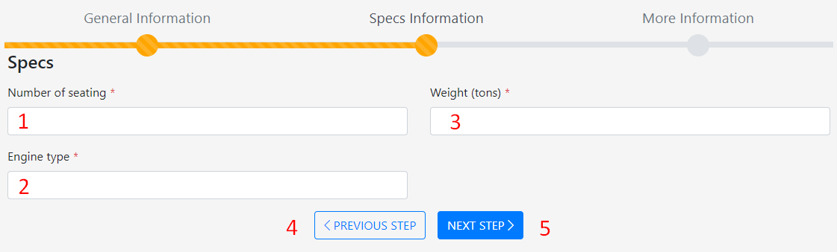

**Fields**

|  |  |  |  |  |  |  |
| --- | --- | --- | --- | --- | --- | --- |
| **No** | **Field Name** | **Description** | **Read only** | **Mandatory** | **Control Type** | **Data Type** |
| 1 | Number of seating | One of specification field of equipment type | No | Yes | TextBox | String |
| 2 | Egine type | One of specification field of equipment type | No | Yes | TextBox | String |
| 3 | Weight | One of specification field of equipment type | No | Yes | TextBox | String |

Table 114 <Fields> Post new equipment step 2

**Buttons/Hyperlinks:**

|  |  |  |  |  |
| --- | --- | --- | --- | --- |
| **No** | **Function** | **Description** | **Validation** | **Outcome** |
| 7 | Previous step | Back to previous step | N/A | Show step 1 |
| 8 | Next step | Move to next step | N/A | Moved to step 3 |

Table 115 <Buttons/Hyperlinks> Post new equipment step 2

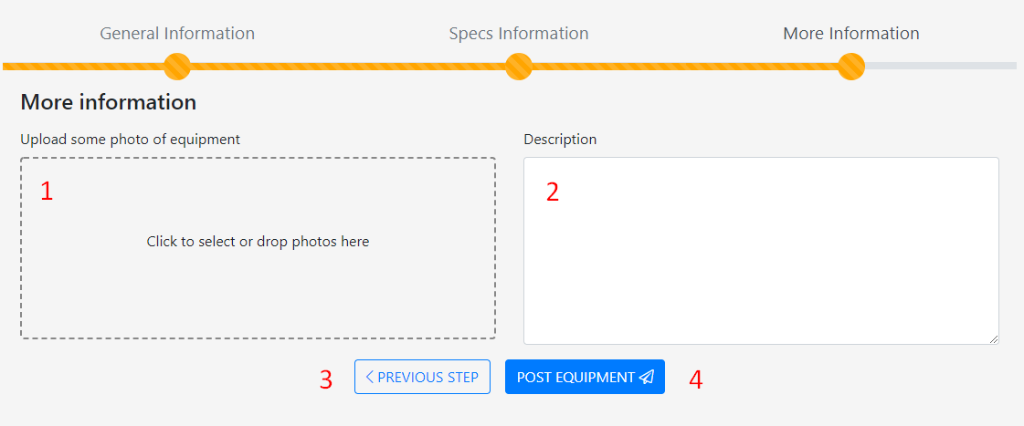

**Fields**

|  |  |  |  |  |  |  |
| --- | --- | --- | --- | --- | --- | --- |
| **No** | **Field Name** | **Description** | **Read only** | **Mandatory** | **Control Type** | **Data Type** |
| 1 | Upload some photos of equipment | Photos of equipment | No | Yes | Image drop zone | Images |
| 2 | Description | Description of equipment | No | Yes | TextBox | String |

Table 116 <Fields> Post new equipment step 3

**Buttons/Hyperlinks:**

|  |  |  |  |  |
| --- | --- | --- | --- | --- |
| **No** | **Function** | **Description** | **Validation** | **Outcome** |
| 7 | Previous step | Back to previous step | N/A | Show step 2 |
| 8 | Post equipment | Post equipment | Validate form | New equipment was added, redirect to equipment detail page |

Table 117 <Buttons/Hyperlinks> Post new equipment step 3

##### View and delete equipments

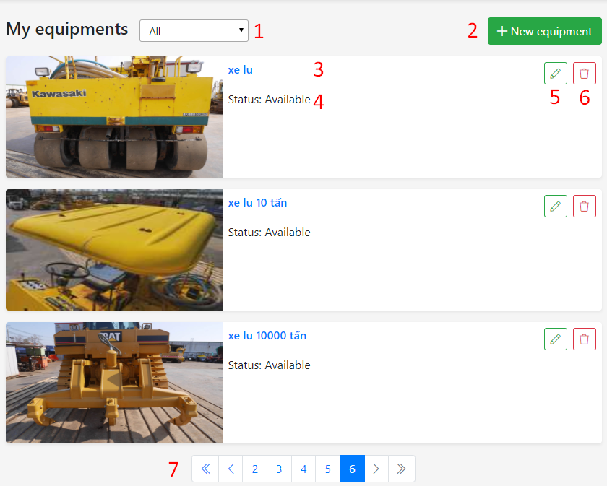

**Fields**

|  |  |  |  |  |  |  |
| --- | --- | --- | --- | --- | --- | --- |
| **No** | **Field Name** | **Description** | **Read only** | **Mandatory** | **Control Type** | **Data Type** |
| 1 | Equipment status | Equipment status filter | No | Yes | Select box | String |
| 3 | Equipment name | Name of equipment | No | Yes | Text | String |
| 4 | Equipment status | Status of equipment | No | Yes | Text | String |

Table 118 <Fields> Post new equipment step 2

**Buttons/Hyperlinks:**

|  |  |  |  |  |
| --- | --- | --- | --- | --- |
| **No** | **Function** | **Description** | **Validation** | **Outcome** |
| 2 | New equipment | Add new equipment | N/A | Show add equipment page |
| 5 | Edit | Edit equipment | N/A | Show edit equipment page |
| 6 | Delete | Delete equipment | Not included in any transaction | The equipment was deleted |
| 7 | Pagination | Pagination of list equipments | N/A | Show equipment of the page |

Table 119 <Buttons/Hyperlinks> View and delete equipment

##### Edit equipment

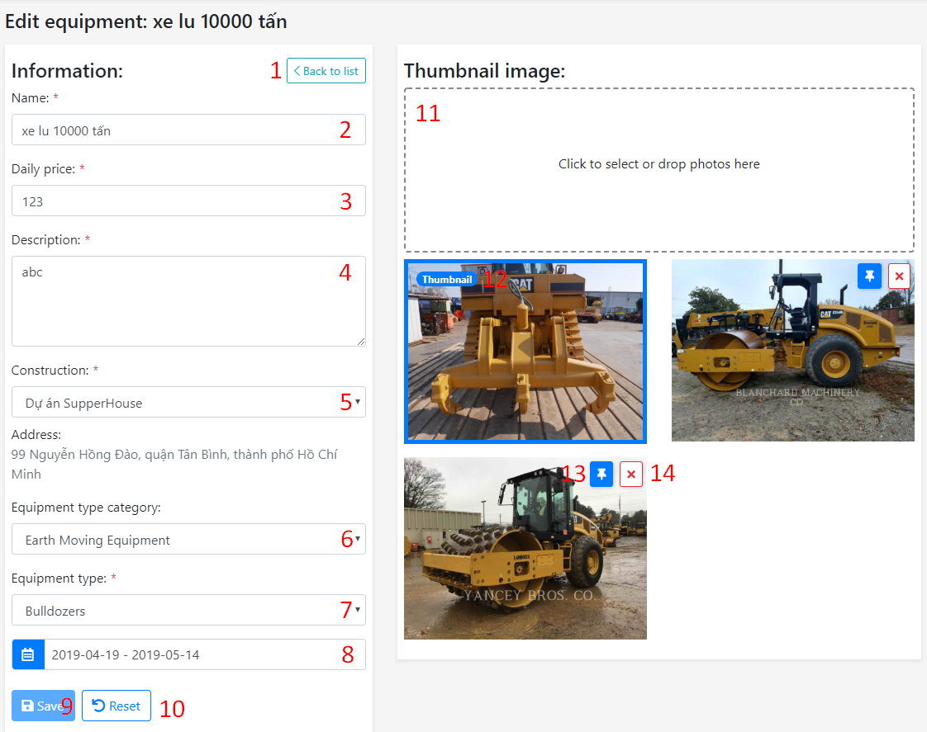

**Fields**

|  |  |  |  |  |  |  |
| --- | --- | --- | --- | --- | --- | --- |
| **No** | **Field Name** | **Description** | **Read only** | **Mandatory** | **Control Type** | **Data Type** |
| 2 | Name | Name of equipment | No | Yes | Text box | String |
| 3 | Daily price | Daily price of equipment | No | Yes | Text box | Number |
| 4 | Description | Description of equipment | No | Yes | Text box | String |
| 5 | Construction | Construction where equipment located | No | Yes | Select box | Number |
| 6 | Equipment category | Category of equipment | No | No | Select box | Number |
| 7 | Equipment type | Type of equipment | No | Yes | Select box | Number |
| 8 | Available time range | Available time range of equipment | No | Yes | Date range picker | Date range |
| 11 | Thumbnail image | Upload more thumbnail images of equipment | No | Yes | Image dropzone | Images |
| 12 | Thumbnail | Show image was selected as equipment thumbnail | No | No | Text | N/A |

Table 120 <Fields> Edit equipment

**Buttons/Hyperlinks:**

|  |  |  |  |  |
| --- | --- | --- | --- | --- |
| **No** | **Function** | **Description** | **Validation** | **Outcome** |
| 9 | Save | Save all field of equipment | One of field was changed | Equipment was updated with successfully message |
| 8 | Reset | Reset all changed field | N/A | All changed field was reseted |
| 13 | Set thumnail | Set image as equipment thumbnail | Image is not selected as equipment thumbnail | Equipment thumbnail was changed to current image |
| 14 | Delete image | Delete equipment’s image | Image is not selected as equipment thumbnail | Current image was deleted |

Table 121 <Buttons/Hyperlinks> Edit equipment

##### Manage equipment transactions

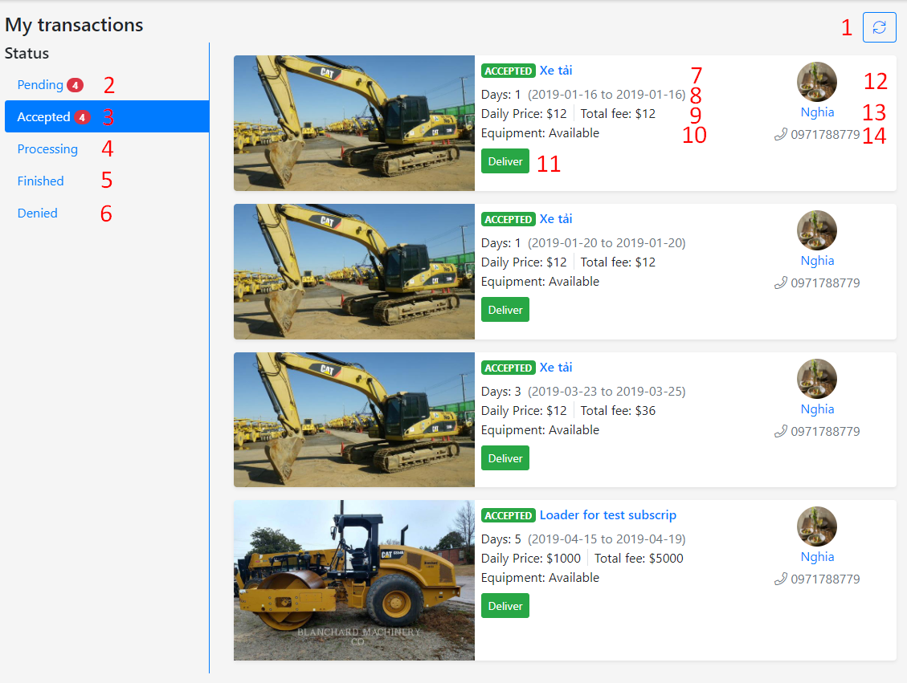

**Fields**

|  |  |  |  |  |  |  |
| --- | --- | --- | --- | --- | --- | --- |
| **No** | **Field Name** | **Description** | **Read only** | **Mandatory** | **Control Type** | **Data Type** |
| 2 | Name | Name of equipment | No | Yes | Text box | String |
| 3 | Daily price | Daily price of equipment | No | Yes | Text box | Number |
| 4 | Description | Description of equipment | No | Yes | Text box | String |
| 5 | Construction | Construction where equipment located | No | Yes | Select box | Number |

Table 122 <Fields> Manage equipment transactions

**Buttons/Hyperlinks:**

|  |  |  |  |  |
| --- | --- | --- | --- | --- |
| **No** | **Function** | **Description** | **Validation** | **Outcome** |
| 9 | Save | Save all field of equipment | One of field was changed | Equipment was updated with successfully message |
| 8 | Reset | Reset all changed field | N/A | All changed field was reseted |
| 13 | Set thumnail | Set image as equipment thumbnail | Image is not selected as equipment thumbnail | Equipment thumbnail was changed to current image |
| 14 | Delete image | Delete equipment’s image | Image is not selected as equipment thumbnail | Current image was deleted |

Table 123 <Buttons/Hyperlinks> Manage equipment transactions

##### Manage subscriptions

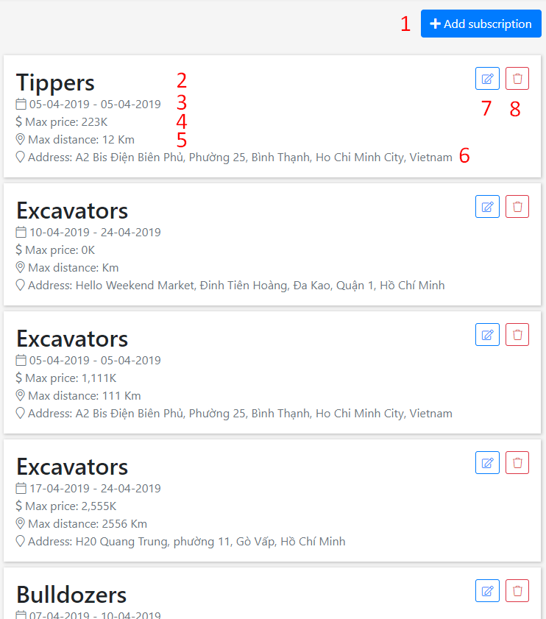

**Fields**

|  |  |  |  |  |  |  |
| --- | --- | --- | --- | --- | --- | --- |
| **No** | **Field Name** | **Description** | **Read only** | **Mandatory** | **Control Type** | **Data Type** |
| 2 | Equipment type name | Equipment type of subscription | N/A | N/A | Text | N/A |
| 3 | Available time range | Availabel time range of subscription | N/A | N/A | Text | N/A |
| 4 | Max price | Max price of subcription | N/A | N/A | Text | N/A |
| 5 | Max disctance | Max distance of subcription | N/A | N/A | Text | N/A |
| 6 | Address | Address of subscription | N/A | N/A | Text | N/A |

Table 124 <Fields> Manage equipment subscriptions

**Buttons/Hyperlinks:**

|  |  |  |  |  |
| --- | --- | --- | --- | --- |
| **No** | **Function** | **Description** | **Validation** | **Outcome** |
| 1 | Add new subscription | Add new subscription | N/A | Show add equipment subscription form |
| 7 | Edit subscription | Edit subscription | N/A | Show edit equipment subscription form |
| 8 | Delete subscription | Delete subscription | N/A | Equipment subscription deleted |

Table 125 <Buttons/Hyperlinks> Manage equipment subscriptions

#### Mobile application

##### Login

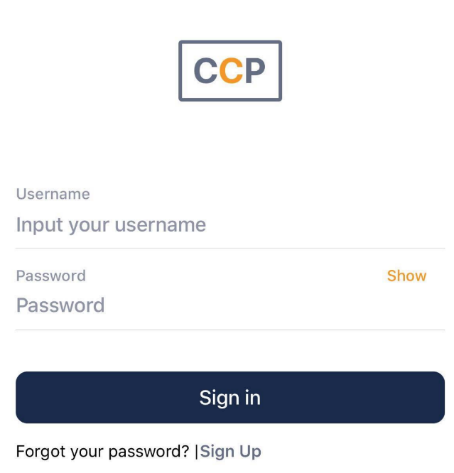

**Fields**

|  |  |  |  |  |  |  |
| --- | --- | --- | --- | --- | --- | --- |
| **No** | **Field Name** | **Description** | **Read only** | **Mandatory** | **Control Type** | **Data Type** |
| 1 | Username | Input username to login | No | Yes | TextInput | String |
| 2 | Password | Input password to login | No | Yes | TextInput | String |

Table 15 <Fields> Login

**Buttons/Hyperlinks:**

|  |  |  |  |  |
| --- | --- | --- | --- | --- |
| **No** | **Function** | **Description** | **Validation** | **Outcome** |
| 3 | Login | Login into the system | Required | User logged in into the system |
| 4 | Signup | Navigate to signup screen | N/A | Navigate to signup screen |

##### Register

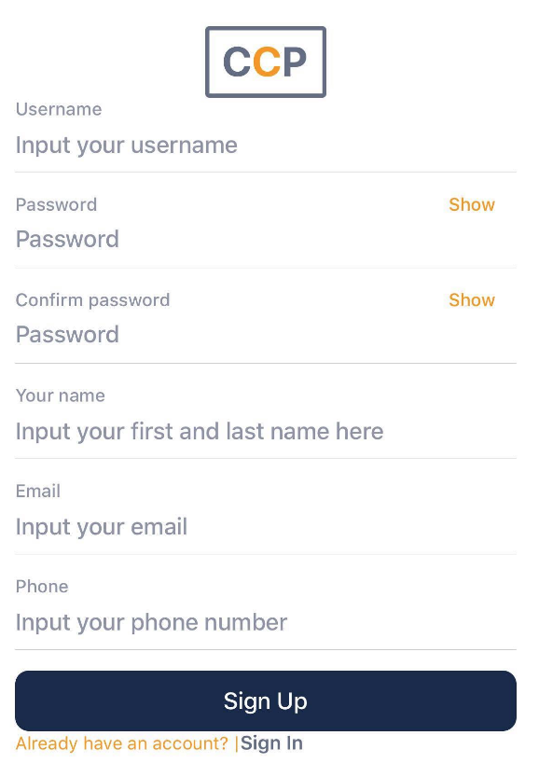

**Fields**

|  |  |  |  |  |  |  |
| --- | --- | --- | --- | --- | --- | --- |
| **No** | **Field Name** | **Description** | **Read only** | **Mandatory** | **Control Type** | **Data Type** |
| 1 | Username | Input username to login | No | Yes | TextInput | String |
| 2 | Password | Input password to login | No | Yes | TextInput | String |
| 3 | Confirm password | Confirm password | No | Yes | TextInput | String |
| 4 | Your name | Input first name and last name | No | Yes | TextInput | String |
| 5 | Email | Input email | No | Yes | TextInput | String |
| 6 | Phone | Input phone | No | Yes | TextInput | String |

Table 15 <Fields> Login

**Buttons/Hyperlinks:**

|  |  |  |  |  |
| --- | --- | --- | --- | --- |
| **No** | **Function** | **Description** | **Validation** | **Outcome** |
| 3 | Signup |  | Required | User logged in into the system |

##### Menu bar



##### Search equipment

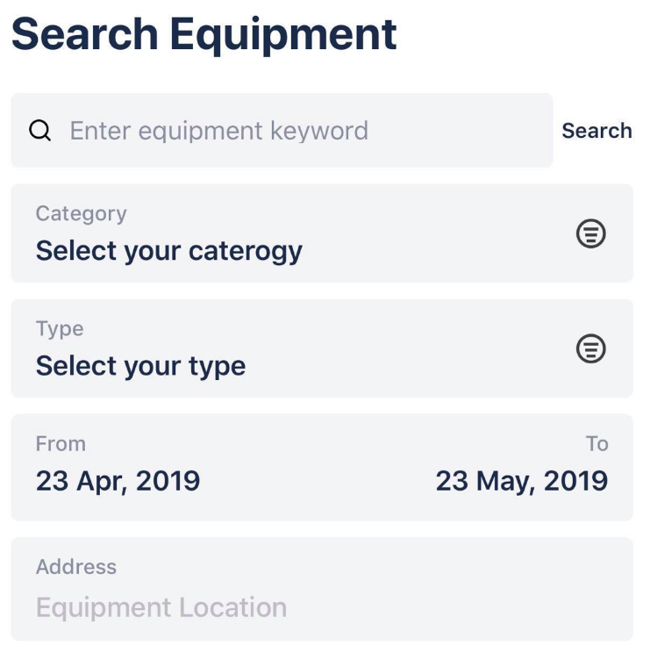

**Fields**

|  |  |  |  |  |  |  |
| --- | --- | --- | --- | --- | --- | --- |
| **No** | **Field Name** | **Description** | **Read only** | **Mandatory** | **Control Type** | **Data Type** |
| 1 | Keyword | Keyword to search | No | No | TextBox | String |
| 2 | Equipment category | Category of equipment | No | No | Select box | Number |
| 3 | Equipment type | Type of equipment | No | Yes | Select box | Number |
| 4 | Start at | Begin date of hiring period | No | Yes | Date picker | Date string |
| 5 | End at | End date of hiring period | No | Yes | Date picker | Date string |
| 6 | Address | Address to search | No | No | Location select | Location |

**Buttons/Hyperlinks:**

|  |  |  |  |  |
| --- | --- | --- | --- | --- |
| **No** | **Function** | **Description** | **Validation** | **Outcome** |
| 1 | Search | Search equipments | N/A | Search equipments with inputed criteria and show results |

##### Equipment search result

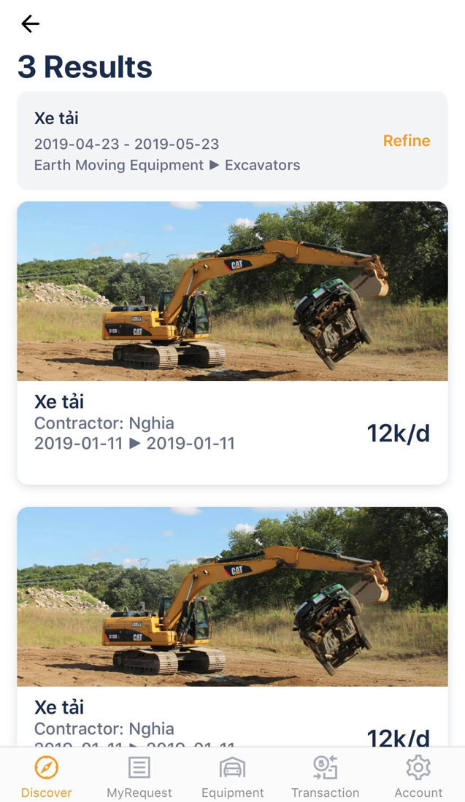

##### View equipment detail

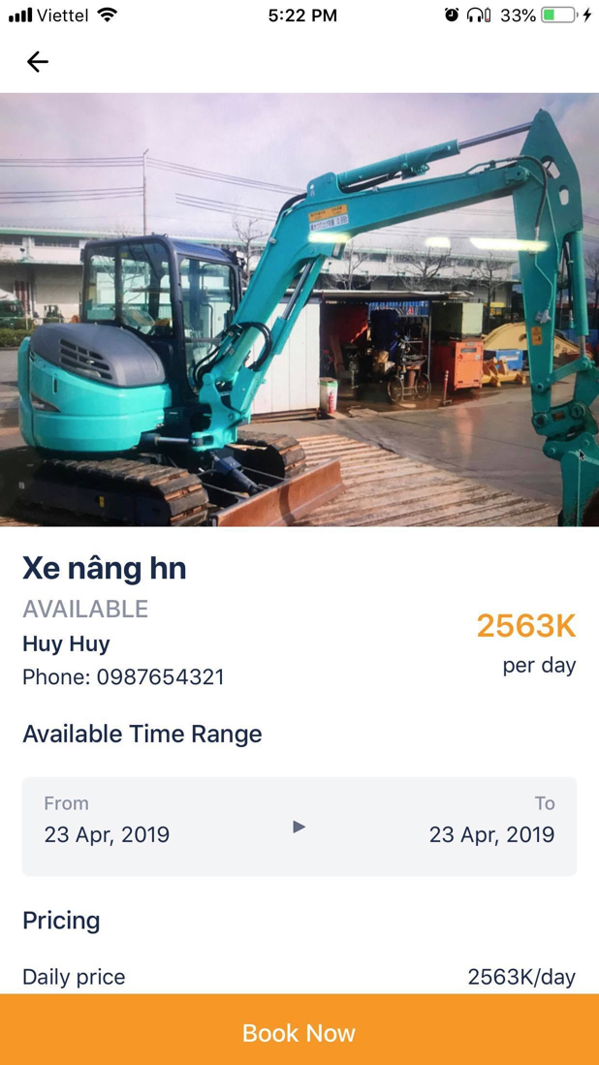

##### View equipment transaction as supplier

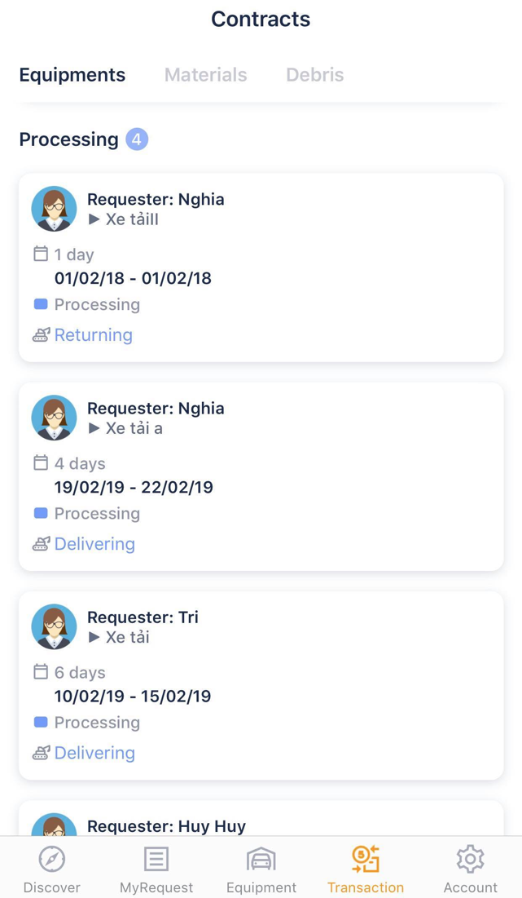

##### Post equipment

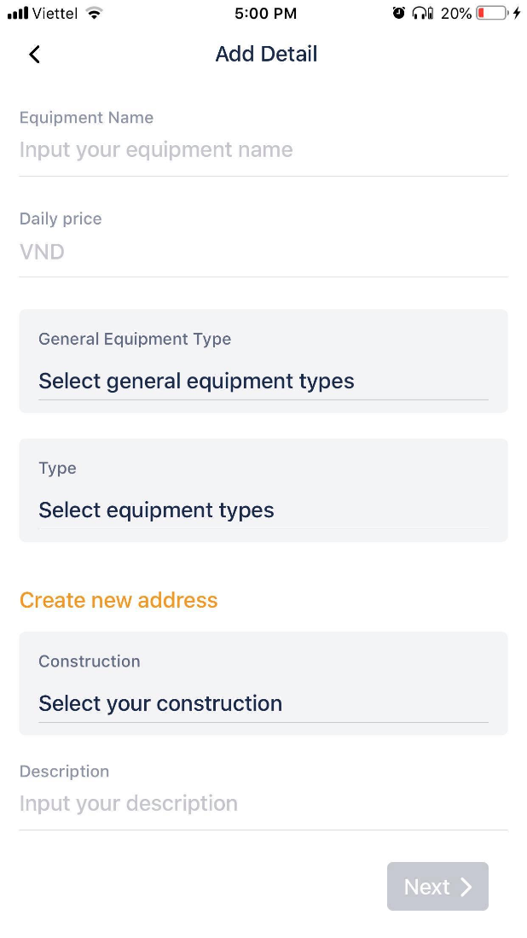

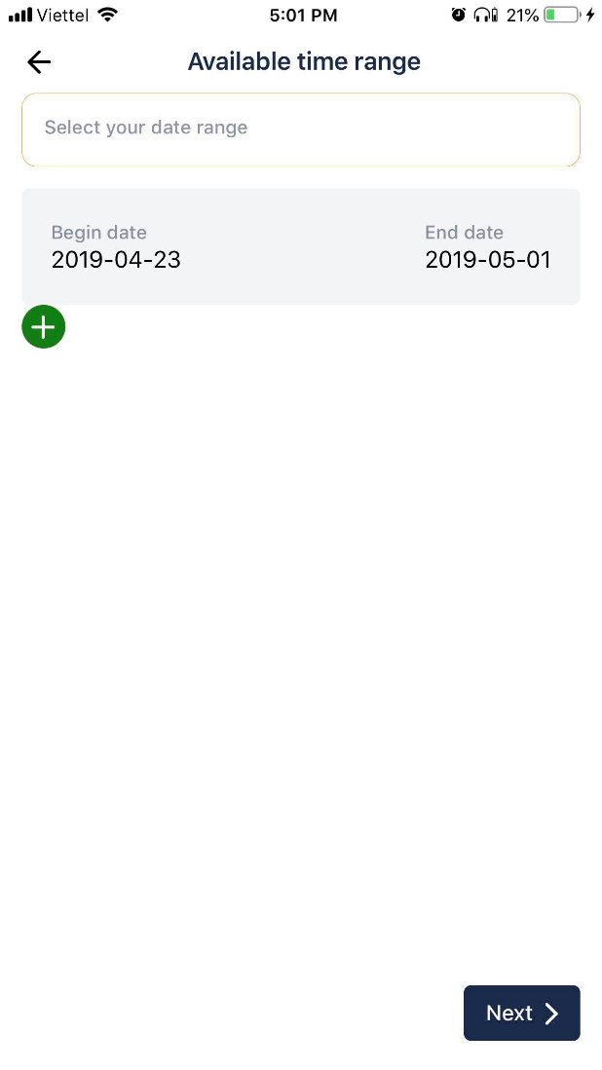

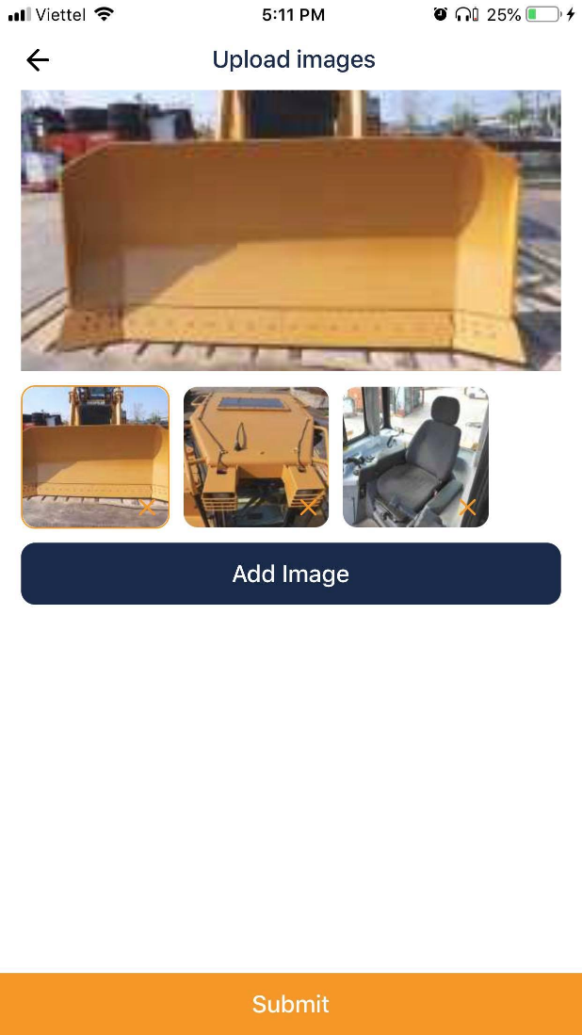

##### Account

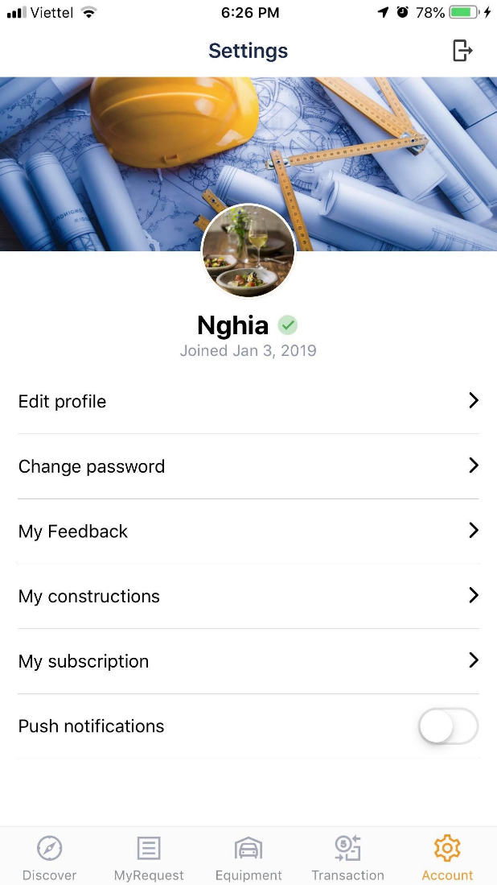

##### Manage construction

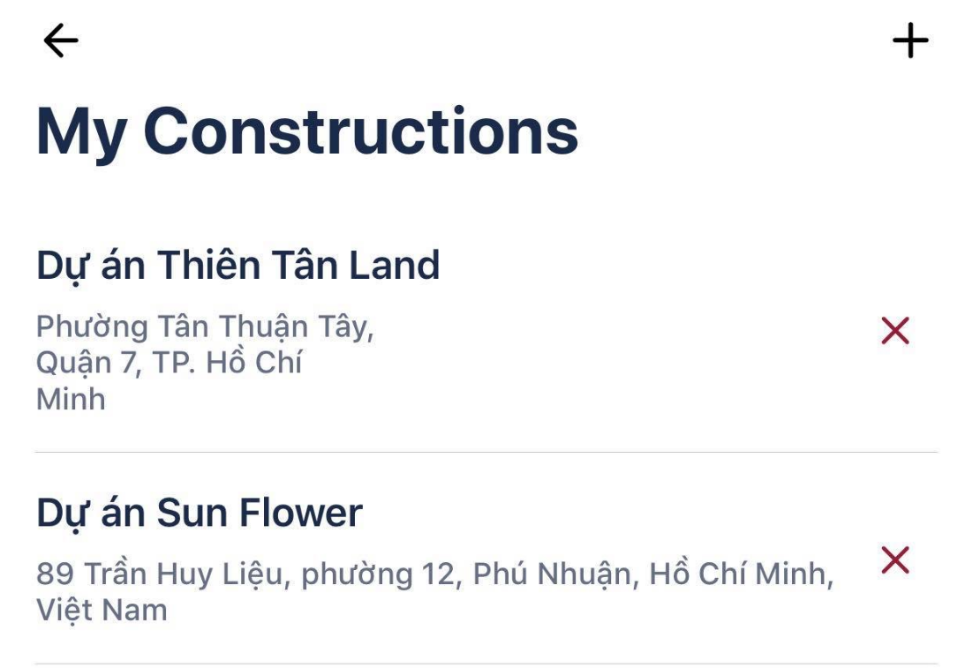

##### Edit profile

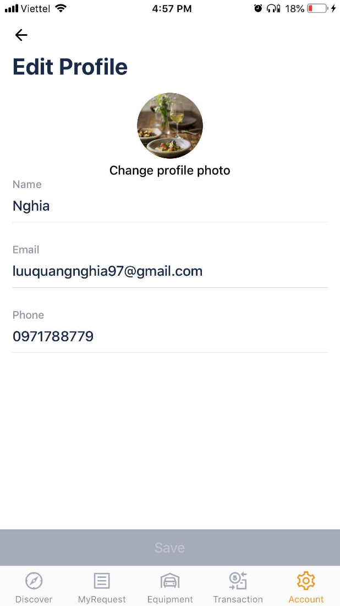

##### Manage subscription

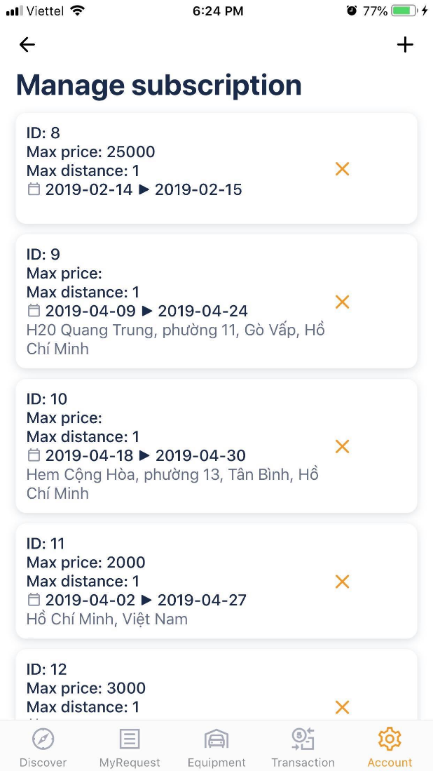

#### Web admin application

##### Login

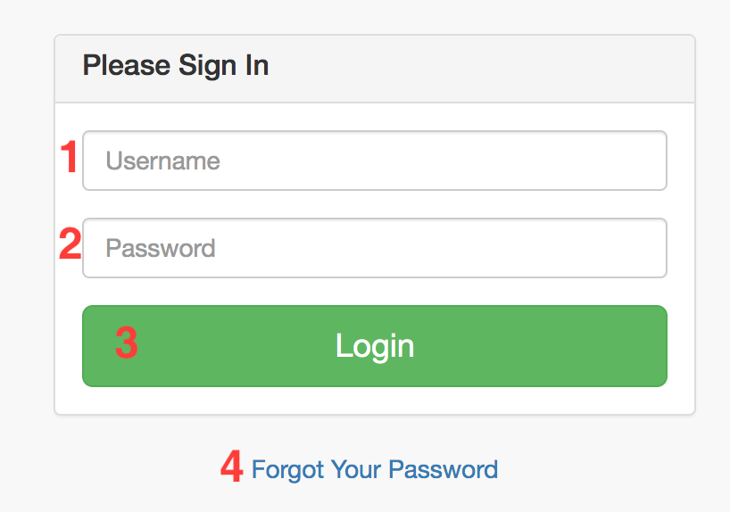

**Fields**

|  |  |  |  |  |  |  |
| --- | --- | --- | --- | --- | --- | --- |
| **No** | **Field Name** | **Description** | **Read only** | **Mandatory** | **Control Type** | **Data Type** |
| 1 | Useranme | Username to login | No | Yes | Text Box | String |
| 2 | Password | Password to login | No | Yes | Text Box | String |

Table 126 <Fields> Login

**Buttons/Hyperlinks:**

|  |  |  |  |  |
| --- | --- | --- | --- | --- |
| **No** | **Function** | **Description** | **Validation** | **Outcome** |
| 3 | Login | Login into the system | Required | User logged in into the system |
| 4 | Forgot Your Password | Forgot your password link | N/A | Redirect to home page |

Table 127 <Buttons/Hyperlinks> Login

##### Main menu

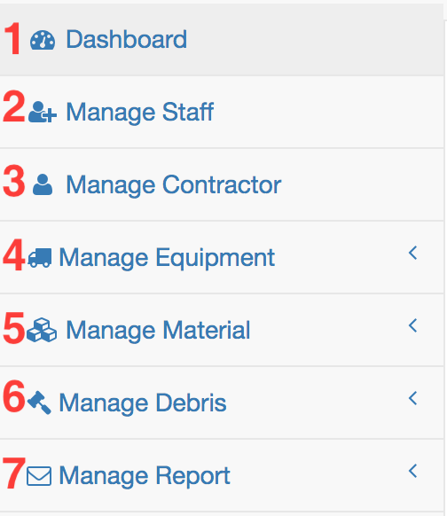

**Buttons/Hyperlinks:**

|  |  |  |  |  |
| --- | --- | --- | --- | --- |
| **No** | **Function** | **Description** | **Validation** | **Outcome** |
| 1 | Dashboard | Dashboard link | N/A | Redirect to dashboard |
| 2 | Manage Staff | Manage staff link | N/A | Redirect to manage staff |
| 3 | Manage Registered User | Manage Registered User link | N/A | Redirect to manage Registered User |
| 4 | Manage Equipment | Manage equipment link | N/A | Redirect to manage equipment |
| 5 | Manage Material | Manage material link | N/A | Redirect to manage material |
| 6 | Manage Debris | Manage debris link | N/A | Redirect to manage debris |
| 7 | Manage Report | Manage report link | N/A | Redirect to manage report |

Table 128 <Buttons/Hyperlinks> Main menu

##### Equipment menu

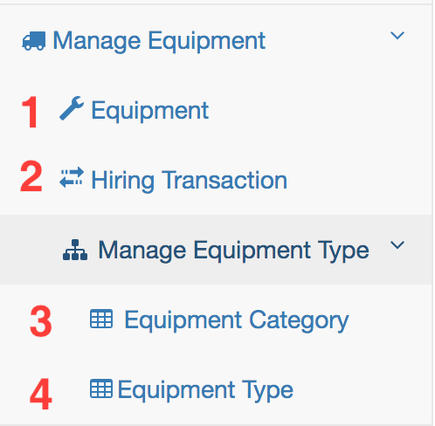

**Buttons/Hyperlinks:**

|  |  |  |  |  |
| --- | --- | --- | --- | --- |
| **No** | **Function** | **Description** | **Validation** | **Outcome** |
| 1 | Equipment | Manage equipment link | N/A | Redirect to manage equipment |
| 2 | Hiring Transaction | Manage hiring transaction link | N/A | Redirect to manage hiring transaction |
| 3 | Equipment Category | Manage equipment category link | N/A | Redirect to manage equipment category |
| 4 | Equipment Type | Manage equipment type link | N/A | Redirect to manage equipment type |

Table 129 <Buttons/Hyperlinks> Equipment menu

##### Material menu

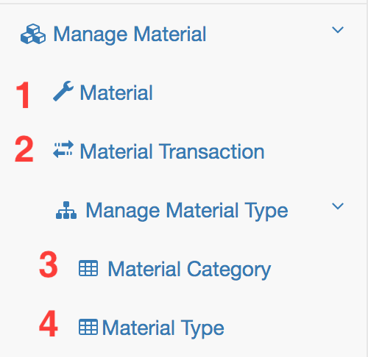

**Buttons/Hyperlinks:**

|  |  |  |  |  |
| --- | --- | --- | --- | --- |
| **No** | **Function** | **Description** | **Validation** | **Outcome** |
| 1 | Material | Manage material link | N/A | Redirect to manage material |
| 2 | Material Transaction | Manage material transaction link | N/A | Redirect to manage material transaction |
| 3 | Material Category | Manage material category link | N/A | Redirect to manage material category |
| 4 | Material Type | Manage material type link | N/A | Redirect to manage material type |

Table 130 <Buttons/Hyperlinks> Material menu

##### Debris menu

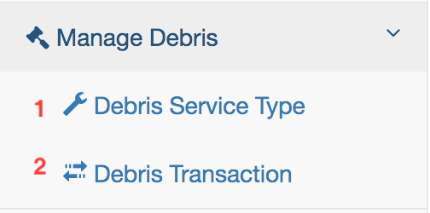

**Buttons/Hyperlinks:**

|  |  |  |  |  |
| --- | --- | --- | --- | --- |
| **No** | **Function** | **Description** | **Validation** | **Outcome** |
| 1 | Debris | Manage debris link | N/A | Redirect to manage debris |
| 2 | Debris Transaction | Manage debris transaction link | N/A | Redirect to manage debris transaction |

Table 131 <Buttons/Hyperlinks> Debris menu

##### Report menu

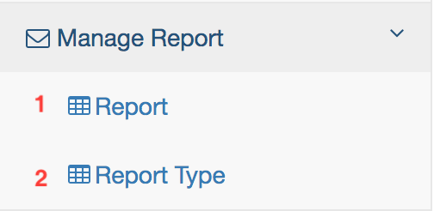

**Buttons/Hyperlinks:**

|  |  |  |  |  |
| --- | --- | --- | --- | --- |
| **No** | **Function** | **Description** | **Validation** | **Outcome** |
| 1 | Report | Manage report link | N/A | Redirect to manage report |
| 2 | Report Type | Manage report type link | N/A | Redirect to manage report type |

Table 132 <Buttons/Hyperlinks> Report menu

##### Dashboard

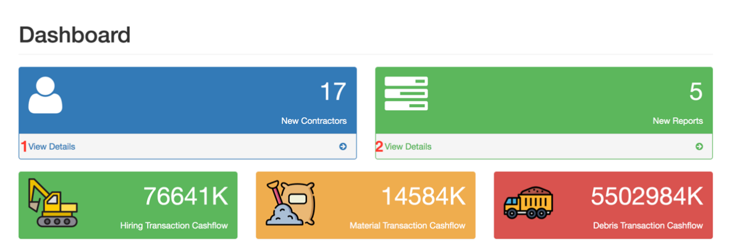

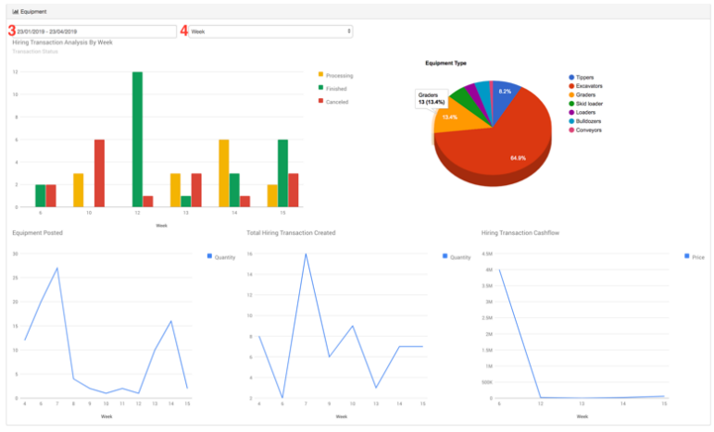

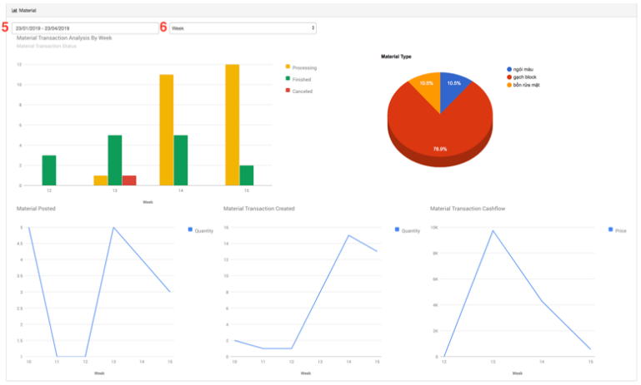

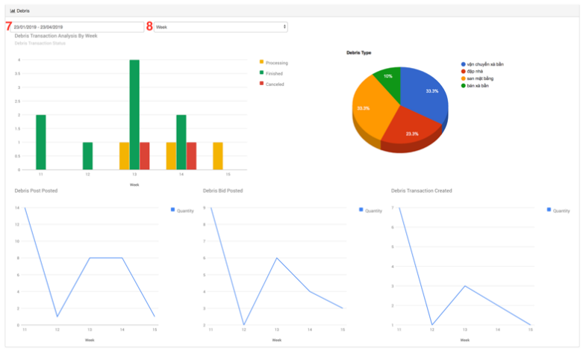

**Fields**

|  |  |  |  |  |  |  |
| --- | --- | --- | --- | --- | --- | --- |
| **No** | **Field Name** | **Description** | **Read only** | **Mandatory** | **Control Type** | **Data Type** |
| 3 | Equipment Analysic DateRange | Equipment analysic’s daterange | No | Yes | Date Range | Date |
| 4 | Equipment Analysic TimeUnit | Equipment analysic’s time unit | No | Yes | Dropdown List | String |
| 5 | Material Analysic DateRange | Material analysic’s daterange | No | Yes | Date Range | Date |
| 6 | Material Analysic TimeUnit | Material analysic’s time unit | No | Yes | Dropdown List | String |
| 7 | Debris Analysic DateRange | Debris analysic’s daterange | No | Yes | Date Range | Date |
| 8 | Debris Analysic TimeUnit | Debris analysic’s time unit | No | Yes | Dropdown List | String |

Table 133 <Fields> Dashboard

**Buttons/Hyperlinks:**

|  |  |  |  |  |
| --- | --- | --- | --- | --- |
| **No** | **Function** | **Description** | **Validation** | **Outcome** |
| 1 | Registered User Detail | Registered User detail link | N/A | Redirect to manage Registered User |
| 2 | Report Detail | Report detail link | N/A | Redirect to manage report |

Table 134 <Buttons/Hyperlinks> Dashboard

##### Manage Staff

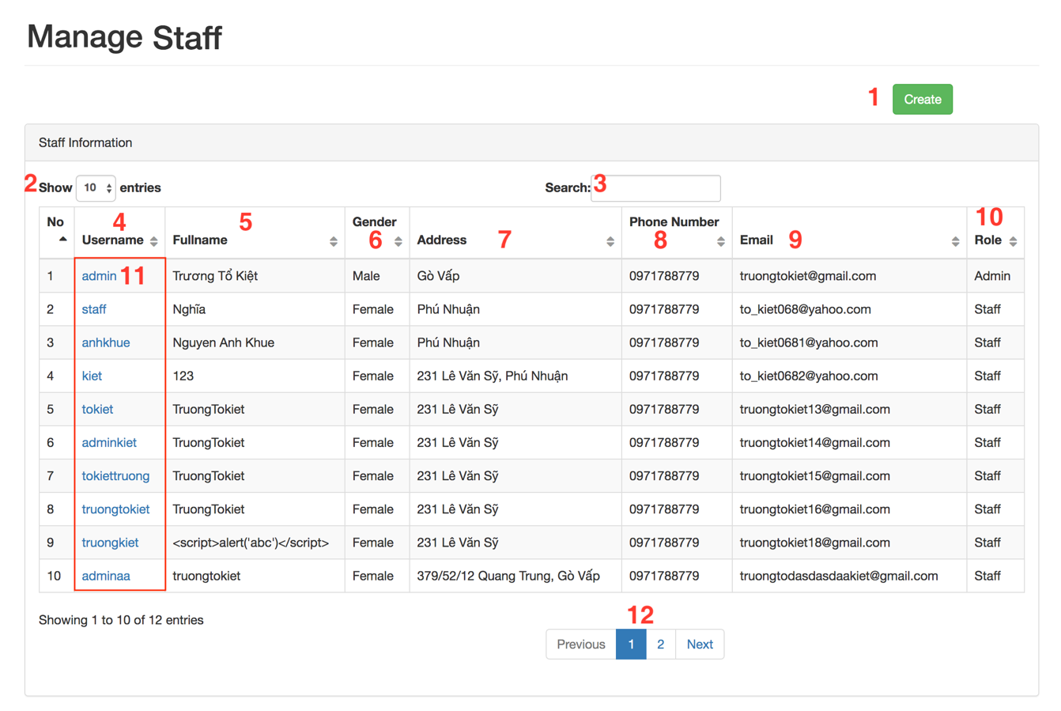

**Fields**

|  |  |  |  |  |  |  |
| --- | --- | --- | --- | --- | --- | --- |
| **No** | **Field Name** | **Description** | **Read only** | **Mandatory** | **Control Type** | **Data Type** |
| 2 | Number of entry | Number of entry | No | Yes | Dropdown List | Integer |
| 3 | Search | Search value | No | No | Text | String |
| 4 | Username | Staff’s username | No | Yes | Text | String |
| 5 | Fullname | Staff’s fullname | No | Yes | Text | String |
| 6 | Gender | Staff’s gender | No | Yes | Text | String |
| 7 | Address | Staff’s address | No | Yes | Text | String |
| 8 | Phone Number | Staff’s phone number | No | Yes | Text | String |
| 9 | Email | Staff’s email | No | Yes | Text | String |
| 10 | Role | Staff’s role | No | Yes | Text | String |

Table 135 <Fields> Manage Staff

**Buttons/Hyperlinks:**

|  |  |  |  |  |
| --- | --- | --- | --- | --- |
| **No** | **Function** | **Description** | **Validation** | **Outcome** |
| 1 | Create Staff | Staff create link | N/A | Redirect to create staff |
| 11 | Staff Detail | Staff detail link | N/A | Redirect to manage staff |
| 12 | Pagination | Pagination for manage staff | N/A | Switch to respective page based on user clicked |

Table 136 <Buttons/Hyperlinks> Manage Staff

##### Manage Registered User

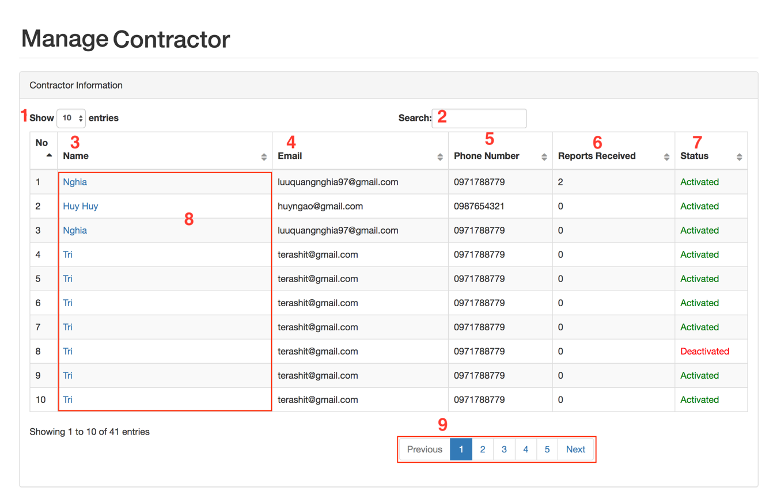

**Fields**

|  |  |  |  |  |  |  |
| --- | --- | --- | --- | --- | --- | --- |
| **No** | **Field Name** | **Description** | **Read only** | **Mandatory** | **Control Type** | **Data Type** |
| 1 | Number of entry | Number of entry | No | Yes | Dropdown List | Integer |
| 2 | Search | Search value | No | No | Text | String |
| 3 | Name | Registered User’s name | No | Yes | Text | String |
| 4 | Email | Registered User’s email | No | Yes | Text | String |
| 5 | Phone Number | Registered User’s phone number | No | Yes | Text | String |
| 6 | Reports Received | Registered User’s reports received | No | Yes | Text | String |
| 7 | Status | Registered User’s status | No | Yes | Text | String |

Table 137 <Fields> Manage Registered User

**Buttons/Hyperlinks:**

|  |  |  |  |  |
| --- | --- | --- | --- | --- |
| **No** | **Function** | **Description** | **Validation** | **Outcome** |
| 8 | Registered User Detail | Registered User detail link | N/A | Redirect to manage Registered User |
| 9 | Pagination | Pagination for manage Registered User | N/A | Switch to respective page based on user clicked |

Table 138 <Buttons/Hyperlinks> Manage Registered User

##### Manage Equipment Category

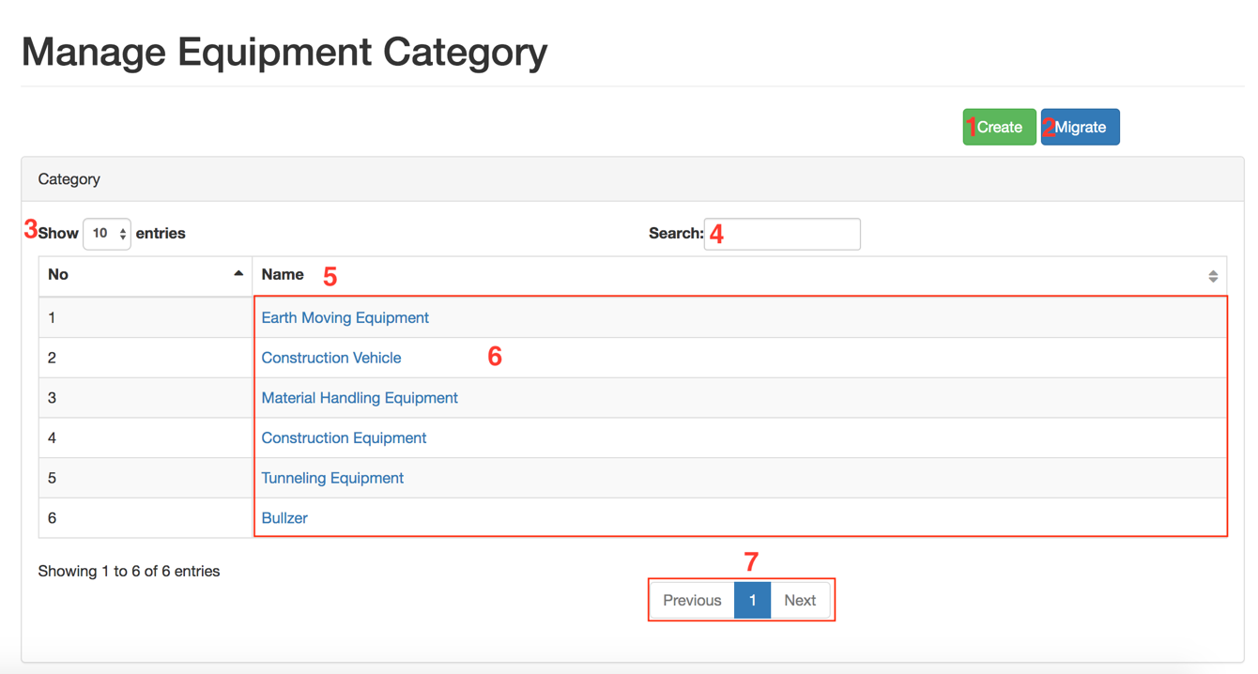

**Fields**

|  |  |  |  |  |  |  |
| --- | --- | --- | --- | --- | --- | --- |
| **No** | **Field Name** | **Description** | **Read only** | **Mandatory** | **Control Type** | **Data Type** |
| 3 | Number of entry | Number of entry | No | Yes | Dropdown List | Integer |
| 4 | Search | Search value | No | No | Text | String |
| 5 | Name | Equipment category’s name | No | Yes | Text | String |

Table 139 <Fields> Manage Equipment Category

**Buttons/Hyperlinks:**

|  |  |  |  |  |
| --- | --- | --- | --- | --- |
| **No** | **Function** | **Description** | **Validation** | **Outcome** |
| 1 | Create Equipment Category | Equipment category create link | N/A | Redirect to create Equipment Category |
| 2 | Migrate Equipment Category | Equipment category migrate link | N/A | Redirect to migrate Equipment Category |
| 6 | Equipment Category Detail | Equipment Category detail link | N/A | Redirect to Equipment Category detail |
| 7 | Pagination | Pagination for manage Equipment Category | N/A | Switch to respective page based on user clicked |

Table 140 <Buttons/Hyperlinks> Manage Equipment Category

##### Manage Equipment Type

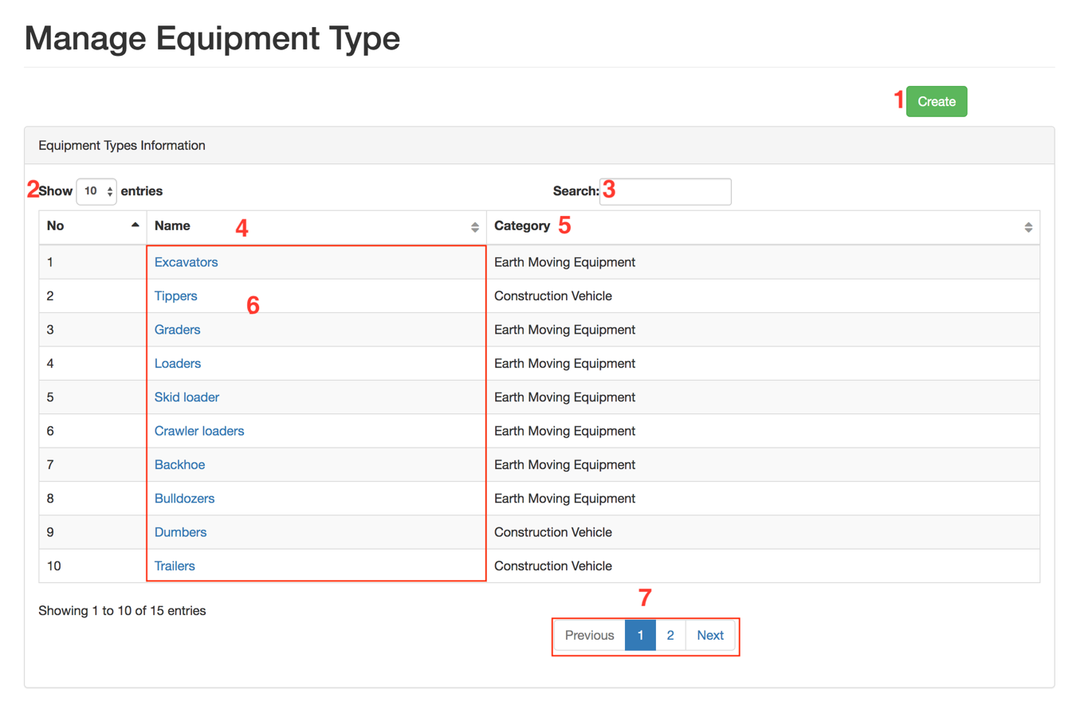

**Fields**

|  |  |  |  |  |  |  |
| --- | --- | --- | --- | --- | --- | --- |
| **No** | **Field Name** | **Description** | **Read only** | **Mandatory** | **Control Type** | **Data Type** |
| 2 | Number of entry | Number of entry | No | Yes | Dropdown List | Integer |
| 4 | Search | Search value | No | No | Text | String |
| 5 | Name | Equipment type’s name | No | Yes | Text | String |

Table 141 <Fields> Manage Equipment Type

**Buttons/Hyperlinks:**

|  |  |  |  |  |
| --- | --- | --- | --- | --- |
| **No** | **Function** | **Description** | **Validation** | **Outcome** |
| 1 | Create Equipment Type | Equipment type create link | N/A | Redirect to create Equipment type |
| 6 | Equipment type Detail | Equipment type detail link | N/A | Redirect to equipment type detail |
| 7 | Pagination | Pagination for manage Equipment type | N/A | Switch to respective page based on user clicked |

Table 142 <Buttons/Hyperlinks> Manage Equipment Type

##### Manage Equipment

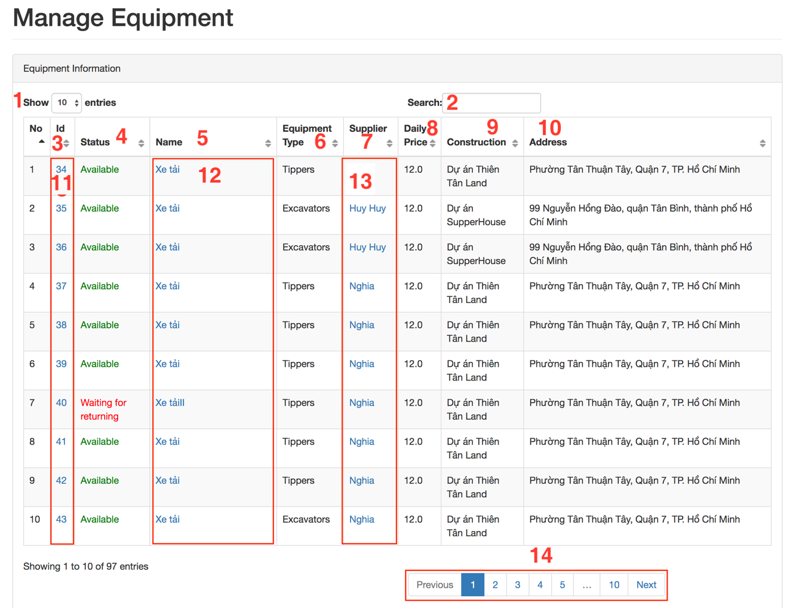

**Fields**

|  |  |  |  |  |  |  |
| --- | --- | --- | --- | --- | --- | --- |
| **No** | **Field Name** | **Description** | **Read only** | **Mandatory** | **Control Type** | **Data Type** |
| 1 | Number of entry | Number of entry | No | Yes | Dropdown List | Integer |
| 2 | Search | Search value | No | No | Text | String |
| 3 | Id | Equipment’s id | No | Yes | Text | String |
| 4 | Status | Equipment’s status | No | Yes | Text | String |
| 5 | Name | Equipment’s name | No | Yes | Text | String |
| 6 | Equipment Type | Equipment Type | No | Yes | Text | String |
| 7 | Supplier | Equipment’s supplier | No | Yes | Text | String |
| 8 | Daily Price | Equipment’s daily price | No | Yes | Text | String |
| 9 | Construction | Construction | No | Yes | Text | String |
| 10 | Address | Equipment’s address | No | Yes | Text | String |

Table 143 <Fields> Manage Equipment

**Buttons/Hyperlinks:**

|  |  |  |  |  |
| --- | --- | --- | --- | --- |
| **No** | **Function** | **Description** | **Validation** | **Outcome** |
| 11 | Equipment Detail | Equipment type detail link | N/A | Redirect to equipment detail |
| 12 | Equipment Detail | Equipment detail link | N/A | Redirect to equipment detail |
| 13 | Supplier Detail | Supplier detail link | N/A | Redirect to supplier detail |
| 14 | Pagination | Pagination for manage Equipment | N/A | Switch to respective page based on user clicked |

Table 144 <Buttons/Hyperlinks> Manage Equipment

##### Manage Hiring Transaction

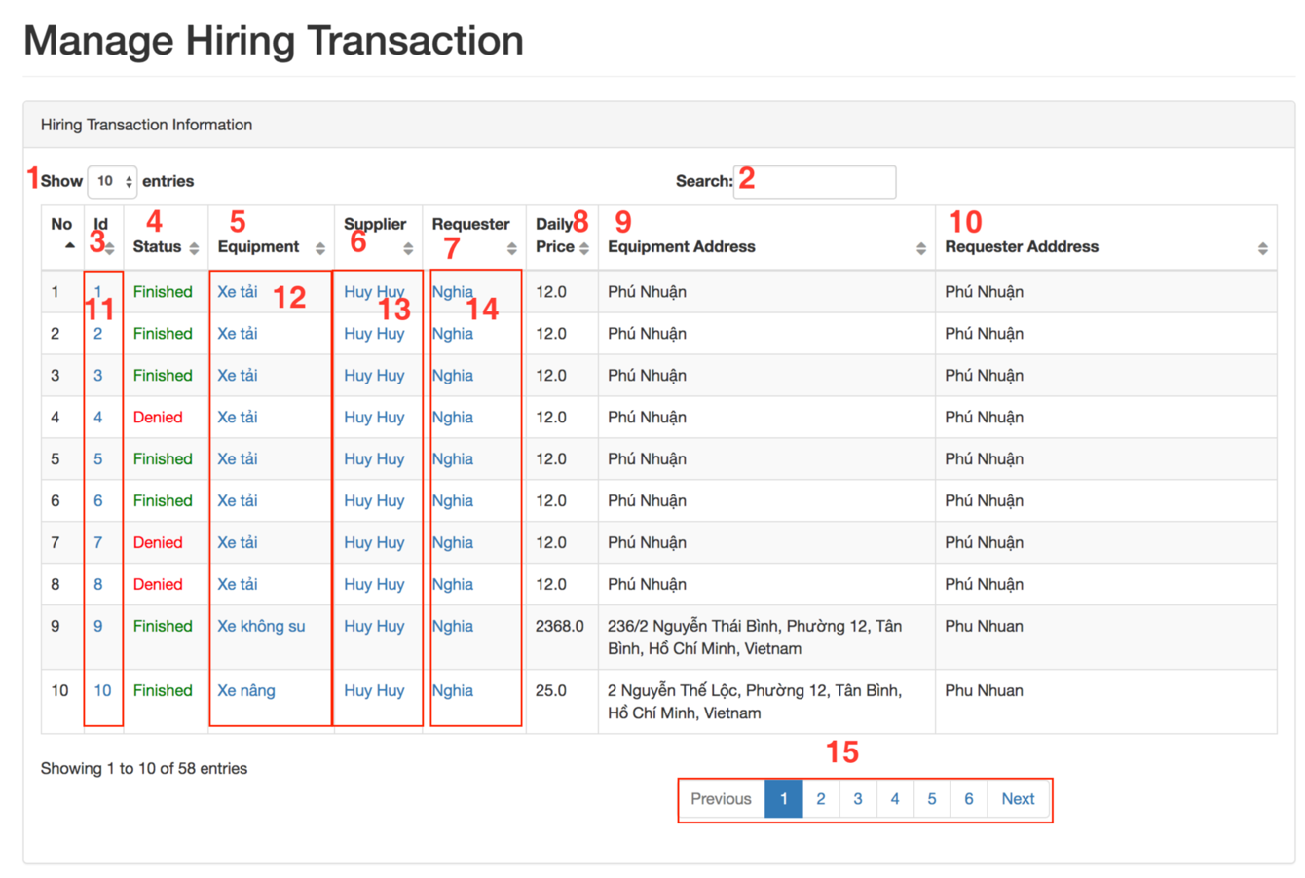

**Fields**

|  |  |  |  |  |  |  |
| --- | --- | --- | --- | --- | --- | --- |
| **No** | **Field Name** | **Description** | **Read only** | **Mandatory** | **Control Type** | **Data Type** |
| 1 | Number of entry | Number of entry | No | Yes | Dropdown List | Integer |
| 2 | Search | Search value | No | No | Text | String |
| 3 | Id | Equipment’s id | No | Yes | Text | String |
| 4 | Status | Equipment’s status | No | Yes | Text | String |
| 5 | Equipment name | Equipment’s name | No | Yes | Text | String |
| 6 | Supplier | Equipment’s supplier | No | Yes | Text | String |
| 7 | Requester | Transaction’s requester | No | Yes | Text | String |
| 8 | Daily Price | Equipment’s daily price | No | Yes | Text | String |
| 9 | Equipment Address | Equipment’s address | No | Yes | Text | String |
| 10 | Requester Address | Requester’s address | No | Yes | Text | String |

Table 145 <Fields> Manage Hiring Transaction

**Buttons/Hyperlinks:**

|  |  |  |  |  |
| --- | --- | --- | --- | --- |
| **No** | **Function** | **Description** | **Validation** | **Outcome** |
| 11 | Hiring Transaction Detail | Hiring transaction detail link | N/A | Redirect to hiring transaction detail |
| 12 | Equipment Detail | Equipment detail link | N/A | Redirect to equipment detail |
| 13 | Supplier Detail | Supplier detail link | N/A | Redirect to supplier detail |
| 14 | Requester Detail | Requester detail link | N/A | Redirect to requester detail |
| 15 | Pagination | Pagination for manage Equipment | N/A | Switch to respective page based on user clicked |

Table 146 <Buttons/Hyperlinks> Manage Hiring Transaction

## Database Design

### Entity Relationship Diagram (ERD)

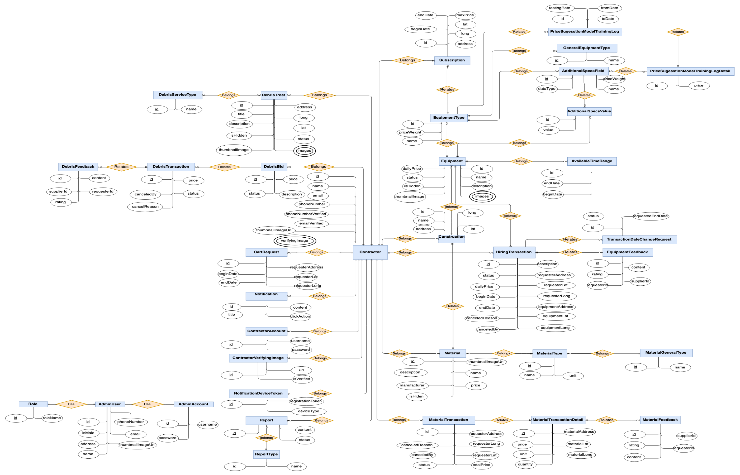

Figure 24 Entity Relation Diagram

### Data Dictionary

|  |  |
| --- | --- |
| Entity Data Dictionary: describe content of all entities | |
| **Entity Name** | **Description** |
| Registered UserAccount | Contain Registered User account information |
| AdditionalSpecsField | Contain additional specs fields information |
| AdditionalSpecsValue | Contain additional specs value information |
| AdminUser | Contain admin user profile information |
| AdminAccount | Contain admin account information |
| AvailableTimeRange | Contain available time range information of a equipment |
| Construction | Contain construction information |
| Registered User | Contain Registered User profile information |
| Equipment | Contain equipment information |
| EquipmentType | Contain equipment type information |
| Report | Contain information of reported behavior |
| ReportType | Contain report type information |
| GeneralEquipmentType | Contain equipment category information |
| HiringTransaction | Contain hiring transaction information |
| Notification | Contain notification information |
| Subscription | Contain subscription information |
| TransactionDateChangeRequest | Contain information of hiring transaction’s date changing request |
| NotificationDeviceToken | Contain information of the token of each device for notification |
| GeneralMaterialType | Contain information of material category, which has multiple material types |
| Material | Contain material information |
| MaterialTransaction | Contain material transaction information |
| MaterialType | Contain material type information |
| DebrisBid | Contain bid information for a debris post |
| DebrisFeedback | Contain feedback information for a finished debris transaction |
| DebrisPost | Contain post information for a debris service |
| DebrisServiceType | Contain debris service type information |
| DebrisTransaction | Contain debris transaction information |
| MaterialTransactionDetail | Contain material transaction detail information |
| MaterialFeedback | Contain feedback information of a finished material transaction |
| EquipmentFeedback | Contain feedback information for a finished hiring transaction |
| Registered UserVerifyingImage | Contain verifying image information |
| Role | Contain role information |
| PriceSuggestionModalTrainingLogDetail | Contain Price Suggestion Model training log detail information |
| PriceSuggestionModalTrainingLog | Contain Price Suggestion Model training log information |

Table 147 Entity Relationship Diagram Dictionary

#### Registered UserAccount

|  |  |  |  |
| --- | --- | --- | --- |
| **Attribute** | **Type** | **Visibility** | **Description** |
| id | Integer | Private | Unique identifier of Registered User account |
| username | String | Private | Registered User account’s username |
| password | String | Private | Account’s password |
| Registered UserId | Integer | Private | Registered User’s id |
| createdTime | Datetime | Private | The created time of the data |
| updatedTime | Datetime | Private | The updated time of the data |

#### AdditionalSpecsField

|  |  |  |  |
| --- | --- | --- | --- |
| **Attribute** | **Type** | **Visibility** | **Description** |
| id | Integer | Private | Unique identifier of an additional specs field |
| name | String | Private | Additional specs field’s name |
| dataType | String | Private | Additional specs field’s data type |
| equipmentTypeId | Integer | Private | Equipment type’s id |
| idDeleted | Tiny Integer | Private | Soft delete information |
| createdTime | Datetime | Private | The created time of the data |
| updatedTime | Datetime | Private | The updated time of the data |

#### AdditionalSpecsValue

|  |  |  |  |
| --- | --- | --- | --- |
| **Attribute** | **Type** | **Visibility** | **Description** |
| id | Integer | Private | Unique identifier of an additional specs value |
| value | String | Private | Additional specs value’s name |
| additionalSpecsFieldId | Integer | Private | Contain information of the mentioned attribute |
| equipmentId | Integer | Private | Contain information of the mentioned attribute |
| createdTime | Datetime | Private | The created time of the data |
| updatedTime | Datetime | Private | The updated time of the data |

#### AdminUser

|  |  |  |  |
| --- | --- | --- | --- |
| **Attribute** | **Type** | **Visibility** | **Description** |
| id | Integer | Private | Unique identifier of an additional specs value |
| name | String | Private | Contain information of the mentioned attribute |
| isMale | Bit | Private | Contain information of the mentioned attribute |
| phone | String | Private | Contain information of the mentioned attribute |
| email | String | Private | Contain information of the mentioned attribute |
| roleId | Integer | Private | Contain information of the mentioned attribute |
| thumbnailImage | String | Private | Thumbnail image url |
| address | String | Private | Contain information of the mentioned attribute |

#### AdminAccount

|  |  |  |  |
| --- | --- | --- | --- |
| **Attribute** | **Type** | **Visibility** | **Description** |
| id | Integer | Private | Unique identifier of an admin account |
| username | String | Private | Contain information of the mentioned attribute |
| password | String | Private | Contain information of the mentioned attribute |
| adminUserId | Integer | Private | Contain information of the mentioned attribute |

#### AvailableTimeRange

|  |  |  |  |
| --- | --- | --- | --- |
| **Attribute** | **Type** | **Visibility** | **Description** |
| id | Integer | Private | Unique identifier of an available time range |
| beginDate | Date | Private | The begin date of hiring transaction |
| endDate | Date | Private | The end date of hiring transaction |
| equipmentId | Integer | Private | Contain information of the mentioned attribute |

#### Construction

|  |  |  |  |
| --- | --- | --- | --- |
| **Attribute** | **Type** | **Visibility** | **Description** |
| id | Integer | Private | Unique identifier of the construction |
| name | String | Private | Contain information of the mentioned attribute |
| address | String | Private | Contain information of the mentioned attribute |
| long | Double | Private | Contain information of the mentioned attribute |
| lat | Double | Private | Contain information of the mentioned attribute |
| isDeleted | Tiny Integer | Private | Soft delete information |
| Registered UserId | Integer | Private | Contain information of the mentioned attribute |

#### Registered User

|  |  |  |  |
| --- | --- | --- | --- |
| **Attribute** | **Type** | **Visibility** | **Description** |
| id | Integer | Private | Unique identifier of a Registered User |
| name | String | Private | Contain information of the mentioned attribute |
| email | Bit | Private | Contain information of the mentioned attribute |
| phoneNumber | String | Private | Contain information of the mentioned attribue |
| thumbnailImage | String | Private | Contain information of the mentioned attribue |
| isActivated | Integer | Private | Contain information of the mentioned attribute |
| createdTime | String | Private | The created time of the data |
| updatedTime | String | Private | The updated time of the data |
| isDeleted | Tiny Integer | Private | Soft delete information |

#### EquipmentImage

|  |  |  |  |
| --- | --- | --- | --- |
| **Attribute** | **Type** | **Visibility** | **Description** |
| id | Integer | Private | Unique identifier of an equipment image |
| url | String | Private | Contain information of the mentioned attribute |
| equipmentId | Integer | Private | Contain information of the mentioned attribute |
| createdTime | String | Private | The created time of the data |
| updatedTime | String | Private | The updated time of the data |

#### Equipment

|  |  |  |  |
| --- | --- | --- | --- |
| **Attribute** | **Type** | **Visibility** | **Description** |
| id | Integer | Private | Unique identifier of an equipment |
| name | String | Private | Contain information of the mentioned attribute |
| dailyPrice | Double | Private | Contain information of the mentioned attribute |
| description | String | Private | Contain information of the mentioned attribute |
| status | String | Private | Contain information of the mentioned attribute |
| thumbnailImageId | Integer | Private | Contain information of the mentioned attribute |
| isDeleted | Tiny Integer | Private | Soft delete information |
| createdTime | Datetime | Private | The updated time of the data |
| updatedTime | Datetime | Private | The updated time of the data |
| equipmentTypeId | Integer | Private | Contain information of the mentioned attribute |
| Registered UserId | Integer | Private | Contain information of the mentioned attribute |
| constructionId | Integer | Private | Contain information of the mentioned attribute |
| equipmentImageId | Integer | Private | Contain information of the mentioned attribute |

#### EquipmentType

|  |  |  |  |
| --- | --- | --- | --- |
| **Attribute** | **Type** | **Visibility** | **Description** |
| id | Integer | Private | Unique identifier of an equipment type |
| name | String | Private | Contain information of the mentioned attribute |
| generalEquipmentTypeId | Integer | Private | Contain information of the mentioned attribute |
| isDeleted | Bit | Private | Soft delete information |
| createdTime | Datetime | Private | The created time of the data |
| updatedTime | Datetime | Private | The updated time of the data |
| priceWeight | Double | Private | Contain information of the mentioned attribute |

#### Report

|  |  |  |  |
| --- | --- | --- | --- |
| **Attribute** | **Type** | **Visibility** | **Description** |
| id | Integer | Private | Unique identifier of report |
| content | String | Private | Additional specs field’s name |
| createdTime | Datetime | Private | The updated time of the data |
| updatedTime | Datetime | Private | The updated time of the data |
| toRegistered UserId | Datetime | Private | Contain information of the mentioned attribute |
| fromRegistered UserId | Datetime | Private | Contain information of the mentioned attribute |
| reportTypeId | Double | Private | Contain information of the mentioned attribute |
| status | String | Private | Contain information of the mentioned attribute |
| isDeleted | Bit | Private | Soft delete information |

#### ReportType

|  |  |  |  |
| --- | --- | --- | --- |
| **Attribute** | **Type** | **Visibility** | **Description** |
| id | Integer | Private | Unique identifier of report type |
| name | String | Private | Additional specs field’s name |
| isDeleted | Bit | Private | Soft delete information |
| createdTime | Datetime | Private | The updated time of the data |
| updatedTime | Datetime | Private | The updated time of the data |

#### GeneralEquipmentType

|  |  |  |  |
| --- | --- | --- | --- |
| **Attribute** | **Type** | **Visibility** | **Description** |
| id | Integer | Private | Unique identifier of a general equipment type |
| name | String | Private | General equipment type name |
| isDeleted | Bit | Private | Soft delete information |
| createdTime | Datetime | Private | The created time of the data |
| updatedTime | Datetime | Private | The updated time of the data |

#### HiringTransaction

|  |  |  |  |
| --- | --- | --- | --- |
| **Attribute** | **Type** | **Visibility** | **Description** |
| id | Integer | Private | Unique identifier of hiring transaction |
| status | String | Private | Hiring transaction’s status |
| dailyPrice | Double | Private | Contain information of the mentioned attribute |
| createdTime | Datetime | Private | The updated time of the data |
| updatedTime | Datetime | Private | The updated time of the data |
| beginDate | Date | Private | The begin date of hiring transaction |
| endDate | Date | Private | The begin date of hiring transaction |
| equipmentAddress | String | Private | Contain information of the mentioned attribute |
| equipmentLong | Double | Private | Contain information of the mentioned attribute |
| equipmentLat | Double | Private | Contain information of the mentioned attribute |
| requesterAddress | String | Private | Contain information of the mentioned attribute |
| requesterLong | Double | Private | Contain information of the mentioned attribute |
| requesterLat | Double | Private | Contain information of the mentioned attribute |
| isDeleted | Bit | Private | Soft delete information |
| equipmentId | Integer | Private | Contain information of the mentioned attribute |
| requesterId | Integer | Private | Contain information of the mentioned attribute |
| cancelReason | String | Private | Contain information of the mentioned attribute |
| canceledBy | Integer | Private | Contain information of the mentioned attribute |

#### Notification

|  |  |  |  |
| --- | --- | --- | --- |
| **Attribute** | **Type** | **Visibility** | **Description** |
| id | Integer | Private | Unique identifier of notification |
| title | String | Private | Additional specs field’s name |
| content | String | Private | Contain information of the mentioned attribute |
| isRead | Tiny Integer | Private | Contain information of the mentioned attribute |
| Registered UserId | Integer | Private | Contain information of the mentioned attribute |
| clickAction | String | Private | Contain information of the mentioned attribute |

#### Subscription

|  |  |  |  |
| --- | --- | --- | --- |
| **Attribute** | **Type** | **Visibility** | **Description** |
| id | Integer | Private | Unique identifier of an additional specs value |
| equipmentTypeId | String | Private | Additional specs field’s name |
| Registered UserId | Bit | Private | Contain information of the mentioned attribute |
| maxPrice | Double | Private | Contain information of the mentioned attribute |
| beginDate | Date | Private | Contain information of the mentioned attribute |
| endDate | Date | Private | Contain information of the mentioned attribute |
| createdTime | Datetime | Private | The updated time of the data |
| updatedTime | Datetime | Private | The updated time of the data |
| lat | Double | Private | Contain information of the mentioned attribute |
| long | Double | Private | Contain information of the mentioned attribute |
| maxDistance | Double | Private | Contain information of the mentioned attribute |
| address | String | Private | Contain information of the mentioned attribute |

#### TransactionDateChangeRequest

|  |  |  |  |
| --- | --- | --- | --- |
| **Attribute** | **Type** | **Visibility** | **Description** |
| id | Integer | Private | Unique identifier of an additional specs value |
| requestedEndDate | Date | Private | Additional specs field’s name |
| isDeleted | Bit | Private | Soft delete information |
| createdTime | Datetime | Private | The updated time of the data |
| updatedTime | Datetime | Private | The updated time of the data |
| status | String | Private | Contain information of the mentioned attribute |
| transactionId | Integer | Private | Contain information of the mentioned attribute |

#### NotificationDeviceToken

|  |  |  |  |
| --- | --- | --- | --- |
| **Attribute** | **Type** | **Visibility** | **Description** |
| id | Integer | Private | Unique identifier of a general equipment type |
| registrationToken | String | Private | General equipment type name |
| Registered UserId | Integer | Private | Soft delete information |
| deviceType | String | Private |  |
| createdTime | Datetime | Private | The created time of the data |
| updatedTime | Datetime | Private | The updated time of the data |

#### GeneralMaterialType

|  |  |  |  |
| --- | --- | --- | --- |
| **Attribute** | **Type** | **Visibility** | **Description** |
| id | Integer | Private | Unique identifier of a general material type |
| name | String | Private | General material type name |
| isDeleted | Bit | Private | Soft delete information |
| createdTime | Datetime | Private | The created time of the data |
| updatedTime | Datetime | Private | The updated time of the data |

#### Material

|  |  |  |  |
| --- | --- | --- | --- |
| **Attribute** | **Type** | **Visibility** | **Description** |
| id | Integer | Private | Unique identifier of a material |
| name | String | Private | Material’s name |
| price | Double | Private | Material’s price |
| manufacturer | String | Private | Material’s manufacturer |
| description | String | Private | Material’s description |
| isHidden | Tiny Integer | Private | Hide material post |
| isDeleted | Bit | Private | Soft delete information |
| createdTime | Datetime | Private | The created time of the data |
| updatedTime | Datetime | Private | The updated time of the data |
| constructionId | Integer | Private | Construction id |
| Registered UserId | Integer | Private | Registered User id |
| materialTypeId | Integer | Private | Material type id |
| thumbnailImageUrl | String | Private | Material thumbnail image |

#### MaterialTransaction

|  |  |  |  |
| --- | --- | --- | --- |
| **Attribute** | **Type** | **Visibility** | **Description** |
| id | Integer | Private | Unique identifier of a material transaction |
| totalPrice | Double | Private | Material transaction total price |
| requesterAddress | String | Private | Material transaction requester address |
| requesterLat | Double | Private | Requester latitude |
| requesterLong | Double | Private | Requester longitude |
| status | String | Private | Material transaction’s status |
| isDeleted | Bit | Private | Soft delete information |
| createdTime | Datetime | Private | The created time of the data |
| updatedTime | Datetime | Private | The updated time of the data |
| requesterId | Integer | Private | Requester’s id |
| supplierId | Integer | Private | Supplier’s id |
| cancelReason | String | Private | Material transaction cancel reason |
| canceledBy | Integer | Private | Material transaction canceled by id |

#### MaterialType

|  |  |  |  |
| --- | --- | --- | --- |
| **Attribute** | **Type** | **Visibility** | **Description** |
| id | Integer | Private | Unique identifier of a material type |
| name | String | Private | Material type name |
| isDeleted | Bit | Private | Soft delete information |
| createdTime | Datetime | Private | The created time of the data |
| updatedTime | Datetime | Private | The updated time of the data |
| generalMaterialTypeId | Integer | Private | Id of general material type |
| unit | Integer | Private | Define unit of material |

#### DebrisBid

|  |  |  |  |
| --- | --- | --- | --- |
| **Attribute** | **Type** | **Visibility** | **Description** |
| id | Integer | Private | Unique identifier of a debris bid |
| price | Double | Private | Debris bid’s price |
| status | String | Private | Debris bid’s status |
| createdTime | Datetime | Private | The created time of the data |
| updatedTime | Datetime | Private | The updated time of the data |
| isDeleted | Bit | Private | Soft delete information |
| supplierId | Integer | Private | Supplier’s id |
| debrisPostId | Integer | Private | Debris post’s id |
| description | String | Private | Description of debris bid |

#### DebrisFeedback

|  |  |  |  |
| --- | --- | --- | --- |
| **Attribute** | **Type** | **Visibility** | **Description** |
| id | Integer | Private | Unique identifier of a debris feedback |
| rating | Double | Private | Feedback rating |
| content | String | Private | Feedback content |
| requesterId | Integer | Private | Requester’s id |
| supplierId | Integer | Private | Supplier’s Id |
| createdTime | Datetime | Private | The created time of the data |
| updatedTime | Datetime | Private | The updated time of the data |
| debrisTransactionId | Integer | Private | Debris transaction’s id |

#### DebrisPost

|  |  |  |  |
| --- | --- | --- | --- |
| **Attribute** | **Type** | **Visibility** | **Description** |
| id | Integer | Private | Unique identifier of a debris post |
| title | String | Private | Debris post’s title |
| address | String | Private | Debris post’s address |
| longitude | Double | Private | Debris post’s longitude |
| latitude | Double | Private | Debris post’s latitude |
| description | String | Private | Debris post’s description |
| status | String | Private | Debris post’s status |
| isHidden | Tiny Integer | Private | Soft remove debris post |
| isDeleted | Bit | Private | Soft delete information |
| createdTime | Datetime | Private | The created time of the data |
| updatedTime | Datetime | Private | The updated time of the data |
| requesterId | Integer | Private | Requester’s id |
| thumbnailImageId | Integer | Private | Thumbnail image’s id |

#### DebrisServiceType

|  |  |  |  |
| --- | --- | --- | --- |
| **Attribute** | **Type** | **Visibility** | **Description** |
| id | Integer | Private | Unique identifier of a debris service type |
| name | String | Private | Debris service type name |
| isDeleted | Bit | Private | Soft delete information |
| createdTime | Datetime | Private | The created time of the data |
| updatedTime | Datetime | Private | The updated time of the data |

#### DebrisTransaction

|  |  |  |  |
| --- | --- | --- | --- |
| **Attribute** | **Type** | **Visibility** | **Description** |
| id | Integer | Private | Unique identifier of a debris transaction |
| price | Double | Private | Debris transaction’s price |
| status | String | Private | Debris transaction’s status |
| cancelReason | Integer | Private | Debris transaction’s cancel reason |
| requesterId | Integer | Private | Requester’s id |
| supplierId | String | Private | Debris transaction name |
| createdTime | Datetime | Private | The created time of the data |
| updatedTime | Datetime | Private | The updated time of the data |
| debrisPostId | Integer | Private | Debris post’s id |
| debrisBidId | Integer | Private | Debris bid’s id |
| canceledBy | Integer | Private | Debris transaction canceled by id |

#### DebrisImage

|  |  |  |  |
| --- | --- | --- | --- |
| **Attribute** | **Type** | **Visibility** | **Description** |
| id | Integer | Private | Unique identifier of a debris image |
| url | String | Private | Debris image’s url |
| debrisPostId | Bit | Private | Debris post ‘s id |
| createdTime | Datetime | Private | The created time of the data |
| updatedTime | Datetime | Private | The updated time of the data |

#### MaterialTransactionDetail

|  |  |  |  |
| --- | --- | --- | --- |
| **Attribute** | **Type** | **Visibility** | **Description** |
| id | Integer | Private | Unique identifier of a material transaction detail |
| quantity | Double | Private | Material transaction detail’s quantity |
| unit | String | Private | Material transaction detail’s unit |
| price | Double | Private | Material transaction detail’s price |
| materialLat | Double | Private | Material transaction detail’s latitude |
| materialLong | Double | Private | Material transaction detail’s longitude |
| materialAddress | String | Private | Material transaction detail’s address |
| isDeleted | Bit | Private | Soft delete information |
| createdTime | Datetime | Private | The created time of the data |
| updatedTime | Datetime | Private | The updated time of the data |
| materialId | Integer | Private | Material’s id |
| materialTransactionId | Integer | Private | Material transaction’s id |

#### MaterialFeedback

|  |  |  |  |
| --- | --- | --- | --- |
| **Attribute** | **Type** | **Visibility** | **Description** |
| id | Integer | Private | Unique identifier of a material feedback |
| rating | Double | Private | Material feedback’s rating |
| content | String | Private | Material feedback’s  content |
| createdTime | Datetime | Private | The created time of the data |
| updatedTime | Datetime | Private | The updated time of the data |
| supplierId | Integer | Private | Supplier’s id |
| requesterId | Integer | Private | Requester’s id |
| materialTransactionDetailId | Integer | Private | Material transaction detail’s id |

#### EquipmentFeedback

|  |  |  |  |
| --- | --- | --- | --- |
| **Attribute** | **Type** | **Visibility** | **Description** |
| id | Integer | Private | Unique identifier of a equipment feedback |
| rating | Double | Private | Equipment feedback’s rating |
| content | String | Private | Equipment feedback’s  content |
| isDeleted | Bit | Private | Soft delete information |
| createdTime | Datetime | Private | The created time of the data |
| updatedTime | Datetime | Private | The updated time of the data |
| supplierId | Integer | Private | Supplier’s id |
| requesterId | Integer | Private | Requester’s id |
| hiringTransactionId | Integer | Private | Equipment transaction’s id |

#### Registered UserVerifyingImage

|  |  |  |  |
| --- | --- | --- | --- |
| **Attribute** | **Type** | **Visibility** | **Description** |
| id | Integer | Private | Unique identifier of a Registered User verifying image |
| url | String | Private | Registered User verifying image’s url |
| Registered UserId | Integer | Private | Registered User’s id |
| isVerified | Tiny Integer | Private | Verify image information |
| createdTime | Datetime | Private | The created time of the data |
| updatedTime | Datetime | Private | The updated time of the data |

Role

|  |  |  |  |
| --- | --- | --- | --- |
| **Attribute** | **Type** | **Visibility** | **Description** |
| id | Integer | Private | Unique identifier of role |
| roleName | String | Private | Role’s name |

PriceSuggestionModalTrainingLogDetail

|  |  |  |  |
| --- | --- | --- | --- |
| **Attribute** | **Type** | **Visibility** | **Description** |
| id | Integer | Private | Unique identifier of price suggestion detail |
| weight | Double | Private | Contain information of the mentioned attribute |
| priceSuggestionModelTraninglog Id | Integer | Private | Contain information of the mentioned attribute |
| additionalSpecsFieldId | Integer | Private | Contain information of the mentioned attribute |
| createdTime | Datetime | Private | The updated time of the data |
| updatedTime | Datetime | Private | The updated time of the data |

PriceSuggestionModalTrainingLog

|  |  |  |  |
| --- | --- | --- | --- |
| **Attribute** | **Type** | **Visibility** | **Description** |
| id | Integer | Private | Unique identifier of price suggestion |
| weight | Double | Private | Contain information of the mentioned attribute |
| toDate | Integer | Private | Contain information of the mentioned attribute |
| fromDate | Integer | Private | Contain information of the mentioned attribute |
| equipmentTypeId | Integer | Private | Contain information of the mentioned attribute |
| createdTime | Datetime | Private | The updated time of the data |
| updatedTime | Datetime | Private | The updated time of the data |

## AlgorithEMP

### Price suggestion model

#### Definition

Price suggestion model is a method to suggest the proper price using historical data

#### Problem

The system is expected to provide a price suggestion based on user input of a equipment information. Each equipment have different additional specifications as mentions in user requirements. Therefore, each equipment type must be provided with a different model for the most precision results

#### Solution

##### Linear regression

Linear regression can be understood as "finding the best fitting straight line for a set of data". Linear regression is used to show or predict the linear relationship between variables. Linear regression is simple and commonly used in machine learning fields.

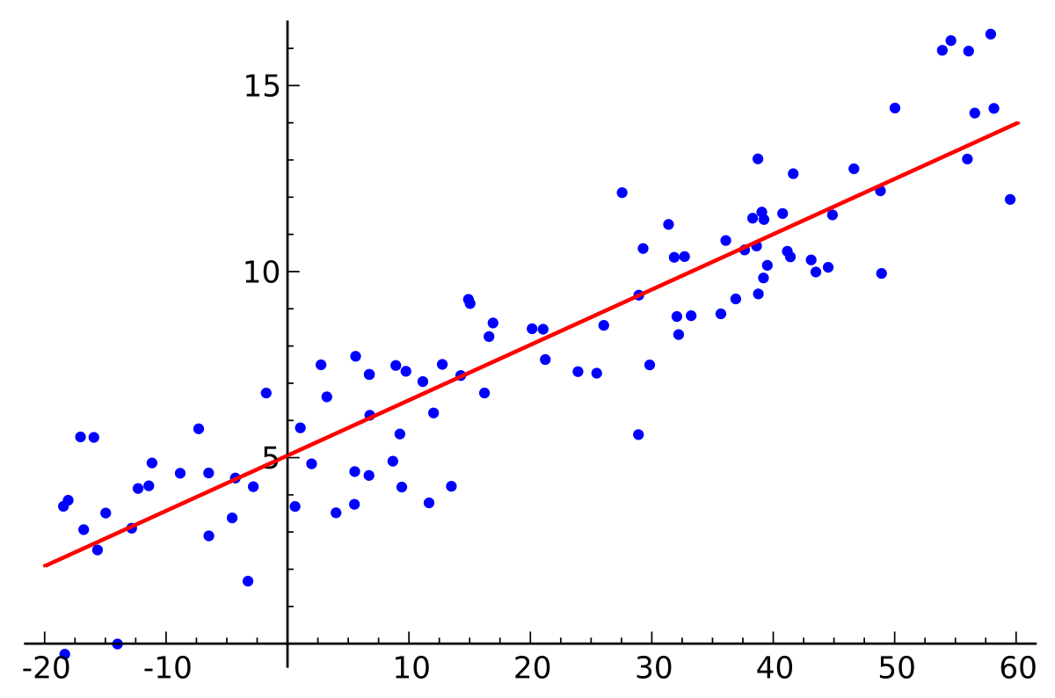

**Figure 25 Linear regression plot - from Wikipedia**

The simple form of Linear Regression can be described by the following equations:

Y= β0 + β1x

Linear regression can also applied in multi-variable related probleEMP where there are more than 1 value of (x), like the current situation. Therefore, multi-variable Linear Regression can be represented by the following equation:

$$f(X)=X.θ$$

In above equation:

X:  Input feature value of each instance. ( matrix mxn)

θ: hypothesis parameters (co-efficient) of the model (vector (nx1))

with:

m: number of samples or dataset

n: number of features of the model

Linear regression has the following benefits:

* Benefits
* Simple
  + Fast to train
  + Can used for multiple-variable probleEMP (more than 1 variable)
  + Works in most cases
* Trade-offs:
  + Validation rate is not high because not all variable relationships are purely linear
  + Sensitive to noise (outliers)

##### Cost function for linear regression:

A cost function is a function that tell us "how good" our model is. For linear regression, one of the most commonly used cost function is Least Squared Error function:

$$E=\frac{1}{2m}\sum_{i=1}^{m}{{(h_{θ}\left(x^{\left(i\right)}\right)-y^{\left(i\right)}))}^{2}}$$

With $h_{θ}\left(x^{\left(i\right)}\right)$  
**:**prediction result

$y^{\left(i\right)}$**:** actual price

**m:** number of samples used to train

**The smaller the cost function, the better the model is**

##### Training approach with linear regression

To train a machine learning model with linear regression, there are 2 available approaches:

* 1. **Gradient descent**

Gradient descent is an optimization algorithm used to minimize the cost function by iteratively moving a point toward its local minimum point. In machine learning, we use gradient descent to update the weights of our model.

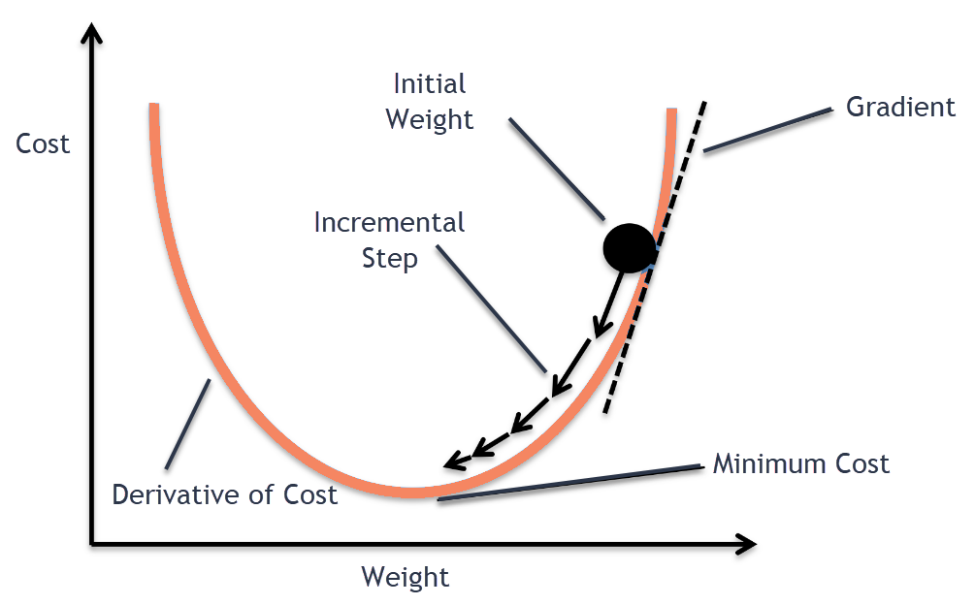

**Figure 26 Gradient Descent Plot**

Gradient descent allows us to set up hyper-parameters before training process, including number of iterations, initial weights, learning rates. Therefore, Gradient descent is highly customizable and stable with noise and outliers.

Gradient descent haves the following benefits and trade-offs:

* Benefits:
  + Can manually adjust model result by setting the number of iteration loops
  + Can endure noise thanks to high customizability
* Trade off:
  + Slow because of the iteration needed for training
  + Require initial parameters
  + Need many manual run to figure out the best result
  1. **Normal equation**

Normal Equation is an analytical approach to directly calculate the model weight θ without using Gradient Descent. The normal equation can be described as the following:

$$θ={(X^{T}X)}^{-1}. (X^{T}Y)$$

In the above equation,

**θ** : hypothesis parameters that define it the best. (vector nx1)

**X** : Input feature value of each instance. ( matrix mxn)

**Y** : Output value of each instance. ( vector mx1)

with :

**m**: number of samples or dataset

**n**: number of features of the model

Normal equation is inferred by applying derivative on the cost function, which is Least Squared Error function to find the local minimuEMP. Because of the characteristic of the squared function, the local minimum is also the global minimuEMP, which is our desired final result. Because the final hypothesis parameters is calculated directly with 1 step, the hypothesis is very fast. However, because there are no manually tuning and setting involved, Normal Equation approach can easily affected by noise and outliers in the dataset.

Using normal equation would also have benefits and trade-offs:

* Benefits:
  + Fast with 1-step learning
  + No related initial settings needed
* Trade-offs:
  + Cannot manually adjusted, so it is very sensible to noise

##### Implementation

We choose to use **normal equations** approach instead of **gradient descent** because:

* Faster
* Because of the project scope, there would be no human involved

For each equipment type, we would train a separate model

$$θ={(X^{T}X)}^{-1}. (X^{T}Y)$$

Input:

* X: additional specs values of all the equipments of the equipment type
* Y: price of the equipments

Output:

* $θ$: hypothesis parameters of the model

Hypothesis parameters would be used to calculate suggested price by linear regression equation:

$$f(X)=X.θ$$

With:

* **X**: input values of the equipment need to suggest price
* $θ:$ hypothesis parameters of the model
* $f(X)$: suggested price

# System implementation & Test

## Introduction

### Overview

This section provides in detail all necessary information about implementation information and testing procedure of EMP includes test plans, test cases, test result and risks estimations.

### Test Approach

* Goal: To test the whole system based on the core workflow.
* Method: System Testing, Black-box Testing.

## Database Relationship Diagram

### Physical Diagram

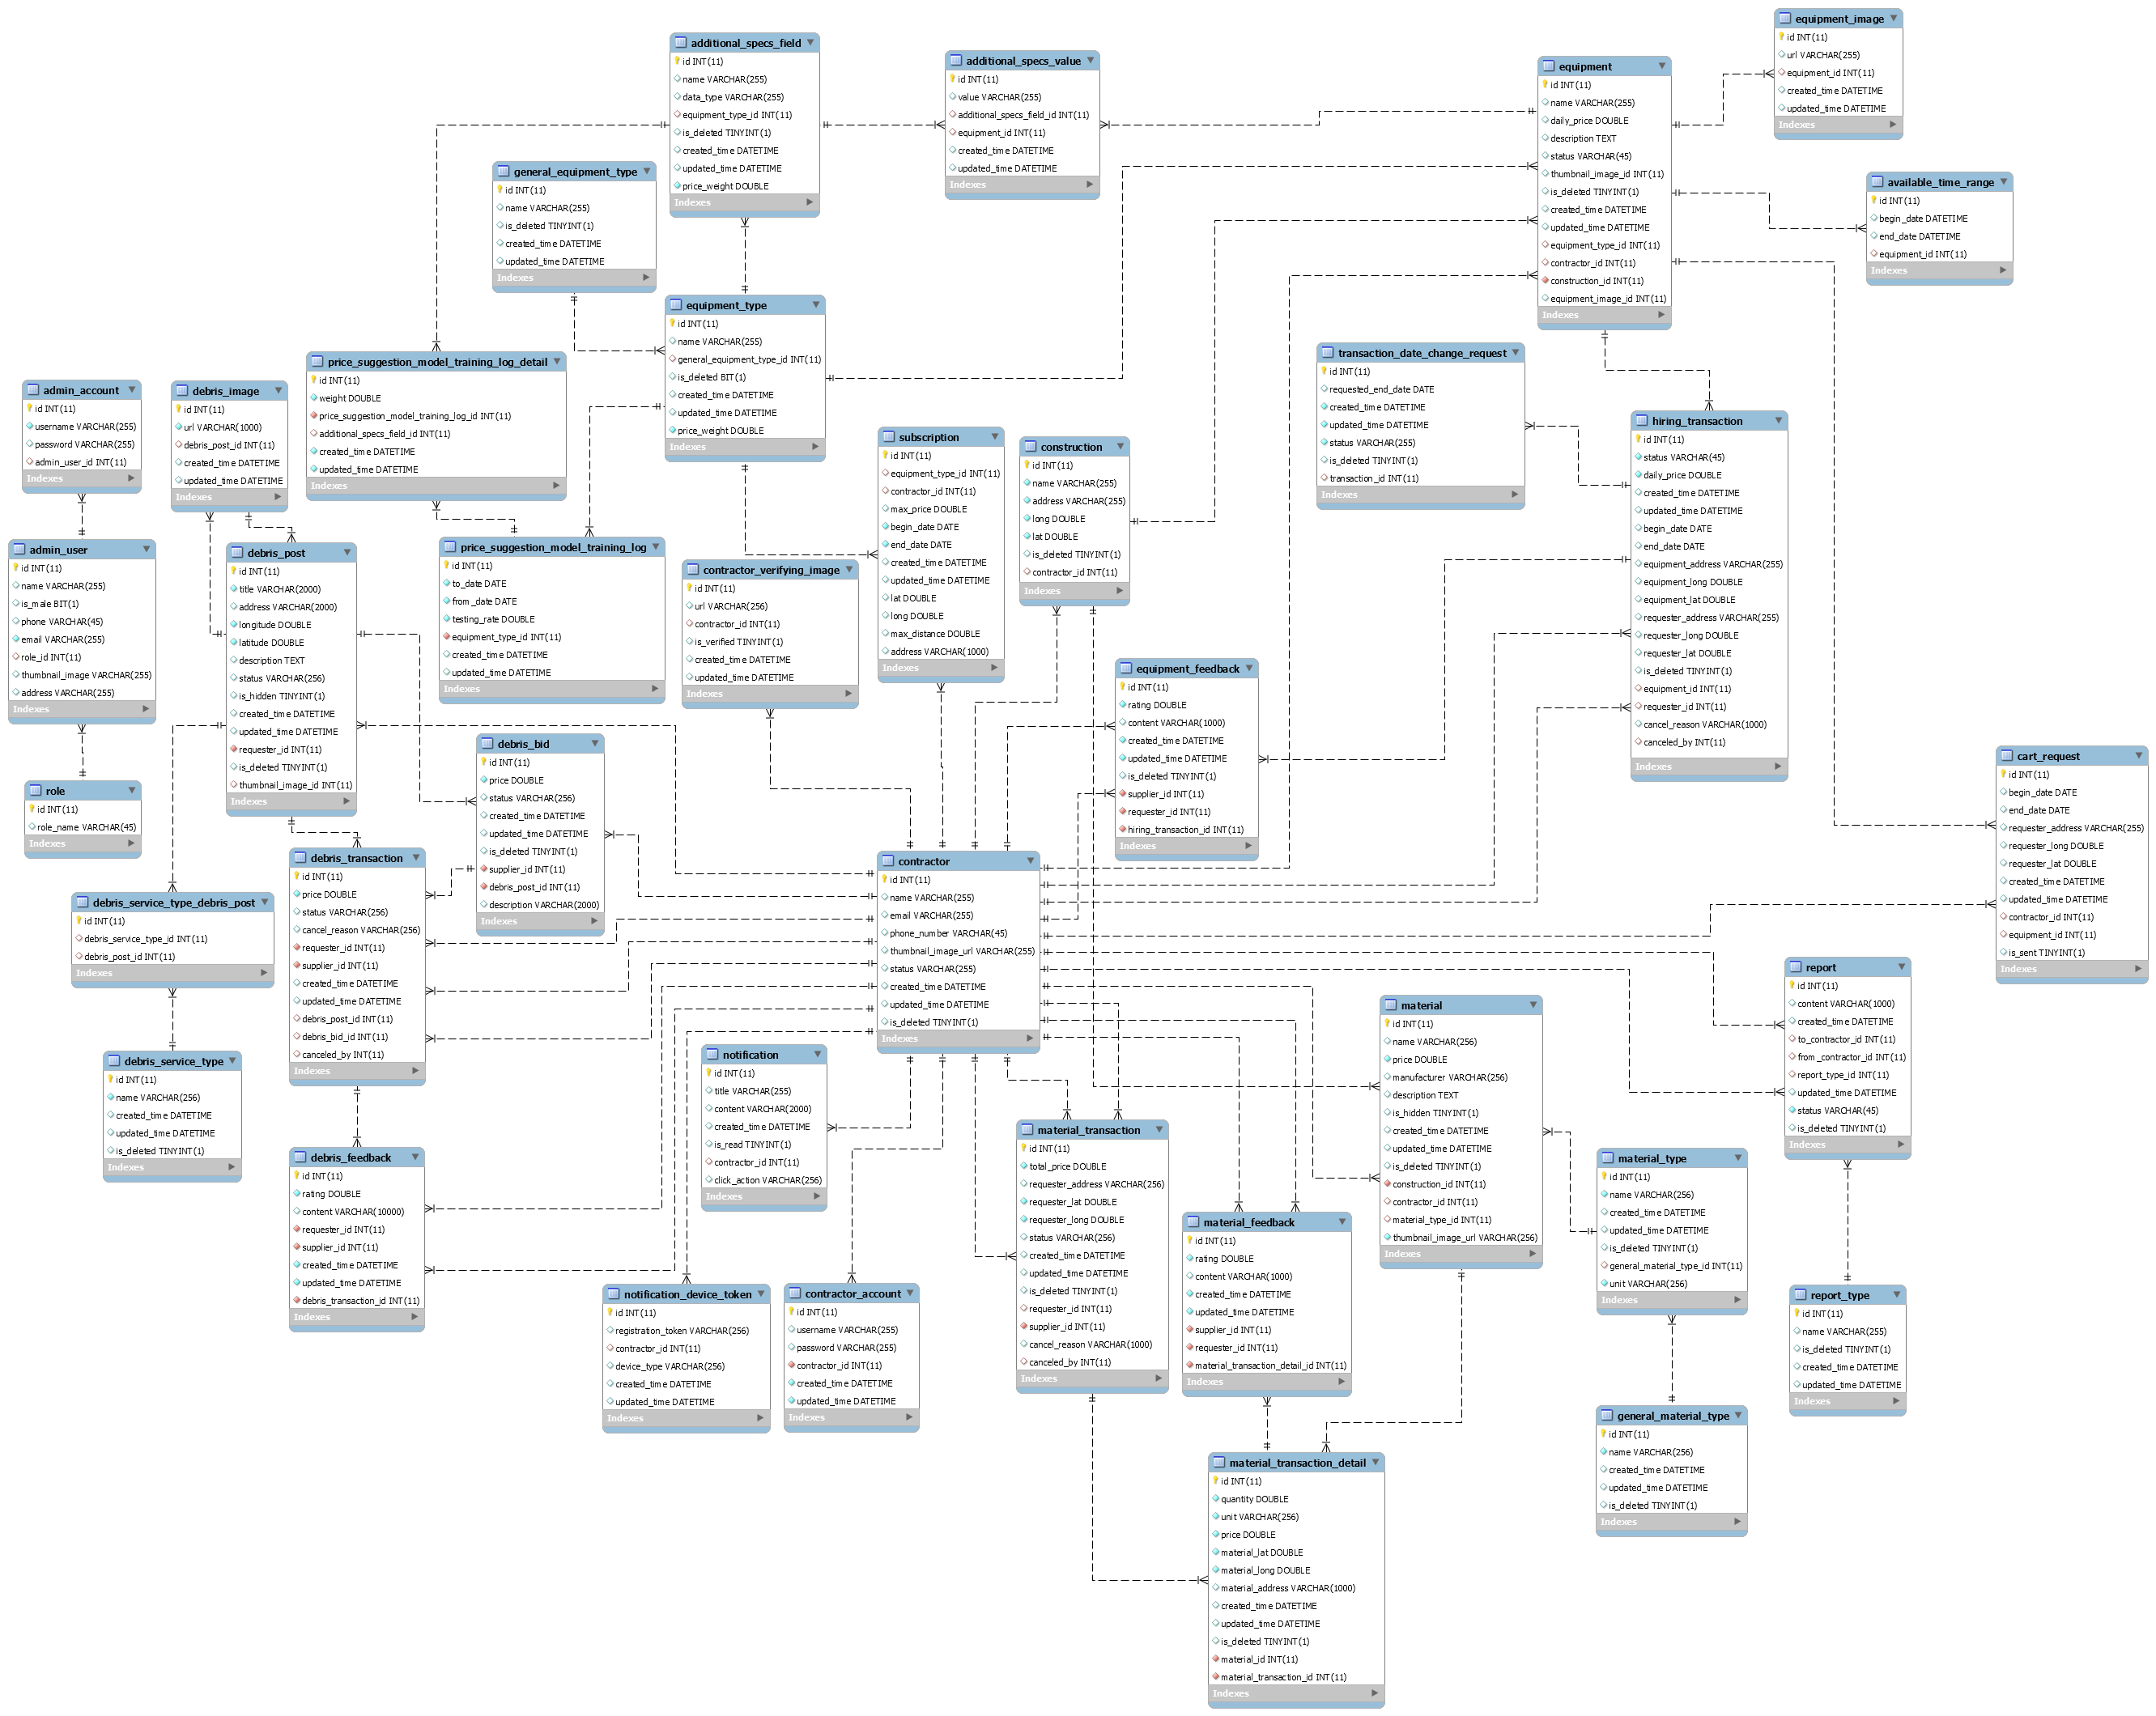

Figure 27: Physical Diagram

### Data dictionary

|  |  |
| --- | --- |
| **Data dictionary: describe content of all tables** | |
| **Entity name** | **Description** |
| additional_specs_field | Describe all additional specifications field of each equipment type in the system |
| additional_specs_value | Describe all additional specifications value of each equipment in the system |
| admin_account | Describe all admin account in the system |
| admin_user | Describe all admin user in the system |
| available_time_range | Describe all available time range of each equipment in the system |
| construction | Describe all constructions of each Registered User in the system |
| Registered User | Describe all Registered User in the system |
| Registered User_account | Describe all accounts of Registered Users in the system |
| Registered User_verifying_image | Describe all images to verify account of each Registered User in the system |
| debris_bid | Describe all bids of each debris post in the system |
| debris_feedback | Describe all feedbacks of each debris post in the system |
| debris_image | Describe all images of each debris post in the system |
| debris_post | Describe all debris post in the system |
| debris_service_type | Describe all debris service types in the system |
| debris_service_type_debris_post | Describe all relations between debris posts and debris service types in the system |
| debris_transaction | Describe all debris transactions in the system |
| equipment | Describe all equipments in the system |
| equipment_feedback | Describe all feedbacks of each equipment transaction in the system |
| equipment_image | Describe all images of each equipment in the system |
| equipment_type | Describe all equipment types in the system |
| general_equipment_type | Describe all equipment type categories in the system |
| general_material_type | Describe all material type categories in the system |
| hiring_transaction | Describe all hiring equipment transactions in the system |
| material | Describe all materials in the system |
| material_feedback | Describe all feebacks of each detail of material transaction in the system |
| material_transaction | Describe all material transactions in the system |
| material_transaction_detail | Describe all details of each material transaction in the system |
| material_type | Describe all material types in the system |
| notification | Describe all notifications of each Registered User in the system |
| notification_device_token | Describe all device’s notification token of each Registered User in the system |
| report | Describe all reports about bad behaviors of each Registered User in the system |
| report_type | Describe all bad behavior types in the system |
| role | Describe all role in the system |
| subscription | Describe all subscription for equipment in the system |
| transaction_date_change_request | Describe all requests about changing transaction’s date in the system |
| PriceSuggestionModalTrainingLogDetail | Describe price Suggestion Model training log detail in the system |
| PriceSuggestionModalTrainingLog | Contain Price Suggestion Model training log in the system |

Figure 28: Data Dictionary

## Test Plan

The purpose of this section is to verify and ensure that EMPSC meets its design specification and other requirements from user. The following part will describe which features to be tested and which will not.

### Features to be tested

* Registered User:
  + Request an equipment transaction
  + Change status of equipment transaction
  + Request an material transaction
  + Change status of material transaction
  + Post a debris service request
  + Bid a debris post
  + Choose a bid
  + Change status of debris transaction

### Features not to be tested

* Registered User:
  + Register, login, logout, view home page, search
  + Manage equipment
  + Manage materials
  + Manage debris posts
  + Manage equipment subscriptions
* Admin:
  + Manage users
  + Manage reports
  + Manage feedbacks
  + Manage equipment types
  + Manage equipment categories
  + Manage material types
  + Manage material categories
  + Manage debris service types

## System Testing Test Case

### Registered User testing case:

#### Request an equipment transaction:

|  |  |  |  |  |  |  |  |
| --- | --- | --- | --- | --- | --- | --- | --- |
| **ID** | **Test case description** | **Test case procedure** | **Expected output** | **Inter-dependence test case** | **Result** | **Test date** | **Note** |
| QET_01 | Registered User request for hiring equipment with receive address | 1. Search equipment  2. Click on equipment  3. Enter address input ‘ho chi minh’  4. Select first suggest address  5. Click “Request for hiring” button | Request button is disabled. Can not click to request. | N/A | Pass | 09/04/2019 |  |
| QET_02 | Registered User request for hiring equipment with date range | 1. Search equipment  2. Click on equipment  3. Select a date range  4. Click “Request for hiring” button | Request button is disabled. Can not click to request. | N/A | Pass | 09/04/2019 |  |
| QET_03 | Registered User request for hiring equipment with receive address | 1. Search equipment  2. Click on equipment  3. Enter address input ‘ho chi minh’  4. Select date range  4. Select first suggest address  5. Click “Request for hiring” button | New equipment transaction created and system shows success message: “Request for hiring this device was sent!” | N/A | Pass | 09/04/2019 |  |

#### Change status of equipment transaction

|  |  |  |  |  |  |  |  |
| --- | --- | --- | --- | --- | --- | --- | --- |
| **ID** | **Test case description** | **Test case procedure** | **Expected output** | **Inter-dependence test case** | **Result** | **Test date** | **Note** |
| CSOET_01 | Registered User accept a transaction | 1. Login as supplier in test case QET_03  2. Navigate to “My equipment transactions” screen (/equipments/supply)  3. Click “Accept” button on the transaction of QET_03  4. Click “Yes” button | System shows success message, the transaction’s status was changed to “Accepted” | QET_03 | Pass | 09/04/2019 |  |
| CSOET_02 | Registered User change equipment transaction’s status to processing | 1. Click “Accepted” status on statuses menu  2. Click “Deliver” button  3. Click “Yes” button | System shows success message, the transaction’s status was change to “Processing”, equipment status of the transaction was changed to “Delivering” | CSOET_01 | Pass | 09/04/2019 |  |
| CSOET_03 | Registered User change equipment’s status of transaction’s to renting | 1. Login as requester of the transaction  2. Navigate to “Requested transactions” screen. (/equipments/request)  3. Click “Processing” menu on statuses menu  4. Click “Receive” button on the transaction  5. Click “Yes” button | System shows success message, equipment status of the transaction was changed to “Renting” | CSOET_02 | Pass | 09/04/2019 |  |
| CSOET_04 | Registered User change equipment’s status of transaction’s to returning | 1. At requested equipments screen, status = proccessing, click “Return equipment”  2. Click “Yes” button | System shows success message, equipment status of the transaction was changed to “Returning” | CSOET_03 | Pass | 09/04/2019 |  |
| CSOET_05 | Supplier receive equipment | 1. Login as supplier in test case QET_04  2. Navigate to “My equipment transactions” screen (/equipments/supply)  3. Click “Receive” button on the transaction of QET_04  4. Click “Yes” button | System shows success message, the transaction’s status was changed to “Finished” and equipment’s status of the transaction was changed to “Available” | QET_04 | Pass | 09/04/2019 |  |

# Software User’s Manual

## Installation Guide

### Setting up environment at server

#### Hardware requirements

|  |  |  |
| --- | --- | --- |
| **Server** | **Minimum Requirements** | **Recommended** |
| **Internet Connection** | Cable, Wi-Fi (8 Mbps) | Cable, Wi-Fi (50 Mbps or more) |
| **Operating System** | CentOS 6 | CentOS 7 or Ubuntu 18 |
| **Computer Processor** | Intel® Xeon ® 1.4GHz | Intel® Xeon ® Quad Core (12M Cache, 2.50 GHz) |
| **Computer Memory** | 2GB RAM | 8GB or more |
| **Storage space** | 3GB | 5GB or more |

#### Software requirement

|  |  |  |
| --- | --- | --- |
| **Name** | **Name/Version** | **Description** |
| **Environment** | Java EE 8.0, Node v10 | Specification for developing web application |
| **Dependency manager, build tool** | Yarn v1.15.2, Gradle 5.3.1, Maven 3.6.1 | Dependency managers, build tools for development |
| **Operating System** | Window 10 or Ubuntu 16 or MacOS | Operating system and platform for development |
| **Modeling tool** | StarUML, Draw.io | Used to design diagram |
| **IDE** | IntelliJ IDEA 2018.1.5, Visual Studio Code 1.27.2 | Programming tools |
| **DBEMP** | MySQL 8.0 | Used to create & manage the database for development |
| **Web browser** | Chrome 69 or above. | Testing browser |
| **Mobile OS** | iOS 10 or above | Testing mobile device operating system |
| **Deployment Server** | Docker Compose 1.24.0 or above | Deployment environment for production |

### Deployment at server side

#### Prepare deployment package

* **Development**

Download and install Java  
Link download: <http://www.oracle.com/technetwork/java/javase/downloads/java-archive-javase8-2177648.html>

* + Download and install IntelliJ IDEA (Includes Gradle and Maven)  
    Link download:  
    [https://www.jetbrains.com/idea/download/#section=windows](https://www.jetbrains.com/idea/download/)
  + Download and install MySQL 8.0  
    Link download:  
    <https://dev.mysql.com/downloads/installer/>
  + Download and install NodeJS v10 (Inludes NPM 6)  
    Link download:  
    <https://nodejs.org/en/download/>
  + Download and install Yarn  
    Link download:  
    <https://yarnpkg.com/lang/en/docs/install/#windows-stable>
* **Production**  
  Download and install Docker Compose:  
  Link download: <https://docs.docker.com/compose/install/>

#### Configure Server before deploy

* Development:
  + MySQL 8.0: create new database and new user and grant all privileges on the new database to the new user.
  + Web API application:
    - Copy capstone-EMP/client-api/src/main/tomee/deploy-conf/ tomee.xml to capstone-EMP/client-api/src/main/tomee/deploy/tomee.xml
    - Edit connection string
  + Web Admin application:
    - Edit connection string in file: capstone-EMP/webadmin/src/main/resources/application.properties

### Deploy web application on server

#### Development

* Database:
  + Restore database from file capstone-EMP/database/init.sql
* Web API application:
  + Open IntelliJ IDEA and open folder capstone-EMP/client-api as a project
  + At the top menu, click Run button
* Web admin application:
  + Open IntelliJ IDEA and open folder capstone-EMP/webadmin as a project
  + At the top menu, click Run button
* Web client:
  + Open VSCode and open folder capstone-EMP/client-web
  + Open intergrated terminal and run command: “yarn” to install dependency packages and “yarn dev” to start web client for development
* Mobile Application:
  + Open VSCode and open folder capstone-EMP/client-mobile
  + Open intergrated terminal and run command: “yarn” to install dependency packages and “yarn dev” to start web client for development
  + Open expo in iPhone and connect to printed URL in the terminal

#### Production

* For web application (includes Web API, Web Admin, Web Client, database):
  + Open terminal at project folder and run command: “docker-compose up”
* For mobile application:
  + Open terminal at client-mobile folder of project
  + Install dependency packages with command: “yarn”
  + Build application with command: “expo build:ios”

## User Guide

### Web application

### Mobile application

#### Search equipment

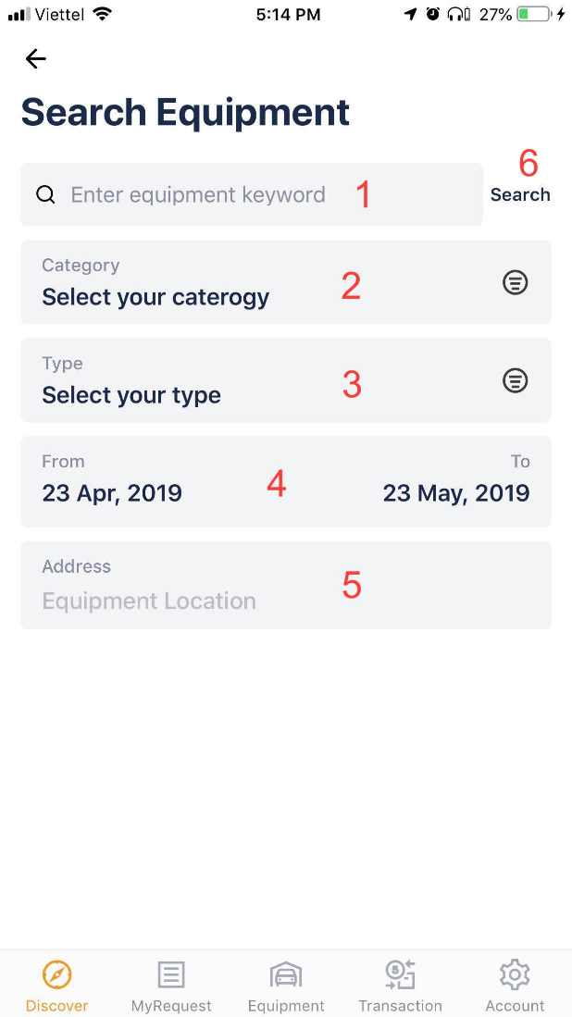

|  |  |
| --- | --- |
| **Step** | **Description** |
| 1 | Fill equipment keyword field |
| 2 | Select equipment category |
| 3 | Select equipment type |
| 4 | Select equipment time range ( from date - to date ) |
| 5 | Fill equipment address field |
| 6 | Click “Search” button |

#### View equipment results

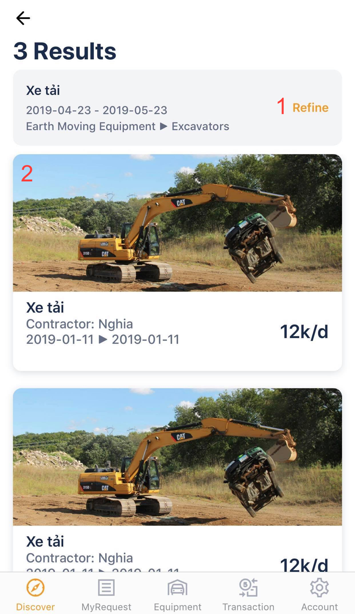

|  |  |
| --- | --- |
| **Step** | **Description** |
| 1 | Click “Refine” button to go back to search screen |
| 2 | Click equipment item to navigate to equipment detail |

#### View equipment detail

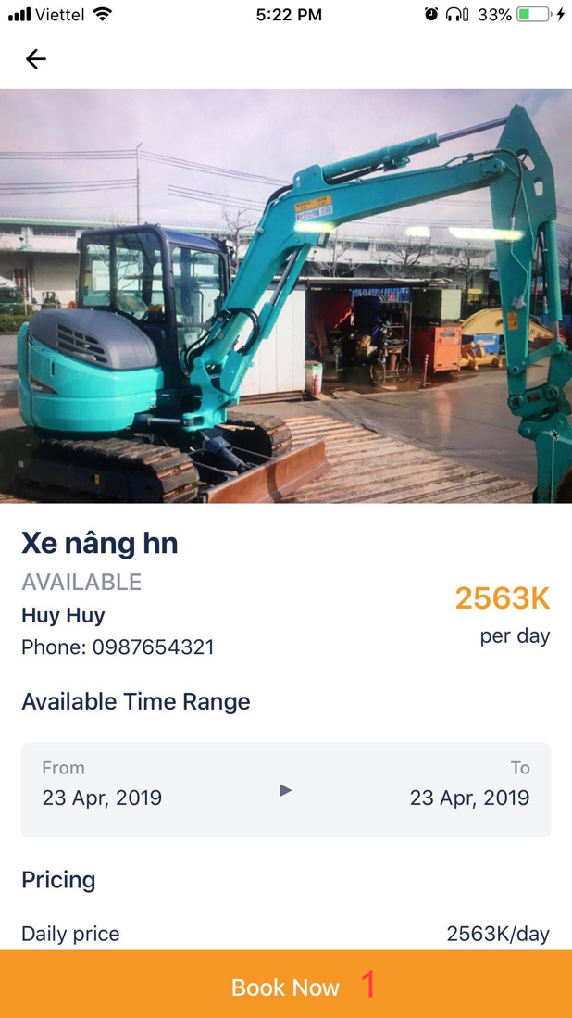

|  |  |
| --- | --- |
| **Step** | **Description** |
| 1 | Click “Book now” button to request equipment |

#### Manage equipment in my request

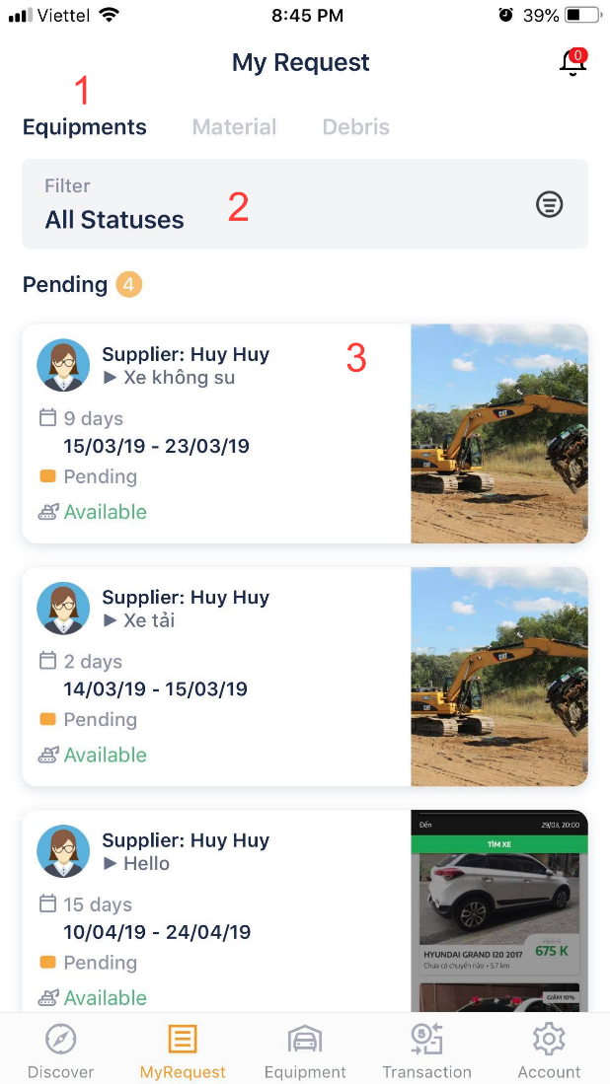

|  |  |  |
| --- | --- | --- |
| **Step** | **Description** | |
| Pre-condition | User must login |
| 1 | Click “Equipment” button to view list equipment | |
| 2 | Click “Filter” button to filter list equipment |
| 3 | Click on equipment item to view equipment detail |

|  |  |
| --- | --- |
| **Step** | **Description** |
| 1 | Click “Cancel” button to cancel request equipment |

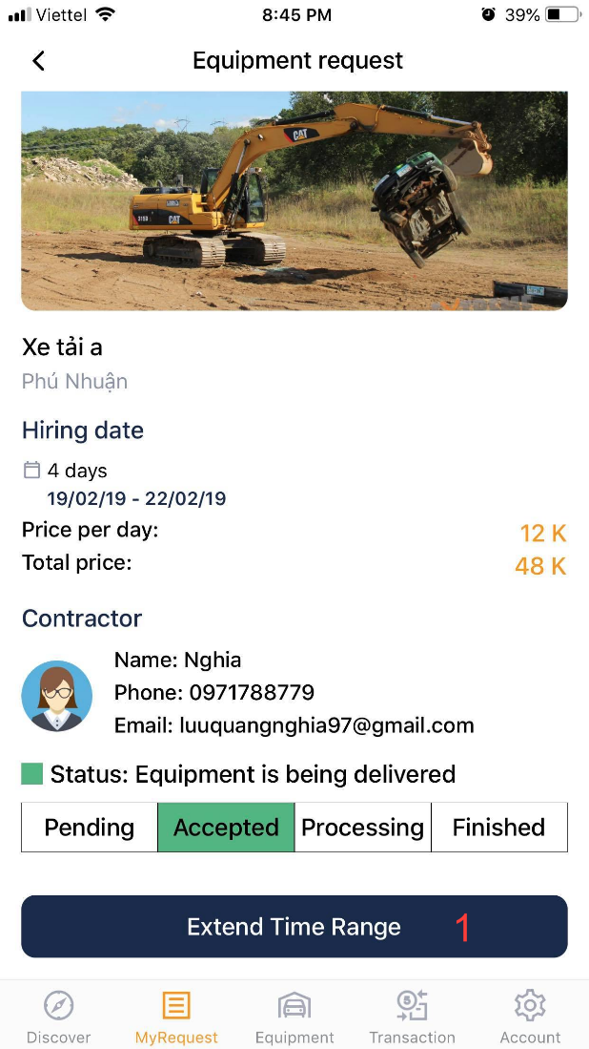

|  |  |
| --- | --- |
| **Step** | **Description** |
| Pre-condition | Equipment must be accepted |
| 1 | Click “Extend time range” button to request adjust time range |

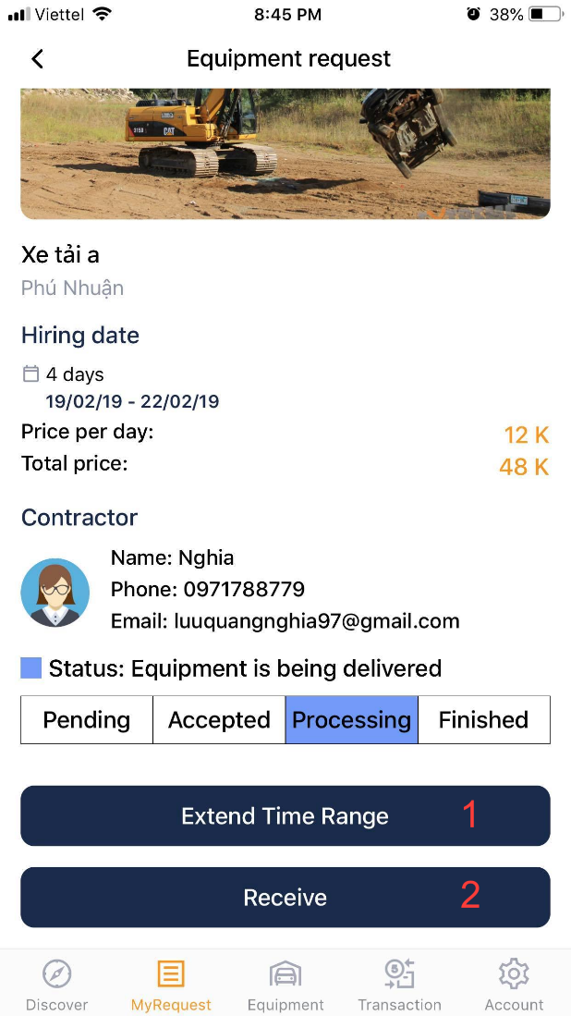

|  |  |
| --- | --- |
| **Step** | **Description** |
| Pre-condition | Supplier must be press delivering |
| 1 | Click “Extend time range” button to request adjust time range |
| 2 | Click “Receive” to receive equipment |

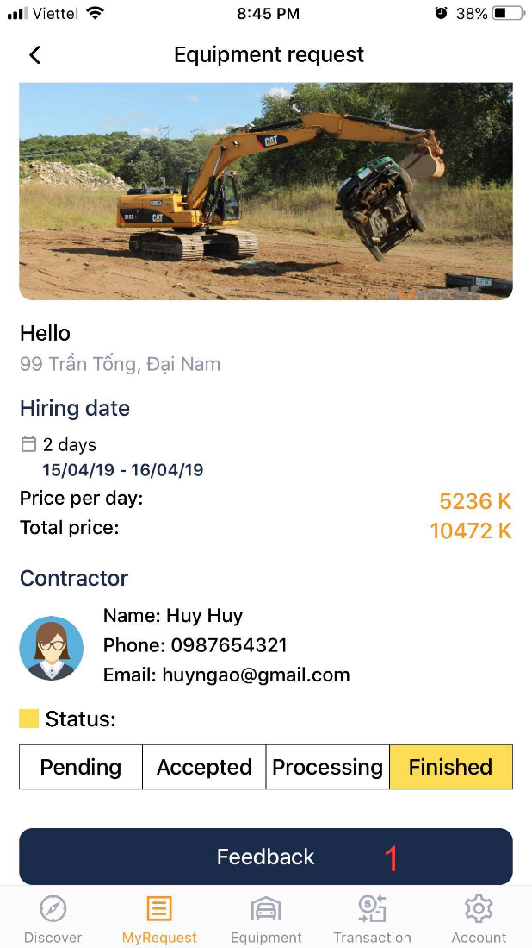

|  |  |
| --- | --- |
| **Step** | **Description** |
| 1 | Click “Feedback” button to feedback transaction |

#### Manage equipment storage

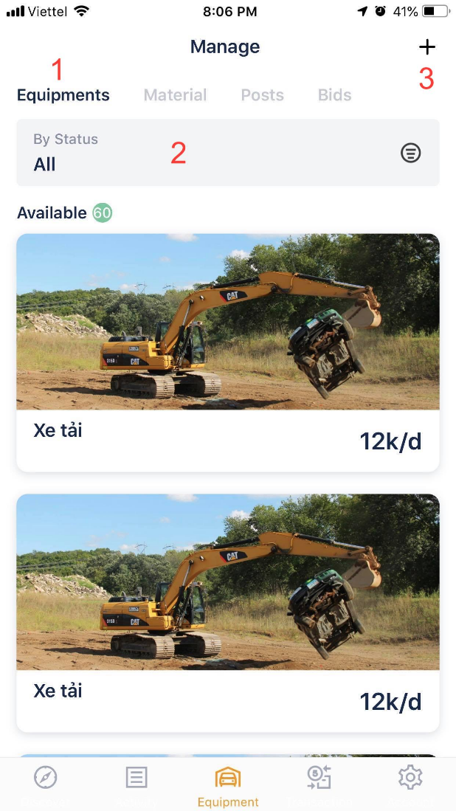

|  |  |
| --- | --- |
| **Step** | **Description** |
| Pre-condition | User must login |
| 1 | Click “ equipment” button to view my equipment list |
| 2 | Click “filter” button to filter my equipment |
| 3 | Click “+” button to post new equipment |

#### Post equipment

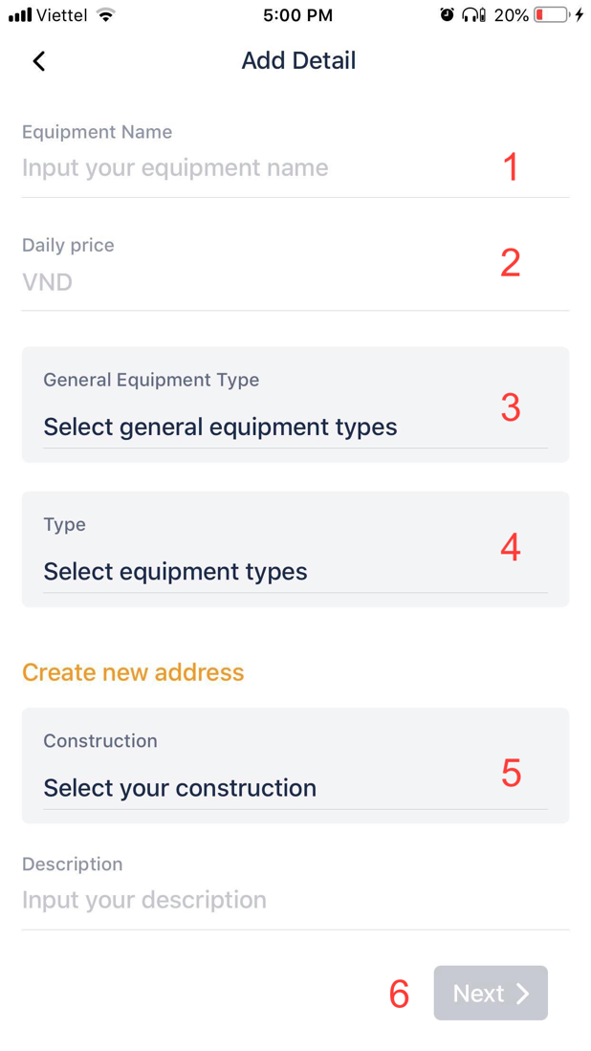

|  |  |
| --- | --- |
| **Step** | **Description** |
| 1 | Fill the field “Equipment name” |
| 2 | Fill the field “Daily price” |
| 3 | Select equipment category |
| 4 | Select equipment type |
| 5 | Select construction field |
| 6 | Click “Next” button to the next step |

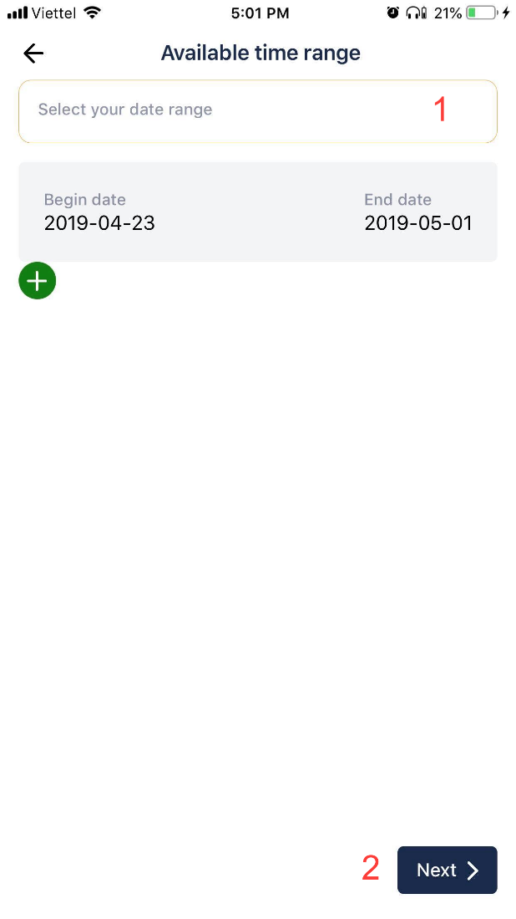

|  |  |
| --- | --- |
| **Step** | **Description** |
| 1 | Select time rage |
| 2 | Click “Next” button to the next step |

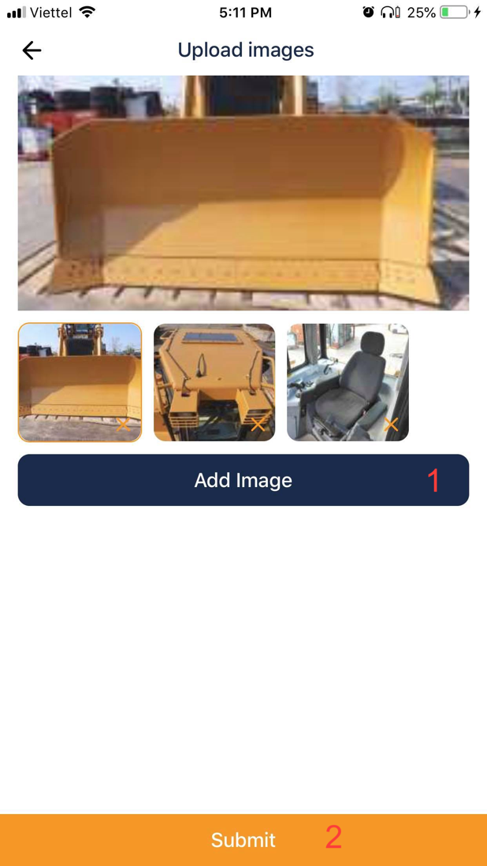

|  |  |
| --- | --- |
| **Step** | **Description** |
| 1 | Click “Add Image” to select image from camera roll |
| 2 | Click “Submit” button to submit post equipment |

# Appendix

1. **Spring Framework** *[Online]* Available: https:/spring.io/docs/reference.
2. **MySQL** *[Online]* Available: <https://dev.mysql.com/doc/>.
3. **ReactJS** *[Online]* Available: <https://reactjs.org/docs/getting-started.html>
4. **React Native** *[Online]* Available: <https://facebook.github.io/react-native/docs/getting-started>
5. **IntelliJ IDEA** *[Online]* Available: <https://www.jetbrains.com/idea/documentation/>
6. **WebStorm** *[Online]* Available: <https://www.jetbrains.com/webstorm/features/>
7. **Visual Studio Code** *[Online]* Available: <https://code.visualstudio.com/docs>
8. **Nodejs** *[Online]* Available: <https://nodejs.org/en/docs/>